|  |  |
| --- | --- |
| **­** | **MINISTRY OF EDUCATION AND TRAINING** |

**FPT UNIVERSITY**

|  |  |
| --- | --- |
| **Capstone Project Document** | |
| **Location-based Augmented Reality Game System for Coffee House** | |
| **Group 5** | |
| **Group members** | Hồ Minh Quân – Team Leader – SE61193  Lê Khải Thông – Team Member – SE61443  Phùng Văn Bửu – Team Member – SE61491  Nguyễn Hải Phong – Team Member – 60193 |
| **Supervisor** | Lâm Hữu Khánh Phương |
| **Ext. Supervisor** | N/A |
| **Capstone Project Code** | ARG |

- Ho Chi Minh City, 12 September, 2016 -

***ACKNOWLEDGEMENT***

In order to be able to finish this ARG project, we have got a lot of help from other people. We would love to thank each person who helped us on this project.

First of all, we would like to thank FPT University for giving us a change to work on this project, a chance to improve ourselves within 4 years.

Secondly, we are really thankful to Mr. Lam Huu Khanh Phuong - our supervisor. He has been always with us giving a lot useful suggestions from the very beginning till the end of this project. We would like to give a special thanks to him for supporting us with a suitable place to work, for helping us when we have no idea about some problems.

Next, we would like to thank all of the instructors who has lectured us in (about) 4 years.

And we shall not forget about all of the authors from the documentations we read.

Most importantly, we would like to dedicate this work to our parents. Thanks for supporting us from the first day when we were born.

In conclusion, thanks everyone, it has been a pleasure working with all of you.

**ARG TEAM.**

Table of Contents

Table of Contents 3

List of Tables 7

List of Figures 10

Definitions, Acronyms and Abbreviations 15

A. Introduction 16

1. Project Information 16

2. Introduction 16

3. Current Situation 16

4. Problem Definition 16

5. Proposed Solution 17

5.1. Feature functions 17

5.2. Advantages 17

5.3. Disadvantages 17

6. Functional Requirements 17

7. Roles and Responsibilities 18

B. Software Project Management Plan 19

1. Problem Definition 19

1.1. Name of this Capstone Project 19

1.2. Problem Abstract 19

1.3. Project Overview 19

1.4. Development Environment 21

2. Project Organization 22

2.1. Software Process Model 22

2.2. Roles and Responsibilities 24

2.3. Tools and Techniques 25

3. Project Management Plan 26

3.1. Product Backlog 26

3.2. Deliverables 27

3.3. All Meeting Minutes 28

4. Coding Convention 28

4.1. Naming Conventions 28

4.2. Layout Conventions 29

4.3. Commenting Conventions 29

4.4. Language Guidlines 29

String Data Type 29

Implicitly Typed Local Variables 29

Arrays 30

&& and || Operators 30

New Operator 30

Campaign Handling 30

Static Members 30

LINQ Queries 31

C. Software Reuirement Specification 32

1. User Requirement Specification 32

1.1. Guest Requirement 32

1.2. Administrator Requirement 32

1.3. Organizer Requirement 32

1.4. Normal user/Authorized User Requirement 32

2. System Requirement Specification 33

2.1. External Interface Requirement 33

2.2. System Overview Use Case 34

2.3. List of Use Cases 42

2.4. Web Application Use Cases 42

2.5. Mobile Application Use Cases 183

3. Software System Attribute 238

3.1. Usability 238

3.2. Reliability 238

3.3. Availability 238

3.4. Security 238

3.5. Maintainability 238

3.6. Portability 239

3.7. Performance 239

4. Conceptual Diagram 240

D. Software Design Description 243

1. Design Overview 243

2. System Architectural Design 244

2.1. Web applicaiton architecture description 244

2.2. Mobile application architecture description 244

3. Component Diagram 245

4. Detailed Description 246

4.1. Class diagram 246

4.2. Class diagram explanation 248

4.3. Interaction diagram 258

4.4. Web application 258

4.5. Mobile application 261

5. User Interface Design 271

5.1. Web application user interface 271

5.2. Mobile application user interface 295

6. Database design 317

6.1. Entity relationship diagram 317

6.2. Data dictionary 318

7. Algorithms 319

7.1. Mobile application algorithms 319

7.2. Strategy for future expand plan 324

E. システム展開とテスト 326

1. 初めに 326

1.1. 概要 326

1.2. テストアプローチ 326

2. データベースの関係図 327

2.1. 物理のダイアグラム 327

2.2. データ辞書 328

3. パフォーマンス対策 329

3.1. ARGサーバ接続速度 329

4. テスト計画 330

4.1. テスト行う機能: 330

4.2. テスト行わない機能: 330

5. システムテストのテストケース 331

5.1. 通信ダイアグラム 331

5.2. テストケース 333

F. ソフトウェアユーザーマニュアル 353

1. インストレーションガイド 353

1.1. サーバ側の環境設定 353

1.2. サーバ側に展開します 353

2. ユーザーガイド 357

2.1. ウェブアプリケーション 357

2.2. 登録します 357

2.3. ログイン 358

2.4. 売店を作成します 359

2.5. キャンペーンを作成します 361

2.6. ゲームを作成します 363

2.7. モバイルアプリケーション 366

2.8. 登録します 366

2.9. ログイン 367

2.10. キャンペーンに参加します 368

2.11. ゲームをします 369

2.12. 賞品を交換します 370

2.13. プレゼントを受け取ります 371

G. Appendix 373

List of Tables

Table 1 - Roles and Responsibility 18

Table 2 - Hardware Requirements for Web server 21

Table 3 - Hardware Requirements for Web development 21

Table 4 – Software Requirement 22

Table 5: Roles and Responsibilities Details 25

Table 6 – Tools 25

Table 7 - Techniques 26

Table 8 – Product backlog 27

Table 9 - Desciption of Use Case for Web Application 38

Table 10 - Description of Actor for Web Application 38

Table 11 - Desciption of Use Case for Mobile Application 41

Table 12 - Description of Actor for Mobile Application 41

Table 13 - Conceptual Diagram Data Dictionary 242

Table 14 - Components Dictionary 245

Table 15 - Class dictionary 248

Table 58 - <User Interface-Field> Regster 272

Table 59 - <User Interface-Button/Hypperlinks> Register 273

Table 60 - <User Interface-Field> Login 273

Table 61 - <User Interface-Button/Hypperlinks> Login 273

Table 62 - <User Interface-Field> Manage Campaign 274

Table 63 - <User Interface-Button/Hypperlinks> Manage campaign 274

Table 64 - <User Interface-Field> Create new campaign 276

Table 65 - <User Interface-Button/Hypperlinks> Create new campaign 276

Table 66 - <User Interface-Field> Edit Campaign 277

Table 67 - <User Interface-Button/Hypperlinks> Edit Campaign 278

Table 68 - <User Interface-Field> Manage Organizer 278

Table 69 - <User Interface-Button/Hypperlinks> Manage Organizer 279

Table 70 - <User Interface-Field> Edit Organizer 280

Table 71 - <User Interface-Button/Hypperlinks> Edit Organizer 280

Table 72 - <User Interface-Field> Edit Campaign Category 280

Table 73 - <User Interface-Button/Hypperlinks> Edit Campaign Category 281

Table 74 - <User Interface-Field> View Participant List 281

Table 75 - <User Interface-Button/Hypperlinks> View Participant List 282

Table 76 - <User Interface-Button/Hypperlinks> Manage Campaign Component 282

Table 77 - <User Interface-Field> Manage Survey 283

Table 78 - <User Interface-Button/Hypperlinks> Manage Survey 283

Table 79 - <User Interface-Field> Create Survey 284

Table 80 - <User Interface-Button/Hypperlinks> Create Survey 284

Table 81 - <User Interface-Field> Create Question For Survey 286

Table 82 - <User Interface-Button/Hypperlinks> Create Question For Survey 286

Table 83 - <User Interface-Field> Manage Activity 287

Table 84 - <User Interface-Button/Hypperlinks> Manage Activity 288

Table 85 - <User Interface-Field> Create Game 288

Table 86 - <User Interface-Button/Hypperlinks> Create Question For Survey 289

Table 87 - <User Interface-Field> Manage Prize 289

Table 88 - <User Interface-Button/Hypperlinks> Manage Prize 290

Table 89 - <User Interface-Field> Create Prize 291

Table 90 - <User Interface-Button/Hypperlinks> Create Prize 291

Table 91 - <User Interface-Field> Manage Store 292

Table 92 - <User Interface-Button/Hypperlinks> Manage Store 292

Table 93 - <User Interface-Field> Create Store 293

Table 94 - <User Interface-Button/Hypperlinks> Create Store 293

Table 95 - <User Interface-Field> Manage Wifi Router 294

Table 96 - <User Interface-Button/Hypperlinks> Manage Wifi Router 294

Table 97 - <User Interface-Field> Create Wifi Router 295

Table 98 - <User Interface-Button/Hypperlinks> Create Wifi Router 295

Table 99 - <User Interface-Field> Register – Mobile App 297

Table 100 - <User Interface-Button/Hypperlinks> Register – Mobile App 297

Table 101 - <User Interface-Field> Login – Mobile App 298

Table 102 - <User Interface-Button/Hypperlinks> Login – Mobile App 298

Table 103 - <User Interface-Field> Home – Mobile App 299

Table 104 - <User Interface-Button/Hypperlinks> Home – Mobile App 300

Table 105 - <User Interface-Field> My Brand – Mobile App 300

Table 106 - <User Interface-Button/Hypperlinks> My Brand – Mobile App 301

Table 107 - <User Interface-Button/Hypperlinks> Brand Detail – Mobile App 302

Table 108 - <User Interface-Button/Hypperlinks> Claim Gift – Mobile App 303

Table 109 - <User Interface-Button/Hypperlinks> Campaign Detail – Mobile App 304

Table 110 - <User Interface-Button/Hypperlinks> Join Activity – Mobile App 305

Table 111 - <User Interface-Button/Hypperlinks> Prize – Mobile App 306

Table 112 - <User Interface-Button/Hypperlinks> Redeem Prize – Mobile App 308

Table 113 - <User Interface-Button/Hypperlinks> Side Menu – Mobile App 309

Table 114 - <User Interface-Button/Hypperlinks> My Campaign – Mobile App 310

Table 116 - <User Interface-Button/Hypperlinks> Coupon List – Mobile App 311

Table 117 - <User Interface-Field> Redeem Coupon – Mobile App 311

Table 118 - <User Interface-Button/Hypperlinks> Redeem Coupon – Mobile App 312

Table 119 - <User Interface-Button/Hypperlinks> Profile – Mobile App 312

Table 120 - <User Interface-Button/Hypperlinks> Play Game – Mobile App 314

Table 121 - <User Interface-Button/Hypperlinks> In-game Shop – Mobile App 315

Table 122 - <User Interface-Button/Hypperlinks> Game Setting – Mobile App 316

Table 123 - Entity dictionary 319

Table 124 – データ辞書：実本の内容をすべて記述します 329

Table 125 – ARGサーバ接続速度テストケース 330

Table 126 - ARGサーバ接続速度テストの結果 330

Table 127 - ログインテストケース 335

Table 128 - 登録しますテストケース 341

Table 129 - ゲームのメニューテストケース 343

Table 130 - ゲームをするテストケース 345

Table 130 – ホーム画面テストケース 347

Table 130 – メニューテストケース 348

Table 130 – キャンペーンテストケース 350

Table 130 – 商品を交換するテストケース 352

Table 131 - ハードウェア要求 353

Table 132 - ソフトウェア要求 353

List of Figures

Figure 1: Agile Development Model 22

Figure 2: Scrum Process 23

Figure 3 - System Overview Use Case for web application 34

Figure 4 - System Overview Use Case for mobile application 39

Figure 5 - Guest Overview Use Cases 42

Figure 6 - <Guest> Register UCD 42

Figure 7 - <Guest> Login UCD 45

Figure 8 - <Guest, Authorized user> Search campaign UCD 47

Figure 9 - <Guest, Authorized user> Filter campaign UCD 50

Figure 10 - <Guest, Authorized user> View campaign detail UCD 53

Figure 11 - <Guest, Authorized user> View component UCD 55

Figure 12 - <Guest, Authorized user> Comment via facebook UCD 57

Figure 13 - Athorized User Overview Use Cases 59

Figure 14 - <Authorized user> Logout UCD 59

Figure 15 - Admin Overview Use Cases 61

Figure 16 - <Admin> Create category UCD 61

Figure 17 - <Admin> Edit category UCD 63

Figure 18 - <Admin> Delete category UCD 65

Figure 19 - <Admin> Approve request UCD 68

Figure 20 - <Admin> Reject request UCD 69

Figure 21 - <Admin> Create account for organizer UCD 71

Figure 22 - <Admin> Delete account of organizer UCD 74

Figure 23 - <Admin> Create organizer UCD 76

Figure 24 - <Admin> Edit organizer UCD 79

Figure 25 - <Admin> Delete organizer UCD 82

Figure 26 - Normal User Overview Use Cases 84

Figure 27 - Organizer Overview Use Cases 103

Figure 28 - <Organizer> Create campaign UCD 103

Figure 29 - <Organizer> Edit campaign UCD 107

Figure 30 - <Organizer> View campaign basic info UCD 110

Figure 31 - <Organizer> View campaign component UCD 112

Figure 32 - <Organizer> Create campaign component UCD 114

Figure 33 - <Organizer> Edit campaign component UCD 116

Figure 34 - <Organizer> Delete campaign component UCD 119

Figure 35 - <Organizer> Create survey UCD 121

Figure 36 - <Organizer> Edit survey UCD 123

Figure 37 - <Organizer> Delete survey UCD 125

Figure 38 - <Organizer> Create question UCD 128

Figure 39 - <Organizer> Edit question UCD 131

Figure 40 - <Organizer> Delete question UCD 134

Figure 41 - <Organizer> View list participation UCD 136

Figure 42 - <Organizer> Send notification UCD 138

Figure 43 - <Organizer> Edit campaign component detail UCD 140

Figure 44 - <Organizer> Delete campaign component detail UCD 143

Figure 45 - <Organizer> Send campaign approving request UCD 145

Figure 46 - <Organizer> Create activity UCD 147

Figure 47 - <Organizer> Edit activity UCD 151

Figure 48 - <Organizer> Delete activity UCD 154

Figure 49 - <Organizer> View campaign statistic UCD 156

Figure 50 - <Organizer> Create prize UCD 158

Figure 51 - <Organizer> Edit prize UCD 161

Figure 52 - <Organizer> Delete prize UCD 163

Figure 53 - <Organizer> Manage information UCD 165

Figure 54 - <Organizer> Create store UCD 167

Figure 55 - <Organizer> Edit store UCD 171

Figure 56 - <Organizer> Delete store UCD 174

Figure 57 - <Organizer> Create wifi router UCD 176

Figure 58 - <Organizer> Edit wifi router UCD 179

Figure 59 - <Organizer> Delete wifi router UCD 181

Figure 60 - Guest Overview Use Case 183

Figure 61 - <Guest> Register UCD 184

Figure 62 - <Guest> Login UCD 187

Figure 63 - Authorized user overview use case 189

Figure 64 - <Authorized user> Logout UCD 190

Figure 65 - <Authorized user> View joined campaign UCD 191

Figure 66 - <Authorized user>View brand list UCD 193

Figure 67 - <Authorized user> View my brand list UCD 195

Figure 68 - <Authorized user> Join campaign UCD 196

Figure 69 - <Authorized user> View tutorial UCD 199

Figure 70 - <Authorized user> Buy item UCD 200

Figure 71 - <Authorized user> View profile UCD 203

Figure 72 - <Authorized user> View coupon history UCD 205

Figure 73 - <Authorized user> Redeem coupon UCD 207

Figure 74 - <Authorized user> View brand detail information UCD 209

Figure 75 - <Authorized user> View brand campaign list UCD 211

Figure 76 - <Authorized user> View campaign detail information UCD 213

Figure 77 - <Authorized user> View prize list UCD 215

Figure 78 - <Authorized user> Redeem prize UCD 217

Figure 79 - <Authorized user> Claim gift UCD 220

Figure 80 - <Authorized user> View item UCD 224

Figure 81 - <Authorized user> View campaign activities UCD 227

Figure 82 - <Authorized user> Play game UCD 230

Figure 83 - <Authorized user> Adjust sound UCD 234

Figure 84 - <Authorized user> Gain item UCD 236

Figure 85 - Conceptual Diagram 240

Figure 86 - System architectural design 244

Figure 87 - Component Diagram 245

Figure 88 - Class diagram 246

Figure 89 - <Guest> Register SD 258

Figure 90 - <Guest> Login SD 259

Figure 91 - <Authorized User> Logout SD 260

Figure 92 - <Normal User> Join Campaign SD 260

Figure 93 - <Normal User> Join Activity SD 261

Figure 94 - <Guest> Register AD 262

Figure 95 - <Guest> Login AD 263

Figure 96 - <Authorized User> Logout AD 263

Figure 97 - <Authorized User> Join Campaign AD 264

Figure 98 - <Authorized User> Buy Item AD 265

Figure 99 - <Authorized User> Redeem Coupon AD 266

Figure 100 - <Authorized User> Redeem Prize AD 267

Figure 101 - <Authorized User> Claim Gift AD 268

Figure 102 - <Authorized User> Play game AD 269

Figure 103 - <Authorized User> Adjust sound AD 270

Figure 104 - <Authorized User> Gain Item AD 271

Figure 105 – Register UI 272

Figure 106: Login UI 273

Figure 107: Manage Campaign UI 274

Figure 108: Create new campaign UI 275

Figure 109: Edit Campaign UI-1 276

Figure 110 - Edit Campaign UI-2 277

Figure 111: Manage Organizer UI 278

Figure 112: Edit Organizer UI 279

Figure 113: Manage campaign category UI 280

Figure 114: View Participant List UI 281

Figure 115: Manage Campaign Component UI 282

Figure 116: Manage Survey UI 283

Figure 117: Create Survey UI 284

Figure 118 - Create Question For Survey UI-1 285

Figure 119 – Create Question For Survey UI-2 285

Figure 120 – Manage Activity UI 287

Figure 121 – Create Game UI 288

Figure 122 – Manage Prize 289

Figure 123 – Create Prize 290

Figure 124 – Manage Store 292

Figure 125 – Create Store 293

Figure 126 – Manage Wifi Router 293

Figure 127 – Create Wifi Router 294

Figure 128 – Register Mobile App UI 296

Figure 129 – Login Mobile App UI 297

Figure 130 – Home Mobile App UI 299

Figure 131 – My Brand Mobile App UI 300

Figure 132 – Brand Detail Mobile App UI 301

Figure 133 – Claim Gift Mobile App UI 302

Figure 134 – Campaign Detail Mobile App UI 303

Figure 135 – Join Activity Mobile App UI 305

Figure 136 – Prize Mobile App UI 306

Figure 137 – Redeem Prize Mobile App UI 307

Figure 138 – Side Menu Mobile App UI 308

Figure 139 – My Campaign Mobile App UI 310

Figure 140 – Coupon List Mobile UI 311

Figure 141 – Redeem Coupon Mobile App UI 311

Figure 142 – Profile Mobile App UI 312

Figure 143 – Play Game Mobile App UI 313

Figure 144 – In-game Shop Mobile App UI 314

Figure 145 – Game Setting Mobile App UI 316

Figure 146 –Entity Relationship Diagram 317

Figure 147 – <Algorithms> Drop rate distribution flow chart 321

Figure 148 - <Algorithms> Last hit prediction flow chart 324

Figure 149 – Future plan strategy 325

Figure 150 – 物理的なダイアグラム 327

Figure 151 - Communication diagram: Web application 331

Figure 151 - Communication diagram: Web application 332

Figure 152 - ＜ユーザーガイド・ウェブ＞　登録します 357

Figure 153 - ＜ユーザーガイド・ウェブ＞　登録します 358

Figure 154 - ＜ユーザーガイド・ウェブ＞　売店を作成します 360

Figure 155 - ＜ユーザーガイド・モバイル＞　登録します 362

Figure 156 - ＜ユーザーガイド・モバイル＞　ゲームを作成します 365

Figure 157 - ＜ユーザーガイド・モバイル＞　登録します 366

Figure 158 - ＜ユーザーガイド・モバイル＞　ログイン 367

Figure 159 - ＜ユーザーガイド・モバイル＞　キャンペーンに参加します 368

Figure 160 - ＜ユーザーガイド・モバイル＞　ゲームをします 369

Figure 161 - ＜ユーザーガイド・モバイル＞　商品を交換します 370

Figure 162 - ＜ユーザーガイド・モバイル＞　プレゼントを受け取ります 372

Definitions, Acronyms and Abbreviations

|  |  |
| --- | --- |
| **Name** | **Definition** |
| ARG | Location-based Augmented Reality Game System for Coffee House |
| Teek | An in-app point that user gain from participating activities of a campaign. This point will be used to redeem prize in a campaign |
| Coin | A currency in ARG system. Coin will be used to buy in-game item |
| Brand | A coffee brand |
| Organizer | User who has authorized to manage a brand’s information. Or in the other way, they are manager of coffee brand |
| Event | In our business context, we consider event is the same as a campaign |

1. Introduction
   1. Project Information

• Project name: Locastion-based Augmented Reality Game System for Coffee House

• Project Code: ARG

• Product Type: Web application and Mobile application

• Start Date: 01-September-2016

• End Date: 12-December-2016

* 1. Introduction

In this document, we introduce a solution to increase the interaction rate between coffee brand and their customer.

Nowadays, advertising become more and more diffucult for coffe brand, with just common way of advertising like: running a discount campaign, post their campaign on Facebook, on their website, we believe that the percent of customer intersted in these way of advertising is reducing.

Therefore, we build a system called Location-based Augmented Reality Game System For Coffee House (ARG), which whill help coffee brand not only manage their campaign easier, but also help them to increase the interested of customer in their campiagn by implement a mobile phone augmented reality game on mobile phone

We hope that our solution will make a big change in Vietnam with the most convenient with the latest technology trend that will go nowhere.

* 1. Current Situation

Coffe brand run their campaign in the regular way. To make public of this campaign, coffee brand usually print flyer, post on their facebook page, print poster or post their campaign on event promote website.

However, these method is becoming too familiar with customer and customer seems to be loosing their interested in these advertising method

* 1. Problem Definition

Below are disadvantages of the current situation:

• Regular advertising is becoming out of date

• Customer is not interested in regular way of advertising anymore

• It usually cost coffee brand to much money on advertising (print flyer, poster, post their campaign on event promote website) and the success rate is often low.

• Customer do not gain much from these regular advertising method.

* 1. Proposed Solution

Our proposed solution is to build a system name “ARG” that is a coffe brand campaign management tool and a location-based augmented game on mobile phone.

ARG system include a Web application and an Mobile game applicaiton

* + 1. Feature functions
* Web application (for admin, coffee brand manager):
  + Admin can manage category of campaign and which campaign is published to customer.
  + Admin can manage account of coffee brand manager
  + Organizer can manage their campaign, set which store in their chain to run that campaign and view statistic about that campaign
  + Customer can view campaign information and search for campaign, view their profile and their history
* Mobile game application:
  + Customer can view campaign information and search for campaign, view their profile and their history
  + Customer can join campaign and play game and gain point/item
  + Customer can exchange item/point to gift and claim their gift
    1. Advantages
* Farmiliar way of advertising to organizer
* More interested way to gain coupon for customer
* Increase the interaction rate between coffee brand and their customer through the game
* Make a more profitable way to advertising for coffee brand
  + 1. Disadvantages
* System requires user must have the Internet to communicate with it.
* Customer mobile phone must meet the requirement to play game
* Coffee brand takes more time to make a campaign because they need to calculate a resonable prize for customer and which store should this campaign run on.
* Organizer have to enter many information about their store and wifi router of each store at the beginning
  1. Functional Requirements

Functional requirements are listed as below:

* Organizer component

- Manage campaign information: insert, update and delete informaiton relate to their campaign

- View statistic

- Update their profile.

* Admin component

- Manage organizer

- Manage campaign publishing and campaign category

* Customer
  + On web application
    - Customer can search for campaign and view campaign information
    - Join campaign and it’s activity (not game activity)
    - View their profile
  + On mobile application
    - Customer can search for campaign and view campaign information
    - Join campaign and it’s activity (not survey activity)
    - View their profile
  1. Roles and Responsibilities

| **No** | **Full name** | **Role** | **Position** | **Contact** |
| --- | --- | --- | --- | --- |
| 1 | Lâm Hữu Khánh Phương | Project manager | Supervisor | PhuongLHK@fpt.edu.vn |
| 2 | Hồ Minh Quân | Developer | Leader | QuanHMSE61193@fpt.edu.vn |
| 3 | Lê Khải Thông | Developer | Member | ThongLKSE61443@fpt.edu.vn |
| 4 | Phùng Văn Bửu | Developer | Member | BuuPVSE61491@fpt.edu.vn |
| 5 | Nguyễn Hải Phong | Developer | Member | PhongNH60193@fpt.edu.vn |

Table 1 - Roles and Responsibility

1. Software Project Management Plan
   1. Problem Definition
      1. Name of this Capstone Project

* Official name: Location-based Augmented Reality Game System for Coffee House
* Vietnamese name: Game tương tác ảo cho chuỗi cửa hàng cafe
* Abbreviation: ARG
  + 1. Problem Abstract

Nowadays all over the world, advertising is becoming more and more important, and Vietnam is not an exception. There are many ways to do the advertising, one of the most effective ways is through the smartphones. Advertising through smartphones is convenient because the number of people who uses smartphone is increasing day by day. And playing games is considered as the easiest way to attract people’s attention. Unity3D is a suitable tool to make games, plus it supports to build games for smartphones, so we decide to build a game application for smartphones by using Unity3D.

Our game application requires the camera for scanning the pattern. We have found out a very powerful scanning tool – Vuforia. Plus Vuforia can be attached into Unity3D, so we decide to solve our problem by applying this duo – Unity3D and Vuforia.

Both Unity3D and Vuforia are new technology to us, so we need to research how to manipulate and apply them into this challenging project.

* + 1. Project Overview
       1. Current Situation

Below are the problems encountered in this project:

* Wifi connection: the project’s business rule is playing the game application through the specific wifi BSSID of the brand. So if there is no wifi connection, the user cannot play the game or the game may be crashed.
* Mobile side security: some of the information is stored at the mobile side, the data from mobile side is easier to be counterfeited than the server side. So if there are any attacks, they can cause data loss or changes.
  + - 1. The Proposed System

According to the technology researches, we found out that the Unity3D is very capable of resolve the problem of making the game application. Because Unity3D is recommended widely on a lot of forum as a powerful game-making tool. So we choose Unity3D to build the game application.

In the pattern scanning aspect for smartphone camera, we found out that the Vuforia is the most suitable tool for us to apply in this project. Vuforia is a strong pattern scanning tool, plus it can be attached into Unity3D.

We also build a high available web server to maintain the main system to work 24/7 to make sure that if mobile applications have the need of accessing to the server to get or update the information there will always be available.

Our system includes 2 main subsystems:

* An online website for the brand’s owner to help them manage their brand figure and information.
* A mobile application for customers to play game of the brand they join.
  + - 1. Web application

Main web application is common tool to help administrators manage organizer and publishing campaign, it also help organizer to manage their campaign, game and it’s prize.

* For administrators
  + Manage organizer account
  + Manage campaign publishing
* For organizer:
  + Manage their campaign
  + Setting up game and prize for that game
  + View statistic about their campaign
    - 1. Mobile application

Mobile application is a tool to help customer play game, gain item and claim their girf from campaign of organizer. Customer can

* Search and view campaign information
* Play game
* Gain item
* Redeem coupon
* Claim their gift
* View their profile
  + - 1. Boundaries of the System
* The system is intended for customers who has interesting in coffee campaign
* The language of system:
  + Web application: Vietnamese
  + Mobile application: English
* The complete product includes:
* A web application for admin and coffee brand manager owner to manage and create campaign. Customer can search and view campaign on website
* A mobile game appllication for customer to search, view campaign and play game.
  + - 1. Future Plan

With the current system, it hard to make change on mobile game application because some setting can only change by make change in Unity Editor and build a new application

For example

* Hard to change or add more monster model
* Hard to change or add more item to in-game shop

Therefore, in future we are intend to:

* Support loading in-game shop information from server
* Support loading monster model from server.
  + 1. Development Environment
       1. Hardware requirements
* For web server

|  |  |  |
| --- | --- | --- |
| **Hardware** | **Minimum** | **Recommended** |
| Operating system | Windows Server 2012 | Windows Server 2014 or later |
| Internet Connection | Cable, Wireless speed 8Mbps | Cable, Wireless speed 20 Mbps or faster |
| Computer Processor | Intel Core dual 2Ghz | Intel Core i5 or faster |
| Computer Memory | 2GB | 4GB |

Table 2 - Hardware Requirements for Web server

* For Web Development

|  |  |  |
| --- | --- | --- |
| **Hardware** | **Minimum** | **Recommended** |
| Operating system | Windows 7 | Windows 10 |
| Internet Connection | Cable, Wireless speed 8 Mbps | Cable, Wireless speed 15 Mbps or faster |
| Computer Processor | Intel Core dual 2Ghz | Intel Core i5 or faster |
| Computer Memory | 2GB | 4GB |

Table 3 - Hardware Requirements for Web development

* + - 1. Software requirements

|  |  |  |
| --- | --- | --- |
| **Tools** | | |
| Developing Tool | Game IDE | - Unity 5.4.0f3 |
| Web Application | - Visual Studio 2015 |
| Managing Database | - Microsoft® SQL Server® 2014 Management Studio | |
| Source Control | - Sourcetree v1.9.5.0 (server github.com) | |
| Modeling Tool | StarUML v2.7.0 | |
| Web Browser | Chrome 42 | |

Table 4 – Software Requirement

* 1. Project Organization
     1. Software Process Model

The model use for developing this project is Agile model. We choose this model because of following reason:

- Because Unity, calling web service with Unity and Vuforia is the new technologies with us, we need to stay together to learn and build system effectively. So, working in group is best solution for us. And this is a type of Scrum, we research → works → do again → check.

- For our solution, it is very suitable for us to self-organize and face-to-face communication between team member.

- Easy for us to change requirement.

- Agile focus on the code rather than the design and documentation and based on interative approach to software development.

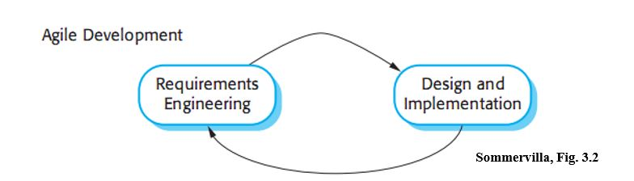

Figure 1: Agile Development Model

*References:

SOFTWARE ENGINEERING 9th Edition, Ian Sommerville (Chapter 3: Agile Softwarev Development, page 63)

- The Scrum approach (Schwaber, 2004; Schwaber and Beedle, 2001) is a general agile method but its focus is on managing iterative development rather than specific technical approaches to agile software engineering.

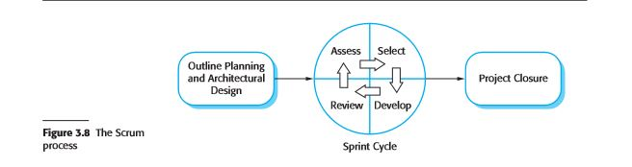

Figure 2: Scrum Process

*References:

SOFTWARE ENGINEERING 9th Edition, Ian Sommerville (Chapter 3: Agile Softwarev Development, page 73)

* + 1. Roles and Responsibilities

|  |  |  |  |  |
| --- | --- | --- | --- | --- |
| **No** | **Full name** | **Team Role** | **Scrum Team Role** | **Responsibilities** |
| **1** | Lâm Hữu Khánh Phương | Supervisor | Product Owner | * Specify user requirements * Control the development process * Support in technique and business logic. |
| **2** | Hồ Minh Quân | Team Leader  Developer | Scrum Master | * Manage process. * Planning Scrum implementations. * Create system architecture design. * Support technique. * Arrange daily meeting. * Track backlog * Create product Increment. * Create test plan. * Configure developing environment. * Code. * Test. * Write document and reports. |
| **3** | Lê Khải Thông | Developer | Scrum Team Member | * Commit individual product on time * Support each other to complete team work * Create product Increment. * Code. * Test. * Write document and reports. |
| **4** | Phùng Văn Bửu | Developer | Scrum Team Member | * Commit individual product on time * Support each other to complete team work * Create product Increment. * Code. * Test. * Write document and reports. |
| **5** | Nguyễn Hải Phong | Developer | Scrum Team Member | * Commit individual product on time * Support each other to complete team work * Create product Increment. * Code. * Test. * Write document and reports. |

Table 5: Roles and Responsibilities Details

* + 1. Tools and Techniques

|  |  |  |
| --- | --- | --- |
| **Tools** | | |
| Developing Tool | Game IDE | - Unity 5.4.0f3 |
| Web Application | - Visual Studio 2015 |
| Managing Database | - Microsoft® SQL Server® 2014 Management Studio | |
| Source Control | - Sourcetree v1.9.5.0 (server github.com) | |
| Modeling Tool | StarUML v2.7.0 | |
| Web Browser | Chrome 42 | |

Table 6 – Tools

|  |  |  |
| --- | --- | --- |
| **Techniques** | | |
| Developing tool | Front end | * JSP v2.3.1 * HTML v5.0 * jQuery v1.12.3 * CSS3 |
| Back end | * .Net MVC 5 |
| Web servers | | * .Net MVC 5 |
| Database Management System | | * Microsoft® SQL Server® 2014 |

Table 7 - Techniques

* 1. Project Management Plan
     1. Product Backlog

|  |  |  |  |  |
| --- | --- | --- | --- | --- |
| **Story  ID** | **Features** | **Task  ID** | **Task description** | **Sprint** |
| 1 | Create Product Backlog | 1.1 | Create Product backlog | 1 |
| 2 | Create Introduction document | 2.1 | Create Introduction document | 1 |
| 2.2 | Review Introduction document | 1 |
| 3 | Learning Unity and Vuforia | 3.1 | Learning Unity, Vuforia | 1 |
| 4 | Create mockup UI | 4.1 | Log in UI | 1 |
| 4.2 | Dashboard UI | 1 |
| 4.3 | Admin web UI | 1 |
| 4.4 | Organizer and User web UI | 1 |
| 4.5 | Mobile app UI | 1 |
| 5 | Create Software Project Management Plan | 5.1 | Problem definition | 2 |
| 5.2 | Project organization | 2 |
| 5.3 | Project management plan | 2 |
| 5.4 | Coding convention | 2 |
| 6 | Create Software Requirements Specifications | 6.1 | User Requirement Specification | 3 |
| 6.2 | External Interface Requirement | 3 |
| 6.3 | Use case diagram | 2 |
| 6.4 | Software System Attributes | 3 |
| 6.5 | Database diagram | 2 |
| 7 | Create Software Design Description | 7.1 | Design Overview | 4 |
| 7.2 | System Architectural Design | 4 |
| 7.3 | Component Diagram | 4 |
| 7.4 | Detailed Description of Components | 4 |
| 7.5 | Sequence Diagram | 3 |
| 7.6 | User Interface Design | 2 |
| 7.7 | Database Design | 4 |
| 7.8 | Coding | 2, 3, 4, 5, 6 |
| 8 | Create Software Test Documentation | 8.1 | Test Plan | 5 |
| 8.2 | Test Cases | 5 |
| 8.3 | Checklists | 5 |
| 9 | Software User’s Manual | 9.1 | Installation Guide | 6 |
| 9.2 | User’s Guide | 6 |

Table 8 – Product backlog

* + 1. Deliverables

|  |  |  |  |  |
| --- | --- | --- | --- | --- |
| **No** | **Deliverable** | **Delivery date** | **Delivery location** | **Note** |
| 1 | Introduction Document, Task list | 18/9/2016 | FU – CMS | Report No.1 |
| 2 | Software Project Management Plan | 23/9/2016 | FU – CMS | Report No.2 |
| 3 | Software Requirements Specification | 1/10/2016 | FU – CMS | Report No.3 |
| 4 | Software Design Description | 15/10/2016 | FU – CMS | Report No.4 |
| 5 | Software Test Documentation Guide Implementation (Coding) | 26/11/2016 | FU – CMS | Report No.5 |
| 6 | Software User’s Manual | 4/12/2016 | FU – CMS | Report No.6 |

Table 9 - Deliverables

* For each sprint, deliverables are potentially shippable product, which can be a part of documents or runnable software application which is implementation of some program features.

* Each sprint, we decide have 2 or 3 week.

* + 1. All Meeting Minutes

Please prefer to “Meeting Minutes” folder in the CD

* 1. Coding Convention
     1. Naming Conventions
* In short examples that do not include using directives, use namespace qualifications. If you know that a namespace is imported by default in a project, you do not have to fully qualify the names from that namespace. Qualified names can be broken after a dot (.) if they are too long for a single line, as shown in the following example.
* You do not have to change the names of objects that were created by using the Visual Studio designer tools to make them fit other guidelines.
  + 1. Layout Conventions

Good layout uses formatting to emphasize the structure of your code and to make the code easier to read. Microsoft examples and samples conform to the following conventions:

* Use the default Code Editor settings (smart indenting, four-character indents, tabs saved as spaces). For more information, see Options, Text Editor, C#, Formatting.
* Write only one statement per line.
* Write only one declaration per line.
* If continuation lines are not indented automatically, indent them one tab stop (four spaces).
* Add at least one blank line between method definitions and property definitions.
* Use parentheses to make clauses in an expression apparent, as shown in the following code.
  + 1. Commenting Conventions
* Place the comment on a separate line, not at the end of a line of code.
* Begin comment text with an uppercase letter.
* End comment text with a period.
* Insert one space between the comment delimiter (//) and the comment text, as shown in the following example.
* Do not create formatted blocks of asterisks around comments.
  + 1. Language Guidlines

The following sections describe practices that the C# team follows to prepare code examples and samples.

### String Data Type

* Use the **+** operator to concatenate short strings, as shown in the following code.
* To append strings in loops, especially when you are working with large amounts of text, use a **StringBuilder** object.

### Implicitly Typed Local Variables

* Use implicit typing for local variables when the type of the variable is obvious from the right side of the assignment, or when the precise type is not important.
* Do not use **var** when the type is not apparent from the right side of the assignment.
* Do not rely on the variable name to specify the type of the variable. It might not be correct.
* Avoid the use of **var** in place of **dynamic**.
* Use implicit typing to determine the type of the loop variable in **for** and **foreach** loops. Unsigned Data Type
* In general, use **int** rather than unsigned types. The use of **int** is common throughout C#, and it is easier to interact with other libraries when you use **int**.

### Arrays

* Use the concise syntax when you initialize arrays on the declaration line. Delegates
* Use the concise syntax to create instances of a delegate type. try-catch and using Statements in Exception Handling
* Use a **try-catch** statement for most exception handling.
* Simplify your code by using the C# **using** statement. If you have a **try-finally** statement in which the only code in the **finally** block is a call to the Dispose method, use a **using** statement instead.

### && and || Operators

* To avoid exceptions and increase performance by skipping unnecessary comparisons, use **&&** instead of **&** and **||** instead of **|** when you perform comparisons, as shown in the following example.

### New Operator

* Use the concise form of object instantiation, with implicit typing, as shown in the following declaration.
* Use object initializers to simplify object creation.

### Campaign Handling

* If you are defining an campaign handler that you do not need to remove later, use a lambda expression.

### Static Members

* Call static members by using the class name: ClassName.StaticMember. This practice makes code more readable by making static access clear. Do not qualify a static member defined in a base class with the name of a derived class. While that code compiles, the code readability is misleading, and the code may break in the future if you add a static member with the same name to the derived class.

### LINQ Queries

* Use meaningful names for query variables. The following example uses seattleCustomers for customers who are located in Seattle.
* Use aliases to make sure that property names of anonymous types are correctly capitalized, using Pascal casing.
* Rename properties when the property names in the result would be ambiguous. For example, if your query returns a customer name and a distributor ID, instead of leaving them as Name and ID in the result, rename them to clarify that Name is the name of a customer, and ID is the ID of a distributor.
* Use implicit typing in the declaration of query variables and range variables.
* clause, as shown in the previous examples.
* Use **where** clauses before other query clauses to ensure that later query clauses operate on the reduced, filtered set of data.
* Use multiple **from** clauses instead of a **join** clause to access inner collections. For example, a collection of Student objects might each contain a collection of test scores. When the following query is executed, it returns each score that is over 90, along with the last name of the student who received the score.

Reference:

https://msdn.microsoft.com/en-us/library/ff926074.aspx

1. Software Reuirement Specification
   1. User Requirement Specification
      1. Guest Requirement

* Guest is a person who doesn’t have access to the system. Guest can use some functions in the system. To use all functions, guest must regiter an account and login. Guest should have these following abilities:
* Login
* Register
* Guest also is the person who can searchs and views campaigns on web.
  + 1. Administrator Requirement

Administrator can manage organizer, campaign category and publishing of campaign.

* Provide account for organizer
* Edit organizer’s account
* Manage campaign category
* Manage publishing of campaign
* Log out
  + 1. Organizer Requirement

Organizer is manager of a coffee brand or a person who have the right to manage brand’s campaign

* Manage their campaign
* Manage campaign’s avtivity
* Send notification to their customer
* View statistic of their campaign
* Manage their store and wifi router
* Log out
  + 1. Normal user/Authorized User Requirement

Normal user (in web application context) or Authorized user (in mobile application context) is user who already have an account on system and login successfully

* Web application
  + Search and view campaign
  + Join campaign
  + Join activity (not game activity)
  + View profile
  + Log out
* Mobile application
  + Search and view campaign
  + Join campaign
  + Join activity (not survey activity)
  + View profile
  + Log out
  1. System Requirement Specification
     1. External Interface Requirement
        1. User interface
* For web application:
* User interface must be friendly and easy to use.
* Website must be responsive, suitable with all devices such as: laptop, tablet or smartphone.
* All functions are arranged and displayed clearly.
* The interface design is an iterate process includes: design, sketching and user assessment.
* For mobile application
* User interface must be friendly and easy to use.
* User interface must auto scale with many different kind of mobile screen (difffrent resolution) as much as possible.
* All functions are arranged and displayed clearly
* The interace design is an iterate process includes: design, sketching and user assessment
  + - 1. Hardware interface
* The system will use the standard hardware and data communications resources of a standard computer.
* Desktop, laptop, smartphone or tablet have ability to connect to the Internet.
  + - 1. Software interface
* The website work with Chrome (v25 or above), Firefox (v46.1) and Safari (v4 or above).
* On mobile: cross platform game application that can run on: Android (4.4 or above), iOS (iOS 7 or above).
  + - 1. Communication protocol
* Use HTTP protocol for communication between mobile application and web service.
* Use HTTP protocol for communication between web browser and web server.
  + 1. System Overview Use Case
       1. Web Application

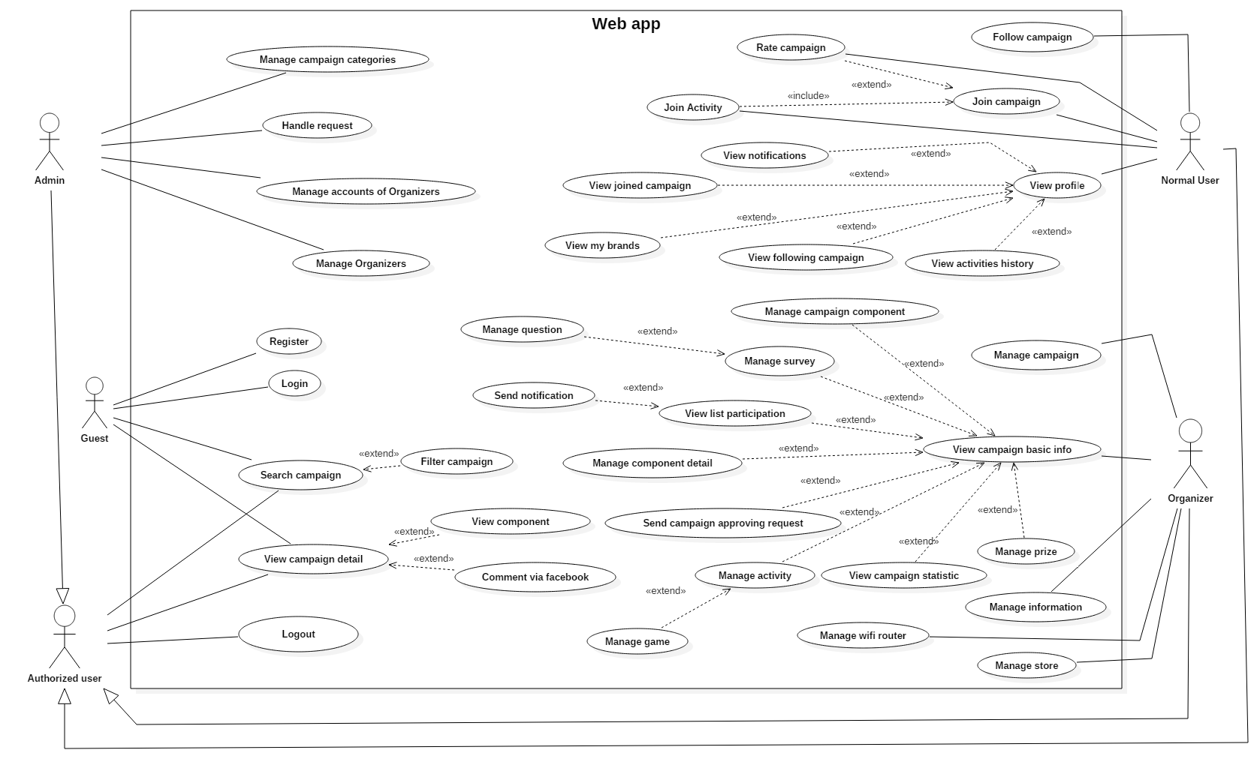

Figure 3 - System Overview Use Case for web application

| **No** | **Actor** | **Use case** | **Description** | **Note** |
| --- | --- | --- | --- | --- |
| 1 | Guest | Register | Register new account |  |
| 2 | Login | Login into system. |  |
| 3 | Search campaign | Search for campaign |  |
| 4 | Filter campaign | Search campaign by using filter |  |
| 5 | View campaign detail | View campaign’s detail information |  |
| 6 | View component | View campaign’s component information |  |
| 7 | Comment via facebook | Comment on campaign by actor’s facebook account |  |
| 8 | Authorized User | Logout | Logout of system |  |
| 9 | Search campaign | Search for campaign |  |
| 10 | Filter campaign | Search campaign by using filter |  |
| 11 | View campaign detail | View campaign’s detail information |  |
| 12 | View component | View campaign’s component information |  |
| 13 | Comment via facebook | Comment on campaign by actor’s facebook account |  |
| 14 | Admin | Create category | Create new category |  |
| 15 | Edit category | Edit caterogy information |  |
| 16 | Delete category | Delete category |  |
| 17 | Approve request | Approve organizer’s request |  |
| 18 | Reject request | Reject organizer’s request |  |
| 19 | Create account for organizer | Create new account for organizer |  |
| 20 | Delete account of organizer | Delete account of organizer |  |
| 21 | Create organizer | Create new organizer |  |
| 22 | Edit organizer | Edit organier information |  |
| 23 | Delete organizer | Delete organizer |  |
| 24 | Normal user | Follow campaign | Follow campaign |  |
| 25 | Join campaign | Join campaign |  |
| 26 | Rate campaign | Rate campaign |  |
| 27 | Do survey | Do survey |  |
| 28 | View profile | View profile information |  |
| 29 | View notification | View notifications |  |
| 30 | View joined campaign | View joined campaign |  |
| 31 | View my brand | View brand that user has become customer |  |
| 32 | View following campaign | View campaign that they has followed |  |
| 33 | View activities history | View history of user activities |  |
| 34 | Organizer | Create campaign | Create new campaign |  |
| 35 | Edit campaign | Edit campaign’s information |  |
| 36 | View campaign basic info | View campaign basic information |  |
| 37 | View campaign component | View campaign component |  |
| 38 | Create campaign component | Create new campaign component |  |
| 39 | Edit campaign component | Edit campaign component |  |
| 40 | Delete campaign component | Delete campaign component |  |
| 41 | Create survey | Create new survey |  |
| 42 | Edit survey | Edit survey |  |
| 43 | Delete survey | Delete survey |  |
| 44 | Create question | Create new question |  |
| 45 | Edit question | Edit question |  |
| 46 | Delete question | Delete question |  |
| 47 | View list participation | View list of campaign’s paticipants |  |
| 48 | Send notification | Send notification to evnet’s participants |  |
| 49 | Edit campaign component detail | Edit campaign component detail |  |
| 50 | Delete campaign component detail | Delete campaign component detail |  |
| 51 | Send campaign approving request | Send request to admin to approve their campaign |  |
| 52 | Create activity | Create new activity |  |
| 53 | Edit activity | Edit activity |  |
| 54 | Delete activity | Delete activity |  |
| 55 | View campaign statistic | View statistic of campaign |  |
| 56 | Create prize | Create prize |  |
| 57 | Edit prize | Edit prize |  |
| 58 | Delete prize | Delete prize |  |
| 59 | Manage information | Edit organizer information |  |
| 60 | Create store | Create new store |  |
| 61 | Edit store | Edit store’s information |  |
| 62 | Delete store | Delete store |  |
| 63 | Create wifi router | Create wifi router |  |
| 64 | Edit wifi router | Edit wifi router’s information |  |
| 65 | Delete wifi router | Delete wifi router |  |

Table 9 - Desciption of Use Case for Web Application

| **No** | **Actor** | **Description** | **Note** |
| --- | --- | --- | --- |
| 1 | Guest | Who does not have an account on system or not login into system yet. |  |
| 2 | Authorized User | Who already register an account and login successfully into system |  |
| 3 | Admin | Admin of system |  |
| 4 | Normal user | Who already register an account and login successfully into system with normal user role |  |
| 5 | Organizer | Normal user with Organizer role |  |

Table 10 - Description of Actor for Web Application

* + - 1. Mobile application

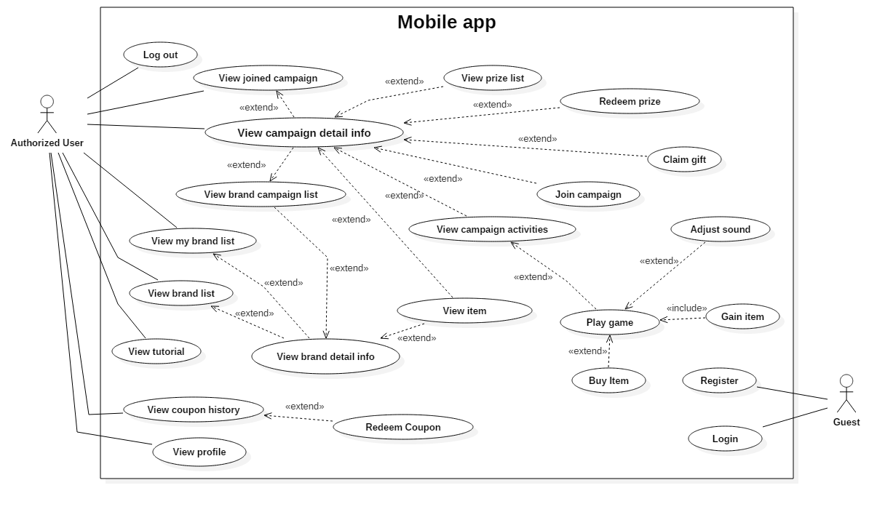

Figure 4 - System Overview Use Case for mobile application

| **No** | **Actor** | **Use case** | **Description** | **Note** |
| --- | --- | --- | --- | --- |
| 1 | Guest | Register | Register new account |  |
| 2 | Login | Login into system. |  |
| 3 | Authorized User | Logout | Logout of system |  |
| 4 | View joined campaign | View list of happening campaign that user already join |  |
| 5 | View brand list | View list of brands |  |
| 6 | View my brand list | View list of brand that user is already an customer |  |
| 7 | Join campaign | Join an happening campaign |  |
| 8 | View tutorial | View game tutorial |  |
| 9 | Buy item | Buy in-game item |  |
| 10 | View profile | View profile information |  |
| 11 | View coupon history | View list of redeemed coupons |  |
| 12 | Redeem coupon | Input code to receive in-game point |  |
| 13 | View brand detail information | View detail information about a brand |  |
| 14 | View brand campaign list | View happening campaigns of a brand |  |
| 15 | View campaign detail | View detail information of a campaign |  |
| 16 | View prize list | View list of prize user can redeem in a campaign |  |
| 17 | Redeem prize | Redeem prize to gift |  |
| 18 | Claim gift | Exchange gift into real gift |  |
| 19 | View customer item | View customer’s item |  |
| 20 | View campaign activities | View list of activities in a campaign |  |
| 21 | Play game | Enjoy the game and gain item to redeem prize |  |
| 22 |  | Adjust sound | Adjust game sound |  |
| 23 | Gain item | Gain item to redeem prize |  |

Table 11 - Desciption of Use Case for Mobile Application

| **No** | **Actor** | **Description** | **Note** |
| --- | --- | --- | --- |
| 1 | Guest | Who does not have an account on system or not login into system yet. |  |
| 2 | Authorized User | Who already register an account and login successfully into system |  |

Table 12 - Description of Actor for Mobile Application

* + 1. List of Use Cases
    2. Web Application Use Cases
       1. Guest Overview Use Cases 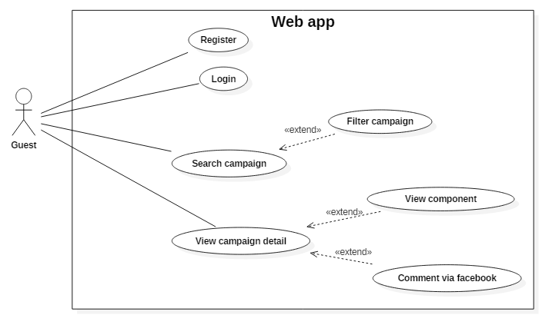

Figure 5 - Guest Overview Use Cases

* + - * 1. <Guest> Register (UC_01)

**Use Case Diagram**

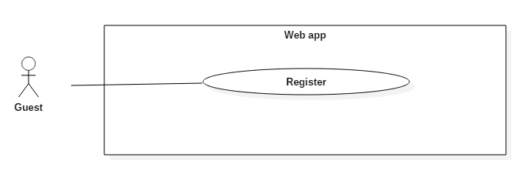

Figure 6 - <Guest> Register UCD

**Use Case Specification**

|  |  |  |  |
| --- | --- | --- | --- |
| **USE CASE – UC_01** | | | |
| **Use Case No.** | 01 | **Use Case Version** | 2.0 |
| **Use Case Name** | Register | | |
| **Author** | Nguyễn Hải Phong | | |
| **Date** | 08/11/2016 | **Priority** | Normal |
| **Actor:**   * Guest   **Summary:**   * This use case allows guest to create new account.   **Goal:**   * User can have an account.   **Triggers:**   * User clicks “Đăng ký” button or click “Đăng ký tài khoản” link.   **Preconditions:**   * N/A   **Post Conditions:**   * **Success:** User login into system with account and password have been registered. * **Fail:** Show error message.   **Main Success Scenario:**   |  |  |  | | --- | --- | --- | | Step | Actor Action | System Response | | 1 | User goes to register page by clicking “Đăng ký” or “Đăng ký tài khoản” link. | System require information:   * Fullname: free text input. * Username: free text input. * Email: text input must contain “@”. * Password: text input with least 6 characters. * Confirmed password: must be same as Password | | 2 | User inputs full required information (Fullname, Username, Password and Confirmed Password). |  | | 3 | User clicks “Đăng ký” button  [Alternative 1] | User will login system with “Normal user” roles.  [Exception 1,2,3,4,5] |   **Alternative:**   |  |  |  | | --- | --- | --- | | Step | Actor action | System Response | | 1 | User clicks “Đơn vị tổ chức” | Register with organizer role. |   **Exceptions:**  [Exception 1]   |  |  |  | | --- | --- | --- | | No | Cause | System Response | | 1 | Fullname is empty | Focus in Fullname field. Show error message | | 2 | Username is empty | Focus in Username field. Show error message | | 3 | Email is empty | Focus in Email field. Show error message | | 4 | Password is empty | Focus in Password field. Show error message |   [Exception 2]   |  |  |  | | --- | --- | --- | | No | Cause | System Response | | 1 | Password is less than 6 letters | Show error message |   [Exception 3]   |  |  |  | | --- | --- | --- | | No | Cause | System Response | | 1 | Confirmed password is not same as Password empty or less than 6 words. | Show error message |   [Exception 4]   |  |  |  | | --- | --- | --- | | No | Cause | System Response | | 1 | “Email” is not contains “@”. | Focus in Email field. Show error message: “Vui lòng bao gồm ‘@’ trong địa chỉ email”. |   [Exception 5]   |  |  |  | | --- | --- | --- | | No | Cause | System Response | | 1 | Network problem exception. | Show message “Có lỗi xảy ra, vui lòng thử lại sau”. |   **Relationships:**  N/A  **Business Rules:**   * Email: Contain “@”. * After register, the user will be logged in to the system and be redirected to home page. * Password: textbox, at least 6 words, required. * If user register with “Người tham gia chiến dịch”, new account will be created with role: Normal user * If user register with “Đơn vị tổ chức”, new account will be created with role: Organizer | | | |

* + - * 1. <Guest> Login (UC_02)

**Use Case Diagram**

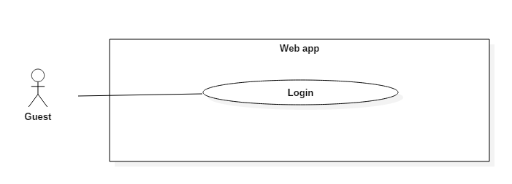

Figure 7 - <Guest> Login UCD

**Use Case Specification**

|  |  |  |  |
| --- | --- | --- | --- |
| **USE CASE – UC_02** | | | |
| **Use Case No.** | 02 | **Use Case Version** | 2.0 |
| **Use Case Name** | Login | | |
| **Author** | Nguyễn Hải Phong | | |
| **Date** | 08/11/2016 | **Priority** | Normal |
| **Actor:**   * Guest.   **Summary:**   * This use case allows guest to login in system.   **Goal:**   * User logged in system.   **Triggers:**   * User clicks “Đăng nhập” button.   **Preconditions:**   * N/A   **Post Conditions:**   * **Success:** User login into system. * **Fail:** Show error message   **Main Success Scenario:**   |  |  |  | | --- | --- | --- | | Step | Actor Action | System Response | | 1 | User goes to Login page by clicking “Đăng nhập”. | System require information:   * Username: text input. * Password: text input with least 6 characters. | | 2 | User inputs information (Username and password)  User clicks “Đăng nhập” button.  [Alternative 1] | User will login system with roles of this account.  [Exception 1,2,3,4,5] |   **Alternative:**   |  |  |  | | --- | --- | --- | | Step | Actor action | System Response | | 1 | User click “Tự đăng nhập lần sau” check box. | System will direct to Home Page next login time. |   **Exceptions:**   |  |  |  | | --- | --- | --- | | No | Cause | System Response | | 1 | Username is empty. | Show error message | | 2 | Password is empty. | Show error message | | 3 | Username is not correct | Show error message | | 4 | Password is not correct. | Show error message | | 5 | Network problem exception. | Show message “Có lỗi xảy ra, vui lòng thử lại sau”. |   **Relationships:**  N/A  **Business Rules:**   * If logged account is “Normal User”, system will redirect them to home page. * If logged account is “Organizer”, system will redirect to “Chiến dịch của bạn” page. * If logged account is “Admin”, system will redirect them to admin dashboard. | | | |

* + - * 1. <Guest, Authorized user> Search campaign (UC_03)

**Use Case Diagram**

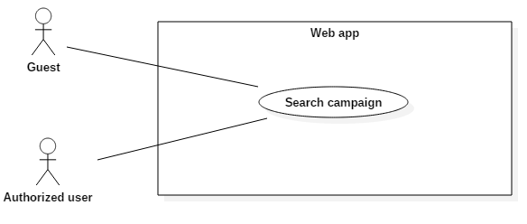

Figure 8 - <Guest, Authorized user> Search campaign UCD

**Use Case Specification**

|  |  |  |  |
| --- | --- | --- | --- |
| **USE CASE – UC_03** | | | |
| **Use Case No.** | 03 | **Use Case Version** | 2.0 |
| **Use Case Name** | Search campaign | | |
| **Author** | Nguyễn Hải Phong | | |
| **Date** | 08/11/2016 | **Priority** | Normal |
| **Actor:**   * Guest * Authorized user   **Summary:**   * This use case allows user to find campaigns with their conditions.   **Goal:**   * User can find any campaign by name, which is created by organizer.   **Triggers:**   * User sends the search command with input contents by clicking “search” icon or pressing enter.   **Preconditions:**   * User is currently in home page.   **Post Conditions:**   * **Success:** User can see result about some campaigns. * **Fail:** Show error message.   **Main Success Scenario:**   |  |  |  | | --- | --- | --- | | Step | Actor Action | System Response | | 1 | Guest is currently in Home Page. | System show text box input for search:   * Tìm chiến dịch, hội thảo: free text input. | | 2 | Guest inputs campaign’s name for search. |  | | 3 | Guest send search’s command by click Search button or press Enter. | Show Campaign(s) by name on search page.  [Exception 1] | | 4 | [Alternative 1,2,3] |  |   **Alternative Scenario:**  [Alternative 1]   |  |  |  | | --- | --- | --- | | Step | Actor action | System Response | | 1 | User click on time dropdown list. | Show list of time condition for filter. | | 2 | User choose one of (Đang diễn ra, Hôm nay, Ngày mai, Tuần này,) for search by time. | Show fit campaign by time. |   [Alternative 2]   |  |  |  | | --- | --- | --- | | Step | Actor action | System Response | | 1 | User click on category dropdown list. | Show list categories for filter. | | 2 | User choose one or more categories. | Show fit campaign by categories. |   [Alternative 3]   |  |  |  | | --- | --- | --- | | Step | Actor action | System Response | | 1 | User click on location and date dropdown list. | Show list of location and date condition for filter. | | 2 | User choose one of(địa điểm, ngày tạo, ngày tổ chức) | Show fit campaign by location and date condition. |   **Exceptions:**   |  |  |  | | --- | --- | --- | | No | Cause | System Response | | 1 | Network problem exception. | Show message “Có lỗi xảy ra, vui lòng thử lại sau”. |   **Relationships:** N/A  **Business Rules:**   * Category: Campaign type, which is created by admin. An campaign belongs to one or more categories. * Time and category filter after search: using “and” condition. * Location and date condition: using location and the date of campaign for search. | | | |

* + - * 1. <Guest, Authorized user> Filter campaign (UC_04)

**Use Case Diagram**

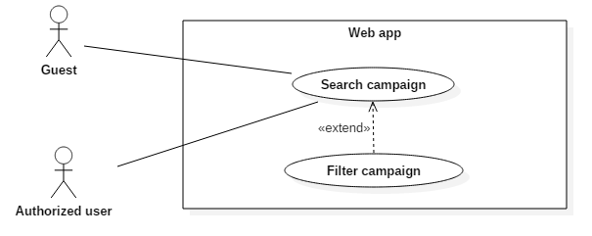

Figure 9 - <Guest, Authorized user> Filter campaign UCD

**Use Case Specification**

|  |  |  |  |
| --- | --- | --- | --- |
| **USE CASE – UC_04** | | | |
| **Use Case No.** | 04 | **Use Case Version** | 2.0 |
| **Use Case Name** | Filter campaign | | |
| **Author** | Nguyễn Hải Phong | | |
| **Date** | 08/11/2016 | **Priority** | Normal |
| **Actor:**   * Guest * Authorized user   **Summary:**   * This use case allows user to filter campaign by category.   **Goal:**   * User can fit campaign related with chosen categories.   **Triggers:**   * User sends the search by categories command.   **Preconditions:**   * N/A   **Post Conditions:**   * **Success:** User can see result about some campaigns. * **Fail:** Show error message.   **Main Success Scenario:**   |  |  |  | | --- | --- | --- | | Step | Actor Action | System Response | | 1 | User goes to bottom of Home page. | Show list category. | | 2 | User click on one of categories | Redirected to Search Page with category is chosen.  [Exception 1] | | 3 | [Alternative 1,2,3] |  |   **Alternative Scenario:**  [Alternative 1]   |  |  |  | | --- | --- | --- | | Step | Actor action | System Response | | 1 | User click on time dropdown list. | Show list of time condition for filter. | | 2 | User choose one of (Đang diễn ra, Hôm nay, Ngày mai, Tuần này,) for search by time. | Show fit campaign by time. |   [Alternative 2]   |  |  |  | | --- | --- | --- | | Step | Actor action | System Response | | 1 | User click on category dropdown list. | Show list categories for filter. | | 2 | User choose one or more categories. | Show fit campaign by categories. |   [Alternative 3]   |  |  |  | | --- | --- | --- | | Step | Actor action | System Response | | 1 | User click on location and date dropdown list. | Show list of location and date condition for filter. | | 2 | User choose one of(địa điểm, ngày tạo, ngày tổ chức) | Show fit campaign by location and date condition. |   **Exceptions:**   |  |  |  | | --- | --- | --- | | No | Cause | System Response | | 1 | Network problem exception. | Show message “Có lỗi xảy ra, vui lòng thử lại sau”. |   **Relationships:** Extend of “Search campaign” use case.  **Business Rules:**   * Category: Campaign type, which is created by admin. An campaign belongs to one or more categories. * Time and category filter after search: using “and” condition. * Location and date condition: using location and the date of campaign for search. | | | |

* + - * 1. <Guest, Authorized user> View campaign detail (UC_05)

**Use Case Diagram**

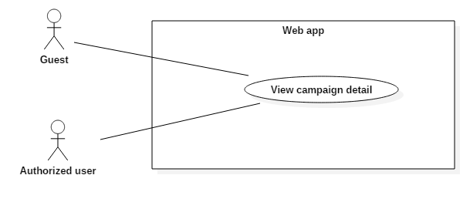

Figure 10 - <Guest, Authorized user> View campaign detail UCD

**Use Case Specification**

|  |  |  |  |
| --- | --- | --- | --- |
| **USE CASE – UC_05** | | | |
| **Use Case No.** | 05 | **Use Case Version** | 2.0 |
| **Use Case Name** | View campaign detail | | |
| **Author** | Nguyễn Hải Phong | | |
| **Date** | 08/11/2016 | **Priority** | Normal |
| **Actor:**   * Guest * Authorized user   **Summary:**   * This use case allows user to view campaign by detail.   **Goal:**   * Guest can view all information of specific campaign.   **Triggers:**   * Guest chooses an campaign.   **Preconditions:**   * N/A   **Post Conditions:**   * **Success:** Show all general information of this campaign. * **Fail:** Show error message.   **Main Success Scenario:**   |  |  |  | | --- | --- | --- | | Step | Actor Action | System Response | | 1 | User click on any campaign. | Redirect to campaign detail page. Show campaign general information.  [Exception 1] |   **Alternative Scenario:** N/A  **Exceptions:**   |  |  |  | | --- | --- | --- | | No | Cause | System Response | | 1 | Network problem exception. | Show message “Có lỗi xảy ra, vui lòng thử lại sau”. |   **Relationships:**  N/A  **Business Rules:** N/A | | | |

* + - * 1. <Guest, Authorized user> View component (UC_06)

**Use Case Diagram**

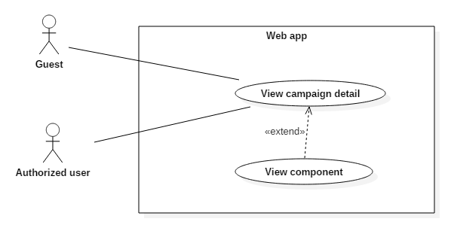

Figure 11 - <Guest, Authorized user> View component UCD

**Use Case Specification**

|  |  |  |  |
| --- | --- | --- | --- |
| **USE CASE – UC_06** | | | |
| **Use Case No.** | 06 | **Use Case Version** | 2.0 |
| **Use Case Name** | View component | | |
| **Author** | Nguyễn Hải Phong | | |
| **Date** | 08/11/2016 | **Priority** | Normal |
| **Actor:**   * Guest   **Summary:**   * This use case allows user to view all component of campaign.   **Goal:**   * User can view all component, view detail component.   **Triggers:**   * Inside an campaign, user choose any component.   **Preconditions:**   * N/A   **Post Conditions:**   * **Success:** All component with information will be load while user view campaign detail. * **Fail:** Show error message.   **Main Success Scenario:**   |  |  |  | | --- | --- | --- | | Step | Actor Action | System Response | | 1 | User goes to campaign detail page. | Show all component created by organizer. | | 2 | User click on any component to view.  [Alternative 1] | Show component information.  [Exception 1] |   **Alternative:**   |  |  |  | | --- | --- | --- | | Step | Actor action | System Response | | 1 | User click “Cancel” button. | Return to campaign detail page. |   **Exceptions:**   |  |  |  | | --- | --- | --- | | No | Cause | System Response | | 1 | Network problem exception. | Show message “Có lỗi xảy ra, vui lòng thử lại sau”. |   **Relationships:** Extend of “View campaign detail” use case.  **Business Rules:** N/A | | | |

* + - * 1. <Guest, Authorized user> Comment via facebook (UC_07)

**Use Case Diagram**

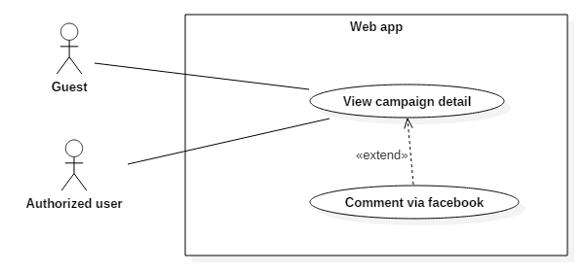

Figure 12 - <Guest, Authorized user> Comment via facebook UCD

**Use Case Specification**

|  |  |  |  |
| --- | --- | --- | --- |
| **USE CASE – UC_07** | | | |
| **Use Case No.** | 07 | **Use Case Version** | 2.0 |
| **Use Case Name** | Comment via facebook | | |
| **Author** | Nguyễn Hải Phong | | |
| **Date** | 08/11/2016 | **Priority** | Normal |
| **Actor:**   * Guest * Authorized user   **Summary:**   * This use case allows user to comment in campaign via Facebook account.   **Goal:**   * User can communicate in campaign feeds with their Facebook account.   **Triggers:**   * User submit comment.   **Preconditions:**   * N/A   **Post Conditions:**   * **Success:** User’s comment will be show in campaign feeds. * **Fail:** Show error message.   **Main Success Scenario:**   |  |  |  | | --- | --- | --- | | Step | Actor Action | System Response | | 1 | User goes to campaign detail page. | Show comment textbox. | | 2 | User input comment content and click “Đăng” button. | Show login form with Facebook account:   * Account: free text input. * Password: free text input. | | 3 | User input require information and click “Login” button.  [Alternative 1] | Show comment content in campaign feeds.  [Exception 1,2] |   **Alternative:**   |  |  |  | | --- | --- | --- | | Step | Actor action | System Response | | 1 | User click “Cancel” button. | Return to campaign detail page. |   **Exceptions:**   |  |  |  | | --- | --- | --- | | No | Cause | System Response | | 1 | Username or password incorrect. | Show message “Username or password incorrect”. | | 2 | Network problem exception. | Show message “Có lỗi xảy ra, vui lòng thử lại sau”. |   **Relationships:** Extend of “View campaign detail” use case.  **Business Rules:**   * + Comment content: include content and Facebook username. | | | |

* + - 1. Authorized User Overview Use Cases

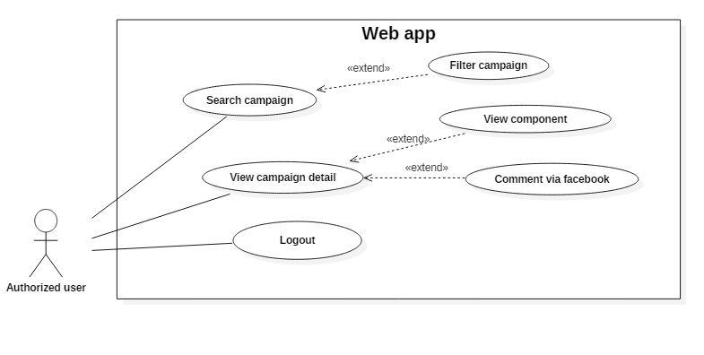

Figure 13 - Athorized User Overview Use Cases

* + - * 1. <Authorized User> Logout (UC_08)

**Use Case Diagram**

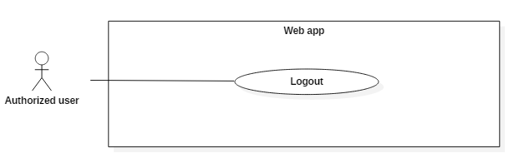

Figure 14 - <Authorized user> Logout UCD

**Use Case Specification**

|  |  |  |  |
| --- | --- | --- | --- |
| **USE CASE – UC_08** | | | |
| **Use Case No.** | 08 | **Use Case Version** | 2.0 |
| **Use Case Name** | Logout | | |
| **Author** | Nguyễn Hải Phong | | |
| **Date** | 08/11/2016 | **Priority** | Normal |
| **Actor:**   * Authorized user.   **Summary:**   * This use case allows user to leave of system.   **Goal:**   * User go out of system.   **Triggers:**   * User send the command do logout.   **Preconditions:**   * User must have logged in system.   **Post Conditions:**   * **Success:** User logged out. * **Fail:** Show error message.   **Main Success Scenario:**   |  |  |  | | --- | --- | --- | | Step | Actor Action | System Response | | 1 | User click on Profile picture. | Show “Đăng xuất” button. | | 2 | User click on “Đăng xuất” button. | Return to Login page.  [Exception 1] |   **Alternative: N/A**  **Exceptions:**   |  |  |  | | --- | --- | --- | | No | Cause | System Response | | 1 | Network problem exception. | Show message “Có lỗi xảy ra, vui lòng thử lại sau”. |   **Relationships:**  N/A  **Business Rules:** N/A | | | |

* + - 1. Admin Overview Use Cases

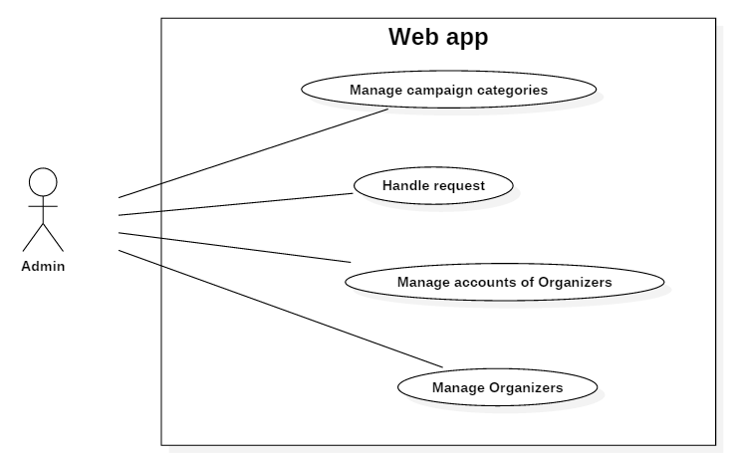

Figure 15 - Admin Overview Use Cases

* + - * 1. <Admin> Manage campaign categories

<Admin> Create category (UC_09)

**Use Case Diagram**

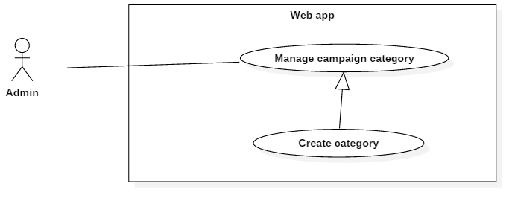

Figure 16 - <Admin> Create category UCD

**Use Case Specification**

|  |  |  |  |
| --- | --- | --- | --- |
| **USE CASE – UC_09** | | | |
| **Use Case No.** | 09 | **Use Case Version** | 2.0 |
| **Use Case Name** | Create category | | |
| **Author** | Lê Khải Thông | | |
| **Date** | 08/11/2016 | **Priority** | Normal |
| **Actor:**   * Admin   **Summary:**   * This use case allows admin to create new category.   **Goal:**   * Create new category.   **Triggers:**   * Admin click “Tạo mới” button in “Quản lý loại chiến dịch” page.   **Preconditions:**   * Actor login successfully with Admin role.   **Post Conditions:**   * **Success:** New category is created. * **Fail:** Show error message   **Main Success Scenario:**   |  |  |  | | --- | --- | --- | | Step | Actor Action | System Response | | 1 | Admin go to “Quản lý loại chiến dịch” page. | Show list of all categories. | | 2 | Admin click button “Tạo mới”. | Show create form:   * Loại chiến dịch: free text input required * Mô tả: free text input * Hình ảnh: image selector | | 3 | Admin input all require field. Then click button “Tạo mới”.  [Alternative 1] | Show success message. Show new account in list.  [Exception 1,2] |   **Alternative 1:**   |  |  |  | | --- | --- | --- | | Step | Actor Action | System Response | | 1 | Admin click button “Đóng”. | Return to “Quản lý đơn vị tổ chức” page. |   **Exceptions:**   |  |  |  | | --- | --- | --- | | No | Cause | System Response | | 1 | Network problem exception. | Show message “Có lỗi xảy ra, vui lòng thử lại sau”. | | 2 | “Loại chiến dịch” is empty | Show error message. |   **Relationships:** N/A.  **Business Rules:**   * Category is campaign’s type that using when organizer create new campaign. | | | |

* + - * 1. <Admin> Edit category (UC_10)

**Use Case Diagram**

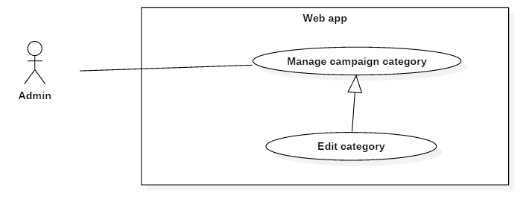

Figure 17 - <Admin> Edit category UCD

**Use Case Specification**

|  |  |  |  |
| --- | --- | --- | --- |
| **USE CASE – UC_10** | | | |
| **Use Case No.** | 10 | **Use Case Version** | 2.0 |
| **Use Case Name** | Edit category | | |
| **Author** | Lê Khải Thông | | |
| **Date** | 08/11/2016 | **Priority** | Normal |
| **Actor:**   * Admin   **Summary:**   * This use case allows admin to edit category’s information.   **Goal:**   * Edit category’s information.   **Triggers:**   * Admin click on edit icon.   **Preconditions:**   * Actor login successfully with Admin role.   **Post Conditions:**   * **Success:** New category information is updated. * **Fail:** Show error message   **Main Success Scenario:**   |  |  |  | | --- | --- | --- | | Step | Actor Action | System Response | | 1 | Admin go to “Quản lý loại chiến dịch” page. | Show list of all categories. | | 2 | Admin icon edit in any category. | Show edit form:   * Loại chiến dịch: free text input required * Mô tả: free text input * Hình ảnh: image selector | | 3 | Admin input all require field. Then click button “Lưu thay đổi”.  [Alternativeố] | Show success message. Show new account in list.  [Exception 1,2] |   **Alternative 1:**   |  |  |  | | --- | --- | --- | | Step | Actor Action | System Response | | 1 | Admin click button “Đóng”. | Close edit form |   **Exceptions:**   |  |  |  | | --- | --- | --- | | No | Cause | System Response | | 1 | “Loại chiến dịch” is empty | Show error message: “Please fill out this field”. | | 2 | Network problem exception. | Show message “Có lỗi xảy ra, vui lòng thử lại sau”. |   **Relationships:** N/A.  **Business Rules:**   * Category is campaign’s type that using when organizer create new campaign. | | | |

* + - * 1. <Admin> Delete category (UC_11)

**Use Case Diagram**

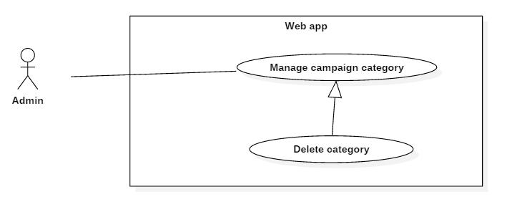

Figure 18 - <Admin> Delete category UCD

**Use Case Specification**

|  |  |  |  |
| --- | --- | --- | --- |
| **USE CASE – UC_11** | | | |
| **Use Case No.** | 11 | **Use Case Version** | 2.0 |
| **Use Case Name** | Delete category | | |
| **Author** | Lê Khải Thông | | |
| **Date** | 08/11/2016 | **Priority** | Normal |
| **Actor:**   * Admin   **Summary:**   * This use case allows admin to delete a category.   **Goal:**   * Delete category   **Triggers:**   * Admin click delete icon.   **Preconditions:**   * Actor login successfully with Admin role.   **Post Conditions:**   * **Success:** Category is removed * **Fail:** Show error message   **Main Success Scenario:**   |  |  |  | | --- | --- | --- | | Step | Actor Action | System Response | | 1 | Admin go to “Quản lý loại chiến dịch” page. | Show list of all categories. | | 2 | Admin icon delete in any category. | Show confirm dialog with following informaiton:   * Bạn có chắc chắn muốn xóa loại chiến dịch này không?: delete message * Xóa: button * Không: button | | 3 | Admin click “Xóa” button  [Alternative 1] | Show success message.  [Exception 1] |   **Alternative 1:**   |  |  |  | | --- | --- | --- | | Step | Actor Action | System Response | | 1 | Admin click button “Không”. | Close confirm dialog |   **Exceptions:**   |  |  |  | | --- | --- | --- | | No | Cause | System Response | | 1 | Network problem exception. | Show message “Có lỗi xảy ra, vui lòng thử lại sau”. |   **Relationships:** N/A.  **Business Rules:**   * When delete a category, system does not delete complete that record out of storage. System changes “Active” field of record from True to False. | | | |

* + - 1. <Admin> Handle request
         1. <Admin> Approve request (UC_12)

**Use Case Diagram**

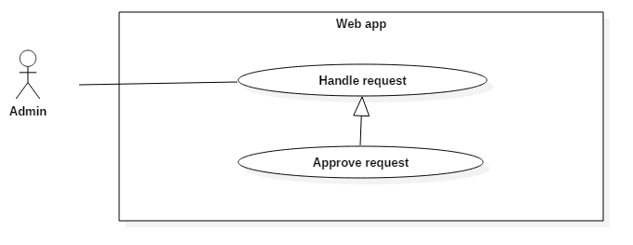

Figure 19 - <Admin> Approve request UCD

**Use Case Specification**

|  |  |  |  |
| --- | --- | --- | --- |
| **USE CASE – UC_12** | | | |
| **Use Case No.** | 12 | **Use Case Version** | 2.0 |
| **Use Case Name** | Approve request | | |
| **Author** | Lê Khải Thông | | |
| **Date** | 08/11/2016 | **Priority** | Normal |
| **Actor:**   * Admin   **Summary:**   * This use case allows admin to approve campaign request.   **Goal:**   * Approve campaign, which will be joined by normal Admin.   **Triggers:**   * Admin click on “Duyệt” button.   **Preconditions:**   * Actor login successfully with Admin role. * Organizer has created an campaign and sent an approve request.   **Post Conditions:**   * **Success:** Campaign status had been changed from “Pending” or “Not approved” to “Approved”. * **Fail:** Show error message   **Main Success Scenario:**   |  |  |  | | --- | --- | --- | | Step | Actor Action | System Response | | 1 | Admin go to “Quản lý chiến dịch” page. | Show list of all campaigns with status. | | 2 | Admin click on button “Duyệt" | Show confirm message   * Đồng ý: button * Hủy bỏ: button * Bạn chắc chắn muốn xóa loại chiến dịch này không: message | | 3 | Admin click button “Đồng ý”.  [Alternative 1] | Show success message. Update campaign status.  [Exception 1] |   **Alternative 1:**   |  |  |  | | --- | --- | --- | | Step | Actor Action | System Response | | 1 | Admin click button “Hủy bỏ”. | Close confirm dialog |   **Exceptions:**   |  |  |  | | --- | --- | --- | | No | Cause | System Response | | 1 | Network problem exception. | Show message “Có lỗi xảy ra, vui lòng thử lại sau”. |   **Relationships:** N/A.  **Business Rules:**   * Campaign has 4 statuses: “New”, “Pending”, “Approve”, “Not approved”. | | | |

* + - * 1. <Admin> Reject request (UC_13)

**Use Case Diagram**

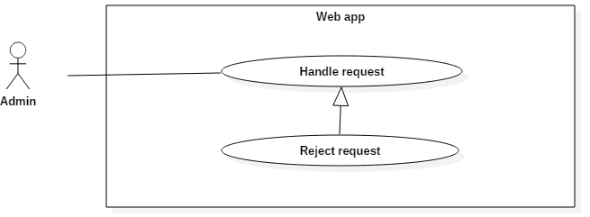

Figure 20 - <Admin> Reject request UCD

**Use Case Specification**

|  |  |  |  |
| --- | --- | --- | --- |
| **USE CASE – UC_13** | | | |
| **Use Case No.** | 13 | **Use Case Version** | 2.0 |
| **Use Case Name** | Reject request | | |
| **Author** | Lê Khải Thông | | |
| **Date** | 08/11/2016 | **Priority** | Normal |
| **Actor:**   * Admin   **Summary:**   * This use case allows admin to reject campaign request.   **Goal:**   * Reject campaign request.   **Triggers:**   * Admin click on “Từ chối” button.   **Preconditions:**   * Actor login successfully with Admin role. * Organizer has created an campaign and sent an approve request.   **Post Conditions:**   * **Success:** Campaign status had been changed “Pending” or “Approved” to “Not approve” * **Fail:** Show error message   **Main Success Scenario:**   |  |  |  | | --- | --- | --- | | Step | Actor Action | System Response | | 1 | Admin go to “Quản lý chiến dịch” page. | Show list of all campaigns with status. | | 2 | Admin click on button “Từ chối" | Show confirm dialog   * OK: button * Cancel: button * Hãy điền lí do từ chối: message | | 3 | Admin click “OK” button.  [Alternative 1] | Update campaign status. Show success message.  [Exception 1] |   **Alternative 1:**   |  |  |  | | --- | --- | --- | | Step | Actor Action | System Response | | 1 | Admin click button “Cancel”. | Close confirm dialog |   **Exceptions:**   |  |  |  | | --- | --- | --- | | No | Cause | System Response | | 1 | Network problem exception. | Show message “Có lỗi xảy ra, vui lòng thử lại sau”. |   **Relationships:** N/A.  **Business Rules:**   * Campaign has 4 statuses: “New”, “Pending”, “Approve”, “Not approved”. * Admin input reason for rejection. This notification will be sent to organizer. | | | |

* + - 1. <Admin> Manage account of organizers
         1. <Admin> Create account for organizer (UC_14)

**Use Case Diagram**

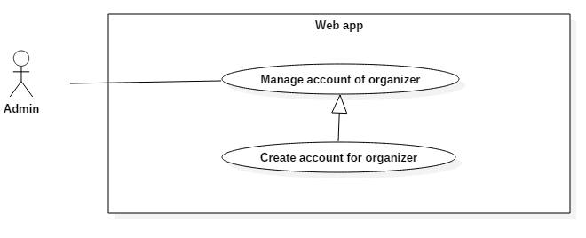

Figure 21 - <Admin> Create account for organizer UCD

**Use Case Specification**

|  |  |  |  |
| --- | --- | --- | --- |
| **USE CASE – UC_14** | | | |
| **Use Case No.** | 14 | **Use Case Version** | 2.0 |
| **Use Case Name** | Create account for organizer | | |
| **Author** | Lê Khải Thông | | |
| **Date** | 08/11/2016 | **Priority** | Normal |
| **Actor:**   * Admin   **Summary:**   * This use case allows admin to create new account for organizer.   **Goal:**   * Admin create new account for organizer.   **Triggers:**   * Admin click on Edit button in organizer’s information.   **Preconditions:**   * Actor login successfully with Admin role   **Post Conditions:**   * **Success:** New account for organizer is created. * **Fail:** Show error message   **Main Success Scenario:**   |  |  |  | | --- | --- | --- | | Step | Actor Action | System Response | | 1 | Admin go to “Quản lý đơn vị tổ chức” page. | Show list of all organizers. | | 2 | Admin click “Quản lý” icon on any organizer. | Show create new account form with following information:   * Họ và tên: free text input. * Email: free text input * Mật khẩu: password input * Nhập lại mật khẩu: password input * List of organizer’s accounts | | 3 | Admin click “Tạo mới” button.  [Alternative 1] | Add new account for organizer into storage. Show success message. Show new account in list.  [Exception 1,2,3,4] |   **Alternative 1:**   |  |  |  | | --- | --- | --- | | Step | Actor Action | System Response | | 1 | Admin click button “Đóng”. | Return to “Quản lý đơn vị tổ chức” page. |   **Exceptions:**  [Exception 1]   |  |  |  | | --- | --- | --- | | No | Cause | System Response | | 1 | “Họ và tên” is empty | Show error message: “Please fill out this field”. | | 2 | “Email” is empty | Show error message: “Please fill out this field”. | | 3 | “Mật khẩu” is empty | Show error message: “Please fill out this field”. |   [Exception 2]   |  |  |  | | --- | --- | --- | | No | Cause | System Response | | 2 | “Nhập lại mật khẩu” is not same with “Mật khẩu” empty or least than 6 words. | Show error message: “Xác nhận mật khẩu không chính xác”. |   [Exception 3]   |  |  |  | | --- | --- | --- | | No | Cause | System Response | | 2 | “Email” is not in valid format. | Show error message: “Please enter an email address”. |   [Exception 4]   |  |  |  | | --- | --- | --- | | No | Cause | System Response | | 1 | Network problem exception. | Show message “Có lỗi xảy ra, vui lòng thử lại sau”. |   **Relationships:** N/A.  **Business Rules:**   * Họ và tên: is required. Min is 1 max is 150. * Email: is required, must contain “@” * Mật khẩu: is required, must be at least 6 character. * Nhập lại mật khẩu: is required, must be the same value as “Mật khẩu” | | | |

* + - * 1. <Admin> Delete account of organizer (UC_15)

**Use Case Diagram**

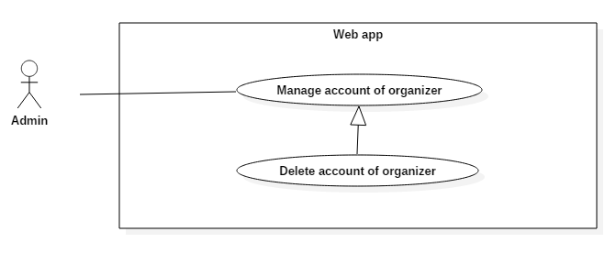

Figure 22 - <Admin> Delete account of organizer UCD

**Use Case Specification**

|  |  |  |  |
| --- | --- | --- | --- |
| **USE CASE – UC_15** | | | |
| **Use Case No.** | 15 | **Use Case Version** | 2.0 |
| **Use Case Name** | Delete account of organizer | | |
| **Author** | Lê Khải Thông | | |
| **Date** | 08/11/2016 | **Priority** | Normal |
| **Actor:**   * Admin.   **Summary:**   * This use case allows Admin to delete an account of organizer.   **Goal:**   * Admin delete an account of organizer.   **Triggers:**   * Admin send the command delete organizer account.   **Preconditions:**   * Actor login successfully with Admin role.   **Post Conditions:**   * **Success:** Delete account of organizer. * **Fail:** Show error message.   **Main Success Scenario:**   |  |  |  | | --- | --- | --- | | Step | Actor Action | System Response | | 1 | Admin go to “Quản lý đơn vị tổ chức” page. | Show list of all organizers. | | 2 | Admin click “Quản lý” icon on any organizer. | Show list of all accounts.  [Exception 1] | | 3 | Admin click delete icon on any account | Show confirm dialog with following informaiton:   * Bạn có chắc chắn muốn xóa tài khoản này không?: delete message * Xóa: button * Không: button | | 4 | Admin Click “Xóa” button  [Alternative 1] | Delete account. Show success message. Remove account from list. |   **Alternative 1:**   |  |  |  | | --- | --- | --- | | Step | Actor Action | System Response | | 1 | Admin click button “Không”. | Close confirm dialog |   **Exceptions:**   |  |  |  | | --- | --- | --- | | No | Cause | System Response | | 1 | Network problem exception. | Show message “Có lỗi xảy ra, vui lòng thử lại sau”. |   **Relationships:** N/A.  **Business Rules:**   * When delete an account of organizer, system does not delete complete that record out of storage. System changes “Active” field of record from True to False. | | | |

* + - 1. <Admin> Manage organizer
         1. <Admin> Create organizer (UC_16)

**Use Case Diagram**

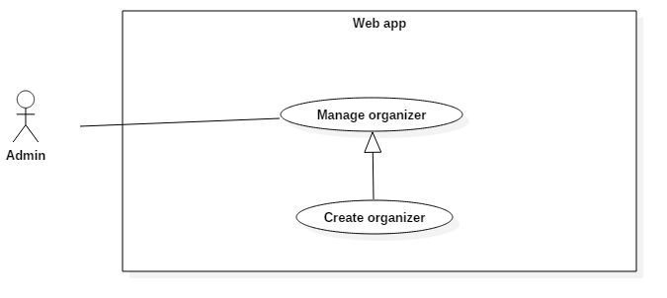

Figure 23 - <Admin> Create organizer UCD

**Use Case Specification**

|  |  |  |  |
| --- | --- | --- | --- |
| **USE CASE – UC_16** | | | |
| **Use Case No.** | 16 | **Use Case Version** | 2.0 |
| **Use Case Name** | Create organizer | | |
| **Author** | Lê Khải Thông | | |
| **Date** | 08/11/2016 | **Priority** | Normal |
| **Actor:**   * Admin   **Summary:**   * This use case allows admin to create new organizer.   **Goal:**   * Admin create organizer in system.   **Triggers:**   * Admin click “Tạo mới” button in “Quản lý đơn vị tổ chức” page.   **Preconditions:**   * Actor login successfully with Admin role   **Post Conditions:**   * **Success:** New organizer is created. * **Fail:** Show error message.   **Main Success Scenario:**   |  |  |  | | --- | --- | --- | | Step | Actor Action | System Response | | 1 | Admin go to “Quản lý đơn vị tổ chức” page. | Show list of all organizers. | | 2 | Admin click button “Tạo mới”. | Show create organizer form:   * Tên: free input text required. * Mô tả: free input text * Số điện thoại: number * Email: text input contains “@” * Address: free text input * Hình ảnh: file upload required   [Exception 1] | | 3 | Admin input all required field and click “Tạo mới”  [Alternative 1] | Add new organizer into Storage and show success message.  [Exception 1,2,3,4,5] |   **Alternative 1:**   |  |  |  | | --- | --- | --- | | No | Actor action | System Response | | 1 | Admin click on button “Đóng”. | Close create organizer form. |   **Exceptions:**  [Exception 1]   |  |  |  | | --- | --- | --- | | No | Cause | System Response | | 1 | Network problem exception. | Show message “Có lỗi xảy ra, vui lòng thử lại sau”. |   [Exception 2]   |  |  |  | | --- | --- | --- | | No | Cause | System Response | | 1 | “Tên” is empty | Show message “Vui lòng điền vào trường này”. | | 2 | “Số điện thoại” is empty | Show message “Vui lòng điền vào trường này”. | | 3 | “Email” is empty | Show message “Vui lòng điền vào trường này”. | | 4 | “Địa chỉ” is empty | Show message “Vui lòng điền vào trường này”. | | 5 | “Hình ảnh” is empty | Show message “Vui lòng chọn ảnh”. |   [Exception 3]   |  |  |  | | --- | --- | --- | | No | Cause | System Response | | 1 | File upload has invalid format. | Show message “Không thể đọc file này”. |   [Exception 4]   |  |  |  | | --- | --- | --- | | No | Cause | System Response | | 2 | “Email” is not contains “@”. | Show error message: “Vui lòng bao gồm ‘@’ trong địa chỉ email”. |   [Exception 5]   |  |  |  | | --- | --- | --- | | No | Cause | System Response | | 2 | “Số điện thoại” contains character. | Show error message: “Vui lòng nhập đúng định dạng”. |   **Relationships:**  N/A  **Business Rules:**   * Tên: is required. Min is 1, max is 150 charactes * Mô tả: not required.Min is 1, max is 500 characters * Số điện thoại: is required. Only number, min is 1 max is 50 characters * Email: text input contains “@”. Min is 1 max is 100 characters * Address: is requied. Min ix 1 max is 250 characters * Hình ảnh: Max resolution is 1000x1000 px | | | |

* + - * 1. <Admin> Edit organizer (UC_17)

**Use Case Diagram**

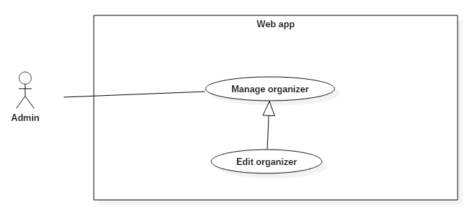

Figure 24 - <Admin> Edit organizer UCD

**Use Case Specification**

|  |  |  |  |
| --- | --- | --- | --- |
| **USE CASE – UC_17** | | | |
| **Use Case No.** | 17 | **Use Case Version** | 2.0 |
| **Use Case Name** | Edit organizer | | |
| **Author** | Lê Khải Thông | | |
| **Date** | 08/11/2016 | **Priority** | Normal |
| **Actor:**   * Admin.   **Summary:**   * This use case allows admin to changes organizer’s information.   **Goal:**   * Admin changes organizer’s information.   **Triggers:**   * Admin click on edit button in organizer info.   **Preconditions:**   * Actor login successfully with Admin role   **Post Conditions:**   * **Success:** Update organizer’s information. * **Fail:** Show error message.   **Main Success Scenario:**   |  |  |  | | --- | --- | --- | | Step | Actor Action | System Response | | 1 | Admin go to “Quản lý đơn vị tổ chức” page. | Show list of all organizers. | | 2 | Admin click icon edit on any organizer. | Show popup include organizer’s information with following info:   * Tên: free input text required. * Mô tả: free input text * Số điện thoại: number * Email: text input contains “@” * Address: free text input * Hình ảnh: file upload   [Exception 1] | | 3 | Admin change any field and click “Lưu thay đổi”  [Alternative 1] | Update new information. Show success message.  [Exception 1,2,3,4,5] |   **Alternative 1:**   |  |  |  | | --- | --- | --- | | Step | Actor Action | System Response | | 1 | Admin click on button “Đóng”. | Return to “Quản lý đơn vị tổ chức” page. |   **Exceptions:**  [Exception 1]   |  |  |  | | --- | --- | --- | | No | Cause | System Response | | 1 | Network problem exception. | Show message “Có lỗi xảy ra, vui lòng thử lại sau”. |   [Exception 2]   |  |  |  | | --- | --- | --- | | No | Cause | System Response | | 1 | “Tên” is empty | Show message “Vui lòng điền vào trường này”. | | 2 | “Số điện thoại” is empty | Show message “Vui lòng điền vào trường này”. | | 3 | “Email” is empty | Show message “Vui lòng điền vào trường này”. | | 4 | “Địa chỉ” is empty | Show message “Vui lòng điền vào trường này”. | | 5 | “Hình ảnh” is empty | Show message “Vui lòng chọn ảnh”. |   [Exception 3]   |  |  |  | | --- | --- | --- | | No | Cause | System Response | | 1 | File upload has invalid format. | Show message “Không thể đọc file này”. |   [Exception 4]   |  |  |  | | --- | --- | --- | | No | Cause | System Response | | 2 | “Email” is not contains “@”. | Show error message: “Vui lòng bao gồm ‘@’ trong địa chỉ email”. |   [Exception 5]   |  |  |  | | --- | --- | --- | | No | Cause | System Response | | 2 | “Số điện thoại” contains character. | Show error message: “Vui lòng nhập đúng định dạng”. |   **Relationships:**  N/A  **Business Rules:**   * Tên: is required. Min is 1, max is 150 charactes * Mô tả: not required.Min is 1, max is 500 characters * Số điện thoại: is required. Only number, min is 1 max is 50 characters * Email: text input contains “@”. Min is 1 max is 100 characters * Address: is requied. Min ix 1 max is 250 characters * Hình ảnh: Max resolution is 1000x1000 px | | | |

* + - * 1. <Admin> Delete organizer (UC_18)

**Use Case Diagram**

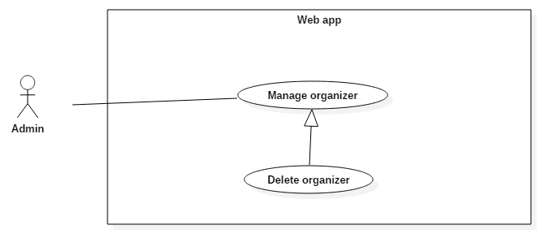

Figure 25 - <Admin> Delete organizer UCD

**Use Case Specification**

|  |  |  |  |
| --- | --- | --- | --- |
| **USE CASE – UC_18** | | | |
| **Use Case No.** | 18 | **Use Case Version** | 2.0 |
| **Use Case Name** | Delete organizer | | |
| **Author** | Lê Khải Thông | | |
| **Date** | 08/11/2016 | **Priority** | Normal |
| **Actor:**   * Admin.   **Summary:**   * This use case allows admin to delete organizer.   **Goal:**   * Delete organizer   **Triggers:**   * Admin click Delete button in organizer’s information.   **Preconditions:**   * Actor login successfully with Admin role   **Post Conditions:**   * **Success:** Delete organizer. Show delete successfully message * **Fail:** Show error message.   **Main Success Scenario:**   |  |  |  | | --- | --- | --- | | Step | Actor Action | System Response | | 1 | Admin go to “Quản lý đơn vị tổ chức” page. | Show list of all organizers. | | 2 | Admin click delete icon on any organizer. | Show confirm dialog with following informaiton:   * Bạn có chắc chắn muốn xóa đơn vị tổ chức này không?: delete message * Xóa: button * Không: button | | 3 | Admin click “Xóa” button.  [Alternative 1] | Show success message.  [Exception 1] |   **Alternative 4:**   |  |  |  | | --- | --- | --- | | Step | Actor Action | System Response | | 1 | Admin click “Không” button. | Close delete confirm dialog. |   **Exceptions:**   |  |  |  | | --- | --- | --- | | No | Cause | System Response | | 1 | Network problem exception. | Show message “Có lỗi xảy ra, vui lòng thử lại sau”. |   **Relationships:** N/A.  **Business Rules:**   * When delete an organizer system does not delete complete that record out of storage. System changes “Active” field of record from True to False. | | | |

* + - 1. Normal User Overview Use Cases

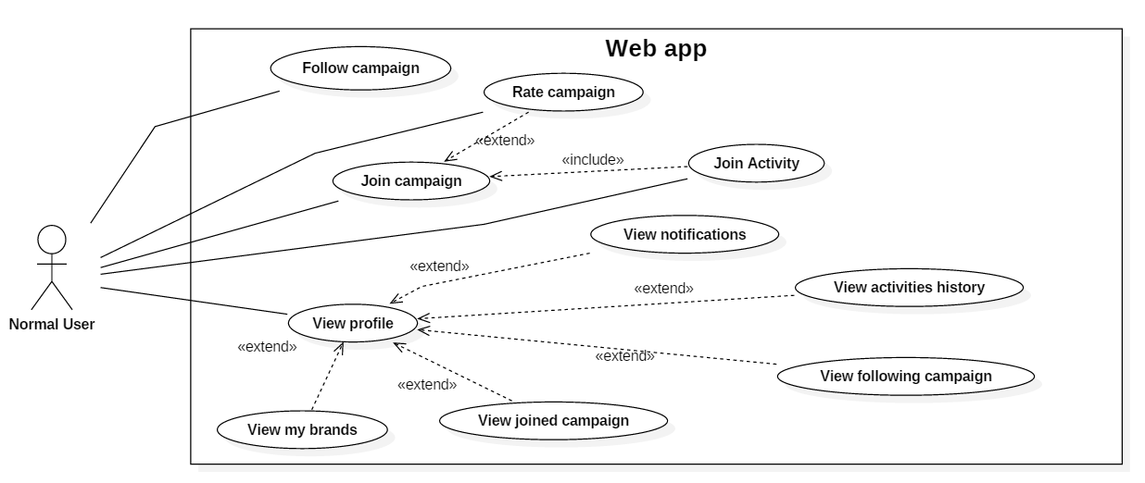

Figure 26 - Normal User Overview Use Cases

* + - * 1. <Normal User> Follow campaign (UC_19)

**Use Case Diagram**

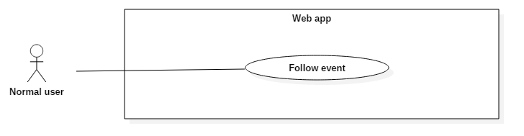

Figure - <Normal User> Follow campaign UCD

**Use Case Specification**

|  |  |  |  |
| --- | --- | --- | --- |
| **USE CASE – UC_19** | | | |
| **Use Case No.** | 19 | **Use Case Version** | 2.0 |
| **Use Case Name** | Follow Campaign | | |
| **Author** | Hồ Minh Quân | | |
| **Date** | 08/11/2016 | **Priority** | Normal |
| **Actor:**   * Normal User   **Summary:**   * This use case allows actor to save campaign to get notification about this campaign.   **Goal:**   * Actor follows campaign.   **Triggers:**   * Actor clicks “Theo dõi” button.   **Preconditions:**   * Actor must login into the system successfully.   **Post Conditions:**   * **Success:** Campaign will be saved in actor profile. * **Fail:** Error message is displayed.   **Main Success Scenario:**   |  |  |  | | --- | --- | --- | | Step | Actor Action | System Response | | 1 | Click “Theo dõi” button. | Show “Bạn đã theo dõi [campaign name]” message.  Change “Theo dõi” button into “Bỏ theo dõi” button.  [Exception 1] |   **Alternative:**   * N/A.   **Exceptions:**   |  |  |  | | --- | --- | --- | | No | Cause | System Response | | 1 | Network problem exception. | Show “Có lỗi xảy ra, vui lòng thử lại” message. |   **Relationships:**   * N/A.   **Business Rules:**   * The campaign which is followed already will have the “Bỏ theo dõi” button. | | | |

* + - * 1. <Normal User> Join campaign (UC_20)

**Use Case Diagram**

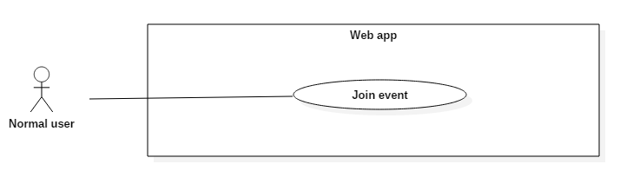

Figure - <Normal User> Join campaign UCD

**Use Case Specification**

|  |  |  |  |
| --- | --- | --- | --- |
| **USE CASE – UC_20** | | | |
| **Use Case No.** | 20 | **Use Case Version** | 2.0 |
| **Use Case Name** | Join Campaign | | |
| **Author** | Hồ Minh Quân | | |
| **Date** | 08/11/2016 | **Priority** | Normal |
| **Actor:**   * Normal User   **Summary:**   * This use case allows actor join into a free campaign.   **Goal:**   * Actor join into a free campaign.   **Triggers:**   * Actor clicks “Đăng ký” button.   **Preconditions:**   * Actor must login into the system successfully.   **Post Conditions:**   * **Success:** Actor becomes participation of this campaign. * **Fail:** Error message is displayed.   **Main Success Scenario:**   |  |  |  | | --- | --- | --- | | Step | Actor Action | System Response | | 1 | Click “Đăng ký” button. | Show confirm message. | | 2 | Click “Đồng ý” button.  [Alternative 1] | Show success message.  [Exception 1] |   **Alternative:**   |  |  |  | | --- | --- | --- | | No | Actor Action | System Response | | 1 | Click “Hủy bỏ” button. | Return to campaign detail page. |   **Exceptions:**   |  |  |  | | --- | --- | --- | | No | Cause | System Response | | 1 | Network problem exception. | Show “Có lỗi xảy ra, vui lòng thử lại” message. |   **Relationships:**   * Extend to “Rate Campaign” use case.   **Business Rules:** N/A | | | |

* + - * 1. <Normal User> Rate campaign (UC_21)

**Use Case Diagram**

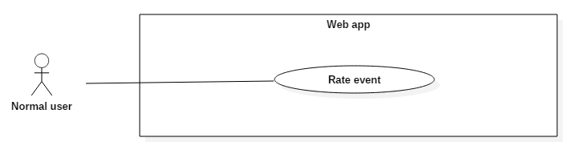

Figure - <Normal User> Rate campaign UCD

**Use Case Specification**

|  |  |  |  |
| --- | --- | --- | --- |
| **USE CASE – UC_21** | | | |
| **Use Case No.** | 21 | **Use Case Version** | 2.0 |
| **Use Case Name** | Rate Campaign | | |
| **Author** | Hồ Minh Quân | | |
| **Date** | 08/11/2016 | **Priority** | Normal |
| **Actor:**   * Normal User   **Summary:**   * This use case allows actor to rate for an campaign.   **Goal:**   * To give the actor the ability to show interest about the campaign.   **Triggers:**   * Actor goes to campaign detail page.   **Preconditions:**   * Actor must login into the system successfully.   **Post Conditions:**   * **Success:** Number of stars will be showed on campaign. * **Fail:** Error message is displayed.   **Main Success Scenario:**   |  |  |  | | --- | --- | --- | | Step | Actor Action | System Response | | 1 | Goes to campaign detail page. | Show number of stars for rating:   * Minimum: 0.5 * Maximum: 5   [Exception 1] | | 2 | Chooses number of stars to rate. | Show number of stars after rating. |   **Alternative:**   * N/A.   **Exceptions:**   |  |  |  | | --- | --- | --- | | No | Cause | System Response | | 1 | Network problem exception. | Show “Có lỗi xảy ra, vui lòng thử lại” message. |   **Relationships:**   * Extend with “Join Campaign” use case.   **Business Rules:**   * Actor can rate for campaign with no limit times. | | | |

* + - * 1. <Normal User> Join activities

<Normal User> Do survey (UC_22)

**Use Case Diagram**

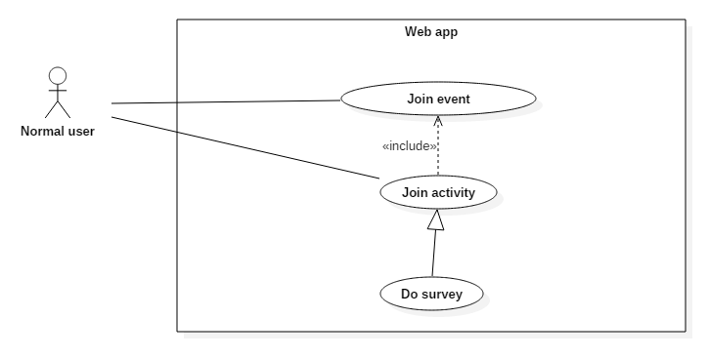

Figure - <Normal User> Do survey UCD

**Use Case Specification**

|  |  |  |  |
| --- | --- | --- | --- |
| **USE CASE – UC_22** | | | |
| **Use Case No.** | 22 | **Use Case Version** | 2.0 |
| **Use Case Name** | Do Survey | | |
| **Author** | Hồ Minh Quân | | |
| **Date** | 09/11/2016 | **Priority** | Normal |
| **Actor:**   * Normal User   **Summary:**   * This use case allows actor to do survey in campaign.   **Goal:**   * To get information from the user.   **Triggers:**   * Actor go to the survey link.   **Preconditions:**   * Actor must login into the system successfully.   **Post Conditions:**   * **Success:** New record will be saved. * **Fail:** Error message is displayed.   **Main Success Scenario:**   |  |  |  | | --- | --- | --- | | Step | Actor Action | System Response | | 1 | Go to the survey link. | Show the survey page.  [Exception 1] | | 2 | Answer all of the questions.  Click “Hoàn thành” button. | Show “Cảm ơn bạn đã làm khảo sát” message.  [Exception 1]  [Exception 2] |   **Alternative:**   * N/A.   **Exceptions:**   |  |  |  | | --- | --- | --- | | No | Cause | System Response | | 1 | Network problem exception. | Show browser’s error message. | | 2 | The question with “Bắt buộc” (*) mark is not answered yet. | Show “Vui lòng trả lời các câu hỏi bắt buộc” message. |   **Relationships:**   * Include with “Join campaign” use case.   **Business Rules:**   * The question with “Bắt buộc” (*) mark must be answered. | | | |

* + - 1. <Normal User> View profile (UC_23)

**Use Case Diagram**

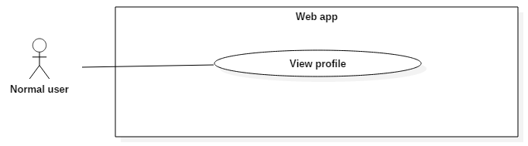

Figure - <Normal User> View profile UCD

**Use Case Specification**

|  |  |  |  |
| --- | --- | --- | --- |
| **USE CASE – UC_23** | | | |
| **Use Case No.** | 23 | **Use Case Version** | 2.0 |
| **Use Case Name** | View profile | | |
| **Author** | Lê Khải Thông | | |
| **Date** | 08/11/2016 | **Priority** | Normal |
| **Actor:**   * Normal user   **Summary:**   * This use case allows user to view their information.   **Goal:**   * View user’s information.   **Triggers:**   * User click “Đến trang cá nhân” button.   **Preconditions:**   * Actor login successfully with Normal user role.   **Post Conditions:**   * **Success:** User’s information is displayed. * **Fail:** Show error message   **Main Success Scenario:**   |  |  |  | | --- | --- | --- | | Step | Actor Action | System Response | | 1 | User click “Đến trang cá nhân” button | Show profile page with user’s information  [Exception 1] |   **Exceptions:**   |  |  |  | | --- | --- | --- | | No | Cause | System Response | | 1 | Network problem exception. | Show message “Có lỗi xảy ra, vui lòng thử lại sau”. |   **Relationships:** N/A.  **Business Rules:** N/A | | | |

* + - 1. <Normal User> View notification (UC_24)

**Use Case Diagram**

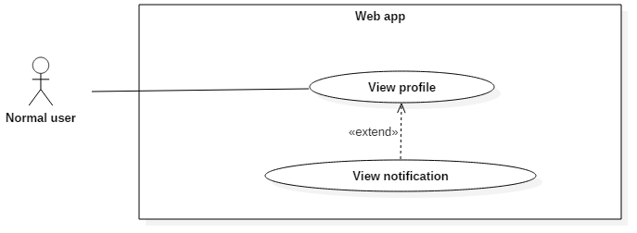

Figure - <Normal User> View notification UCD

**Use Case Specification**

|  |  |  |  |
| --- | --- | --- | --- |
| **USE CASE – UC_24** | | | |
| **Use Case No.** | 24 | **Use Case Version** | 2.0 |
| **Use Case Name** | View notification | | |
| **Author** | Lê Khải Thông | | |
| **Date** | 08/11/2016 | **Priority** | Normal |
| **Actor:**   * Normal user   **Summary:**   * This use case allows user to view their notification.   **Goal:**   * View user’s notification.   **Triggers:**   * User click notification icon.   **Preconditions:**   * Actor login successfully with Normal user role. * At least 1 notification has been sent successfully to user   **Post Conditions:**   * **Success:** User’s notifications is displayed. * **Fail:** Show error message   **Main Success Scenario:**   |  |  |  | | --- | --- | --- | | Step | Actor Action | System Response | | 1 | User click notification icon | Show user’s notifications  [Exception 1] | |  | [Alternative 1]  [Alternative 2] |  |   **Alternative 1:**   |  |  |  | | --- | --- | --- | | No | Cause | System Response | | 1 | User click on a notification’s content | Redirect to profile page and show user’s notification |   **Alternative 2:**   |  |  |  | | --- | --- | --- | | No | Cause | System Response | | 1 | User click on “Xem tất cả” link | Redirect to profile page and show user’s notification |   **Exceptions:**   |  |  |  | | --- | --- | --- | | No | Cause | System Response | | 1 | Network problem exception. | Show message “Có lỗi xảy ra, vui lòng thử lại sau”. |   **Relationships:** Extend from View profile use case.  **Business Rules:** N/A | | | |

* + - 1. <Normal User> View joined campaign (UC_25)

**Use Case Diagram**

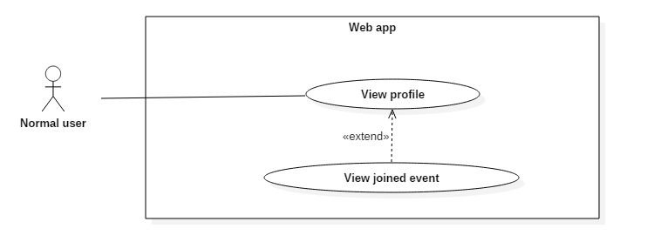

Figure - <Normal User> View joined campaign UCD

**Use Case Specification**

|  |  |  |  |
| --- | --- | --- | --- |
| **USE CASE – UC_25** | | | |
| **Use Case No.** | 25 | **Use Case Version** | 2.0 |
| **Use Case Name** | View joined campaign | | |
| **Author** | Lê Khải Thông | | |
| **Date** | 08/11/2016 | **Priority** | Normal |
| **Actor:**   * Normal user   **Summary:**   * This use case allows user to view campaigns that they has joined.   **Goal:**   * View campaigns that user has joined.   **Triggers:**   * User click “Chiến dịch đã tham gia” tab on Profile page.   **Preconditions:**   * Actor login successfully with Normal user role. * User has joined at least 1 campaign.   **Post Conditions:**   * **Success:** Show campaigns that user has joined. * **Fail:** Show error message   **Main Success Scenario:**   |  |  |  | | --- | --- | --- | | Step | Actor Action | System Response | | 1 | User go to profile page | Show profile page  [Exception 1] | | 2 | User click on “Chiến dịch đã tham gia” tab | Show list of campaigns that user has joined.  [Exception 1] |   **Exceptions:**   |  |  |  | | --- | --- | --- | | No | Cause | System Response | | 1 | Network problem exception. | Show message “Có lỗi xảy ra, vui lòng thử lại sau”. |   **Relationships:** Extend from View profile use case.  **Business Rules:** N/A | | | |

* + - 1. <Normal User> View my brand (UC_26)

**Use Case Diagram**

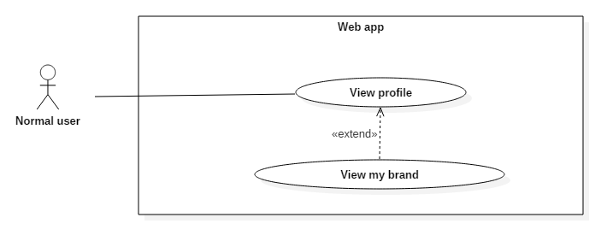

Figure - <Normal User> View my brand UCD

**Use Case Specification**

|  |  |  |  |
| --- | --- | --- | --- |
| **USE CASE – UC_26** | | | |
| **Use Case No.** | 26 | **Use Case Version** | 2.0 |
| **Use Case Name** | View my brand | | |
| **Author** | Lê Khải Thông | | |
| **Date** | 08/11/2016 | **Priority** | Normal |
| **Actor:**   * Normal user   **Summary:**   * This use case allows user to view brands that they has become a customer.   **Goal:**   * View brands that they has become a customer.   **Triggers:**   * User click “Thương hiệu của bạn” tab on Profile page.   **Preconditions:**   * Actor login successfully with Normal user role. * User has become a customer of at least 1 brand.   **Post Conditions:**   * **Success:** Show brands that they has become a customer. * **Fail:** Show error message   **Main Success Scenario:**   |  |  |  | | --- | --- | --- | | Step | Actor Action | System Response | | 1 | User go to profile page | Show profile page  [Exception 1] | | 2 | User click on “Thương hiệu của tôi” tab | Show list of brands that they has become a customer  [Exception 1] |   **Exceptions:**   |  |  |  | | --- | --- | --- | | No | Cause | System Response | | 1 | Network problem exception. | Show message “Có lỗi xảy ra, vui lòng thử lại sau”. |   **Relationships:** Extend from View profile use case.  **Business Rules:**   * Customer: when a normal user join an campaign of an organizer (brand), they will become a customer of that organizer (brand) | | | |

* + - 1. <Normal User> View following campaign (UC_27)

**Use Case Diagram**

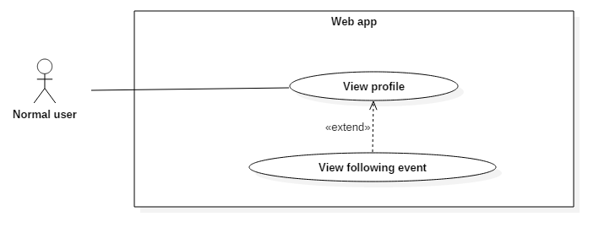

Figure - <Normal User> View following campaign UCD

**Use Case Specification**

|  |  |  |  |
| --- | --- | --- | --- |
| **USE CASE – UC_27** | | | |
| **Use Case No.** | 27 | **Use Case Version** | 2.0 |
| **Use Case Name** | View following campaign | | |
| **Author** | Lê Khải Thông | | |
| **Date** | 08/11/2016 | **Priority** | Normal |
| **Actor:**   * Normal user   **Summary:**   * This use case allows user to view list of campaigns that they are following   **Goal:**   * View list of campaigns that they are following.   **Triggers:**   * User click “Chiến dịch bạn theo dõi” tab on Profile page.   **Preconditions:**   * Actor login successfully with Normal user role. * User has followed at least 1 campaign.   **Post Conditions:**   * **Success:** Show list of campaigns that they are following. * **Fail:** Show error message   **Main Success Scenario:**   |  |  |  | | --- | --- | --- | | Step | Actor Action | System Response | | 1 | User go to profile page | Show profile page  [Exception 1] | | 2 | User click on “Chiến dịch bạn theo dõi” tab | Show list of campaigns that they are following  [Exception 1] |   **Exceptions:**   |  |  |  | | --- | --- | --- | | No | Cause | System Response | | 1 | Network problem exception. | Show message “Có lỗi xảy ra, vui lòng thử lại sau”. |   **Relationships:** Extend from View profile use case.  **Business Rules:** N/A | | | |

* + - 1. <Normal User> View activities history (UC_28)

**Use Case Diagram**

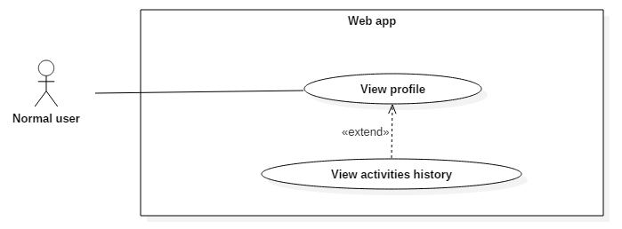

Figure - <Normal User> View activities history UCD

**Use Case Specification**

|  |  |  |  |
| --- | --- | --- | --- |
| **USE CASE – UC_28** | | | |
| **Use Case No.** | 28 | **Use Case Version** | 2.0 |
| **Use Case Name** | View activities history | | |
| **Author** | Lê Khải Thông | | |
| **Date** | 08/11/2016 | **Priority** | Normal |
| **Actor:**   * Normal user   **Summary:**   * This use case allows user to view their activities history   **Goal:**   * View list of campaigns that they are following.   **Triggers:**   * User click “Lịch sử hoạt động” tab on Profile page.   **Preconditions:**   * Actor login successfully with Normal user role. * User done at least 1 activity.   **Post Conditions:**   * **Success:** Show user’s activities history. * **Fail:** Show error message   **Main Success Scenario:**   |  |  |  | | --- | --- | --- | | Step | Actor Action | System Response | | 1 | User go to profile page | Show profile page  [Exception 1] | | 2 | User click on “Lịch sử hoạt động” tab | Show their activities history.  [Exception 1] |   **Exceptions:**   |  |  |  | | --- | --- | --- | | No | Cause | System Response | | 1 | Network problem exception. | Show message “Có lỗi xảy ra, vui lòng thử lại sau”. |   **Relationships:** Extend from View profile use case.  **Business Rules:** N/A | | | |

* + - 1. Organizer Overview Use Cases

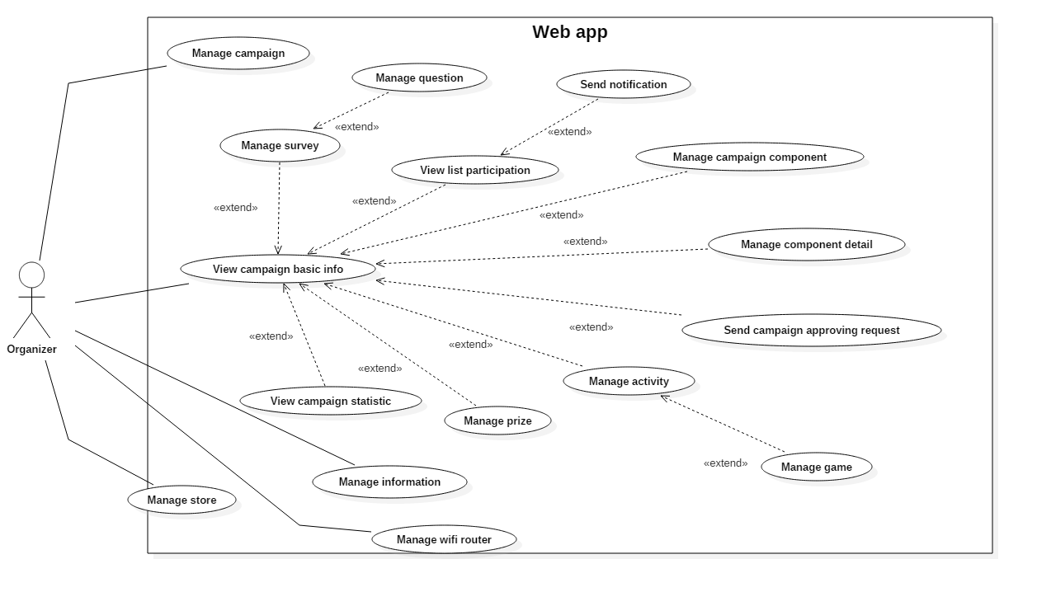

Figure 27 - Organizer Overview Use Cases

* + - * 1. <Organizer> Manage campaign

<Organizer> Create campaign (UC_29)

**Use Case Diagram**

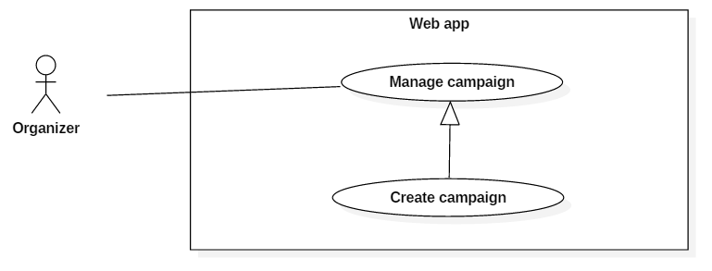

Figure 28 - <Organizer> Create campaign UCD

**Use Case Specification**

|  |  |  |  |
| --- | --- | --- | --- |
| **USE CASE – UC_29** | | | |
| **Use Case No.** | 29 | **Use Case Version** | 2.0 |
| **Use Case Name** | Create campaign | | |
| **Author** | Nguyễn Hải Phong | | |
| **Date** | 08/11/2016 | **Priority** | Normal |
| **Actor:**   * Organizer.   **Summary:**   * This use case allows user to create new campaign.   **Goal:**   * User create new campaign with information.   **Triggers:**   * User send the command create campaign.   **Preconditions:**   * User must have logged in system as Organizer role.   **Post Conditions:**   * **Success:** New campaign had been created. * **Fail:** Show error message.   **Main Success Scenario:**   |  |  |  | | --- | --- | --- | | Step | Actor Action | System Response | | 1 | User go to “Chiến dịch của tôi” page. | Show list of campaign and button “Tạo mới”. | | 2 | User click “Tạo mới” button. | Show popup for creating:   * Tên chiến dịch: free text input required. * Tên đường dẫn: Free text input required (auto generate) * Thời gian: Date time picker required. * Loại chiến dịch: list of category. * Địa chỉ: Google map mapping auto complete text input. * Hình ảnh: File upload required.   [Exception 1] | | 3 | User input all required information and click “Tạo mới” button in popup.  [Alternative 1,2,3,4] | Show success message. Return to “Chiến dịch của tôi” page with new campaign.  [Exception 1,2,3] |   **Alternative:**  [Alternative 1]   |  |  |  | | --- | --- | --- | | Step | Actor action | System Response | | 1 | User click “Ẩn/Hiện bản đồ” | Show or hide google map with address that user input. |   [Alternative 2]   |  |  |  | | --- | --- | --- | | Step | Actor action | System Response | | 1 | User click on “Thời gian” text input. | Show date time picker. | | 2 | User choose “From date” and “End date”. Then click “Apply”. | Generate date time into “Thời gian” text input. |   [Alternative 3]   |  |  |  | | --- | --- | --- | | Step | Actor action | System Response | | 1 | User click on “Chọn tệp” button. | Show popup to choose image file. | | 2 | User choose an image and click “Ok” | Load image in to “Hình ảnh”. |   [Alternative 4]   |  |  |  | | --- | --- | --- | | Step | Actor action | System Response | | 1 | User click on button “Đóng”. | Return to “Chiến dịch của tôi” page. |   **Exceptions:**  [Exception 1]   |  |  |  | | --- | --- | --- | | No | Cause | System Response | | 1 | Network problem exception. | Show message “Có lỗi xảy ra, vui lòng thử lại sau”. |   [Exception 2]   |  |  |  | | --- | --- | --- | | No | Cause | System Response | | 1 | File upload has invalid format. | Show message “Không thể đọc file này”. |   [Exception 3]   |  |  |  | | --- | --- | --- | | No | Cause | System Response | | 1 | “Tên chiến dịch” is empty. | Show message “Vui lòng điền vào trường này”. | | 2 | “Thời gian” is empty | Show message “Vui lòng điền vào trường này”. | | 3 | “Địa chỉ” is empty | Show message “Vui lòng điền vào trường này”. | | 4 | “Hình ảnh” is empty | Show message “Vui lòng điền vào trường này”. |   **Relationships:** N/A.  **Business Rules:**   * Image upload: best at 1040 x 400 (pixels). * Organizer account created by admin. An organizer has one or more accounts. * There’re four status of campaign: “New”, “Pending”, “Approved” and “Not approved” New created campaign has status is “New” | | | |

<Organizer> Edit campaign (UC_30)

**Use Case Diagram**

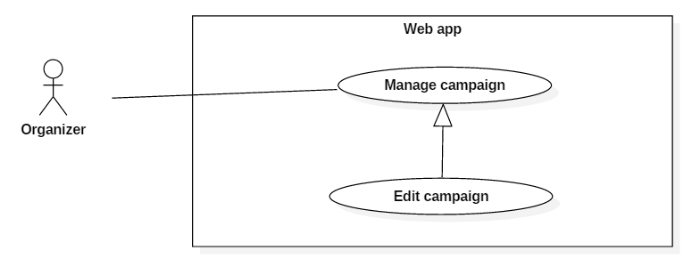

Figure 29 - <Organizer> Edit campaign UCD

**Use Case Specification**

|  |  |  |  |
| --- | --- | --- | --- |
| **USE CASE – UC_30** | | | |
| **Use Case No.** | 30 | **Use Case Version** | 2.0 |
| **Use Case Name** | Edit campaign | | |
| **Author** | Nguyễn Hải Phong | | |
| **Date** | 08/11/2016 | **Priority** | Normal |
| **Actor:**   * Organizer.   **Summary:**   * This use case allows user to edit campaign.   **Goal:**   * User edit campaign with information.   **Triggers:**   * User click “Edit” button.   **Preconditions:**   * User must have logged in system as Organizer role.   **Post Conditions:**   * **Success:** campaign had been edited. * **Fail:** Show error message.   **Main Success Scenario:**   |  |  |  | | --- | --- | --- | | Step | Actor Action | System Response | | 1 | User go to “Chiến dịch của tôi” page. | Show list of campaign and button “Edit”. | | 2 | User click “Edit” button. | Show popup for creating:   * Tên chiến dịch: free text input required. * Tên đường dẫn: Free text input required (auto generate) * Thời gian: Date time picker required. * Loại chiến dịch: list of category. * Địa chỉ: Google map mapping auto complete text input. * Hình ảnh: File upload required.   [Exception 1] | | 3 | User input all required information and click “Tạo mới” button in popup.  [Alternative 1,2,3,4] | Show success message. Return to “Chiến dịch của tôi” page with new campaign.  [Exception 1,2,3] |   **Alternative:**  [Alternative 1]   |  |  |  | | --- | --- | --- | | Step | Actor action | System Response | | 1 | User click “Ẩn/Hiện bản đồ” | Show or hide google map with address that user input. |   [Alternative 2]   |  |  |  | | --- | --- | --- | | Step | Actor action | System Response | | 1 | User click on “Thời gian” text input. | Show date time picker. | | 2 | User choose “From date” and “End date”. Then click “Apply”. | Generate date time into “Thời gian” text input. |   [Alternative 3]   |  |  |  | | --- | --- | --- | | Step | Actor action | System Response | | 1 | User click on “Chọn tệp” button. | Show popup to choose image file. | | 2 | User choose an image and click “Ok” | Load image in to “Hình ảnh”. |   [Alternative 4]   |  |  |  | | --- | --- | --- | | Step | Actor action | System Response | | 1 | User click on button “Đóng”. | Return to “Chiến dịch của tôi” page. |   **Exceptions:**  [Exception 1]   |  |  |  | | --- | --- | --- | | No | Cause | System Response | | 1 | Network problem exception. | Show message “Có lỗi xảy ra, vui lòng thử lại sau”. |   [Exception 2]   |  |  |  | | --- | --- | --- | | No | Cause | System Response | | 1 | File upload has invalid format. | Show message “Không thể đọc file này”. |   [Exception 3]   |  |  |  | | --- | --- | --- | | No | Cause | System Response | | 1 | “Tên chiến dịch” is empty. | Show message “Vui lòng điền vào trường này”. | | 2 | “Thời gian” is empty | Show message “Vui lòng điền vào trường này”. | | 3 | “Địa chỉ” is empty | Show message “Vui lòng điền vào trường này”. | | 4 | “Hình ảnh” is empty | Show message “Vui lòng điền vào trường này”. |   **Relationships:** N/A.  **Business Rules:**   * Image upload: best at 1040 x 400 (pixels). * Organizer account created by admin. An organizer has one or more accounts. * There’re four status of campaign: “New”, “Pending”, “Approved” and “Not approved” New created campaign has status is “New” | | | |

* + - * 1. <Organizer> View campaign basic info (UC_31)

**Use Case Diagram**

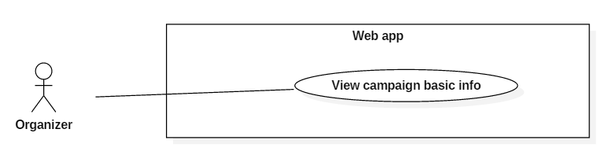

Figure 30 - <Organizer> View campaign basic info UCD

**Use Case Specification**

|  |  |  |  |
| --- | --- | --- | --- |
| **USE CASE – UC_3** | | | |
| **Use Case No.** | 31 | **Use Case Version** | 2.0 |
| **Use Case Name** | View Campaign Basic Info | | |
| **Author** | Hồ Minh Quân | | |
| **Date** | 08/11/2016 | **Priority** | Normal |
| **Actor:**   * Organizer   **Summary:**   * This use case allows actor to view a specific basic info of an campaign.   **Goal:**   * Actor can view information of an campaign.   **Triggers:**   * Actor clicks an campaign from “Chiến dịch của tôi” page.   **Preconditions:**   * Actor must login into the system successfully.   **Post Conditions:**   * **Success:** Campaign detail will be displayed. * **Fail:** Error message is displayed.   **Main Success Scenario:**   |  |  |  | | --- | --- | --- | | Step | Actor Action | System Response | | 1 | Click an campaign. | Show campaign detail with basic information.  [Exception 1] |   **Alternative:**   * N/A.   **Exceptions:**   |  |  |  | | --- | --- | --- | | No | Cause | System Response | | 1 | Network problem exception. | Show “Có lỗi xảy ra, vui lòng thử lại” message. |   **Relationships:** N/A.  **Business Rules:** N/A. | | | |

* + - * 1. <Organizer> Manage campaign component

<Organizer> View campaign component (UC_32)

**Use Case Diagram**

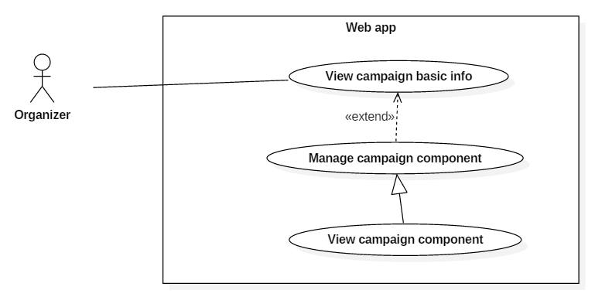

Figure 31 - <Organizer> View campaign component UCD

**Use Case Specification**

|  |  |  |  |
| --- | --- | --- | --- |
| **USE CASE – UC_32** | | | |
| **Use Case No.** | 32 | **Use Case Version** | 2.0 |
| **Use Case Name** | View campaign component | | |
| **Author** | Phùng Văn Bửu | | |
| **Date** | 08/11/2016 | **Priority** | Normal |
| **Actor:**   * Organizer   **Summary:**   * This use case allows organizer to view all component of an campaign.   **Goal:**   * Organizer can view campaign component.   **Triggers:**   * Organizer clicks “Thành phần chiến dịch” tab.   **Preconditions:**   * User were authorized as Organizer role.   **Postconditions:**   * Success: Display all components of an campaign. * Fail: system show error message.   **Main Success Scenario:**   |  |  |  | | --- | --- | --- | | **Step** | **Actor Action** | **System Response** | | 1 | Organizer navigates to “Chiến dịch của tôi” page | Show list of campaign | | 2 | Organizer clicks on an campaign | Show campaign detail with general information. | | 3 | Organizer clicks tab “Thành phần chiến dịch”. | Redirect to “Cấu hình thành phần chiến dịch” page. Display all components of the campaign.  [Exception 1] |   Exception :   | **No** | **Cause** | **System Response** | | --- | --- | --- | | 1 | Database occurs exception. | Display error message. |   **Relationships:**  extends of “View campaign basic info” use case  Business Rules:   * The order of the component in the list is the display ordered in the campaign page. | | | |

<Organizer> Create campaign component (UC_33)

**Use Case Diagram**

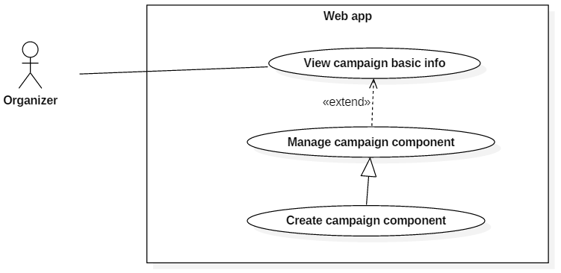

Figure 32 - <Organizer> Create campaign component UCD

**Use Case Specification**

|  |  |  |  |
| --- | --- | --- | --- |
| **USE CASE – UC_33** | | | |
| **Use Case No.** | 33 | **Use Case Version** | 2.0 |
| **Use Case Name** | Create campaign component | | |
| **Author** | Phùng Văn Bửu | | |
| **Date** | 08/11/2016 | **Priority** | Normal |
| **Actor:**   * Organizer   **Summary:**   * This use case allows organizer to create spectacular campaign component.   **Goal:**   * Organizer created campaign component.   **Triggers:**   * Organizer clicks “Tạo mới” button in page “thành phần chiến dịch”.   **Preconditions:**   * User were authorized as Organizer role.   **Postconditions:**   * Success: new campaign component has been created. * Fail: system show error message.   **Main Success Scenario:**   |  |  |  | | --- | --- | --- | | **Step** | **Actor Action** | **System Response** | | 1 | Organizer navigates to “Chiến dịch của tôi” page | Show list of campaign | | 2 | Organizer clicks on an campaign | Show campaign detail with general information. | | 3 | Organizer clicks tab “Thành phần chiến dịch”. | Redirect to “ Cấu hình thành phần chiến dịch” page. | | 4 | Organizer clicks “Tạo mới” button | Show a modal with drop down list of template:   * Diễn giả * Nội dung chương trình * Nhà tài trợ * Tùy chọn | | 5 | Organizer choose one of 4 options. Then fill the form and click “Tạo mới” button.  [Alternative 1] | Display success message.  [Exception 1]  [Exception 2] |   Alternative 1:   | **No** | **Step** | **System Response** | | --- | --- | --- | | 1 | Organizer clicks “Đóng” button | Close the dialog box. |   Exception :   | **No** | **Cause** | **System Response** | | --- | --- | --- | | 1 | Database occurs exception. | Display error message. | | 2 | Invalid Campaign Type Name in case of custom component. | Display error message. |   **Relationships:**  extends of “View campaign basic info” use case  Business Rules:   * Type of campaign component are:   + Diễn giả: Speakers of campaign.   + Nội dung chương trình: content of campaign   + Nhà tài trợ: sponsor of campaign   + Tùy chọn: custom component. | | | |

<Organizer> Edit campaign component (UC_34)

**Use Case Diagram**

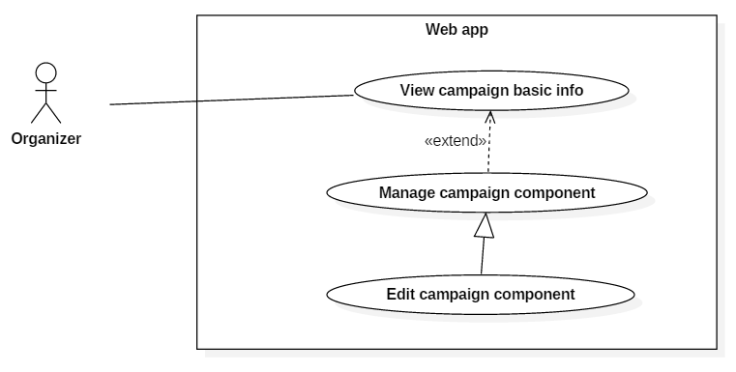

Figure 33 - <Organizer> Edit campaign component UCD

**Use Case Specification**

|  |  |  |  |
| --- | --- | --- | --- |
| **USE CASE – UC_34** | | | |
| **Use Case No.** | 34 | **Use Case Version** | 2.0 |
| **Use Case Name** | Edit campaign component | | |
| **Author** | Phùng Văn Bửu | | |
| **Date** | 08/11/2016 | **Priority** | Normal |
| **Actor:**   * Organizer   **Summary:**   * This use case allows organizer to edit a component of an campaign.   **Goal:**   * Organizer can modify campaign component.   **Triggers:**   * Organizer clicks edit button of a component.   **Preconditions:**   * User were authorized as Organizer role.   **Postconditions:**   * Success: Component changes of an campaign are saved. * Fail: system show error message.   **Main Success Scenario:**   |  |  |  | | --- | --- | --- | | **Step** | **Actor Action** | **System Response** | | 1 | Organizer navigates to “Chiến dịch của tôi” page | Show list of campaign | | 2 | Organizer clicks on an campaign | Show campaign detail with general information. | | 3 | Organizer clicks tab “Thành phần chiến dịch”. | Redirect to “Các thành phần của chiến dịch” page. | | 4 | Organizer clicks edit button of a component. | Display a modal with component‘s information. | | 5 | Organizer clicks “Lưu thay đổi” button.  [Alternative 1] | Display successful message.  [Exception 1]  [Exception 2] |   Alternative 1 :   | **No** | **Step** | **System Response** | | --- | --- | --- | | 1 | Organizer clicks “Đóng” button | Close the dialog box. |   Exception :   | **No** | **Cause** | **System Response** | | --- | --- | --- | | 1 | Invalid Campaign Type Name in case of custom component. | Display error message. | | 2 | Database occurs exception. | Display error message. |   **Relationships:**  extends of “View campaign basic info” use case  Business Rules: N/A | | | |

<Organizer> Delete campaign component (UC_35)

**Use Case Diagram**

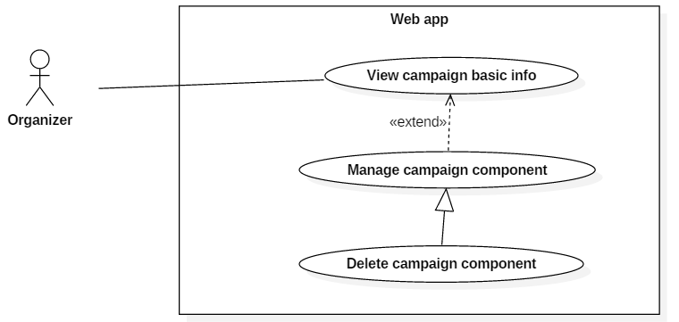

Figure 34 - <Organizer> Delete campaign component UCD

**Use Case Specification**

|  |  |  |  |
| --- | --- | --- | --- |
| **USE CASE – UC_35** | | | |
| **Use Case No.** | 35 | **Use Case Version** | 2.0 |
| **Use Case Name** | Delete campaign component | | |
| **Author** | Phùng Văn Bửu | | |
| **Date** | 08/11/2016 | **Priority** | Normal |
| **Actor:**   * Organizer   **Summary:**   * This use case allows organizer to delete a component of an campaign.   **Goal:**   * Organizer can delete campaign component.   **Triggers:**   * Organizer clicks delete button of a component.   **Preconditions:**   * User were authorized as Organizer role.   **Postconditions:**   * Success: an campaign component is deleted. * Fail: system show error message.   **Main Success Scenario:**   |  |  |  | | --- | --- | --- | | **Step** | **Actor Action** | **System Response** | | 1 | Organizer navigates to “Chiến dịch của tôi” page | Show list of campaign | | 2 | Organizer clicks on an campaign | Show campaign detail with general information. | | 3 | Organizer clicks tab “Thành phần chiến dịch”. | Redirect to “Các thành phần của chiến dịch” page. | | 4 | Organizer clicks delete button of a component. | Display a confirm message with 2 buttons:   * Xóa * Không | | 5 | Organizer clicks “Xóa” button.  [Alternative 1] | Display successful message.  [Exception 1] |   Alternative 1 :   | **No** | **Step** | **System Response** | | --- | --- | --- | | 1 | Organizer clicks “Không” button | Close the dialog box. |   Exception :   | **No** | **Cause** | **System Response** | | --- | --- | --- | | 1 | Database occurs exception. | Display error message. |   **Relationships:**  extends of “View campaign basic info” use case  Business Rules:   * Deleted component cannot be restore | | | |

* + - * 1. <Organizer> Manage survey

<Organizer> Create survey (UC_36)

**Use Case Diagram**

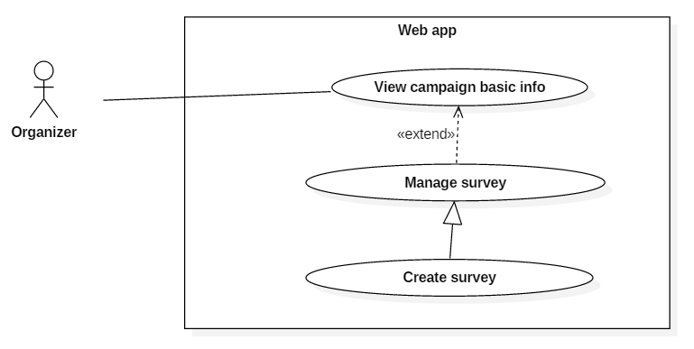

Figure 35 - <Organizer> Create survey UCD

**Use Case Specification**

|  |  |  |  |
| --- | --- | --- | --- |
| **USE CASE – UC_36** | | | |
| **Use Case No.** | 36 | **Use Case Version** | 2.0 |
| **Use Case Name** | Create survey | | |
| **Author** | Phùng Văn Bửu | | |
| **Date** | 08/11/2016 | **Priority** | Normal |
| **Actor:**   * Organizer   **Summary:**   * This use case allows organizer to create new survey.   **Goal:**   * Organizer create a new survey template.   **Triggers:**   * Organizer clicks “Tạo mới” button in “Khảo sát của bạn” page.   **Preconditions:**   * User were authorized as Organizer role.   **Postconditions:**   * Success: new survey template has been created. * Fail: system show error message.   **Main Success Scenario:**   |  |  |  | | --- | --- | --- | | **Step** | **Actor Action** | **System Response** | | 1 | Organizer navigates to “Chiến dịch của tôi” page | Show list of campaign | | 2 | Organizer clicks on an campaign | Show campaign detail with general information. | | 3 | Organizer clicks tab “Khảo sát của bạn”. | Redirect to “Quản lý khảo sát” page with list of survey template. | | 4 | Organizer clicks “Tạo mới” button | Display a modal with template:   * Tên khảo sát * Hình ảnh | | 5 | Organizer fills the form then clicks “Tạo mới” button.  [Alternative 1] | Show success message. Display question management modal.  [Exception 1] |   Alternative 1 :   | **No** | **Step** | **System Response** | | --- | --- | --- | | 1 | Organizer clicks “Đóng” button | Close the dialog box. |   Exception :   | **No** | **Cause** | **System Response** | | --- | --- | --- | | 1 | Database occurs exception. | Display error message. |   **Relationships:**  extends of “View campaign basic info” use case  Business Rules:   * Survey template is used for survey activity. | | | |

<Organizer> Edit survey (UC_37)

**Use Case Diagram**

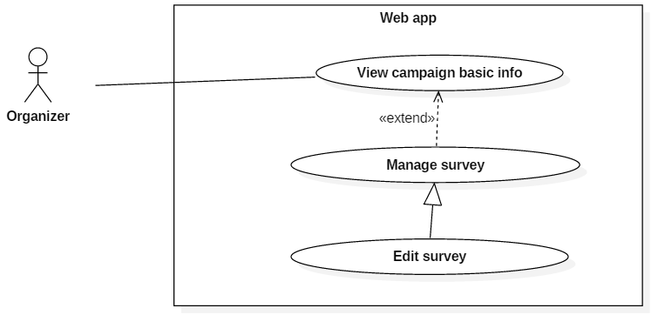

Figure 36 - <Organizer> Edit survey UCD

**Use Case Specification**

|  |  |  |  |
| --- | --- | --- | --- |
| **USE CASE – UC_37** | | | |
| **Use Case No.** | 37 | **Use Case Version** | 2.0 |
| **Use Case Name** | Edit survey | | |
| **Author** | Phùng Văn Bửu | | |
| **Date** | 08/11/2016 | **Priority** | Normal |
| **Actor:**   * Organizer   **Summary:**   * This use case allows organizer to edit a survey.   **Goal:**   * Organizer modify a survey template.   **Triggers:**   * Organizer edit button of a survey.   **Preconditions:**   * User were authorized as Organizer role.   **Postconditions:**   * Success: modified survey has been saved. * Fail: system show error message.   **Main Success Scenario:**   |  |  |  | | --- | --- | --- | | **Step** | **Actor Action** | **System Response** | | 1 | Organizer navigates to “Chiến dịch của tôi” page | Show list of campaign | | 2 | Organizer clicks on an campaign | Show campaign detail with general information. | | 3 | Organizer clicks tab “Khảo sát của bạn”. | Redirect to “Quản lý khảo sát” page with list of survey template. | | 4 | Organizer clicks edit button of a survey | Display a modal with survey information and question. | | 5 | Organizer edits field and then clicks “Lưu thay đổi” button.  [Alternative 1] | Show success message.  [Exception 1] |   Alternative 1 :   | **No** | **Step** | **System Response** | | --- | --- | --- | | 1 | Organizer clicks “Đóng” button | Close the dialog box. |   Exception :   | **No** | **Cause** | **System Response** | | --- | --- | --- | | 1 | Database occurs exception. | Display error message. |   **Relationships:**  extends of “View campaign basic info” use case  Business Rules:   * Survey template is used for survey activity. | | | |

<Organizer> Delete survey (UC_38)

**Use Case Diagram**

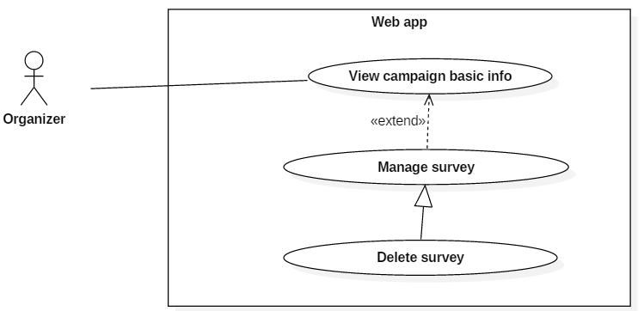

Figure 37 - <Organizer> Delete survey UCD

**Use Case Specification**

|  |  |  |  |
| --- | --- | --- | --- |
| **USE CASE – UC_38** | | | |
| **Use Case No.** | 38 | **Use Case Version** | 2.0 |
| **Use Case Name** | Delete survey | | |
| **Author** | Phùng Văn Bửu | | |
| **Date** | 08/11/2016 | **Priority** | Normal |
| **Actor:**   * Organizer   **Summary:**   * This use case allows organizer to delete a survey.   **Goal:**   * Organizer delete a survey template.   **Triggers:**   * Organizer delete button of a survey.   **Preconditions:**   * User were authorized as Organizer role.   **Postconditions:**   * Success: a survey has been deleted. * Fail: system show error message.   **Main Success Scenario:**   |  |  |  | | --- | --- | --- | | **Step** | **Actor Action** | **System Response** | | 1 | Organizer navigates to “Chiến dịch của tôi” page | Show list of campaign | | 2 | Organizer clicks on an campaign | Show campaign detail with general information. | | 3 | Organizer clicks tab “Khảo sát của bạn”. | Redirect to “Quản lý khảo sát” page with list of survey template. | | 4 | Organizer clicks delete button of a survey | Display a confirm message with 2 buttons:   * Xóa * Không | | 5 | Organizer edits field and then clicks “Xóa” button.  [Alternative 1] | Show success message.  [Exception 1] |   Alternative 1 :   | **No** | **Step** | **System Response** | | --- | --- | --- | | 1 | Organizer clicks “Đóng” button | Close the dialog box. |   Exception :   | **No** | **Cause** | **System Response** | | --- | --- | --- | | 1 | Database occurs exception. | Display error message. |   **Relationships:**  extends of “View campaign basic info” use case  Business Rules:   * Deleted survey cannot be restore * Question inside a survey will also be deleted. | | | |

* + - * 1. <Organizer> Manage question

<Organizer> Create question (UC_39)

**Use Case Diagram**

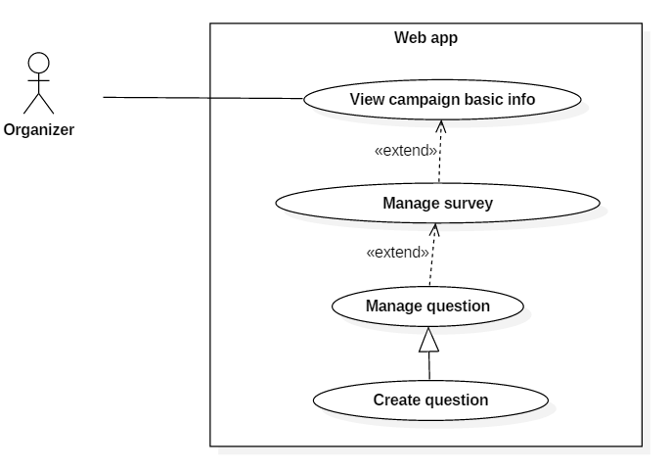

Figure 38 - <Organizer> Create question UCD

**Use Case Specification**

|  |  |  |  |
| --- | --- | --- | --- |
| **USE CASE – UC_39** | | | |
| **Use Case No.** | 39 | **Use Case Version** | 2.0 |
| **Use Case Name** | Create question | | |
| **Author** | Phùng Văn Bửu | | |
| **Date** | 08/11/2016 | **Priority** | Normal |
| **Actor:**   * Organizer   **Summary:**   * This use case allows organizer to create question of a survey.   **Goal:**   * Organizer can create questions for a survey.   **Triggers:**   * Organizer clicks “Thêm câu hỏi mới” button or finish creation of a survey.   **Preconditions:**   * User were authorized as Organizer role.   **Postconditions:**   * Success: a question is created. * Fail: system show error message.   **Main Success Scenario:**   |  |  |  | | --- | --- | --- | | **Step** | **Actor Action** | **System Response** | | 1 | Organizer navigates to “Chiến dịch của tôi” page | Show list of campaign | | 2 | Organizer clicks on an campaign | Show campaign detail with general information. | | 3 | Organizer clicks tab “Khảo sát của bạn”. | Redirect to “Quản lý khảo sát” page with list of survey template. | | 4 | Organizer clicks edit button of a survey | Display a modal with survey information and question. | | 5 | Organizer clicks “Thêm câu hỏi mới” | Show a modal with template:   * Loại câu hỏi: drop down list about question type.   The question content depending on question type:   * Điền nội dung (Nội dung câu hỏi, chú thích câu hỏi) * Đơn lựa chọn (Nội dung cho câu hỏi, chú thích cho câu hỏi, lựa chọn) * Đa lựa chọn (Nội dung cho câu hỏi, chú thích cho câu hỏi, lựa chọn) * Đánh giá (Nội dung cho câu hỏi, chú thích cho câu hỏi, tiêu chí phụ, điểm thấp nhất, điểm cao nhất) * Mô tả (Nội dung mô tả) | | 6 | Organizer choose question type and fills the form. Then click “Tạo câu hỏi” button.  [Alternative 1] | Display successful message.  [Exception 1] |   Alternative 1 :   | **No** | **Step** | **System Response** | | --- | --- | --- | | 1 | Organizer clicks “Đóng” button | Close the dialog box. |   Exception :   | **No** | **Cause** | **System Response** | | --- | --- | --- | | 1 | Database occurs exception. | Display error message. |   **Relationships:**  N/A  Business Rules:   * There are 5 types of question: Fill-in, single choice, multiple choice, rating and descripting question. * Each type of question has different fields. | | | |

<Organizer> Edit question (UC_40)

**Use Case Diagram**

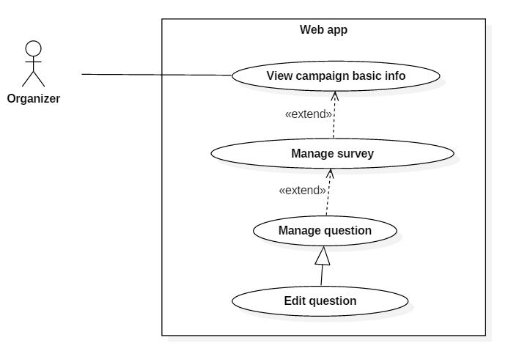

Figure 39 - <Organizer> Edit question UCD

**Use Case Specification**

|  |  |  |  |
| --- | --- | --- | --- |
| **USE CASE – UC_40** | | | |
| **Use Case No.** | 40 | **Use Case Version** | 2.0 |
| **Use Case Name** | Edit question | | |
| **Author** | Phùng Văn Bửu | | |
| **Date** | 09/11/2016 | **Priority** | Normal |
| **Actor:**   * Organizer   **Summary:**   * This use case allows organizer to edit question of a survey.   **Goal:**   * Organizer can edit questions for a survey.   **Triggers:**   * Organizer clicks edit button of a question.   **Preconditions:**   * User were authorized as Organizer role.   **Postconditions:**   * Success: modified question is updated. * Fail: system show error message.   **Main Success Scenario:**   |  |  |  | | --- | --- | --- | | **Step** | **Actor Action** | **System Response** | | 1 | Organizer navigates to “Chiến dịch của tôi” page | Show list of campaign | | 2 | Organizer clicks on an campaign | Show campaign detail with general information. | | 3 | Organizer clicks tab “Khảo sát của bạn”. | Redirect to “Quản lý khảo sát” page with list of survey template. | | 4 | Organizer clicks edit button of a survey | Display a modal with survey information and question. | | 5 | Organizer clicks edit icon of a question | Show a modal with template:   * Loại câu hỏi: drop down list about question type.   The question content depending on question type:   * Điền nội dung (Nội dung câu hỏi, chú thích câu hỏi) * Đơn lựa chọn (Nội dung cho câu hỏi, chú thích cho câu hỏi, lựa chọn) * Đa lựa chọn (Nội dung cho câu hỏi, chú thích cho câu hỏi, lựa chọn) * Đánh giá (Nội dung cho câu hỏi, chú thích cho câu hỏi, tiêu chí phụ, điểm thấp nhất, điểm cao nhất) * Mô tả (Nội dung mô tả) | | 6 | Organizer modify information then click “Lưu thay đổi” button.  [Alternative 1] | Display successful message.  [Exception 1] |   Alternative 1 :   | **No** | **Step** | **System Response** | | --- | --- | --- | | 1 | Organizer clicks “Đóng” button | Close the dialog box. |   Exception :   | **No** | **Cause** | **System Response** | | --- | --- | --- | | 1 | Database occurs exception. | Display error message. |   **Relationships:**  N/A  Business Rules:   * There are 5 types of question: Fill-in , single choice, multiple choice, rating and descripting question. * Each type of question has different fields. | | | |

<Organizer> Delete question (UC_41)

**Use Case Diagram**

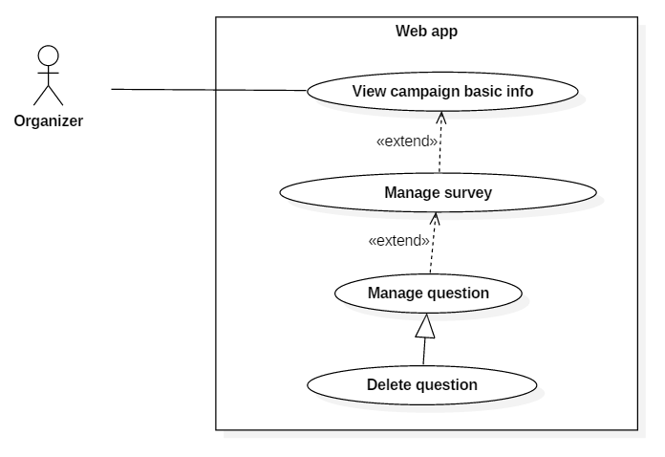

Figure 40 - <Organizer> Delete question UCD

**Use Case Specification**

|  |  |  |  |
| --- | --- | --- | --- |
| **USE CASE – UC_41** | | | |
| **Use Case No.** | 41 | **Use Case Version** | 2.0 |
| **Use Case Name** | Delete question | | |
| **Author** | Phùng Văn Bửu | | |
| **Date** | 09/11/2016 | **Priority** | Normal |
| **Actor:**   * Organizer   **Summary:**   * This use case allows organizer to delete question of a survey.   **Goal:**   * Organizer can delete questions for a survey.   **Triggers:**   * Organizer clicks “Xóa câu hỏi” button of a question.   **Preconditions:**   * User were authorized as Organizer role.   **Postconditions:**   * Success: remove selected question. * Fail: system show error message.   **Main Success Scenario:**   |  |  |  | | --- | --- | --- | | **Step** | **Actor Action** | **System Response** | | 1 | Organizer navigates to “Chiến dịch của tôi” page | Show list of campaign | | 2 | Organizer clicks on an campaign | Show campaign detail with general information. | | 3 | Organizer clicks tab “Khảo sát của bạn”. | Redirect to “Quản lý khảo sát” page with list of survey template. | | 4 | Organizer clicks edit button of a survey | Display a modal with survey information and question. | | 5 | Organizer clicks delete icon of a question | Display a confirm message with 2 buttons:   * Xóa * Không | | 6 | Organizer modify information then click “Xóa” button.  [Alternative 1] | Display successful message.  [Exception 1] |   Alternative 1 :   | **No** | **Step** | **System Response** | | --- | --- | --- | | 1 | Organizer clicks “Không” button | Close the dialog box. |   Exception :   | **No** | **Cause** | **System Response** | | --- | --- | --- | | 1 | Database occurs exception. | Display error message. |   **Relationships:**  N/A  Business Rules:   * Deleted question cannot be restored. | | | |

* + - * 1. <Organizer> View list participation (UC_42)

**Use Case Diagram**

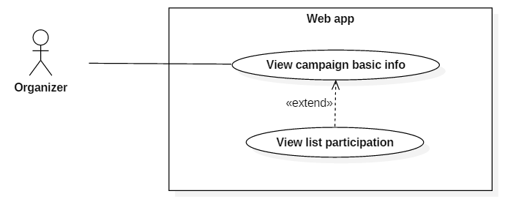

Figure 41 - <Organizer> View list participation UCD

**Use Case Specification**

|  |  |  |  |
| --- | --- | --- | --- |
| **USE CASE – UC_42** | | | |
| **Use Case No.** | 42 | **Use Case Version** | 2.0 |
| **Use Case Name** | View list participation | | |
| **Author** | Phùng Văn Bửu | | |
| **Date** | 08/11/2016 | **Priority** | Normal |
| **Actor:**   * Organizer   **Summary:**   * This use case allows organizer to view list participations of an campaign   **Goal:**   * Organizer can view participants of an campaign   **Triggers:**   * Organizer clicks “Danh sách khách tham gia” tab.   **Preconditions:**   * User were authorized as Organizer role.   **Postconditions:**   * Success: show list participants of an campaign. * Fail: system show error message.   **Main Success Scenario:**   |  |  |  | | --- | --- | --- | | **Step** | **Actor Action** | **System Response** | | 1 | Organizer navigates to “Chiến dịch của tôi” page | Show list of campaign | | 2 | Organizer clicks on an campaign | Show campaign detail with general information. | | 3 | Organizer clicks tab “Danh sách khách tham gia”. | Redirect to page “Danh sách khách” with list of participants. |   **Relationships:**  extends of “View campaign basic info” use case  Business Rules: N/A | | | |

* + - * 1. <Organizer> Send notification (UC_43)

**Use Case Diagram**

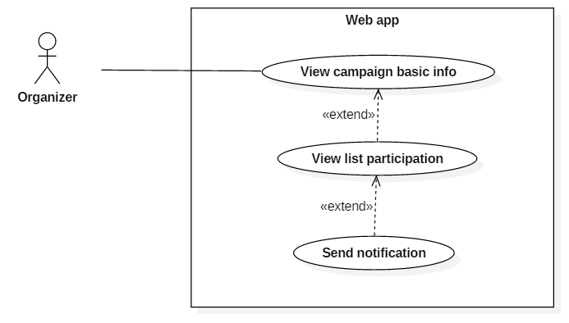

Figure 42 - <Organizer> Send notification UCD

**Use Case Specification**

|  |  |  |  |
| --- | --- | --- | --- |
| **USE CASE – UC_43** | | | |
| **Use Case No.** | 43 | **Use Case Version** | 2.0 |
| **Use Case Name** | Send notification | | |
| **Author** | Phùng Văn Bửu | | |
| **Date** | 09/11/2016 | **Priority** | Normal |
| **Actor:**   * Organizer   **Summary:**   * This use case allows organizer to send message to all participants or followers of an campaign   **Goal:**   * Organizer can send message to campaign’s participants or followers.   **Triggers:**   * Organizer clicks “Gửi tin nhắn” button.   **Preconditions:**   * User were authorized as Organizer role. * Participants or followers is not empty.   **Postconditions:**   * Success: participants or followers of an campaign receive notification about the message. * Fail: system show error message.   **Main Success Scenario:**   |  |  |  | | --- | --- | --- | | **Step** | **Actor Action** | **System Response** | | 1 | Organizer navigates to “Chiến dịch của tôi” page | Show list of campaign | | 2 | Organizer clicks on an campaign | Show campaign detail with general information. | | 3 | Organizer clicks tab “Danh sách khách tham gia”. | Redirect to page “Danh sách khách” with list of participants. | | 4 | Organizer clicks “Gửi tin nhắn” button | Display a modal with template   * Gửi tin nhắn cho: receivers ( participants or followers ) * Nội dung: message content | | 5 | Organizer fills the form then clicks “Gửi” button  [Alternative 1] | Display successful message.  [Exception 1]  [Exception 2] |   Alternative 1 :   | **No** | **Step** | **System Response** | | --- | --- | --- | | 1 | Organizer clicks “Đóng” button | Close the dialog box. |   Exception :   | **No** | **Cause** | **System Response** | | --- | --- | --- | | 1 | Database occurs exception. | Display error message. | | 2 | Empty message content | Display message “Vui long điền vào trường này” |   **Relationships:**  extends of “View list participations” use case  Business Rules: N/A | | | |

* + - * 1. <Organizer> Manage campaign component detail

<Organizer> Edit campaign component detail (UC_44)

**Use Case Diagram**

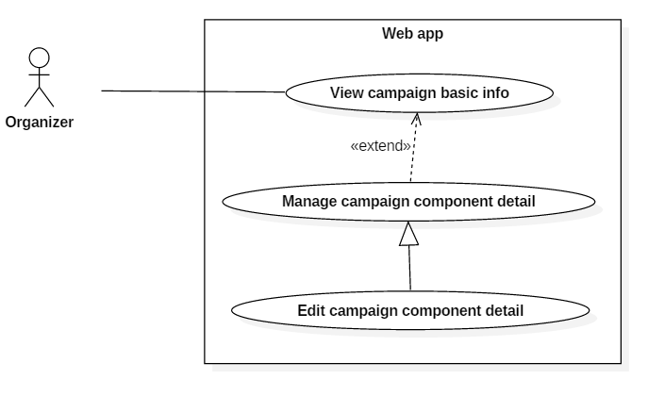

Figure 43 - <Organizer> Edit campaign component detail UCD

**Use Case Specification**

|  |  |  |  |
| --- | --- | --- | --- |
| **USE CASE – UC_44** | | | |
| **Use Case No.** | 44 | **Use Case Version** | 2.0 |
| **Use Case Name** | Edit campaign component detail | | |
| **Author** | Phùng Văn Bửu | | |
| **Date** | 08/11/2016 | **Priority** | Normal |
| **Actor:**   * Organizer   **Summary:**   * This use case allows organizer to edit an item of a component.   **Goal:**   * Organizer can modify campaign component detail information.   **Triggers:**   * Organizer clicks edit button of an item in a component.   **Preconditions:**   * User were authorized as Organizer role. * User has create at least 1 campaign component detail.   **Postconditions:**   * Success: detail information changes of a component are saved. * Fail: system show error message.   **Main Success Scenario:**   |  |  |  | | --- | --- | --- | | **Step** | **Actor Action** | **System Response** | | 1 | Organizer navigates to “Chiến dịch của tôi” page | Show list of campaign | | 2 | Organizer clicks on an campaign | Show campaign detail with general information. | | 3 | Organizer clicks tab “Nội dung thành phần”. | Tab expand to show all component of the campaign grouped by type. | | 4 | Organizer clicks on any type of component. | Redirect to a page that show the list of all component belongs to that type. | | 5 | Organizer clicks edit button of an item. | Display a modal with template depending on component type:   * Diễn giả: (Tên diễn giả, Chức vụ, Chi tiết, Hình ảnh) * Nhà tài trợ: (Tên nhà tài trợ, Mô tả, Chi tiết, Hình ảnh) * Chương trình: (Nội dung, Thời gian, Chi tiết) * Tùy chọn: (Nội dung, Mô tả, Chi tiết, Hình ảnh) | | 6 | Organizer clicks “Lưu thay đổi” button.  [Alternative 1] | Display successful message.  [Exception 1]  [Exception 2] |   Alternative 1 :   | **No** | **Step** | **System Response** | | --- | --- | --- | | 1 | Organizer clicks “Đóng” button | Close the dialog box. |   Exception :   | **No** | **Cause** | **System Response** | | --- | --- | --- | | 1 | Network problem exception. | Display error message. | | 2 | Database occurs exception. | Display error message. | | 3 | Empty data field | Display message “Vui lòng điền vào trường này”. |   **Relationships:**  extends of “View campaign basic info” use case  Business Rules: N/A | | | |

<Organizer> Delete campaign component detail (UC_45)

**Use Case Diagram**

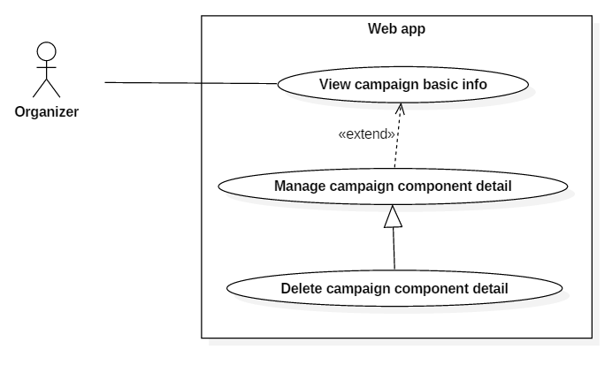

Figure 44 - <Organizer> Delete campaign component detail UCD

**Use Case Specification**

|  |  |  |  |
| --- | --- | --- | --- |
| **USE CASE – UC_45** | | | |
| **Use Case No.** | 45 | **Use Case Version** | 2.0 |
| **Use Case Name** | Delete campaign component detail | | |
| **Author** | Phùng Văn Bửu | | |
| **Date** | 08/11/2016 | **Priority** | Normal |
| **Actor:**   * Organizer   **Summary:**   * This use case allows organizer to delete an item of a component.   **Goal:**   * Organizer can delete an item in campaign component.   **Triggers:**   * Organizer clicks delete button of an item in a component.   **Preconditions:**   * User were authorized as Organizer role. * User has create at least 1 campaign component.   **Postconditions:**   * Success: an item of a component is deleted. * Fail: system show error message.   **Main Success Scenario:**   |  |  |  | | --- | --- | --- | | **Step** | **Actor Action** | **System Response** | | 1 | Organizer navigates to “Chiến dịch của tôi” page | Show list of campaign | | 2 | Organizer clicks on an campaign | Show campaign detail with general information.  [Exception 1] | | 3 | Organizer clicks tab “Nội dung thành phần”. | Tab expand to show all component of the campaign grouped by type.  [Exception 1] | | 4 | Organizer clicks on any type of component. | Redirect to a page that show the list of all component belongs to that type. | | 5 | Organizer clicks delete button of an item. | Display a confirm message with 2 buttons:   * Xóa * Không. | | 6 | Organizer clicks “Xóa” button.  [Alternative 1] | Display successful message.  [Exception 1]  [Exception 2] |   Alternative 1 :   | **No** | **Step** | **System Response** | | --- | --- | --- | | 1 | Organizer clicks “Không” button | Close the dialog box. |   Exception :   | **No** | **Cause** | **System Response** | | --- | --- | --- | | 1 | Network problem exception. | Display error message. | | 2 | Database occurs exception. | Display error message. |   **Relationships:**  extends of “View campaign basic info” use case  Business Rules: N/A | | | |

* + - * 1. <Organizer> Send campaign approving request (UC_46)

**Use Case Diagram**

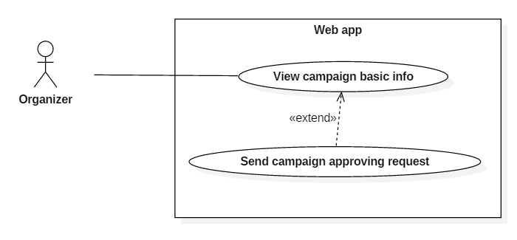

Figure 45 - <Organizer> Send campaign approving request UCD

**Use Case Specification**

|  |  |  |  |
| --- | --- | --- | --- |
| **USE CASE – UC_46** | | | |
| **Use Case No.** | 46 | **Use Case Version** | 2.0 |
| **Use Case Name** | Send campaign approving request | | |
| **Author** | Phùng Văn Bửu | | |
| **Date** | 09/11/2016 | **Priority** | Normal |
| **Actor:**   * Organizer   **Summary:**   * This use case allows organizer to send approving request.   **Goal:**   * Organizer can request admin for approving an campaign.   **Triggers:**   * Organizer clicks “Gửi duyệt” button.   **Preconditions:**   * User were authorized as Organizer role. * Campaign has not been approved   **Postconditions:**   * Success: Campaign approving request was sent to admin * Fail: system show error message.   **Main Success Scenario:**   |  |  |  | | --- | --- | --- | | **Step** | **Actor Action** | **System Response** | | 1 | Organizer navigates to “Chiến dịch của tôi” page | Show list of campaign | | 2 | Organizer clicks on an campaign | Show campaign detail with general information. | | 3 | Organizer clicks “Gửi duyệt” button | Refresh current page and change campaign status to “Chờ duyệt”.  [Exception 1] |   Exception :   | **No** | **Cause** | **System Response** | | --- | --- | --- | | 1 | Database occurs exception. | Display error message. |   **Relationships:**  extends of “View campaign basic info” use case  Business Rules: N/A | | | |

* + - * 1. <Organizer> Manage activity

<Organizer> Create activity (UC_47)

**Use Case Diagram**

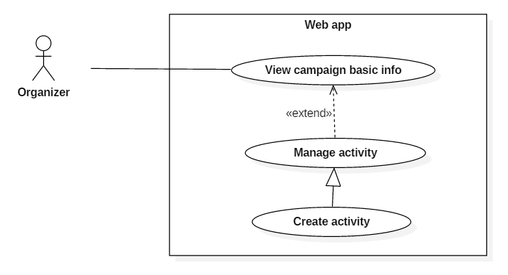

Figure 46 - <Organizer> Create activity UCD

**Use Case Specification**

|  |  |  |  |
| --- | --- | --- | --- |
| **USE CASE – UC_47** | | | |
| **Use Case No.** | 47 | **Use Case Version** | 2.0 |
| **Use Case Name** | Create Activity | | |
| **Author** | Hồ Minh Quân | | |
| **Date** | 09/11/2016 | **Priority** | Normal |
| **Actor:**   * Organizer   **Summary:**   * This use case allows actor to create activity in campaign.   **Goal:**   * Actor creates new activity.   **Triggers:**   * Actor clicks “TẠO MỚI” button.   **Preconditions:**   * Actor must login into the system successfully.   **Post Conditions:**   * **Success:** New activity will be created. * **Fail:** Error message is displayed.   **Main Success Scenario:**   |  |  |  | | --- | --- | --- | | Step | Actor Action | System Response | | 1 | Click “TẠO MỚI” button. | Show drop down list that includes:   * Khảo sát. * Trò chơi. | | 2 | Choose item from the list. | Show popup with information depends on the item:  “Khảo sát” case:   * “Tên hoạt động”: text input. * “Mô tả”: text input. * “Khảo sát”: drop down list.   “Trò chơi” case:   * “Tên trò chơi”: text input. * “Drop rate 1”: 2 types (slider and text input). * “Drop rate 2”: 2 types (slider and text input). * “Drop rate 3”: 2 types (slider and text input). | | 3 | Enter all field, adjust slider, choose item from drop down list in the popup.  Click “Tạo mới” button.  [Alternative 1] | Show success message.  [Exception 1]  [Exception 2]  [Exception 3]  [Exception 4] |   **Alternative:**   |  |  |  | | --- | --- | --- | | No | Actor Action | System Response | | 1 | Click “Đóng” or “X” (close) button. | Close popup. |   **Exceptions:**   |  |  |  | | --- | --- | --- | | No | Cause | System Response | | 1 | Actor does not enter into text input. | Show validate message. | | 2 | “Trò chơi” case:  Sum of the value from 3 drop rate field does not equal 100 percent. | Show error message. | | 3 | “Trò chơi” case:  Any value from the drop rate field equals 0 percent. | Show error message. | | 4 | Network problem exception. | Show “Có lỗi xảy ra, vui lòng thử lại” message. |   **Relationships:**   * Extend with “View Campaign Basic Info” use case.   **Business Rules:**   * All of the field must not be empty. * The drop rate field only accepts integer number. * Sum of the value from 3 drop rate field must equal 100 percent. * All of the value from drop rate field must not equal 0 percent. * The newly added “Khảo sát” activity will include these fields: * “Mô tả”: the description of the activity. * “Loại”: the type of the activity (“Khảo sát” or “Trò chơi”). * “Link tham gia” (“Khảo sát” case): this link is the path to the survey page. The organizer then can provide this link to other user to do the survey. * “Thao tác”: there are 3 buttons in this field (“Sửa”, “Xóa”, “Xuất bản”). | | | |

<Organizer> Edit activity (UC_48)

**Use Case Diagram**

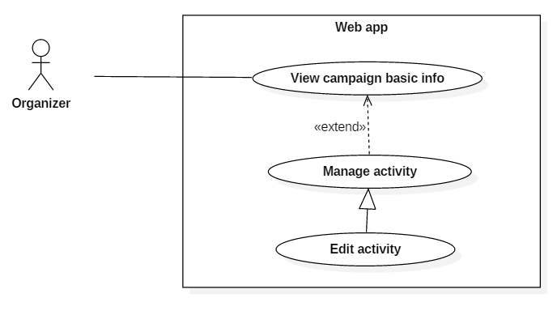

Figure 47 - <Organizer> Edit activity UCD

**Use Case Specification**

|  |  |  |  |
| --- | --- | --- | --- |
| **USE CASE – UC_48** | | | |
| **Use Case No.** | 48 | **Use Case Version** | 2.0 |
| **Use Case Name** | Edit Activity | | |
| **Author** | Hồ Minh Quân | | |
| **Date** | 09/11/2016 | **Priority** | Normal |
| **Actor:**   * Organizer   **Summary:**   * This use case allows actor to edit activity information in campaign.   **Goal:**   * Actor edits information of activity in campaign.   **Triggers:**   * Actor clicks “Sửa” button.   **Preconditions:**   * Actor must login into the system successfully.   **Post Conditions:**   * **Success:** The activity information will be changed. * **Fail:** Error message is displayed.   **Main Success Scenario:**   |  |  |  | | --- | --- | --- | | Step | Actor Action | System Response | | 1 | Click “Sửa” button. | Show popup that includes:   * “Tên hoạt động”: text input. * “Mô tả”: text input. * “Khảo sát”: drop down list (“Khảo sát” case). * “Drop rate 1”: 2 types (slider and text input) (“Trò chơi” case). * “Drop rate 2”: 2 types (slider and text input) (“Trò chơi” case). * “Drop rate 3”: 2 types (slider and text input) (“Trò chơi” case). * “Thời gian”: date time picker. | | 2 | Click “Lưu thay đổi” button.  [Alternative 1] | Show success message.  [Exception 1]  [Exception 2]  [Exception 3]  [Exception 4] |   **Alternative:**   |  |  |  | | --- | --- | --- | | No | Actor Action | System Response | | 1 | Click “Đóng” or “X” (close) button. | Close popup. |   **Exceptions:**   |  |  |  | | --- | --- | --- | | No | Cause | System Response | | 1 | The input field is empty. | Show “Please fill out this field” message. | | 2 | “Trò chơi” case:  Sum of the value from 3 drop rate field does not equal 100 percent. | Show error message. | | 3 | “Trò chơi” case:  Any value from the drop rate field equals 0 percent. | Show error message. | | 4 | Network problem exception. | Show “Có lỗi xảy ra, vui lòng thử lại” message. |   **Relationships:**   * Extend with “View Campaign Basic Info” use case.   **Business Rules:**   * All of the field must not be empty. * The drop rate field only accepts integer number. * Sum of the value from 3 drop rate field must equal 100 percent. * All of the value from drop rate field must not equal 0 percent. | | | |

<Organizer> Delete activity (UC_49)

**Use Case Diagram**

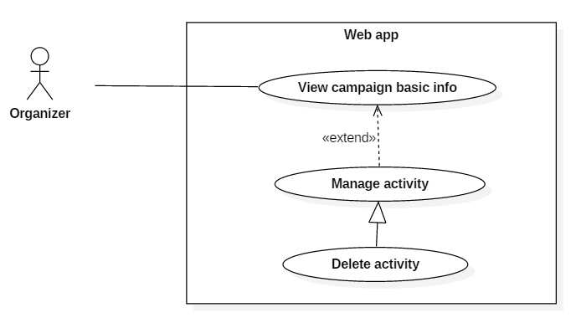

Figure 48 - <Organizer> Delete activity UCD

|  |  |  |  |
| --- | --- | --- | --- |
| **USE CASE – UC_49** | | | |
| **Use Case No.** | 49 | **Use Case Version** | 2.0 |
| **Use Case Name** | Delete Activity | | |
| **Author** | Hồ Minh Quân | | |
| **Date** | 09/11/2016 | **Priority** | Normal |
| **Actor:**   * Organizer   **Summary:**   * This use case allows actor to delete an activity in campaign.   **Goal:**   * Actor deletes an activity.   **Triggers:**   * Actor clicks “Xóa” button.   **Preconditions:**   * Actor must login into the system successfully.   **Post Conditions:**   * **Success:** The activity will be deleted. * **Fail:** Error message is displayed.   **Main Success Scenario:**   |  |  |  | | --- | --- | --- | | Step | Actor Action | System Response | | 1 | Click “Xóa” button. | Show confirm popup. | | 2 | Click “Xóa” button in popup.  [Alternative 1] | Show success message.  [Exception 1] |   **Alternative:**   |  |  |  | | --- | --- | --- | | No | Actor Action | System Response | | 1 | Click “Không” or “X” (close) button. | Close popup. |   **Exceptions:**   |  |  |  | | --- | --- | --- | | No | Cause | System Response | | 1 | Network problem exception. | Show “Có lỗi xảy ra, vui lòng thử lại” message. |   **Relationships:**   * Extend with “View Campaign Basic Info” use case.   **Business Rules:**   * In fact deleting activity is to set the “Active” field from “True” to “False”. * Once the “Active” field is set to “False”, it cannot be set to “True” again. * When an activity is deleted, system will send message to user who has joined the campaign and all user in the same organizer. | | | |

**Use Case Specification**

* + - * 1. <Organizer> View campaign statistic (UC_50)

**Use Case Diagram**

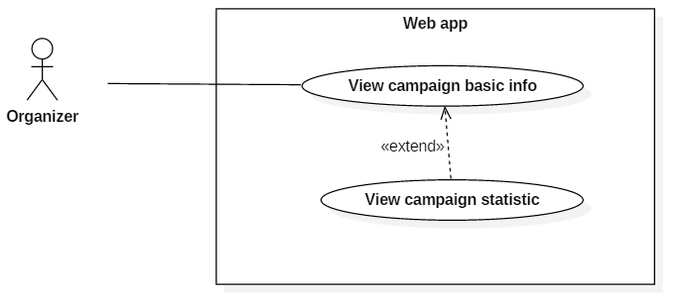

Figure 49 - <Organizer> View campaign statistic UCD

**Use Case Specification**

|  |  |  |  |
| --- | --- | --- | --- |
| **USE CASE – UC_50** | | | |
| **Use Case No.** | 50 | **Use Case Version** | 2.0 |
| **Use Case Name** | View campaign statistic | | |
| **Author** | Phùng Văn Bửu | | |
| **Date** | 08/11/2016 | **Priority** | Normal |
| **Actor:**   * Organizer   **Summary:**   * This use case allows organizer to view statistics of an campaign.   **Goal:**   * Organizer can view statistics about participation or activities information.   **Triggers:**   * Organizer clicks “Thống kê chiến dịch” tab.   **Preconditions:**   * User were authorized as Organizer role.   **Postconditions:**   * Success: show overview statistic of an campaign. * Fail: system show error message.   **Main Success Scenario:**   |  |  |  | | --- | --- | --- | | **Step** | **Actor Action** | **System Response** | | 1 | Organizer navigates to “Chiến dịch của tôi” page | Show list of campaign | | 2 | Organizer clicks on an campaign | Show campaign detail with general information. | | 3 | Organizer clicks tab “Thống kê chiến dịch”. | Redirect to “Thống kê chiến dịch” page with template:   * Number of participation * Number of follower * Number of balls * Number of coins * Number of view * Line chart of daily participation   [Exception 1] |   Alternative 1 :   | **No** | **Step** | **System Response** | | --- | --- | --- | | 1 | Organizer clicks “Không” button | Close the dialog box. |   Exception :   | **No** | **Cause** | **System Response** | | --- | --- | --- | | 1 | Database occurs exception. | Display error message. |   **Relationships:**  extends from “View campaign basic info” use case  Business Rules:   * Balls include fire ball and ice ball that is thrown at the campaign * Coin = Multiplier x 10. It is the coin return to user when participate in an campaign. * Organizer will be charged by the number of coin returned. | | | |

* + - * 1. <Organizer> Manage prize

<Organizer> Create prize (UC_51)

**Use Case Diagram**

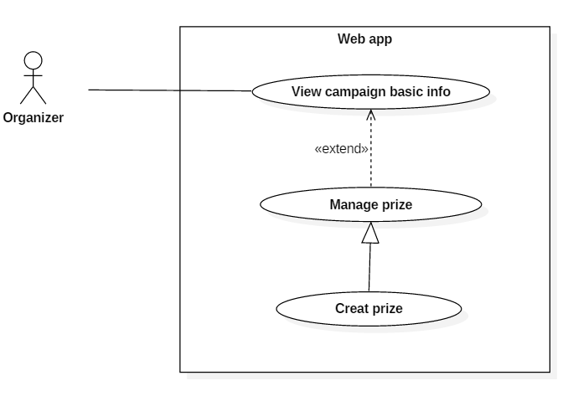

Figure 50 - <Organizer> Create prize UCD

**Use Case Specification**

|  |  |  |  |
| --- | --- | --- | --- |
| **USE CASE – UC_51** | | | |
| **Use Case No.** | 51 | **Use Case Version** | 2.0 |
| **Use Case Name** | Create prize | | |
| **Author** | Lê Khải Thông | | |
| **Date** | 08/11/2016 | **Priority** | Normal |
| **Actor:**   * Organizer   **Summary:**   * This use case allows organizer to create new prize.   **Goal:**   * Reject campaign request.   **Triggers:**   * Admin click on “Tạo phần thưởng” button on “Quản lý phần thưởng” page.   **Preconditions:**   * Actor login successfully with Organizer role.   **Post Conditions:**   * **Success:** New prize is created * **Fail:** Show error message   **Main Success Scenario:**   |  |  |  | | --- | --- | --- | | Step | Actor Action | System Response | | 1 | Organizer go to “Quản lý phần thưởng” page. | Show list of all prize with status. | | 2 | Organizer click “Tạo phần thưởng” | Show create form with following information:   * Tên phần thưởng: text * Điểm Teek: switch button   + - * Teek: integer * Điểm đá quý: switch button   + - * Ruby: integer       * Sapphire: integer       * Citrine: integer * Hình ảnh: image selector * Tạo mới: button * Đóng: button | | 3 | Organizer input required information and click “Tạo mới”  [Alternative 1] | Create new prize. Show success message  [Exception 1] |   **Alternative 1:**   |  |  |  | | --- | --- | --- | | Step | Actor Action | System Response | | 1 | Admin click button “Đóng”. | Close create dialog |   **Exceptions:**   |  |  |  | | --- | --- | --- | | No | Cause | System Response | | 1 | Network problem exception. | Show message “Có lỗi xảy ra, vui lòng thử lại sau”. | | 2 | Tên phần thưởng is not input | Show error message. |   **Relationships:** N/A.  **Business Rules:**   * “Điểm Teek” switch button has 2 states: “On” and “Off”. When actor switch to “On” then sub information of button is displayed and that information become required (value > 0). * “Điểm đá quý” switch button has 2 states: “On” and “Off”. When actor switch to “On” then sub information of button is displayed and that information become required ( value > 0) * Hình ảnh: image maximum resolution is 1040x800 px | | | |

<Organizer> Edit prize (UC_52)

**Use Case Diagram**

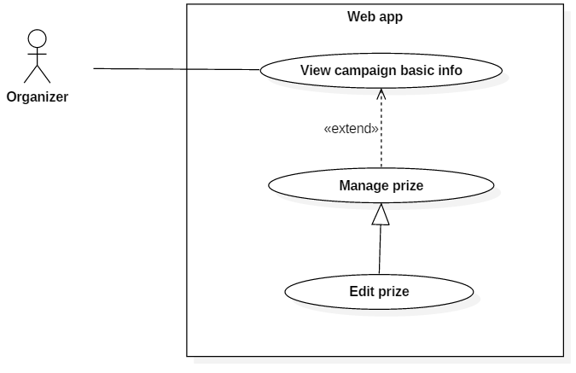

Figure 51 - <Organizer> Edit prize UCD

**Use Case Specification**

|  |  |  |  |
| --- | --- | --- | --- |
| **USE CASE – UC_52** | | | |
| **Use Case No.** | 52 | **Use Case Version** | 2.0 |
| **Use Case Name** | Edit prize | | |
| **Author** | Lê Khải Thông | | |
| **Date** | 08/11/2016 | **Priority** | Normal |
| **Actor:**   * Organizer   **Summary:**   * This use case allows organizer to edit prize information.   **Goal:**   * Update prize information.   **Triggers:**   * Admin click Edit icon on “Quản lý phần thưởng” page.   **Preconditions:**   * Actor login successfully with Organizer role.   **Post Conditions:**   * **Success:** Prize’s information is created * **Fail:** Show error message   **Main Success Scenario:**   |  |  |  | | --- | --- | --- | | Step | Actor Action | System Response | | 1 | Organizer go to “Quản lý phần thưởng” page. | Show list of all prize with status. | | 2 | Organizer click Edit icon | Show edit form with following information:   * Tên phần thưởng: text * Điểm Teek: switch button   + - * Teek: integer * Điểm đá quý: switch button   + - * Ruby: integer       * Sapphire: integer       * Citrine: integer * Hình ảnh: image selector * Lưu thay đổi: button * Đóng: button | | 3 | Organizer input required information and click “Lưu chỉnh sửa”  [Alternative 1] | Create new prize. Show success message  [Exception 1] |   **Alternative 1:**   |  |  |  | | --- | --- | --- | | Step | Actor Action | System Response | | 1 | Admin click button “Đóng”. | Close edit dialog |   **Exceptions:**   |  |  |  | | --- | --- | --- | | No | Cause | System Response | | 1 | Network problem exception. | Show message “Có lỗi xảy ra, vui lòng thử lại sau”. | | 2 | Tên phần thưởng is not input | Show error message. |   **Relationships:** N/A.  **Business Rules:**   * “Điểm Teek” switch button has 2 states: “On” and “Off”. When actor switch to “On” then sub information of button is displayed and that information become required (value > 0). * “Điểm đá quý” switch button has 2 states: “On” and “Off”. When actor switch to “On” then sub information of button is displayed and that information become required ( value > 0) * Hình ảnh: image maximum resolution is 1040x800 px | | | |

<Organizer> Delete prize (UC_53)

**Use Case Diagram**

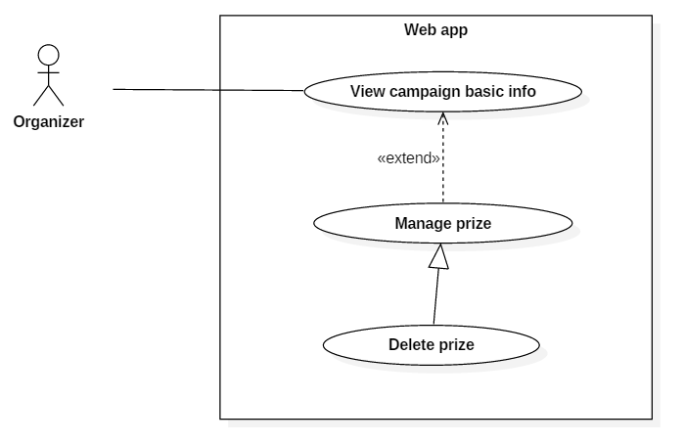

Figure 52 - <Organizer> Delete prize UCD

**Use Case Specification**

|  |  |  |  |
| --- | --- | --- | --- |
| **USE CASE – UC_53** | | | |
| **Use Case No.** | 53 | **Use Case Version** | 2.0 |
| **Use Case Name** | Delete prize | | |
| **Author** | Lê Khải Thông | | |
| **Date** | 08/11/2016 | **Priority** | Normal |
| **Actor:**   * Organizer   **Summary:**   * This use case allows organizer to delete a prize.   **Goal:**   * Delete prize information.   **Triggers:**   * Admin click Edit icon on “Quản lý phần thưởng” page.   **Preconditions:**   * Actor login successfully with Organizer role. * Has at least 1 available prize   **Post Conditions:**   * **Success:** Prize is deleted * **Fail:** Show error message   **Main Success Scenario:**   |  |  |  | | --- | --- | --- | | Step | Actor Action | System Response | | 1 | Organizer go to “Quản lý phần thưởng” page. | Show list of all prize with status. | | 2 | Organizer click Edit icon | Show confirm dialog with following information:   * Bạn có muốn xóa không? Bạn sẽ không hoàn tác được: message * OK: button * Cancel: button | | 3 | Organizer click “OK” button  [Alternative 1] | Update prize into storage. Remove prize from prize list |   **Alternative 1:**   |  |  |  | | --- | --- | --- | | Step | Actor Action | System Response | | 1 | Admin click button “Cancel”. | Close confirm dialog |   **Exceptions:**   |  |  |  | | --- | --- | --- | | No | Cause | System Response | | 1 | Network problem exception. | Show message “Có lỗi xảy ra, vui lòng thử lại sau”. |   **Relationships:** N/A.  **Business Rules:**   * When delete a prize, system does not delete complete that record out of storage. System changes “Active” field of record from True to False. | | | |

* + - * 1. <Organizer> Manage information (UC_54)

**Use Case Diagram**

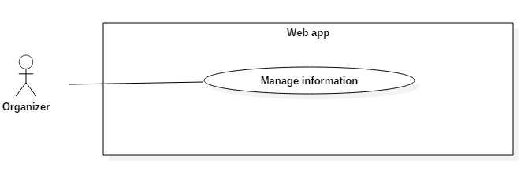

Figure 53 - <Organizer> Manage information UCD

**Use Case Specification**

|  |  |  |  |
| --- | --- | --- | --- |
| **USE CASE – UC_54** | | | |
| **Use Case No.** | 54 | **Use Case Version** | 2.0 |
| **Use Case Name** | Manage information | | |
| **Author** | Lê Khải Thông | | |
| **Date** | 08/11/2016 | **Priority** | Normal |
| **Actor:**   * Organizer   **Summary:**   * This use case allows organizer to edit their information.   **Goal:**   * Update organizer’s information.   **Triggers:**   * Admin click “Cập nhật” button on “Thông tin chung” page.   **Preconditions:**   * Actor login successfully with Organizer role. * Has at least 1 available prize   **Post Conditions:**   * **Success:** Organizer’s information is updated. * **Fail:** Show error message   **Main Success Scenario:**   |  |  |  | | --- | --- | --- | | Step | Actor Action | System Response | | 1 | Organizer go to “Thông tin chung” page. | Show organizer’s information with following information:   * Organizer name * Phone number * Email * Address * Description * Cập nhật: button | | 2 | Organizer click “Cập nhật” button | Show edit dialog with following information:   * Organizer name: text * Phone number: number * Email: text * Address: text * Description: image selector * Cập nhật: button * Close: button | | 3 | Organizer edit information and click “Cập nhật” button  [Alternative 1] | Update prize into storage. Show success message, close edit dialog  [Exception 2] |   **Alternative 1:**   |  |  |  | | --- | --- | --- | | Step | Actor Action | System Response | | 1 | Admin click button “Close”. | Close edit dialog |   **Exceptions:**   |  |  |  | | --- | --- | --- | | No | Cause | System Response | | 1 | Network problem exception. | Show message “Có lỗi xảy ra, vui lòng thử lại sau”. | | 2 | Missing required information | Show error message |   **Relationships:** N/A.  **Business Rules:** N/A | | | |

* + - * 1. <Organizer> Manage store

<Organizer> Create store (UC_55)

**Use Case Diagram**

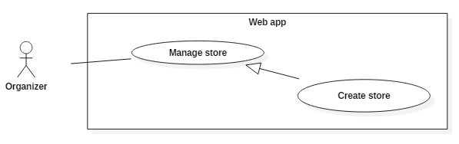

Figure 54 - <Organizer> Create store UCD

**Use Case Specification**

|  |  |  |  |
| --- | --- | --- | --- |
| **USE CASE – UC_55** | | | |
| **Use Case No.** | 55 | **Use Case Version** | 2.0 |
| **Use Case Name** | Create store | | |
| **Author** | Nguyễn Hải Phong | | |
| **Date** | 08/11/2016 | **Priority** | Normal |
| **Actor:**   * Organizer.   **Summary:**   * This use case allows user to create new store.   **Goal:**   * User create new store with information.   **Triggers:**   * User send command create store.   **Preconditions:**   * User must have logged in system as Organizer role.   **Post Conditions:**  **- Success:** New store had been created.  - **Fail:** Show error message  **Main Success Scenario:**   |  |  |  | | --- | --- | --- | | Step | Actor Action | System Response | | 1 | User login system with Organizer role. |  | | 2 | User click “Danh sách cửa hàng” button. | Show list of stores and “Tạo mới” button. | | 3 | User click “Tạo mới” button. | Show popup for creating:   * Tên cửa hàng: free text input required. * Email: include ‘@’ required. * Số điện thoại: free integer input required. * Fax: free integer input required. * Giờ mở cửa: Date time picker required. * Giờ đóng cửa: Date time picker required. * “Sẵn sàng” Switch button: on * Địa chỉ: Google map mapping auto complete text input.   [Exception 1] | | 4 | User input required information and click “Tạo mới” button in popup.  [Alternative ] | Show success message. Redirected to “Chiến dịch của tôi” page with new campaign.  [Exception ] |   **Alternative Scenario:**  [Alternative 1]   |  |  |  | | --- | --- | --- | | Step | Actor action | System Response | | 1 | User click “Ẩn/Hiện bản đồ” | Show or hide google map with address that user input.1 |   [Alternative 2]   |  |  |  | | --- | --- | --- | | Step | Actor action | System Response | | 1 | User click on “Giờ mở cửa” text input. | Show date time picker. | | 2 | User choose time and free click outside the popup. | Generate time into “Giờ mở cửa” text input. | | 3 | User click on “Giờ đóng cửa” text input. | Show time picker. | | 4 | User choose time and free click outside the popup. | Generate time into “Giờ đóng cửa” text input. |   [Alternative 3]   |  |  |  | | --- | --- | --- | | Step | Actor action | System Response | | 1 | User click on button “Đóng”. | Redirected to “Chiến dịch của tôi” page. |   **Exceptions:**  [Exception 1]   |  |  |  | | --- | --- | --- | | No | Cause | System Response | | 1 | Network problem exception. | Show message “Có lỗi xảy ra, vui lòng thử lại sau”. |   [Exception 2]   |  |  |  | | --- | --- | --- | | No | Cause | System Response | | 1 | “Tên cửa hàng” is empty. | Show message “Please fill this field”. | | 2 | “Email” is empty. | Show message “Please fill this field”. | | 3 | “Số điện thoại” is empty. | Show message “Please fill this field”. | | 4 | “Fax” is empty. | Show message “Please fill this field”. | | 5 | “Giờ mở cửa” is empty. | Show message “Please fill this field”. | | 6 | “Giờ đóng cửa” is empty. | Show message “Please fill this field”. |   **Relationships:**  N/A  **Business Rules:**   * Store name is unique. * Fax is unique. * Store’s status can be “ready” or “not ready”. | | | |

<Organizer> Edit store (UC_56)

**Use Case Diagram**

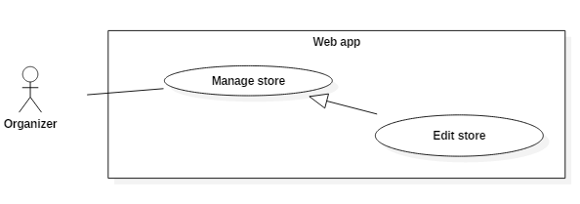

Figure 55 - <Organizer> Edit store UCD

**Use Case Specification**

|  |  |  |  |
| --- | --- | --- | --- |
| **USE CASE – UC_56** | | | |
| **Use Case No.** | 56 | **Use Case Version** | 2.0 |
| **Use Case Name** | Edit store | | |
| **Author** | Nguyễn Hải Phong | | |
| **Date** | 08/11/2016 | **Priority** | Normal |
| **Actor:**  - Organizer.  **Summary:**   * This use case allows user to edit exist store.   **Goal:**   * User edit store with information.   **Triggers:**   * User send command edit store.   **Preconditions:**   * User must have logged in system as Organizer role.   **Post Conditions:**   * **Success:** Store had been edit. * **Fail:** Show error message.   **Main Success Scenario:**   |  |  |  | | --- | --- | --- | | Step | Actor Action | System Response | | 1 | User login system with Organizer role. |  | | 2 | User click “Danh sách cửa hàng” button. | Show list of stores and Edit button. | | 3 | User click edit button. | Show popup for edit:   * Tên cửa hàng: free text input required. * Email: include ‘@’ required. * Số điện thoại: free integer input required. * Fax: free integer input required. * Giờ mở cửa: Date time picker required. * Giờ đóng cửa: Date time picker required. * “Sẵn sàng” Switch button: on * Địa chỉ: Google map mapping auto complete text input.   [Exception 1] | | 4 | User input required information and click “Tạo mới” button in popup.  [Alternative ] | Show success message. Redirected to “Chiến dịch của tôi” page with new campaign.  [Exception ] |   **Alternative Scenario:**  [Alternative 1]   |  |  |  | | --- | --- | --- | | Step | Actor action | System Response | | 1 | User click “Ẩn/Hiện bản đồ” | Show or hide google map with address that user input.1 |   [Alternative 2]   |  |  |  | | --- | --- | --- | | Step | Actor action | System Response | | 1 | User click on “Giờ mở cửa” text input. | Show date time picker. | | 2 | User choose time and free click outside the popup. | Generate time into “Giờ mở cửa” text input. | | 3 | User click on “Giờ đóng cửa” text input. | Show time picker. | | 4 | User choose time and free click outside the popup. | Generate time into “Giờ đóng cửa” text input. |   [Alternative 3]   |  |  |  | | --- | --- | --- | | Step | Actor action | System Response | | 1 | User click on button “Đóng”. | Redirected to “Chiến dịch của tôi” page. |   **Exceptions:**  [Exception 1]   |  |  |  | | --- | --- | --- | | No | Cause | System Response | | 1 | Network problem exception. | Show message “Có lỗi xảy ra, vui lòng thử lại sau”. |   [Exception 2]   |  |  |  | | --- | --- | --- | | No | Cause | System Response | | 1 | “Tên cửa hàng” is empty. | Show message “Please fill this field”. | | 2 | “Email” is empty. | Show message “Please fill this field”. | | 3 | “Số điện thoại” is empty. | Show message “Please fill this field”. | | 4 | “Fax” is empty. | Show message “Please fill this field”. | | 5 | “Giờ mở cửa” is empty. | Show message “Please fill this field”. | | 6 | “Giờ đóng cửa” is empty. | Show message “Please fill this field”. |   **Relationships:**  N/A  **Business Rules:**   * Store name is unique. * Fax is unique. * Store’s status can be “ready” or “not ready”. | | | |

<Orgnizer> Delete store (UC_57)

**Use Case Diagram**

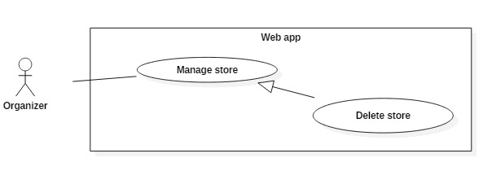

Figure 56 - <Organizer> Delete store UCD

**Use Case Specification**

|  |  |  |  |
| --- | --- | --- | --- |
| **USE CASE – UC_57** | | | |
| **Use Case No.** | 57 | **Use Case Version** | 2.0 |
| **Use Case Name** | Delete store | | |
| **Author** | Nguyễn Hải Phong | | |
| **Date** | 08/11/2016 | **Priority** | Normal |
| **Actor:**  - Organizer.  **Summary:**   * This use case allows user delete store.   **Goal:**   * User delete store with its information.   **Triggers:**   * User send command delete store.   **Preconditions:**   * User must have logged in system as Organizer role.   **Post Conditions:**   * **Success:** Store has been deleted. * **Fail:** Show error message.   **Main Success Scenario:**   |  |  |  | | --- | --- | --- | | Step | Actor Action | System Response | | 1 | User login system with Organizer role. |  | | 2 | User click “Danh sách cửa hàng” button. | Show list of stores and Delete button. | | 3 | User click Delete button. | Show popup with “Bạn có chắc chắn muốn xóa cửa hàng này?” message.  [Exception 1] | |  | User click “Có” button.  [Alternative 1] | [Exception 1] |   **Alternative Scenario:**  [Alternative 1]   |  |  |  | | --- | --- | --- | | Step | Actor action | System Response | | 1 | User click “Cancel” button. | Close popup. |   **Exceptions:**  [Exception 1]   |  |  |  | | --- | --- | --- | | No | Cause | System Response | | 1 | Network problem exception. | Show message “Có lỗi xảy ra, vui lòng thử lại sau”. |   **Relationships:**  N/A  **Business Rules:** N/A | | | |

* + - * 1. <Organizer> Manage wifi router

<Organizer> Create wifi router (UC_58)

**Use Case Diagram**

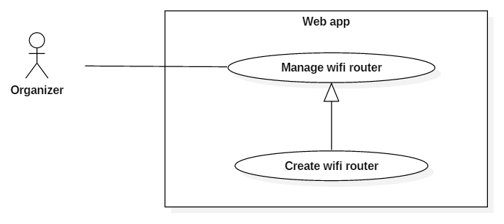

Figure 57 - <Organizer> Create wifi router UCD

**Use Case Specification**

|  |  |  |  |
| --- | --- | --- | --- |
| **USE CASE – UC_58** | | | |
| **Use Case No.** | 58 | **Use Case Version** | 2.0 |
| **Use Case Name** | Create wifi router | | |
| **Author** | Nguyễn Hải Phong | | |
| **Date** | 08/11/2016 | **Priority** | Normal |
| **Actor:**   * Organizer   **Summary:**   * This use case allows user create new Route wifi.   **Goal:**   * User create new Route wifi with information.   **Triggers:**   * User send command create route wifi.   **Preconditions:**   * User must have logged in system as Organizer role.   **Post Conditions:**   * **Success:** New route wifi had been created. * **Fail:** Show error message   **Main Success Scenario:**   |  |  |  | | --- | --- | --- | | Step | Actor Action | System Response | | 1 | User goes to “Chiến dịch của tôi” page |  | | 2 | User click “Danh sách Router Wifi” page | Show list of Router Wifi and “Tạo mới” button. | | 3 | User click “Tạo mới” button. | Show popup with following information:   * Tên wifi: free text input required. * BSSID: free input with BSSID format. * Cửa hàng: show dropdown list with list of store for chosen. | | 4 | User click “OK” button.  [Alternative 1] | Close popup create router wifi and show records of router wifi with the new router wifi.  [Exception 1] |   **Alternative:**   |  |  |  | | --- | --- | --- | | Step | Actor action | System Response | | 1 | User click “Cancel” button | Close popup and return to “danh sách router wifi” page. |   **Exceptions:**   |  |  |  | | --- | --- | --- | | No | Cause | System Response | | 1 | Network problem exception. | Show message “Có lỗi xảy ra, vui lòng thử lại sau”. |   **Relationships:**  N/A  **Business Rules:**   * BSSID must input with BSSID format: * Input with only following characters: * 0,1,2,3,4,5,6,7,8,9,a,b,c,d,e,f * Input must have 16 character separate group of two with “:” mark. | | | |

<Organizer> Edit wifi router (UC_59)

**Use Case Diagram**

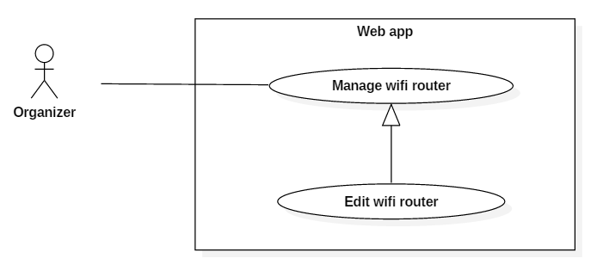

Figure 58 - <Organizer> Edit wifi router UCD

**Use Case Specification**

|  |  |  |  |
| --- | --- | --- | --- |
| **USE CASE – UC_59** | | | |
| **Use Case No.** | 59 | **Use Case Version** | 2.0 |
| **Use Case Name** | Edit wifi router | | |
| **Author** | Nguyễn Hải Phong | | |
| **Date** | 08/11/2016 | **Priority** | Normal |
| **Actor:**   * Organizer   **Summary:**   * This use case allows user edit Route wifi.   **Goal:**   * User edit Route wifi with information.   **Triggers:**   * User send command edit route wifi.   **Preconditions:**   * User must have logged in system as Organizer role.   **Post Conditions:**   * **Success:** New route wifi had been edited. * **Fail:** Show error message   **Main Success Scenario:**   |  |  |  | | --- | --- | --- | | Step | Actor Action | System Response | | 1 | User goes to “Chiến dịch của tôi” page |  | | 2 | User click “Danh sách Router Wifi” page | Show list of Router Wifi and edit button. | | 3 | User click edit button. | Show popup with following information:   * Tên wifi: free text input required. * BSSID: free input with BSSID format. * Cửa hàng: show dropdown list with list of store for chosen. | | 4 | User click “OK” button.  [Alternative 1] | Close popup edit router wifi and show records of router wifi with the new router wifi.  [Exception 1] |   **Alternative:**   |  |  |  | | --- | --- | --- | | Step | Actor action | System Response | | 1 | User click “Cancel” button | Close popup and return to “danh sách router wifi” page. |   **Exceptions:**   |  |  |  | | --- | --- | --- | | No | Cause | System Response | | 1 | Network problem exception. | Show message “Có lỗi xảy ra, vui lòng thử lại sau”. |   **Relationships:**  N/A  **Business Rules:**   * BSSID must input with BSSID format: * Input with only following characters: * 0,1,2,3,4,5,6,7,8,9,a,b,c,d,e,f * Input must have 16 character separate group of two with “:” mark. | | | |

<Organizer> Delete wifi router (UC_60)

**Use Case Diagram**

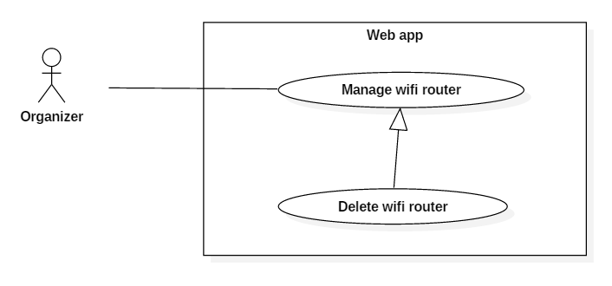

Figure 59 - <Organizer> Delete wifi router UCD

**Use Case Specification**

|  |  |  |  |
| --- | --- | --- | --- |
| **USE CASE – UC_60** | | | |
| **Use Case No.** | 60 | **Use Case Version** | 2.0 |
| **Use Case Name** | Delete wifi router | | |
| **Author** | Nguyễn Hải Phong | | |
| **Date** | 08/11/2016 | **Priority** | Normal |
| **Actor:**   * Organizer.   **Summary:**   * This use case allows user delete wifi.   **Goal:**   * User delete wifi with its information.   **Triggers:**   * User send command delete wifi.   **Preconditions:**   * User must have logged in system as Organizer role.   **Post Conditions:**   * **Success:** Wifi has been deleted. * **Fail:** Show error message   **Main Success Scenario:**   |  |  |  | | --- | --- | --- | | Step | Actor Action | System Response | | 1 | User goes to “chiến dịch của tôi” page. |  | | 2 | User click “Danh sách wifi” button. | Show list of wifi and Delete button. | | 3 | User click Delete button. | Show popup with “Bạn có chắc chắn muốn xóa router này?” message.  [Exception 1] | |  | User click “Có” button.  [Alternative 1] | [Exception 1] |   **Alternative Scenario:**  [Alternative 1]   |  |  |  | | --- | --- | --- | | Step | Actor action | System Response | | 1 | User click “Cancel” button. | Close popup. |   **Exceptions:**  [Exception 1]   |  |  |  | | --- | --- | --- | | No | Cause | System Response | | 1 | Network problem exception. | Show message “Có lỗi xảy ra, vui lòng thử lại sau”. |   **Relationships:**  N/A  **Business Rules:** N/A | | | |

* + 1. Mobile Application Use Cases
       1. Guest Overview Use Cases

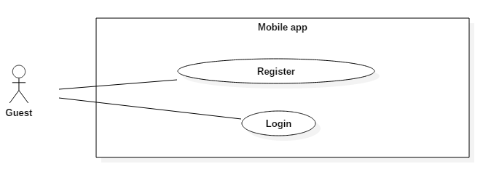

Figure 60 - Guest Overview Use Case

* + - * 1. <Guest> Register (UC_61)

**Use Case Diagram**

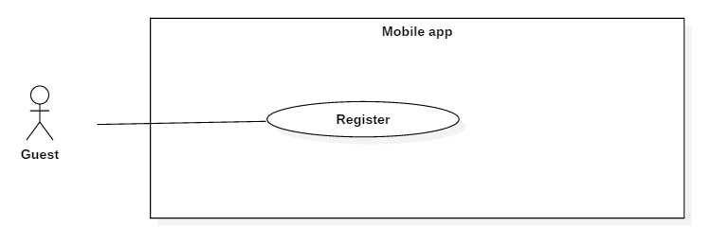

Figure 61 - <Guest> Register UCD

**Use Case Specification**

|  |  |  |  |
| --- | --- | --- | --- |
| **USE CASE – UC_61** | | | |
| **Use case No.** | 61 | **Use** **CaseVersion** | 2.0 |
| **Use Case Name** | Register | | |
| **Author** | Nguyễn Hải Phong | | |
| **Date** | 10/10/2016 | **Priority** | Normal |
| **Actor:**   * Guest.   **Summary:**   * Guests can register one account with the information they want.   **Goal:**   * Guests registers successfully.   **Triggers:**   * Guests tap link “Don’t have account? Sign up now” on Login screen.   **Preconditions:**   * Not login yet.   **Post Conditions:**   * **Success:** Display Home screen. * **Fail:** Show error message.   **Main Success Scenario:**   |  |  |  | | --- | --- | --- | | Step | Actor Action | System Response | | 1 | Guest tap link “ Don’t have account? Sign up now” on Login Screen. | Show a log in forn with following information:   * Full Name: Guest’s full name * Email: Guest’s email * Username: Guest’s username * Password: Guest’s password * Re-enter password: Guest’s password | | 2 | Input value |  | | 3 | Tap “register”  [Alternative 1,2] | [Exception 1,2,3,4,5,6,7,8,9,10] | | 4 |  | Display Home Screen |   **Alternative 1:**   |  |  |  | | --- | --- | --- | | No | Actor action | System Response | | 1 | Tap “Register” button | Display Home Screen | | 2 | Tap “Cancel” button | Display Login Screen |   **Exceptions:**   |  |  |  | | --- | --- | --- | | No | Cause | System Response | | 1 | Guest does not input full name in “full name” field. | Show dialog “Please enter fullname”. | | 2 | Guest does not input email in email’s field. | Show dialog “Please enter email”. | | 3 | Guest does not input Username in Username’s field. | Show dialog “Please enter username”. | | 4 | Guest does not input Password in Password’s field. | Show dialog “Please enter password”. | | 5 | Guest does not input Re-enter password in “re-enter Password” field. | Show dialog “Re-enter password not match”. | | 6 | Guest input incorrect email format in email’s field . | Show dialog “ Email format is not valid”. | | 7 | Guest input re-enter password not the same as password. | Show dialog “ Re-enter password is not match”. | | 8 | Guest input exist email . | Show dialog “ Connection Error! Failed to create new user. Email ‘xxx’ is already taken”. | | 9 | Guest input exist username. | Show dialog “ Connection Error! Failed to create new user. Username ‘xxx’ is already taken”. | | 10 | Guest input password less than 8 characters. | Show dialog “Password must be at least 8 characters” |   **Relationships:**   * N/A   **Business Rules:**   * One email can only register one account. * Username and email must be unique. * Email pattern: **/^ [a-zA-Z0-9.! #$%&'*+\/=? ^_` {|} ~-]+@[a-zA-Z0-9](?:[a-zA-Z0-9-]{0,61}[a-zA-Z0-9])?(?:\.[a-zA-Z0-9](?:[a-zA-Z0-9-]{0,61}[azA-Z0-9])?)*$/** (following *RFC 5322 standard)*. * Username and password will be encrypted on server side using AES encoding. * Username valid: [A-Za-z0-9] and length is 1-20 characters. * Password valid: [A-Za-z0-9] and length is 6-10 characters. | | | |

* + - * 1. <Guest> Login (UC_62)

**Use Case Diagram**

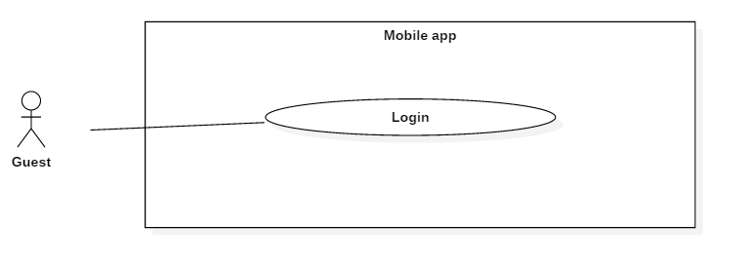

Figure 62 - <Guest> Login UCD

**Use Case Specification**

|  |  |  |  |
| --- | --- | --- | --- |
| **USE CASE – UC_62** | | | |
| **Use Case No.** | 62 | **Use Case Version** | 2.0 |
| **Use Case Name** | Login | | |
| **Author** | Nguyễn Hải Phong | | |
| **Date** | 10/10/2016 | **Priority** | Normal |
| **Actor:**   * Guest   **Summary:**   * Guest login into app.   **Goal:**   * Guest login to the app successfully.   **Triggers:**   * Open the mobile app.   **Preconditions:**   * Not login yet.   **Post Conditions:**   * **Success:** Display home screen. * **Fail:** Show error message.   **Main Success Scenario:**   |  |  |  | | --- | --- | --- | | Step | Actor Action | System Response | | 1 | Guest open the app | Show a log in form with following information:   * Username: username * Password: password. * Link “Don’t have account? Sign up now”. * Login: button. | | 2 | Input value |  | | 3 | Tap “Log in”  [Alternative 1] | Check username and password  [Exception 1, 2]. | | 4 |  | Show home screen. |   **Alternative 1:**   |  |  |  | | --- | --- | --- | | No | Actor action | System Response | | 1 | Customer tap link “Don’t have account? Sign up now” | Display register page. |   **Exceptions:**   |  |  |  | | --- | --- | --- | | No | Cause | System Response | | 1 | Customer does not input username and password | Display “Please input username and password” message. | | 2 | Customer input username does not exist or username exist but password dost not match. | Display “Connection Error! Username or password is not correct”. |   **Relationships**: N/A  **Business Rules:**   * Username and password must not be empty. * Username and password must exist and correct. * Only activated account can login to the system. | | | |

* + - 1. Authorized User Overview Usecases

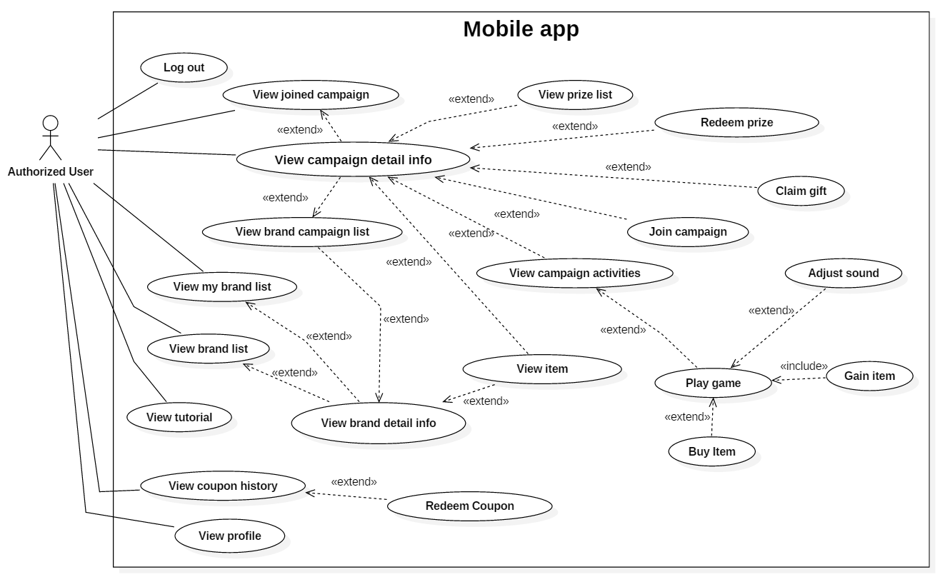

Figure 63 - Authorized user overview use case

* + - * 1. <Authorized User> Logout (UC_63)

**Use Case Diagram**

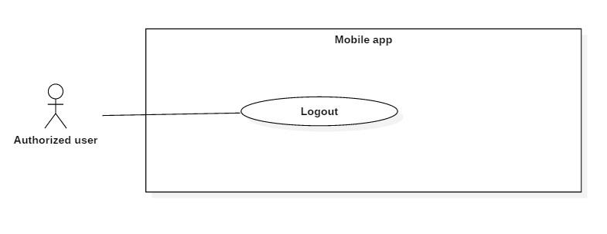

Figure 64 - <Authorized user> Logout UCD

**Use Case Specification**

|  |  |  |  |
| --- | --- | --- | --- |
| **USE CASE – UC_63** | | | |
| **Use Case No.** | 63 | **Use Case Version** | 2.0 |
| **Use Case Name** | Log out | | |
| **Author** | Nguyễn Hải Phong | | |
| **Date** | 10/10/2016 | **Priority** | High |
| **Actor:**   * Authorized user   **Summary:**   * This use case allows authorized user Logout Mobile App.   **Goal:**   * Authorized user log out mobile app successfully.   **Triggers:**   * Authorized user tap “Log out” button in profile’s information.   **Preconditions:**   * User were authorized access to the system.   **Post Conditions:**   * **Success:** Redirected to Login Screen. * **Fail:** Show error message.   **Main Success Scenario:**   |  |  |  | | --- | --- | --- | | Step | Actor Action | System Response | | 1 | Authorized user tap “Log out” button.  Alternative [1] | Redirected to Login Screen |   **Alternative 1:**   |  |  |  | | --- | --- | --- | | No | Actor action | System Response | | 1 | Authorized user tap “Close” button | Close “Menu”. |   **Exceptions**: N/a  **Relationships**: N/a  **Business** **Rules**:   * User were authorized access to the system. | | | |

* + - * 1. <Authorized User> View joined campaign (UC_64)

**Use Case Diagram**

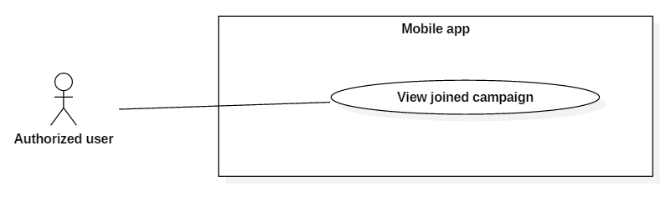

Figure 65 - <Authorized user> View joined campaign UCD

**Use Case Specification**

|  |  |  |  |
| --- | --- | --- | --- |
| **USE CASE – UC_64** | | | |
| **Use Case No.** | 64 | **Use Case Version** | 2.0 |
| **Use Case Name** | View Joined Campaign | | |
| **Author** | Nguyễn Hải Phong | | |
| **Date** | 10/10/2016 | **Priority** | High |
| **Actor:**   * Authorized user   **Summary:**   * This use case allows authorized user view joined campaign.   **Goal:**   * Authorized user can view all of campaigns user has joined.   **Triggers:**   * Authorized user tap Menu button   **Preconditions:**   * User were authorized access to the system.   **Post Conditions:**   * **Success:** Authorized user can view Joined campaigns on “My Campaigns” tab. * **Fail:** Show error message.   **Main Success Scenario:**   |  |  |  | | --- | --- | --- | | Step | Actor Action | System Response | | 1 | Authorized user tap My Campaigns button.  Alternative [1] | System get API return a list of joined campaigns on “My Campaigns” tab. |   **Alternative 1:**   |  |  |  | | --- | --- | --- | | No | Actor action | System Response | | 1 | Authorized user tap on “x” button | Close menu |   **Exceptions:** N/A  **Relationships:** N/A  **Business Rules:** Only show the happening campaigns | | | |

* + - * 1. <Authorized User> View brand list (UC_65)

**Use Case Diagram**

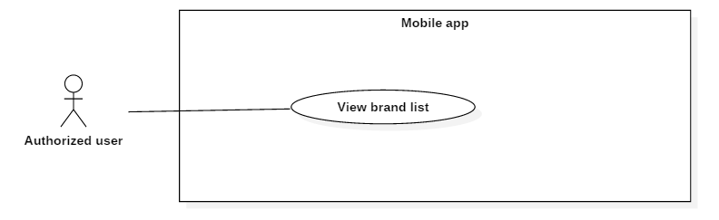

Figure 66 - <Authorized user>View brand list UCD

**Use Case Specification**

|  |  |  |  |
| --- | --- | --- | --- |
| **USE CASE – UC_65** | | | |
| **Use Case No.** | 65 | **Use Case Version** | 2.0 |
| **Use Case Name** | View Brand List | | |
| **Author** | Nguyễn Hải Phong | | |
| **Date** | 10/10/2016 | **Priority** | High |
| **Actor:**   * Authorized user   **Summary:**   * This use case allows authorized user view Brand list.   **Goal:**   * Authorized user view brand list successfully.   **Triggers:**   * Authorized user login into the app.   **Preconditions:**   * User were authorized access to the system.   **Post Conditions:**   * **Success:** Authorized user view a list of brand. * **Fail:** Show error message.   **Main Success Scenario:**   |  |  |  | | --- | --- | --- | | Step | Actor Action | System Response | | 1 | User were authorized access to the system. | System return a list of brand. |   **Alternative**: N/A  **Exceptions**: N/A  **Business** **Rules**: Only show active brands. | | | |

* + - * 1. <Authorized User> View my brand list (UC_66)

**Use Case Diagram**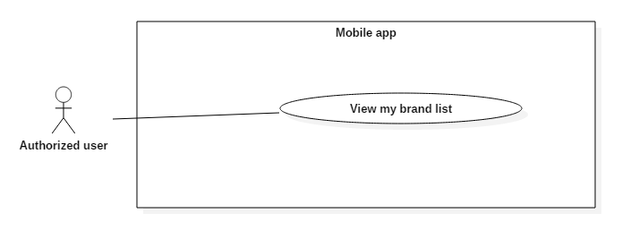

Figure 67 - <Authorized user> View my brand list UCD

**Use Case Specification**

|  |  |  |  |
| --- | --- | --- | --- |
| **USE CASE – UC_66** | | | |
| **Use Case No.** | 66 | **Use Case Version** | 2.0 |
| **Use Case Name** | View My Brand List | | |
| **Author** | Hồ Minh Quân | | |
| **Date** | 02/11/2016 | **Priority** | Normal |
| **Actor:**   * Authorized User   **Summary:**   * This use case allows actor can view the list of the brand that the actor has joined before.   **Goal:**   * To know what brands that the actor has joined before and what activities that these brands have.   **Triggers:**   * Actor taps the “My Brands” tab.   **Preconditions:**   * User must login into the system successfully.   **Post Conditions:**   * **Success:** The list of the brand is showed and able to be interacted. * **Fail:** Error message is displayed.   **Main Success Scenario:**   |  |  |  | | --- | --- | --- | | Step | Actor Action | System Response | | 1 | Tap the “My Brands” tab. | Show the list of the brands that the actor has joined before. |   **Alternative:**   * N/A   **Exceptions:**   * N/A   **Relationships:**   * Extend to “View Brand Detail Info” use case.   **Business Rules:**   * There is no duplicated brand in the list. * Each brand in list must have these fields: * Avatar of brand. * Name of brand. * Category of brand. * Store amount of brand. * The activity icons in each brand are respective to the activities that the brand has at the current time and the number of activity icons does not exceed 3. | | | |

* + - * 1. <Authorized User> Join campaign (UC_67)

**Use Case Diagram**

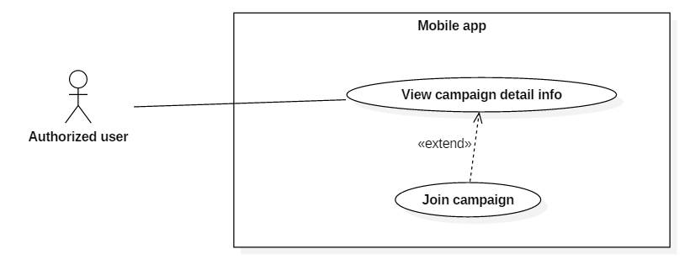

Figure 68 - <Authorized user> Join campaign UCD

**Use Case Specification**

|  |  |  |  |
| --- | --- | --- | --- |
| **USE CASE – UC_67** | | | |
| **Use Case No.** | 67 | **Use Case Version** | 2.0 |
| **Use Case Name** | Join Campaign | | |
| **Author** | Nguyễn Hải Phong | | |
| **Date** | 10/10/2016 | **Priority** | Normal |
| **Actor:**   * Authorized user   **Summary:**   * This use case allows authorized user Join Campaign.   **Goal:**   * Authorized user join campaign successfully.   **Triggers:**   * Authorized user tap campaign show up on Campaigns Tab.   **Preconditions:**   * User were authorized access to the system.   **Post Conditions:**   * **Success:** * Success Join Campaign. * Redirected to “Campaign Details” screen. * **Fail:** Unsuccessful message will be shown.   **Main Success Scenario:**   |  |  |  | | --- | --- | --- | | Step | Actor Action | System Response | | 1 | Authorized user tap on campaigns | Show screen that relate with the campaign Authorized user navigate.  Exception [1] | | 2 | Authorized user tap on [Tham Gia] button  Alternative [1,2] | System get API and redirected to Campaign Details Screen. |   **Alternative 1:**   |  |  |  | | --- | --- | --- | | No | Actor action | System Response | | 1 | Authorized user tap on [<] button | Redirected to Campaign’s list screen. | | 2 | Authorized user tap on [refresh] button | Refresh screen. |   **Exceptions**:   |  |  |  | | --- | --- | --- | | No | Cause | System Response | | 1 | no internet connection | Show “No Internet connection” Message |   **Relationships:** get extend from “View Campaign Details info” Use Case  **Business Rules:**   * Authorized user must have log in as role “Authorized user” * Authorized user must have at least 10 coins to join an campaigns * Authorized user gain [10*xxx] coins. “xxx” base on how multi that brands set on that campaign. | | | |

* + - * 1. <Authorized User> View tutorial (UC_68)

**Use Case Diagram**

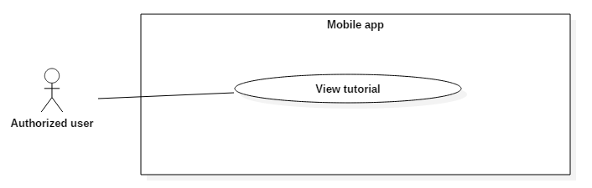

Figure 69 - <Authorized user> View tutorial UCD

**Use Case Specification**

|  |  |  |  |
| --- | --- | --- | --- |
| **USE CASE – UC_68** | | | |
| **Use Case No.** | 68 | **Use Case Version** | 2.0 |
| **Use Case Name** | View Tutorial | | |
| **Author** | Hồ Minh Quân | | |
| **Date** | 02/11/2016 | **Priority** | Normal |
| **Actor:**   * Authorized User   **Summary:**   * This use case allows actor can view the tutorial that shows how to play game.   **Goal:**   * To give instruction how to play game to the actor.   **Triggers:**   * Actor taps the “Help” button from the “SideMenu”.   **Preconditions:**   * User must login into the system successfully.   **Post Conditions:**   * **Success:** The “TurorialScene” is showed. * **Fail:** Error message is displayed.   **Main Success Scenario:**   |  |  |  | | --- | --- | --- | | Step | Actor Action | System Response | | 1 | Tap the “Help” button. | Switch to the “Tutorial Scene”. |   **Alternative:**   * N/A   **Exceptions:**   * N/A   **Relationships:**   * N/A   **Business Rules:**   * N/A | | | |

* + - * 1. <Authorized User> Buy item (UC_69)

**Use Case Diagram**

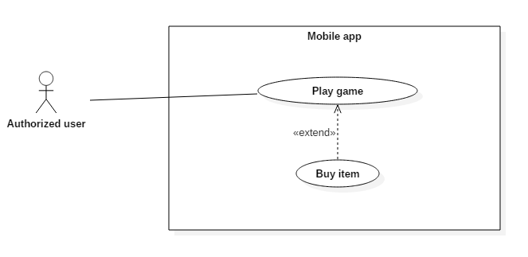

Figure 70 - <Authorized user> Buy item UCD

**Use Case Specification**

|  |  |  |  |
| --- | --- | --- | --- |
| **USE CASE – UC_09** | | | |
| **Use Case No.** | 09 | **Use Case Version** | 2.0 |
| **Use Case Name** | Buy Item | | |
| **Author** | Hồ Minh Quân | | |
| **Date** | 02/11/2016 | **Priority** | High |
| **Actor:**   * Authorized User   **Summary:**   * This use case allows actor can buy item in when playing game.   **Goal:**   * To increase the amount of item in order to kill the dragon.   **Triggers:**   * Actor taps the item icon in shop.   **Preconditions:**   * User must login into the system successfully.   **Post Conditions:**   * **Success:** The item which is bought will have its amount increased and the coin amount will be decreased respectively to the bought item. * **Fail:** Error message is displayed.   **Main Success Scenario:**   |  |  |  | | --- | --- | --- | | Step | Actor Action | System Response | | 1 | Tap the “Shop” button from the “Menu” button. | Show the shop. | | 2 | [Alternative 1] |  | | 3 | Tap the item icon. | [Exception 1]  Show the “Buy now” confirm dialog. | | 4 | [Alternative 2] |  | | 5 | Tap the “Buy now” button. | [Exception 2]  The item amount will be increased and the coin amount will be decreased respectively to the bought item. |   **Alternative:**   |  |  |  | | --- | --- | --- | | No | Actor Action | System Response | | 1 | Tap the “X” (close) button in shop. | Close the shop. | | 2 | Tap the “X” (close) button in “Buy now” confirm dialog. | Close the “Buy now” confirm dialog. |   **Exceptions:**   |  |  |  | | --- | --- | --- | | No | Cause | System Response | | 1 | Coin is not enough. | Show the “Not enough coin” message dialog. | | 2 | Cannot connect to server. | Show server error message. |   **Relationships:**   * Extend with “Play Game” use case.   **Business Rules:**   * Each item in shop must have these fields: * Avatar of item. * Amount of item. * Name of item. * Saving percent (if it is pack item) * Coin required of item. * Each item in shop must be interactive. * Cannot interact with anything except the dialog that is being showed. | | | |

* + - * 1. <Authorized User> View profile (UC_70)

**Use Case Diagram**

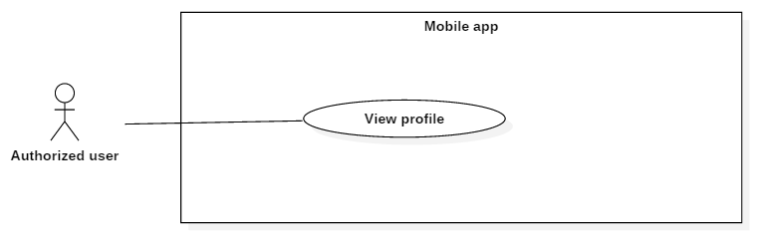

Figure 71 - <Authorized user> View profile UCD

**Use Case Specification**

|  |  |  |  |
| --- | --- | --- | --- |
| **USE CASE – UC_70** | | | |
| **Use Case No.** | 70 | **Use Case Version** | 2.0 |
| **Use Case Name** | View Profile | | |
| **Author** | Nguyễn Hải Phong | | |
| **Date** | 10/10/2016 | **Priority** | High |
| **Actor:**   * Authorized user.   **Summary:**   * This use case allows authorized user view their profile   **Goal:**   * Authorized user view profile successfully.   **Triggers:**   * Authorized user tap menu then tap “profile” button.   **Preconditions:**   * User were authorized access to the system.   **Post Conditions:**   * **Success:** Authorized user view their own information. * **Fail:** show error message.   **Main Success Scenario:**   |  |  |  | | --- | --- | --- | | Step | Actor Action | System Response | | 1 | Authorized user tap menu | Show sub-screen with Profile button include. | | 2 | Authorized user tap profile button  Alternative [] | System return Screen with Authorized user information:  -Name  -Email  -Number  -Coins  -Brands (brand Authorized user joined)  -Campaigns (Campaign Authorized user joined) | | 3 | Alternative [1,2,3] |  |   **Alternative**:   |  |  |  | | --- | --- | --- | | No | Actor action | System Response | | 1 | Authorized user tap “x” button | Close menu | | 2 | Authorized user tap “menu” button | Show menu | | 3 | Authorized user tap “ refresh” button | Refresh profile |   **Exceptions:** N/A  **Relationships:** N/A  **Business** **Rules**: | | | |

* + - * 1. <Authorized User> View coupon history (UC_71)

**Use Case Diagram**

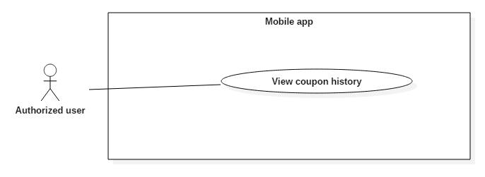

Figure 72 - <Authorized user> View coupon history UCD

**Use Case Specification**

|  |  |  |  |
| --- | --- | --- | --- |
| **USE CASE – UC_71** | | | |
| **Use Case No.** | 71 | **Use Case Version** | 2.0 |
| **Use Case Name** | View Coupon History | | |
| **Author** | Hồ Minh Quân | | |
| **Date** | 02/11/2016 | **Priority** | Normal |
| **Actor:**   * Authorized User   **Summary:**   * This use case allows actor can view the list of coupon that the actor has redeemed before.   **Goal:**   * To know what coupons that the actor has redeemed before.   **Triggers:**   * Actor taps the “Coupons” button from the “SideMenu”.   **Preconditions:**   * User must login into the system successfully.   **Post Conditions:**   * **Success:** The list of redeemed coupon in “CouponScene” is showed. * **Fail:** Error message is displayed.   **Main Success Scenario:**   |  |  |  | | --- | --- | --- | | Step | Actor Action | System Response | | 1 | Tap the “Coupons” button. | Switch to the “CouponScene”.  [Exception 1]  Show the list of redeemed coupon. |   **Exceptions:**   |  |  |  | | --- | --- | --- | | No | Cause | System Response | | 1 | Cannot connect to server. | Show server error message. |   **Relationships:**   * Extend to “Redeem Coupon” use case.   **Business Rules:**   * Each record of the list must have these fields: * Avatar of brand where the coupon was redeemed. * Redeemed time. * Message shows how many coin that the “Authorized User” get from the redeemed coupon. * The code that has been generated from the redeemed coupon. | | | |

* + - * 1. <Authorized User> Redeem coupon (UC_72)

**Use Case Diagram**

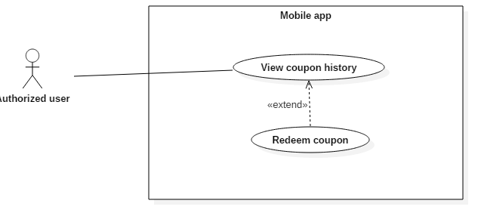

Figure 73 - <Authorized user> Redeem coupon UCD

**Use Case Specification**

|  |  |  |  |
| --- | --- | --- | --- |
| **USE CASE – UC_72** | | | |
| **Use Case No.** | 72 | **Use Case Version** | 2.0 |
| **Use Case Name** | Redeem Coupon | | |
| **Author** | Hồ Minh Quân | | |
| **Date** | 02/11/2016 | **Priority** | High |
| **Actor:**   * Authorized User   **Summary:**   * This use case allows actor can gain the coin by entering the generated.   **Goal:**   * To increase the coin amount.   **Triggers:**   * Actor taps the “+” (add) button from the “CouponScene”.   **Preconditions:**   * User must login into the system successfully.   **Post Conditions:**   * **Success:** New record is added to the list of redeemed coupon, and the coin amount is increased. * **Fail:** Error message is displayed.   **Main Success Scenario:**   |  |  |  | | --- | --- | --- | | Step | Actor Action | System Response | | 1 | Tap the “+” (add) button. | Show the “Please enter code” dialog. | | 2 | Enter generated code.  [Alternative 1] |  | | 3 | Tap “OK” button.  [Alternative 1] | Send to verify.  [Exception 1]  [Exception 2]  [Exception 3]  [Exception 4]  Add new record to database.  Increase the coin amount.  Refresh the list of redeemed coupon.  Show success message. |   **Alternative:**   |  |  |  | | --- | --- | --- | | No | Actor Action | System Response | | 1 | Tap the “Cancel” button. | Show the “Please enter code” dialog. |   **Exception:**   |  |  |  | | --- | --- | --- | | No | Cause | System Response | | 1 | Actor have not entered generated code yet. | Show the “Please enter code” message. | | 2 | The generated code is not correct. | Show the “Code is not correct, please try again” message. | | 3 | The generated code is out of date. | Show the “Code is out of date, please try another one” message. | | 4 | Cannot connect to server. | Show server error message. |   **Relationships:**   * Extend with “View Coupon History” use case.   **Business Rules:**   * The newly added record will be the first record of the list. * Cannot interact with anything except the dialog that is being showed. | | | |

* + - * 1. <Authorized User> View brand detail information (UC_73)

**Use Case Diagram**

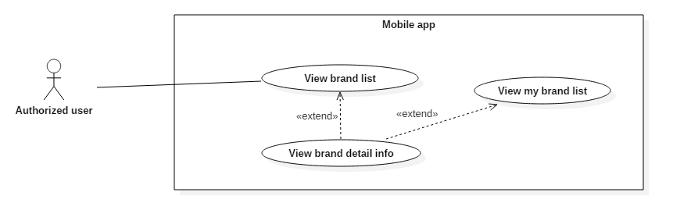

Figure 74 - <Authorized user> View brand detail information UCD

**Use Case Specification**

|  |  |  |  |
| --- | --- | --- | --- |
| **USE CASE – UC_73** | | | |
| **Use Case No.** | 73 | **Use Case Version** | 2.0 |
| **Use Case Name** | View brand detail information | | |
| **Author** | Phùng Văn Bửu | | |
| **Date** | 02/11/2016 | **Priority** | Normal |
| **Actor:**   * Authorized User   **Summary:**   * This use case allows Authorized User to browse detail information of a specific brand.   **Goal:**   * Authorized User view brand’s detail information.   **Triggers:**   * Authorized User select on an item in all brands list or my brands list.   **Preconditions:**   * User were authorized access to the system.   **Postconditions:**   * Success: system shows detail information of the brand to Authorized User. * Fail: system show error message.   **Main Success Scenario:**   |  |  |  | | --- | --- | --- | | **Step** | **Actor Action** | **System Response** | | 1 | Authorized User navigates to Home Screen |  | | 2 | Authorized User taps a brand. | Brand Detail Screen appears with information of selected brand. [Exception 1]  [Exception 2] | | 3 | Authorized User selects [Information] tab | Selected brand’s information appears. [Exception 3] |   Exception :   | **No** | **Step** | **System Response** | | --- | --- | --- | | 1 | Database occurs exception. | Display error message. | | 2 | Internet disconnected. | Display connection error message. | | 3 | Empty data. | Display empty campaign message |   **Relationships:**  extend View my brand list use case and View brand list use case  Business Rules:   * Brand’s information include their brand name, logo, description | | | |

* + - * 1. <Authorized User> View brand campaign list (UC_74)

**Use Case Diagram**

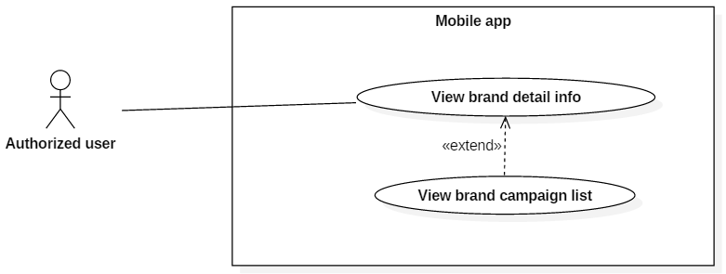

Figure 75 - <Authorized user> View brand campaign list UCD

**Use Case Specification**

|  |  |  |  |
| --- | --- | --- | --- |
| **USE CASE – UC_74** | | | |
| **Use Case No.** | 74 | **Use Case Version** | 2.0 |
| **Use Case Name** | View brand campaign list | | |
| **Author** | Phùng Văn Bửu | | |
| **Date** | 02/11/2016 | **Priority** | Normal |
| **Actor:**   * Authorized User   **Summary:**   * This use case allows Authorized User to browse all available campaigns of a specific brand.   **Goal:**   * Authorized User view brand’s campaign.   **Triggers:**   * Authorized User select on an item in all brands list or my brands list.   **Preconditions:**   * User were authorized access to the system.   **Postconditions:**   * Success: system shows available campaigns of the brand to Authorized User. * Fail: system show error message.   **Main Success Scenario:**   |  |  |  | | --- | --- | --- | | **Step** | **Actor Action** | **System Response** | | 1 | Authorized User navigates to Home Screen |  | | 2 | Authorized User taps a brand. | Brand Detail Screen appears with information of selected brand. [Exception 1]  [Exception 2] | | 3 | Authorized User selects [Campaign] tab | Selected brand’s available campaigns appear. [Exception 3] |   Exception :   | **No** | **Step** | **System Response** | | --- | --- | --- | | 1 | Database occurs exception. | Display error message. | | 2 | Internet disconnected. | Display connection error message. | | 3 | Empty data. | Display empty campaign message |   **Relationships:**  extend View my brand list use case and View brand list use case  Business Rules:   * Available campaigns include upcoming and in-progress campaigns. | | | |

* + - * 1. <Authorized User> View campaign detail information (UC_75)

**Use Case Diagram**

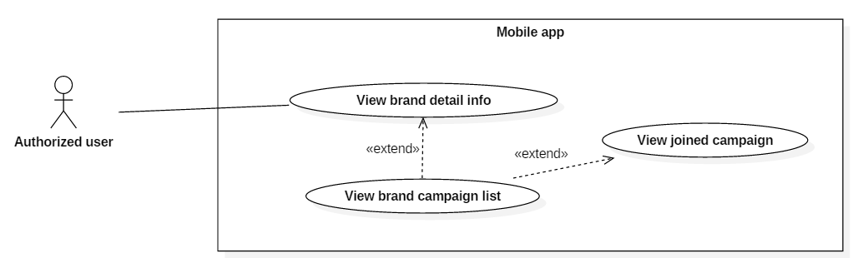

Figure 76 - <Authorized user> View campaign detail information UCD

**Use Case Specification**

|  |  |  |  |
| --- | --- | --- | --- |
| **USE CASE – UC_75** | | | |
| **Use Case No.** | 75 | **Use Case Version** | 2.0 |
| **Use Case Name** | View campaign detail information | | |
| **Author** | Phùng Văn Bửu | | |
| **Date** | 02/11/2016 | **Priority** | Normal |
| **Actor:**   * Authorized User   **Summary:**   * This use case allows Authorized User to browse campaign detail information.   **Goal:**   * Authorized User view campaign’s detail information.   **Triggers:**   * Authorized User select on an item in the campaign list.   **Preconditions:**   * User were authorized access to the system.   **Postconditions:**   * Success: system shows detail information of selected campaign to Authorized User. * Fail: system show error message.   **Main Success Scenario:**   |  |  |  | | --- | --- | --- | | **Step** | **Actor Action** | **System Response** | | 1 | Authorized User navigates to Campaign Detail Screen |  | | 2 | Authorized User selects [Information] tab | Campaign Name, Campaign Multiplier, Campaign start date and end date and all its available store are displayed. [Exception 1]  [Exception 2] |   Exception :   | **No** | **Step** | **System Response** | | --- | --- | --- | | 1 | Database occurs exception. | Display error message. |   **Relationships:**  extend View brand campaign list use case and View my campaign list use case  Business Rules:   * Default multiplier (if not defined) is 1. * Start date and end date include time and in 24-hour format * Available stores are stores in which the campaign occurs | | | |

* + - * 1. <Authorized User> View prize list (UC_76)

**Use Case Diagram**

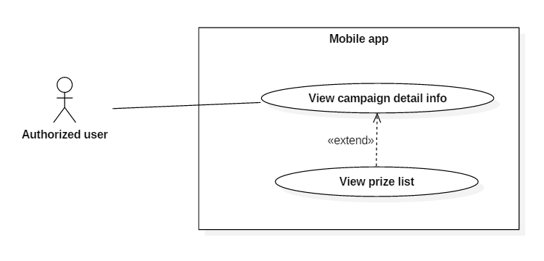

Figure 77 - <Authorized user> View prize list UCD

**Use Case Specification**

|  |  |  |  |
| --- | --- | --- | --- |
| **USE CASE – UC_76** | | | |
| **Use Case No.** | 76 | **Use Case Version** | 2.0 |
| **Use Case Name** | View prize list | | |
| **Author** | Phùng Văn Bửu | | |
| **Date** | 02/11/2016 | **Priority** | Normal |
| **Actor:**   * Authorized user   **Summary:**   * This use case allows Authorized User to browse prizes of an campaign.   **Goal:**   * Authorized User view campaign’s prizes.   **Triggers:**   * Authorized User taps [Prize] tab in Campaign Detail Screen.   **Preconditions:**   * User were authorized access to the system.   **Postconditions:**   * Success: system shows detail information of selected campaign to Authorized User. * Fail: system show error message.   **Main Success Scenario:**   |  |  |  | | --- | --- | --- | | **Step** | **Actor Action** | **System Response** | | 1 | Authorized User navigates to Campaign Detail Screen |  | | 2 | Authorized User selects [Prize] tab | A list of available prize is displayed. [Exception 1]  [Exception 2] |   Exception :   | **No** | **Step** | **System Response** | | --- | --- | --- | | 1 | Database occurs exception. | Display error message. | | 2 | Empty data | Display empty prize message |   **Relationships:**  extend View brand campaign list use case and View my campaign list use case  Business Rules:   * Prizes are displayed in ascending Teek or Gems order. | | | |

* + - * 1. <Authorized User> Redeem prize (UC_77)

**Use Case Diagram**

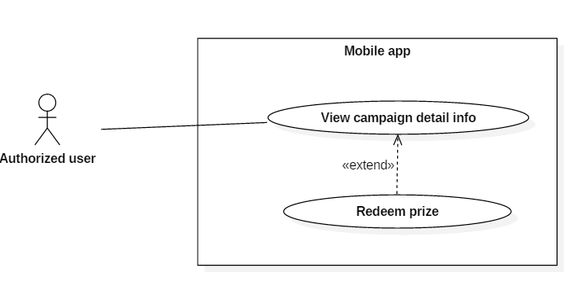

Figure 78 - <Authorized user> Redeem prize UCD

**Use Case Specification**

|  |  |  |  |
| --- | --- | --- | --- |
| **USE CASE – UC_77** | | | |
| **Use Case No.** | 77 | **Use Case Version** | 2.0 |
| **Use Case Name** | Redeem prize | | |
| **Author** | Phùng Văn Bửu | | |
| **Date** | 03/11/2016 | **Priority** | Normal |
| **Actor:**   * Authorized User   **Summary:**   * This use case allows Authorized User to use their Teek or Gems to redeem prize.   **Goal:**   * Authorized User redeems a prize.   **Triggers:**   * Authorized User select on an item in the prize list.   **Preconditions:**   * User were authorized access to the system.   **Postconditions:**   * Success: system shows successful message to Authorized User. * Fail: system show error message.   **Main Success Scenario:**   |  |  |  | | --- | --- | --- | | **Step** | **Actor Action** | **System Response** | | 1 | Authorized User navigates to Campaign Detail Screen |  | | 2 | Authorized User selects [Prize] tab | A list of available prize is displayed. [Exception 1]  [Exception 2] | | 3 | Authorized User taps on a prize | A dialog with detail prize information is shown to Authorized User. | | 4 | Authorized User taps on [Redeem with Teek] button  [Alternative 1] | A confirm dialog box is displayed with message: “Are you sure?”. | | 5 | Authorized User choose [Yes]  [Alternative 2] | A successful message is displayed to Authorized User.  [Exception 3] |   Alternative 1:   | **No** | **Step** | **System Response** | | --- | --- | --- | | 1 | Authorized User taps on [Redeem with Gems] button | A confirm dialog box is displayed with message: “Are you sure?”. | | 2 | Authorized User choose [Yes]  [Alternative 2] | A successful dialog box is displayed.  [Exception 4] |   Alternative 2:   | **No** | **Step** | **System Response** | | --- | --- | --- | | 1 | Authorized User choose [No] | The confirm dialog is closed. |   Exception :   | **No** | **Step** | **System Response** | | --- | --- | --- | | 1 | Database occurs exception. | Display error message. | | 2 | Empty data | Display empty prize message | | 3 | Insufficient Teek | Display error message “Not enough Teek”. | | 4 | Insufficient Gems | Display error message “Not enough Gems”. |   **Relationships:**  extend View prize list use case  Business Rules:   * Prize can be redeem by Gems or Teek if available. * Redeemed prize cannot be refund. | | | |

* + - * 1. <Authorized User> Claim gift (UC_78)

**Use Case Diagram**

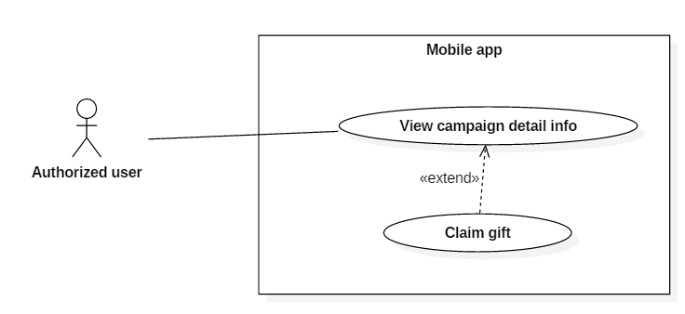

Figure 79 - <Authorized user> Claim gift UCD

**Use Case Specification**

|  |  |  |  |
| --- | --- | --- | --- |
| **USE CASE – UC_78** | | | |
| **Use Case No.** | 78 | **Use Case Version** | 2.0 |
| **Use Case Name** | Claim gift | | |
| **Author** | Lê Khải Thông | | |
| **Date** | 02/11/2016 | **Priority** | Normal |
| **Actor:**   * Authorized user   **Summary:**   * This use case allows authorized user to exchange in-game gift into real-life gift. * The gift is different according to each campaign and is exchanged at the brand’s store   **Goal:**   * Exchange in-game gift into real-life gift   **Triggers:**   * Authorized user select the gift they want to claim.   **Preconditions:**   * Authorized user login successfully * Authorized user already redeem at least 1 prize in the campaign they have joined and that gift is not claimed yet. * Authorized user or brand’s staff must have master code. * Authorized user is at one of brand’s store   **Post Conditions:**   * **Success:**    + Successful message is displayed.   + Claim date is update to storage. * **Fail:** Error message is displayed.   **Main Success Scenario:**   |  |  |  | | --- | --- | --- | | Step | Actor Action | System Response | | 1 | Authorized user taps the campaign to view campaign detail information | Show selected campaign detail information  [Exception 1] | | 2 | Authorized user taps “Gift” button | Show redeemed gift list of Authorized user in that campaign  [Exception 2] | | 3 | Authorized user taps the gift they want to exchange  [Alternative 1]  [Alternative 2] | Show dialog with following components:   * Message: “Please input master code” * Master code: blank text input, required, length [0-100] * Cancel: button * OK: button | | 4 | Authorized user input master code provided by brand or ask brand’s staff to input master code |  | | 5 | Authorized user or staff taps “OK” button  [Alternative 3] | Send API to server to check gift’s status  [Exception 3]  [Exception 4]  [Exception 5] | | 6 |  | Show success dialog with following information:   * Success message contains gift’s name and brand name * Auto-close time: count down the time the dialog will be automatically closed. * OK: button | | 7 | Authorized user show success dialog to brand’s staff |  | | 8 | Authorized user taps “OK” button  [Alternative 4] | Close message dialog and reload the gift list  [Exception 1] |   **Alternative 1:**   |  |  |  | | --- | --- | --- | | No | Actor action | System Response | | 1 | Authorized user taps “Close” button | Close gift list dialog |   **Alternative 2:**   |  |  |  | | --- | --- | --- | | No | Actor action | System Response | | 1 | Authorized user taps the gift they already exchanged before | Do nothing |   **Alternative 3:**   |  |  |  | | --- | --- | --- | | No | Actor action | System Response | | 1 | Authorized user taps “Cancel” button | Close input master code dialog |   **Alternative 4:**   |  |  |  | | --- | --- | --- | | No | Actor action | System Response | | 1 | Authorized user does not taps “OK” button. Auto-close time is timeout | Close message dialog and reload the gift list  [Exception 1] |   **Exceptions:**   |  |  |  | | --- | --- | --- | | No | Cause | System Response | | 1 | Cannot get campaign detail information | Show error message | | 2 | Cannot get gift list from server | Show server error message | | 3 | Authorized user or staff does not input master code | Show message “Please input master code” | | 4 | Master code is not correct | Show message “Master code is incorrect” | | 5 | Cannot update gift’s information on server | Show server error message |   **Relationships:**  Extend from View campaign detail info use case.  **Business Rules:**   * Authorized user can only claim the unclaimed gift * Authorized user can only claim the gift they have redeemed in that campaign * Master code must correct with master code the brand has set for that campaign * After claim gift successfully system must update claim time and status of gift in storage * Auto-close time for success dialog is 5 minutes | | | |

* + - * 1. <Authorized User> View item (UC_79)

**Use Case Diagram**

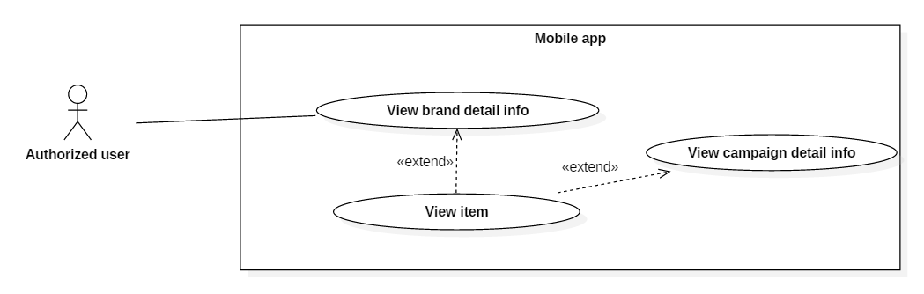

Figure 80 - <Authorized user> View item UCD

**Use Case Specification**

|  |  |  |  |
| --- | --- | --- | --- |
| **USE CASE – UC_79** | | | |
| **Use Case No.** | 79 | **Use Case Version** | 2.0 |
| **Use Case Name** | View item | | |
| **Author** | Lê Khải Thông | | |
| **Date** | 02/11/2016 | **Priority** | Normal |
| **Actor:**   * Authorized user   **Summary:**   * This use case allows authorized user to view the amount item they are having * The item is different according to campaigns belong to what brand   **Goal:**   * View the amount of item they are having   **Triggers:**   * Authorized user taps “Info” tab in Brand detail information screen or Authorized user view campaign detail information.   **Preconditions:**   * Authorized user login successfully   **Post Conditions:**   * **Success:** Item amount is displayed * **Fail:** Error message is displayed.   **Main Success Scenario:**   |  |  |  | | --- | --- | --- | | Step | Actor Action | System Response | | 1 | Authorized user taps the brand to view brand detail information  [Alternative 1] | Show brand detail information  [Exception 1] | | 2 | Authorized user taps “Info” tab | Show item amount of Authorized user in that brand with the following information:   * Teek: number of teek of Authorized user * Ruby: number of ruby of Authorized user * Sapphire: number of sapphire of Authorized user * Citrine: number of citrine of Authorized user   [Exception 2] |   **Alternative 1:**   |  |  |  | | --- | --- | --- | | No | Actor action | System Response | | 1 | Authorized user taps “Campaign” tab | Show campaign list of that brand  [Exception 3]  [Exception 4] | | 2 | Authorized user taps the campaign they want to view detail information | Show campaign detail information contains the item amount of Authorized user in that brand with the following information:   * Teek: number of teek of Authorized user * Ruby: number of ruby of Authorized user * Sapphire: number of sapphire of Authorized user * Citrine: number of citrine of Authorized user   [Exception 2] |   **Exceptions:**   |  |  |  | | --- | --- | --- | | No | Cause | System Response | | 1 | Cannot get brand detail information | Show error message | | 2 | Cannot get item information | Show item value as default value | | 3 | Brand has no available campaign at view time | Show no available campaign message | | 4 | Cannot get brand campaign list | Show error message |   **Relationships:**  Extend from View brand detail info use case and View campaign detail info use case.  **Business Rules:**   * Default values for Authorized user item if app cannot get item values from server are   + Teek: 0   + Ruby: 0   + Sapphire: 0   + Citrine: 0 * Only show the campaigns that already Approved by admin * Only show the activities that already published | | | |

* + - * 1. <Authorized User> View campaign activities (UC_80)

**Use Case Diagram**

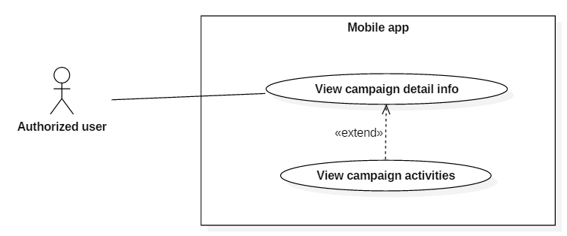

Figure 81 - <Authorized user> View campaign activities UCD

**Use Case Specification**

|  |  |  |  |
| --- | --- | --- | --- |
| **USE CASE – UC_80** | | | |
| **Use Case No.** | 80 | **Use Case Version** | 2.0 |
| **Use Case Name** | View campaign activities | | |
| **Author** | Lê Khải Thông | | |
| **Date** | 02/11/2016 | **Priority** | Normal |
| **Actor:**   * Authorized user   **Summary:**   * This use case allows Authorized user to view the activities they can do to gain point or item * The activities is different according to campaign. The activities is set by brand   **Goal:**   * View the activities they can do to gain point or item   **Triggers:**   * Authorized user go into campaign detail information screen   **Preconditions:**   * Authorized user login successfully   **Post Conditions:**   * **Success:** Campaign’s activities is displayed * **Fail:** Error message is displayed.   **Main Success Scenario:**   |  |  |  | | --- | --- | --- | | Step | Actor Action | System Response | | 1 | Authorized user taps the brand to view brand detail information  [Alternative 1] | Show brand detail information with list of campaign  [Exception 1]  [Exception 2] | | 2 | Authorized user taps campaign they want to view detail information | Show campaign information with activities of that campaign  [Exception 3]  [Exception 4] |   **Alternative 1:**   |  |  |  | | --- | --- | --- | | No | Actor action | System Response | | 1 | Authorized user taps “My campaigns” in menu | Show list of joined campaign  [Exception 5]  [Exception 6] | | 2 | Authorized user taps campaign they want to view detail information | Show campaign information with activities of that campaign  [Exception 3]  [Exception 4] |   **Exceptions:**   |  |  |  | | --- | --- | --- | | No | Cause | System Response | | 1 | Cannot get brand detail information | Show error message | | 2 | Brand has no available campaign | Show no available campaign message | | 3 | Campaign has no activities | Show nothing on “Activities” tab | | 4 | Cannot get campaign activities list | Show error message | | 5 | Cannot get list of campaigns that Authorized user is joined | Show error message | | 6 | Authorized user has not joined any campaign yet | Show no available campaign message |   **Relationships:**  Extend from View campaign detail info use case.  **Business Rules:**   * Only show the campaigns that already Approved by admin * Only show the activities that already published | | | |

* + - * 1. <Authorized User> Play game (UC_81)

**Use Case Diagram**

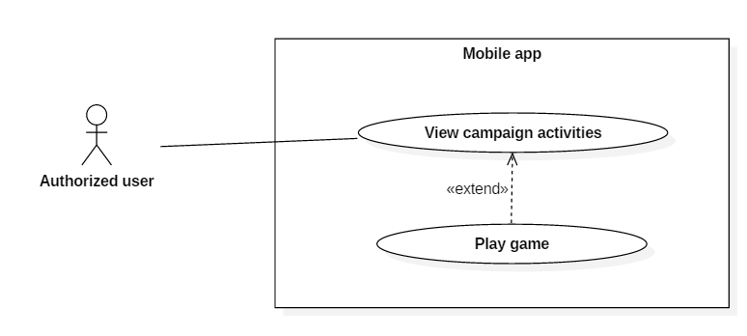

Figure 82 - <Authorized user> Play game UCD

**Use Case Specification**

|  |  |  |  |
| --- | --- | --- | --- |
| **USE CASE – UC_81** | | | |
| **Use Case No.** | 81 | **Use Case Version** | 2.0 |
| **Use Case Name** | Play game | | |
| **Author** | Lê Khải Thông | | |
| **Date** | 02/11/2016 | **Priority** | Normal |
| **Actor:**   * Authorized user   **Summary:**   * This use case allows Authorized user to enjoy the game and gain item * The item gained in game will be used to redeem prize.   **Goal:**   * Play the game   **Triggers:**   * Authorized user go into game screen   **Preconditions:**   * Authorized user login successfully * Campaign contains available game activity * Authorized user is already joined the campaign * Authorized use must connect to internet through a available wifi router of store that runs the campaign.   **Post Conditions:**   * **Success:**   + Authorized user play game, gain item   + Gained item update into storage * **Fail:** Error message is displayed.   **Main Success Scenario:**   |  |  |  | | --- | --- | --- | | Step | Actor Action | System Response | | 1 | Authorized user taps the brand to view brand detail information  [Alternative 1] | Show brand detail information with list of campaign  [Exception 1]  [Exception 2] | | 2 | Authorized user taps campaign they want to view detail information | Show campaign information with activities of that campaign  [Exception 3]  [Exception 4]  [Exception 5] | | 3 | Authorized user taps “Play game” in list of activities | Show game screen, open phone camera  [Exception 6] | | 4 | Authorized user play game, kill the dragon and gain item  [Alternative 2] | Update gained item value and used item value into storage  [Exception 7] |   **Alternative 1:**   |  |  |  | | --- | --- | --- | | No | Actor action | System Response | | 1 | Authorized user taps “My campaigns” in menu | Show list of joined campaign  [Exception 8]  [Exception 9] | | 2 | Authorized user taps campaign they want to view detail information | Show campaign information with activities of that campaign  [Exception 3]  [Exception 4] |   **Alternative 2:**   |  |  |  | | --- | --- | --- | | No | Actor action | System Response | | 1 | Authorized user does not kill the dragon, new dragon will respawn according to business rule | Spawn new dragon with full health |   **Exceptions:**   |  |  |  | | --- | --- | --- | | No | Cause | System Response | | 1 | Cannot get brand detail information | Show error message | | 2 | Brand has no available campaign | Show no available campaign message | | 3 | Campaign has no activities | Show nothing on “Activities” tab | | 4 | Cannot get campaign activities list | Show error message | | 5 | Authorized user had not join the campaign or the campaign contains no available game activity | “Play game” button is not displayed | | 6 | Authorized user not connect to internet through an available wifi router | Show error message | | 7 | Cannot update gained item value or used item value into storage | Show error message | | 8 | Cannot get list of campaigns that Authorized user is joined | Show error message | | 9 | Authorized user has not joined any campaign yet | Show no available campaign message |   **Relationships:**  Extend from View campaign activities use case  **Business Rules:**   * Only show the campaigns that already approved by admin * Available wifi router: is the wifi router which is on a store where the campaign is running * Available activity is activity that is published by brand * About game   + In-game item contains:  |  |  |  | | --- | --- | --- | | **Name and description** | **Used for** | **Gain from** | | Fire ball | Deal damage to kill dragon | Use coin to buy in shop | | Ice ball: damage = fire ball’s damage x2.5 | Deal damage to kill dragon | Use coin to buy in shop | | Gem: There are 3 types of gem: ruby, sapphire and citrine. | Redeem prize | Kill dragon | | Teek: in-app point | Redeem prize | Can only gain from joining campaign or redeem coupon | | Coin | Buy fire ball or ice ball | Buy in shop or do campaign activity |  * + How to play:     - Authorized user use their phone’s camera to scans on a pre-defined pattern in brand store     - Dragon appear on pattern     - Authorized user use fire ball/ ice ball throw at dragon and kill it.     - If after 20 minutes the current dragon is not killed, new dragon will appears.     - After killed the dragon, Authorized user will gain gem(s) according to the algorithm | | | |

* + - * 1. <Authorized User> Adjust sound (UC_82)

**Use Case Diagram**

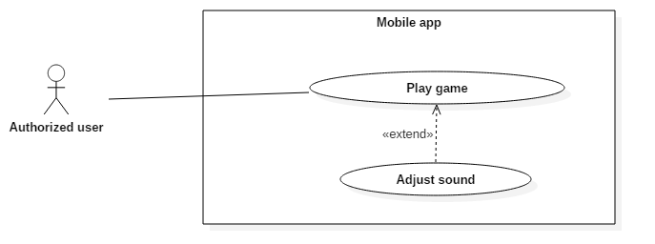

Figure 83 - <Authorized user> Adjust sound UCD

**Use Case Specification**

|  |  |  |  |
| --- | --- | --- | --- |
| **USE CASE – UC_82** | | | |
| **Use Case No.** | 82 | **Use Case Version** | 2.0 |
| **Use Case Name** | Adjust sound | | |
| **Author** | Lê Khải Thông | | |
| **Date** | 02/11/2016 | **Priority** | Normal |
| **Actor:**   * Authorized user   **Summary:**   * This use case allows Authorized user adjust the volume of in-game sound   **Goal:**   * Adjust the volume of in-game sound   **Triggers:**   * Authorized user go into game screen   **Preconditions:**   * Authorized user login successfully * Authorized user go into game screen   **Post Conditions:**   * **Success:** In-game sound is adjust by Authorized user * **Fail:** In-game sound is not changed according to Authorized user’s will   **Main Success Scenario:**   |  |  |  | | --- | --- | --- | | Step | Actor Action | System Response | | 1 | Authorized user go into game screen | Show game screen and load data  [Exception 1] | | 2 | Authorized user taps on “Menu” icon  [Alternative 1] | Show menu | | 3 | Authorized user taps on “Setting” icon | Show Setting panel | | 4 | Adjust background music or effect sound | Change background music or effect sound according to adjustment of Authorized user  [Exception 2] |   **Alternative 1:**   |  |  |  | | --- | --- | --- | | No | Actor action | System Response | | 1 | Authorized user taps on “Menu” icon again | Close menu |   **Exceptions:**   |  |  |  | | --- | --- | --- | | No | Cause | System Response | | 1 | Cannot load data from server | Show error message | | 2 | Cannot adjust sound | Do nothing |   **Relationships:**  Extend from Play game use case  **Business Rules:** N/A | | | |

* + - * 1. <Authorized User> Gain item (UC_83)

**Use Case Diagram**

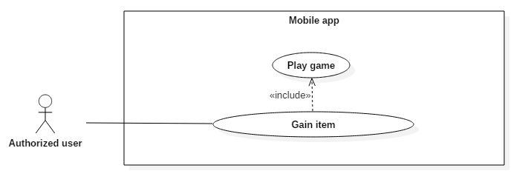

Figure 84 - <Authorized user> Gain item UCD

**Use Case Specification**

|  |  |  |  |
| --- | --- | --- | --- |
| **USE CASE – UC_83** | | | |
| **Use Case No.** | 83 | **Use Case Version** | 2.0 |
| **Use Case Name** | Gain item | | |
| **Author** | Lê Khải Thông | | |
| **Date** | 02/11/2016 | **Priority** | Normal |
| **Actor:**   * Authorized user   **Summary:**   * This use case allows Authorized user to gain more item * The item gained in game will be used to redeem prize.   **Goal:**   * Gain more item   **Triggers:**   * Dragon is killed   **Preconditions:**   * Authorized user login successfully * Campaign contains available game activity * Authorized user is already joined the campaign * Authorized user play game   **Post Conditions:**   * **Success:**   + Gain item   + Gained item update into storage * **Fail:** Error message is displayed.   **Main Success Scenario:**   |  |  |  | | --- | --- | --- | | Step | Actor Action | System Response | | 1 | Authorized user play game and kill the dragon  [Alternative 1] | Start algorithm to calculate the amount of item Authorized user will gain | | 2 |  | Show gained item dialog with following information:   * Amount of item Authorized user gained * OK: button | | 3 | User taps “OK” button | Update gained item into storage  [Exception 1] |   **Alternative 1:**   |  |  |  | | --- | --- | --- | | No | Actor action | System Response | | 1 | Authorized user cannot kill dragon | After 20 minutes new dragon will appears. No item will be gained |   **Exceptions:**   |  |  |  | | --- | --- | --- | | No | Cause | System Response | | 1 | Cannot update gained gem into storage | Show error message |   **Relationships:**  Includes Play game use case  **Business Rules:**   * About game   + In-game item that can be gain:  |  |  |  | | --- | --- | --- | | **Name and description** | **Used for** | **Gain from** | | Gem: There are 3 types of gem: ruby, sapphire and citrine. | Redeem prize | Kill dragon | | Teek: in-app point | Redeem prize | Can only gain from joining campaign or redeem coupon | | Coin | Buy fire ball or ice ball | Buy in shop or do campaign activity |  * + After killed the dragon, authorized user will gain gem(s) according to the algorithm | | | |

* 1. Software System Attribute
     1. Usability
* To use the web application, staff must have basic knowledge about website
* To use the mobile application, user only need basic knowledge about using app store (Google Playstore for Android mobile phone, AppStore for iOS mobile phone,… ). After install the app, user will be able to use it easily after reading the tutorial.
  + 1. Reliability
* The number of sending notification failure are 1 time per 100 notifications.
* Timer tasks run at configured time with 100% execution rate.
  + 1. Availability
* System should take at most 6 hours per month for backup or repairing.
  + 1. Security
* Privacy: Each role of user has a specific permission to interact with system.
* System always checks authorization and authenticated before doing anything.
* Only admin can grant permission to other roles.
  + 1. Maintainability
* The system is divided into separated modules.
* The code is easy to maintain and upgrade.
  + 1. Portability
* The web application is running on Windows 7 or above.
* The mobile application is cross platform, it can run on Android, iOS….
* Providing easy installation.
  + 1. Performance
* All request is handle in maximum time of 12 seconds.
  1. Conceptual Diagram

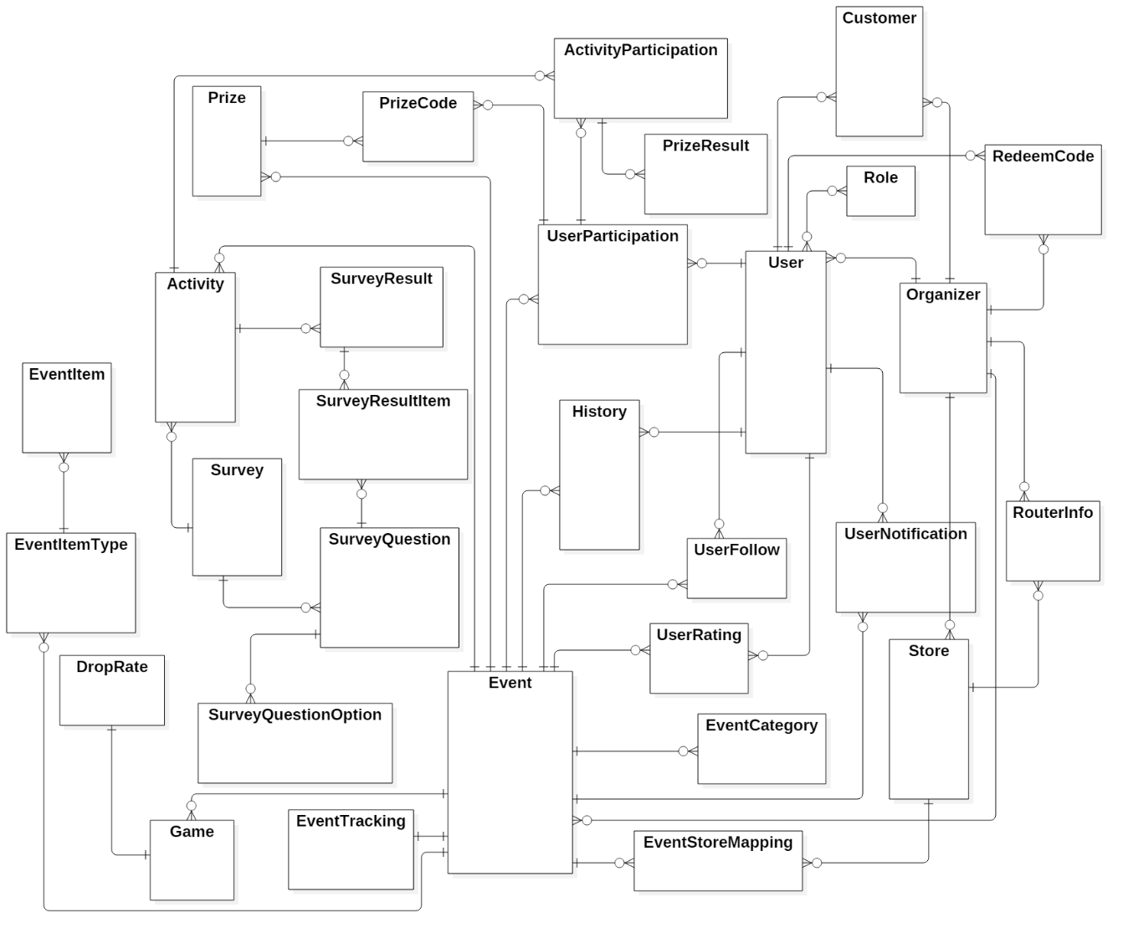

Figure 85 - Conceptual Diagram

**Data Dictionary**

|  |  |  |
| --- | --- | --- |
| **No.** | **Entity Name** | **Description** |
| 1 | Role | Contain role of user, which role a user is |
| 2 | RedeemCode | Contain information of user coupon code |
| 3 | User | Contain all information about user |
| 4 | UserFollow | Contain information about which campaign user is following |
| 5 | History | Contain log of user action |
| 6 | Store | Contain all information about organizer’s store |
| 7 | RouterInfo | Contain all information about wifi router information of all store |
| 8 | Organizer | Contain all information about organizer |
| 9 | Customer | Contain information of relationship between user and organizer |
| 10 | UserRating | Cointain rating result of user about a compaign |
| 11 | UserNotification | Contain notification information to send to user |
| 12 | ActivityParticipation | Contain information about which activity user participated |
| 13 | UserParticipation | Contain information about which campaign user joined |
| 14 | PrizeCode | Cointain information of which prize user has redeemed |
| 15 | Prize | Cointain all information about prize of campaign |
| 16 | Event | Contain all information about campaign |
| 17 | EventItemType | Contain which type of a campaign’s component |
| 18 | EventTracking | Contain statistic about a campaign |
| 19 | EventCategory | Contain information about which type the capaign is |
| 20 | EventItem | Contain information about what component the campaign has |
| 21 | Game | Contain information about game of campaign |
| 22 | DropRate | Contain information about drop rate of item combo in game |
| 23 | Activity | Contain all information about campaign’s activity |
| 24 | Survey | Contain information about survey |
| 25 | SurveyQuestion | Contain information about question of survey |
| 23 | SurveyQuestionOption | Contain information about the option of a question in survey |
| 27 | SurveyResult | Contain information about result of survey when user finish doing the survey |
| 28 | SurveyResultItem | Contain information about result of each question in survey after user finish doing the survey |
| 29 | EventStoreMapping | Contain information about which store the campaign happening at |

Table 13 - Conceptual Diagram Data Dictionary

1. Software Design Description
   1. Design Overview

* This document describes the technical and user interface design of ARG System. It includes the architectural design, the detailed design of common functions and business functions and the design of database model.
* The architectural design describes the overall architecture of the system and the architecture of each main component and subsystem.
* The detailed design describes static and dynamic structure for each component and functions. It includes class diagram, class explanations and sequence diagrams for each use cases.
* The database design describes the relationships between entities and details of each entity.
* Document overview:
* Section 2: gives an overall description of the system architecture design.
* Section 3: gives component diagrams that describes the connection and integration of the system.
* Section 4: gives the detail design description which includes class diagram, class explanation and sequence diagram to details the application functions.
* Section 5: describes screen design.
* Section 6: describes a fully attributed ERD.
* Section 7: describes algorithms.
  1. System Architectural Design

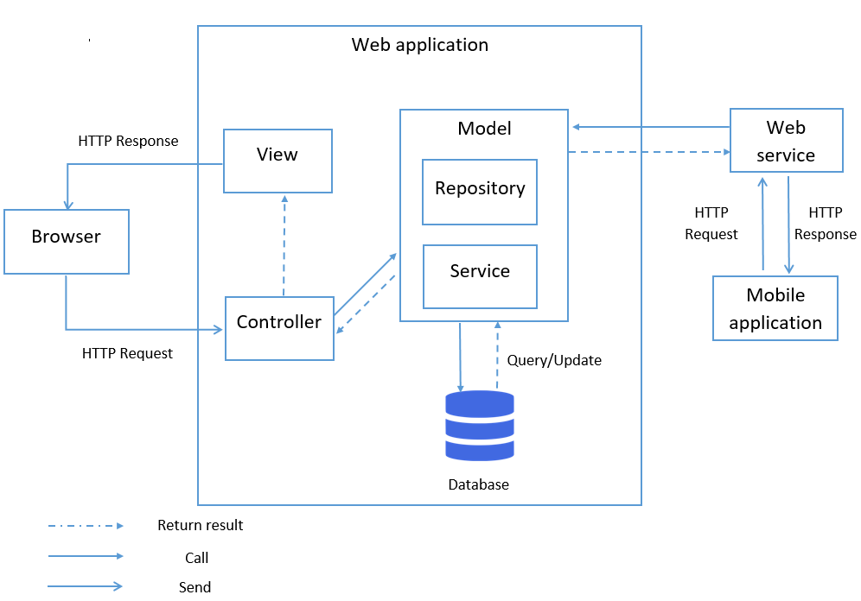

Figure 86 - System architectural design

* + 1. Web applicaiton architecture description

The web app is developed under ASP .NET MVC architecture with the following components:

* Model: Model objects are the parts of the application that implement the logic for the application's data domain.
* View: Views are the components that display the application's user interface.
* Controller: Controllers are the components that handle user interaction, work with the model, and ultimately select a view to render that displays UI.
  + 1. Mobile application architecture description

The application is developed as a cross platform mobile game application with Unity Game Engine. In general, the application architecture conforms to Unity recommeded architecture.

* 1. Component Diagram

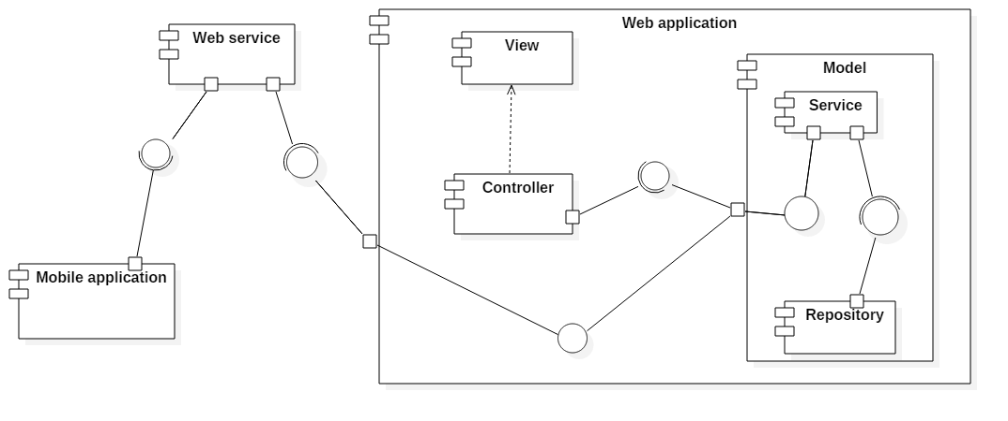

Figure 87 - Component Diagram

| **Components Dictionary: Describes components** | |
| --- | --- |
| Web Apllicaiton | Component to controll the system and process request from mobile. Contains sub component: Model, Web Service, Controller. |
| Controller | Component of web application to handle request from web |
| Model | Component that do the interaction between the system and database. Contain sub components: Repository and Service |
| Service | Component to handle business logic of Web Application component |
| Repository | Component that communicate with database |
| Web service | Component that handle request from mobile application |
| Mobile application | Component to controll game |

Table 14 - Components Dictionary

* 1. Detailed Description
     1. Class diagram

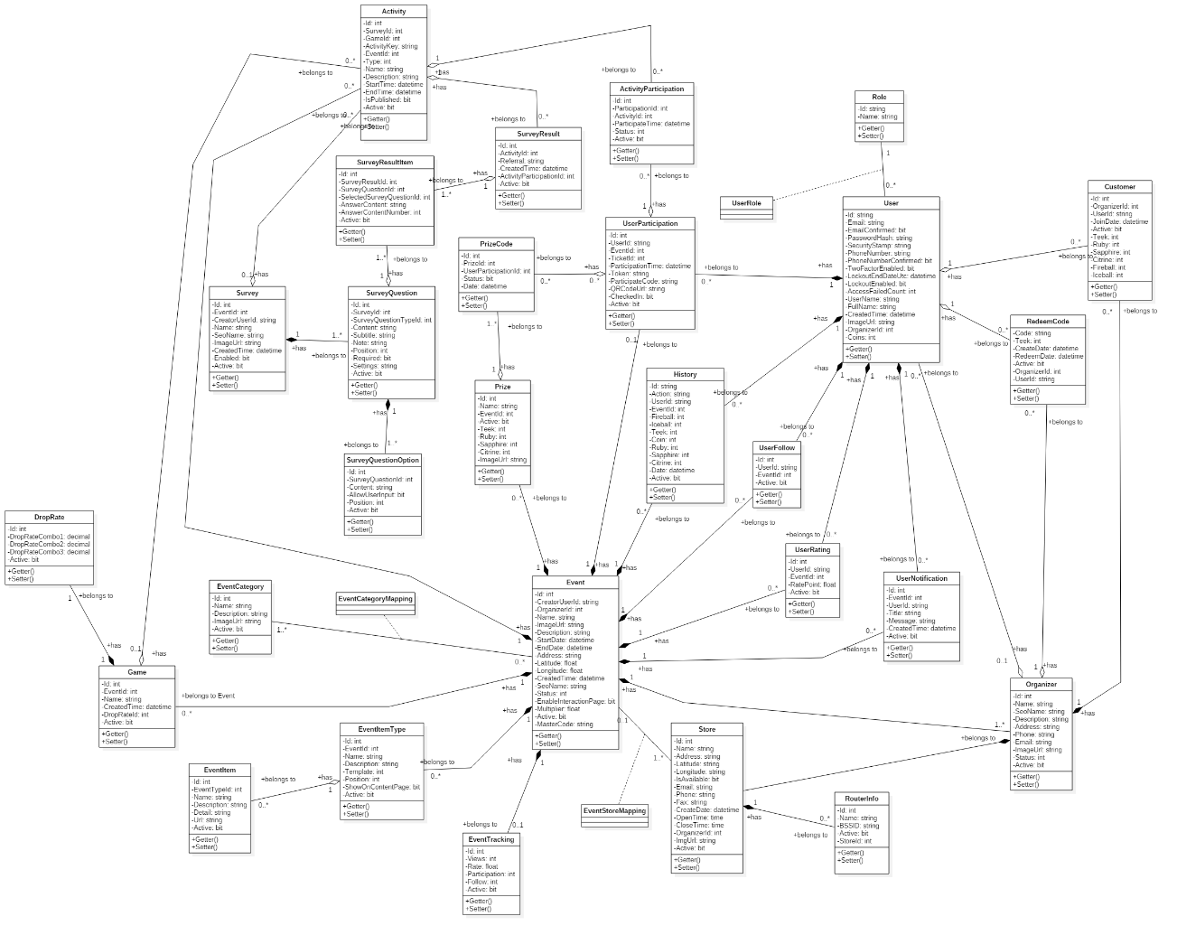

Figure 88 - Class diagram

|  |  |  |
| --- | --- | --- |
| **Class Diagram Dictionary: describe classes** | | |
| **Class Name** | **Mapping column with conceptual diagram** | **Description** |
| Role | Role | Contain role of user, which role a user is |
| RedeemCode | RedeemCode | Contain information of user coupon code |
| User | User | Contain all information about user |
| UserFollow | UserFollow | Contain information about which campaign user is following |
| History | History | Contain log of user action |
| Store | Store | Contain all information about organizer’s store |
| RouterInfo | RouterInfo | Contain all information about wifi router information of all store |
| Organizer | Organizer | Contain all information about organizer |
| Customer | Customer | Contain information of relationship between user and organizer |
| UserRating | UserRating | Cointain rating result of user about a compaign |
| UserNotification | UserNotification | Contain notification information to send to user |
| ActivityParticipation | ActivityParticipation | Contain information about which activity user participated |
| UserParticipation | UserParticipation | Contain information about which campaign user joined |
| PrizeCode | PrizeCode | Cointain information of which prize user has redeemed |
| Prize | Prize | Cointain all information about prize of campaign |
| Event | Event | Contain all information about campaign |
| EventItemType | EventItemType | Contain which type of a campaign’s component |
| EventTracking | EventTracking | Contain statistic about a campaign |
| EventCategory | EventCategory | Contain information about which type the capaign is |
| EventItem | EventItem | Contain information about what component the campaign has |
| Game | Game | Contain information about game of campaign |
| DropRate | DropRate | Contain information about drop rate of item combo in game |
| Activity | Activity | Contain all information about campaign’s activity |
| Survey | Survey | Contain information about survey |
| SurveyQuestion | SurveyQuestion | Contain information about question of survey |
| SurveyQuestionOption | SurveyQuestionOption | Contain information about the option of a question in survey |
| SurveyResult | SurveyResult | Contain information about result of survey when user finish doing the survey |
| SurveyResultItem | SurveyResultItem | Contain information about result of each question in survey after user finish doing the survey |
| EventStoreMapping | EventStoreMapping | Contain information about which store the campaign happening at |
| UserRole | N/A | Map between user and their role |
| EventCategoryMapping | N/A | Map between campaign and it’s category |

Table 15 - Class dictionary

* + 1. Class diagram explanation
       1. Event

**Attributes**

|  |  |  |  |
| --- | --- | --- | --- |
| **Attribute** | **Type** | **Visibility** | **Description** |
| Id | Int | Private | Unique Id of event. |
| CreatorUserId | String | Private | Id of creator user. |
| OrganizerId | Int | Private | Id of organizer that holds the event. |
| Name | String | Private | Name of event. |
| ImageUrl | String | Private | Link of event image. |
| Description | String | Private | The description of event. |
| StartDate | Datetime | Private | The date when the event starts. |
| EndDate | Datetime | Private | The date when the event ends. |
| Address | String | Private | The place where the event is held. |
| Latitude | Float | Private | The latitude of the event. |
| Longitude | Float | Private | The longitude of the event. |
| CreatedTime | Datetime | Private | The time when the event is created. |
| SeoName | String | Private | Is auto generated when creating the event. |
| Status | Int | Private | Show the status of the event.  There are 4 status:   * 0: new * 1: approved by admin * 2: not approved by admin * 3: pending for approved |
| EnableInteractionPage | Bit | Private | There are 2 types:   * False: not allow to enable * True: allow to enable |
| Multiplier | Float | Private | Show the multiplier of coin user can get from event, and multiplier of coin user can get from redeeming coupon. |
| Active | Bit | Private | There are 2 types:   * True: available * False: is deleted |
| MasterCode | String | Private | The code is used to confirm when claiming gift. |

**Methods**

|  |  |  |  |
| --- | --- | --- | --- |
| **Method** | **Return type** | **Visibility** | **Description** |
| Getter | Attribute type | Public | Get attribute value |
| Setter | Void | Public | Set value of attribute |

* + - 1. Customer

**Attributes**

|  |  |  |  |
| --- | --- | --- | --- |
| **Attribute** | **Type** | **Visibility** | **Description** |
| Id | Int | Private | Unique Id of customer. |
| OrganizerId | Int | Private | Id of organizer that the customer joined. |
| UserId | String | Private | Id of customer in User table. |
| JoinDate | Datetime | Private | The date when the customer joined. |
| Active | Bit | Private | There are 2 types:   * True: available * False: is deleted |
| Teek | Int | Private | The Teek amount that customer has. |
| Ruby | Int | Private | The Ruby (item drop from defeating the dragon) amount that customer has. |
| Sapphire | Int | Private | The Sapphire (item drop from defeating the dragon) amount that customer has. |
| Citrine | Int | Private | The Citrine (item drop from defeating the dragon) amount that customer has. |
| Fireball | Int | Private | The Fireball (weapon to defeat the dragon) amount that customer has. |
| Iceball | Int | Private | The Iceball (weapon to defeat the dragon) amount that customer has. |

**Methods**

|  |  |  |  |
| --- | --- | --- | --- |
| **Method** | **Return type** | **Visibility** | **Description** |
| Getter | Attribute type | Public | Get attribute value |
| Setter | Void | Public | Set value of attribute |

* + - 1. Activity

**Attributes**

|  |  |  |  |
| --- | --- | --- | --- |
| **Attribute** | **Type** | **Visibility** | **Description** |
| Id | Int | Private | Unique Id of activity. |
| SurveyId | Int | Private | Id of survey in an event. |
| GameId | Int | Private | Id of game in an event. |
| ActivityKey | String | Private | Key for submiting activity. |
| EventId | Int | Private | Id of event that the current activity belongs to. |
| Description | String | Private | Description of activity. |
| StartTime | Datetime | Private | The time when the event starts. |
| EndTime | Datetime | Private | The time when the event ends. |
| IsPublished | Bit | Private | There are 2 types:   * False: not published * True: published |
| Active | Bit | Private | There are 2 types:   * True: available * False: is deleted |

**Methods**

|  |  |  |  |
| --- | --- | --- | --- |
| **Method** | **Return type** | **Visibility** | **Description** |
| Getter | Attribute type | Public | Get attribute value |
| Setter | Void | Public | Set value of attribute |

* + - 1. Game

**Attributes**

|  |  |  |  |
| --- | --- | --- | --- |
| **Attribute** | **Type** | **Visibility** | **Description** |
| Id | Int | Private | Unique Id of game. |
| EventId | Int | Private | Id of event that the game belongs to. |
| Name | String | Private | Name of the game. |
| CreatedTime | Datetime | Private | The time when the game is created. |
| DropRateId | Int | Private | Id of droprate belongs to this game. |
| Active | Bit | Private | There are 2 types:   * True: available * False: is deleted |

**Methods**

|  |  |  |  |
| --- | --- | --- | --- |
| **Method** | **Return type** | **Visibility** | **Description** |
| Getter | Attribute type | Public | Get attribute value |
| Setter | Void | Public | Set value of attribute |

* + - 1. Prize

**Attributes**

|  |  |  |  |
| --- | --- | --- | --- |
| **Attribute** | **Type** | **Visibility** | **Description** |
| Id | Int | Private | Unique Id of prize. |
| Name | String | Private | Name of prize. |
| EventId | Int | Private | Id of event that the prize belongs to. |
| Active | Bit | Private | There are 2 types:   * True: available * False: is deleted |
| Teek | Int | Private | The Teek amount that the prize requires. |
| Ruby | Int | Private | The Ruby amount that the prize requires. |
| Sapphire | Int | Private | The Sapphire amount that the prize requires. |
| Citrine | Int | Private | The Citrine amount that the prize requires. |
| ImageUrl | String | Private | The prize image link. |

**Methods**

|  |  |  |  |
| --- | --- | --- | --- |
| **Method** | **Return type** | **Visibility** | **Description** |
| Getter | Attribute type | Public | Get attribute value |
| Setter | Void | Public | Set value of attribute |

* + - 1. PrizeCode

**Attributes**

|  |  |  |  |
| --- | --- | --- | --- |
| **Attribute** | **Type** | **Visibility** | **Description** |
| Id | Int | Private | Unique Id of prizecode. |
| PrizeId | Int | Private | Id of prize that the prizecode belongs to. |
| UserParticipationId | Int | Private | Id of userpaticipation that shows which user joins in which event. |
| Status | Bit | Private | There are 2 types:   * True: prizecode was redeemed already * False: prizecode was not redeemed |
| Date | Datetime | Private | The date when the prizecode is redeemed. |

**Methods**

|  |  |  |  |
| --- | --- | --- | --- |
| **Method** | **Return type** | **Visibility** | **Description** |
| Getter | Attribute type | Public | Get attribute value |
| Setter | Void | Public | Set value of attribute |

* + - 1. RedeemCode

**Attributes**

|  |  |  |  |
| --- | --- | --- | --- |
| **Attribute** | **Type** | **Visibility** | **Description** |
| Code | String | Private | The code for redeeming. |
| Teek | Int | Private | The Teek amount earned from the redeemcode. |
| CreateDate | Datetime | Private | The date when the redeemcode is created. |
| RedeemDate | Datetime | Private | The date when the redeemcode is entered. |
| Active | Bit | Private | There are 2 types:   * True: available * False: is deleted |
| OrganizerId | Int | Private | Id of organizer which the redeemcode belongs to. |
| UserId | String | Private | Id of user who enters the redeemcode. |

**Methods**

|  |  |  |  |
| --- | --- | --- | --- |
| **Method** | **Return type** | **Visibility** | **Description** |
| Getter | Attribute type | Public | Get attribute value |
| Setter | Void | Public | Set value of attribute |

* + - 1. History

**Attributes**

|  |  |  |  |
| --- | --- | --- | --- |
| **Attribute** | **Type** | **Visibility** | **Description** |
| Id | Int | Private | Unique Id of history. |
| Action | String | Private | Name of action. |
| UserId | String | Private | Id of user who did this action. |
| EventId | Int | Private | Id of event which the action was done. |
| Fireball | Int | Private | Fireball amount changes in this action. |
| Iceball | Int | Private | Icaball amount changes in this action. |
| Teek | Int | Private | Teek amount changes in this action. |
| Coin | Int | Private | Coin amount changes in this action. |
| Ruby | Int | Private | Ruby amount changes in this action. |
| Sapphire | Int | Private | Sapphire amount changes in this action. |
| Citrine | Int | Private | Citrine amount changes in this action. |
| Date | Datetime | Private | The date when this action was done. |
| Active | Bit | Private | There are 2 types:   * True: available * False: is deleted |

**Methods**

|  |  |  |  |
| --- | --- | --- | --- |
| **Method** | **Return type** | **Visibility** | **Description** |
| Getter | Attribute type | Public | Get attribute value |
| Setter | Void | Public | Set value of attribute |

* + - 1. Organizer

**Attributes**

|  |  |  |  |
| --- | --- | --- | --- |
| **Attribute** | **Type** | **Visibility** | **Description** |
| Id | Int | Private | Unique Id of organizer. |
| Name | String | Private | Name of organizer. |
| SeoName | String | Private | Is auto generated when creating the event. |
| Description | String | Private | Description of organizer. |
| Address | String | Private | Address of organizer. |
| Phone | String | Private | Phone number of organizer. |
| Email | String | Private | Email of organizer. |
| ImageUrl | String | Private | Organizer image link. |
| Status | Int | Private |  |
| Active | Bit | Private | There are 2 types:   * True: available * False: is deleted |

**Methods**

|  |  |  |  |
| --- | --- | --- | --- |
| **Method** | **Return type** | **Visibility** | **Description** |
| Getter | Attribute type | Public | Get attribute value |
| Setter | Void | Public | Set value of attribute |

* + - 1. RouterInfo

**Attributes**

|  |  |  |  |
| --- | --- | --- | --- |
| **Attribute** | **Type** | **Visibility** | **Description** |
| Id | Int | Private | Unique Id of routerinfo. |
| Name | String | Private | Name of routerinfo. |
| BSSID | String | Private | The BSSID code. |
| Active | Bit | Private | There are 2 types:   * True: available * False: is deleted |
| StoreId | Int | Private | Id of store that the BSSID belongs to. |

**Methods**

|  |  |  |  |
| --- | --- | --- | --- |
| **Method** | **Return type** | **Visibility** | **Description** |
| Getter | Attribute type | Public | Get attribute value |
| Setter | Void | Public | Set value of attribute |

* + - 1. Store

**Attribute**s

|  |  |  |  |
| --- | --- | --- | --- |
| **Attribute** | **Type** | **Visibility** | **Description** |
| Id | Int | Private | Unique Id of store. |
| Name | String | Private | Name of store. |
| Address | String | Private | Address of store. |
| Latitude | String | Private | Latitude of store. |
| Longitude | String | Private | Longitude of store. |
| IsAvailable | Bit | Private | There are 2 types:   * True: the store is available * False: the store is not available |
| Email | String | Private | Email of store. |
| Phone | String | Private | Phone of store. |
| Fax | String | Private | Fax of store. |
| CreateDate | Datetime | Private | The date when the store is created. |
| OpenTime | Time | Private | The time when the store starts in a date. |
| CloseTime | Time | Private | The time when the store ends in a date. |
| OrganizerId | Int | Private | Id of organizer that the store belongs to. |
| ImgUrl | String | Private | Store image link. |
| Active | Bit | Private | There are 2 types:   * True: available * False: is deleted |

**Methods**

|  |  |  |  |
| --- | --- | --- | --- |
| **Method** | **Return type** | **Visibility** | **Description** |
| Getter | Attribute type | Public | Get attribute value |
| Setter | Void | Public | Set value of attribute |

* + 1. Interaction diagram
    2. Web application
       1. <Guest> Register

**Summary:** This diagram show how the Guest create new account

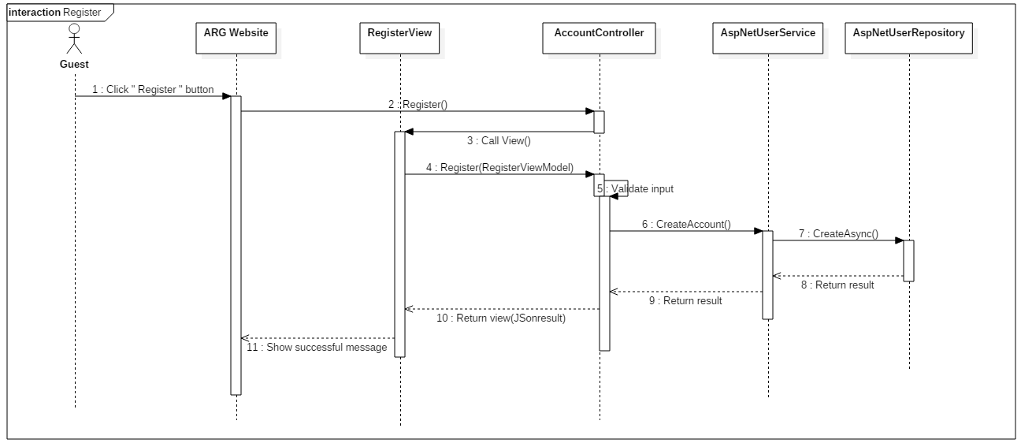

Figure 89 - <Guest> Register SD

* + - 1. <Guest> Login

**Summary:** This diagram show how the Guest login into system

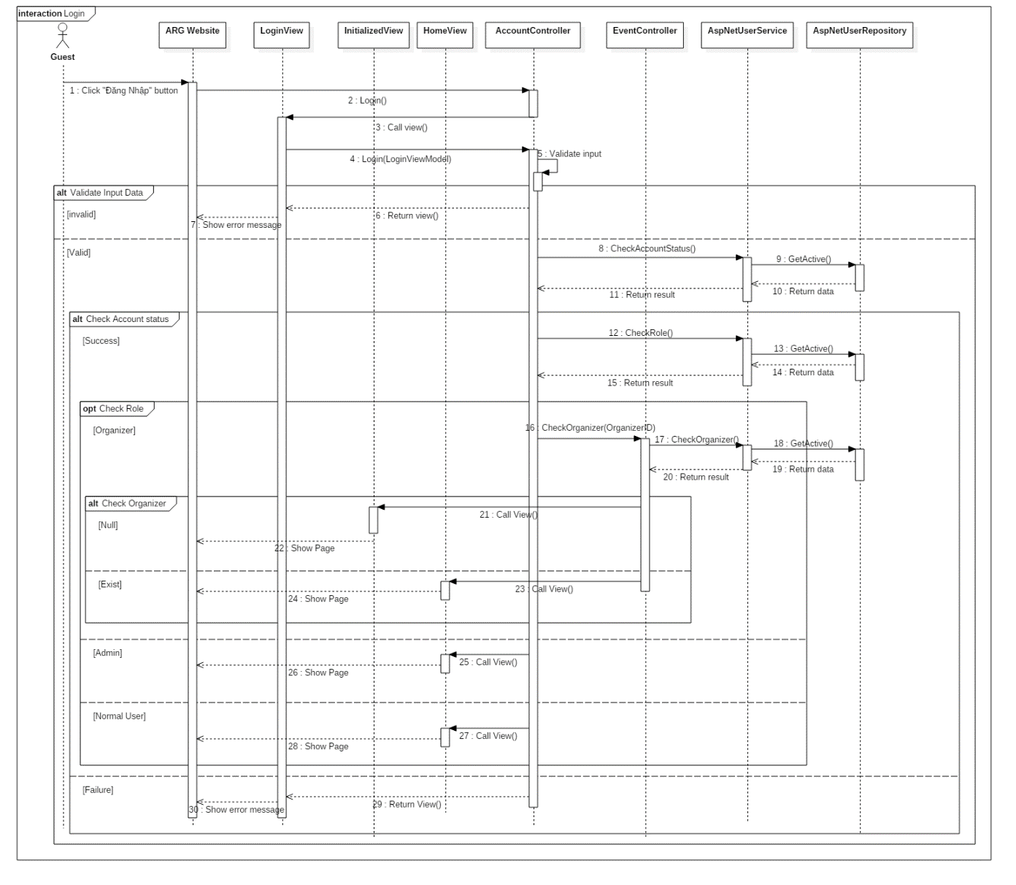

Figure 90 - <Guest> Login SD

* + - 1. <Authorized User> Logout

**Summary:** This diagram show how the Authorize User logout of system

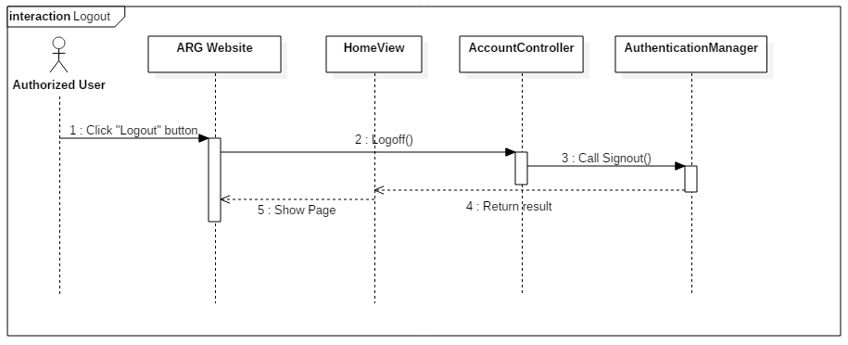

Figure 91 - <Authorized User> Logout SD

* + - 1. <Normal User> Join campaign

**Summary:** This diagram show how the Normal User join a campaign

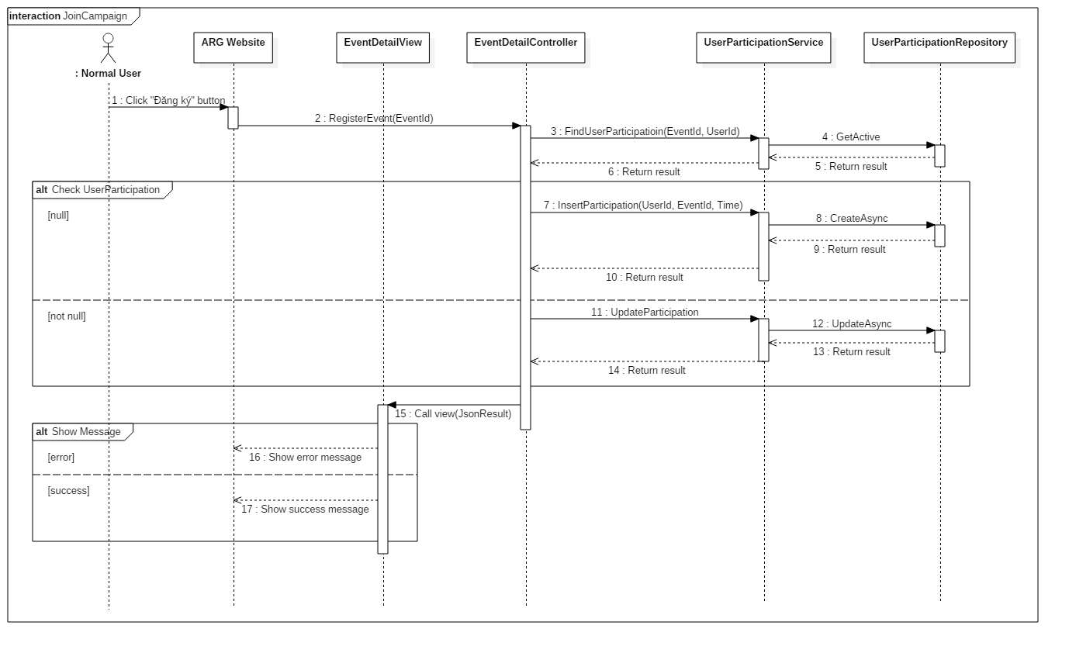

Figure 92 - <Normal User> Join Campaign SD

* + - 1. <Normal User> Join activity

**Summary:** This diagram show how the Normal User join activity of campaign

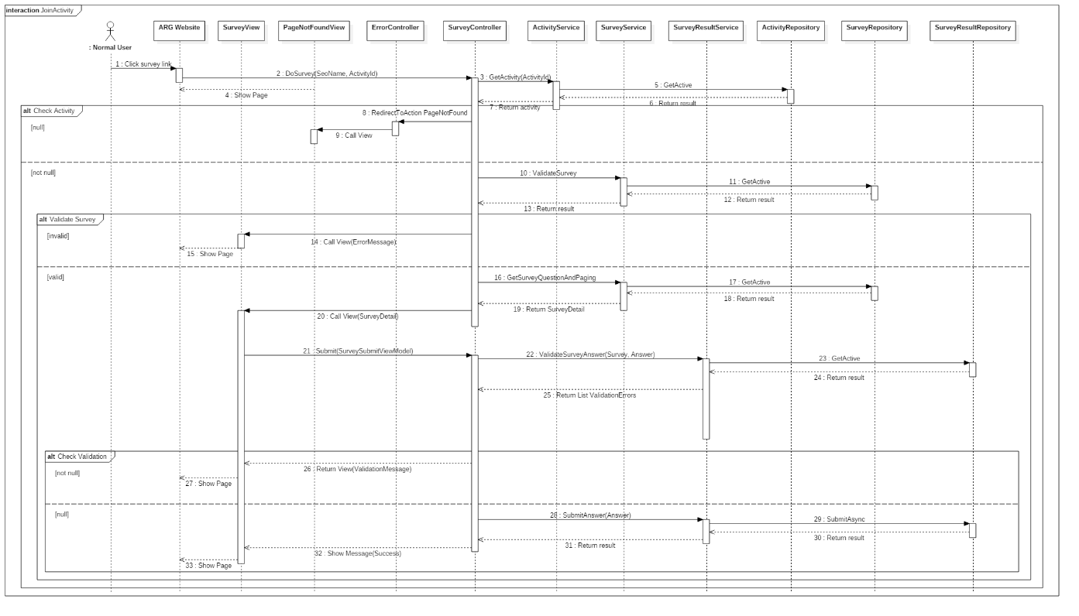

Figure 93 - <Normal User> Join Activity SD

* + 1. Mobile application
       1. <Guest> Register

**Summary:** This diagram show how the Guest register a new account

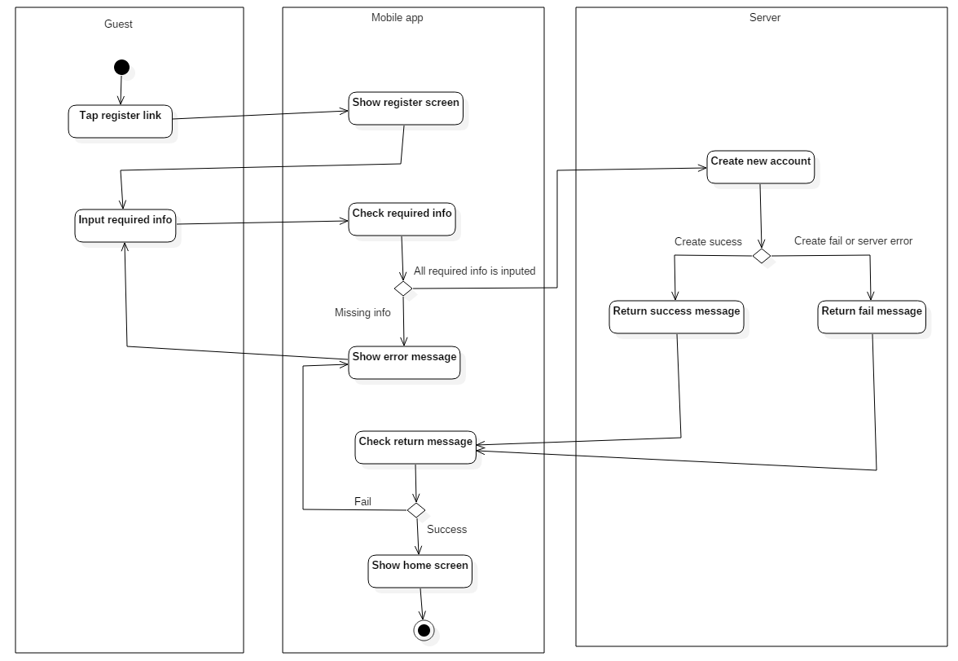

Figure 94 - <Guest> Register AD

* + - 1. <Guest> Login

**Summary:** This diagram show how the Guest login into app

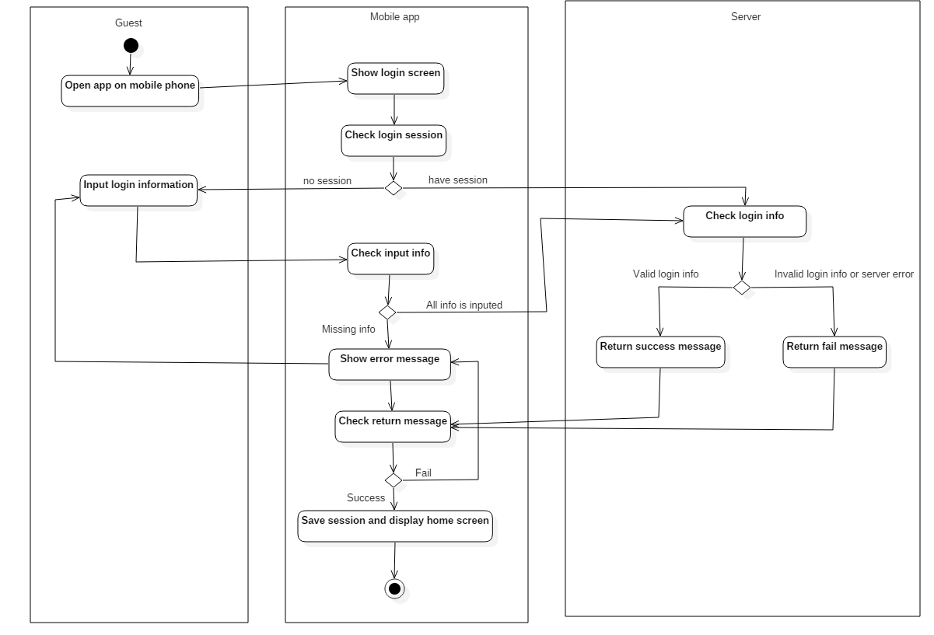

Figure 95 - <Guest> Login AD

* + - 1. <Authorized User> Logout

**Summary:** This diagram show how the Authorized user logout of app

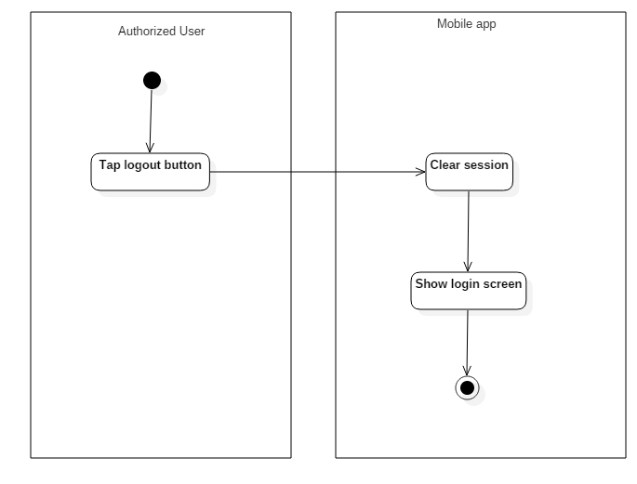

Figure 96 - <Authorized User> Logout AD

* + - 1. <Authorized User> Join campaign

**Summary:** This diagram show the Authorized user join campaign

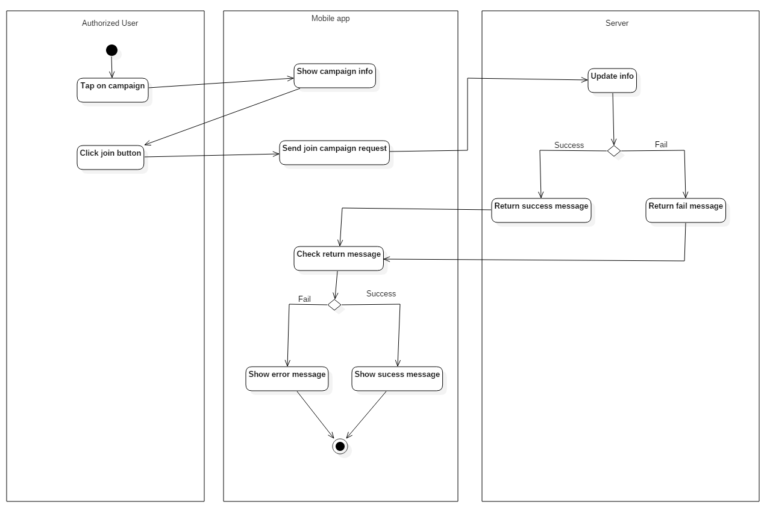

Figure 97 - <Authorized User> Join Campaign AD

* + - 1. <Authorized User> Buy item

**Summary:** This diagram show the Authorized user buy item in game

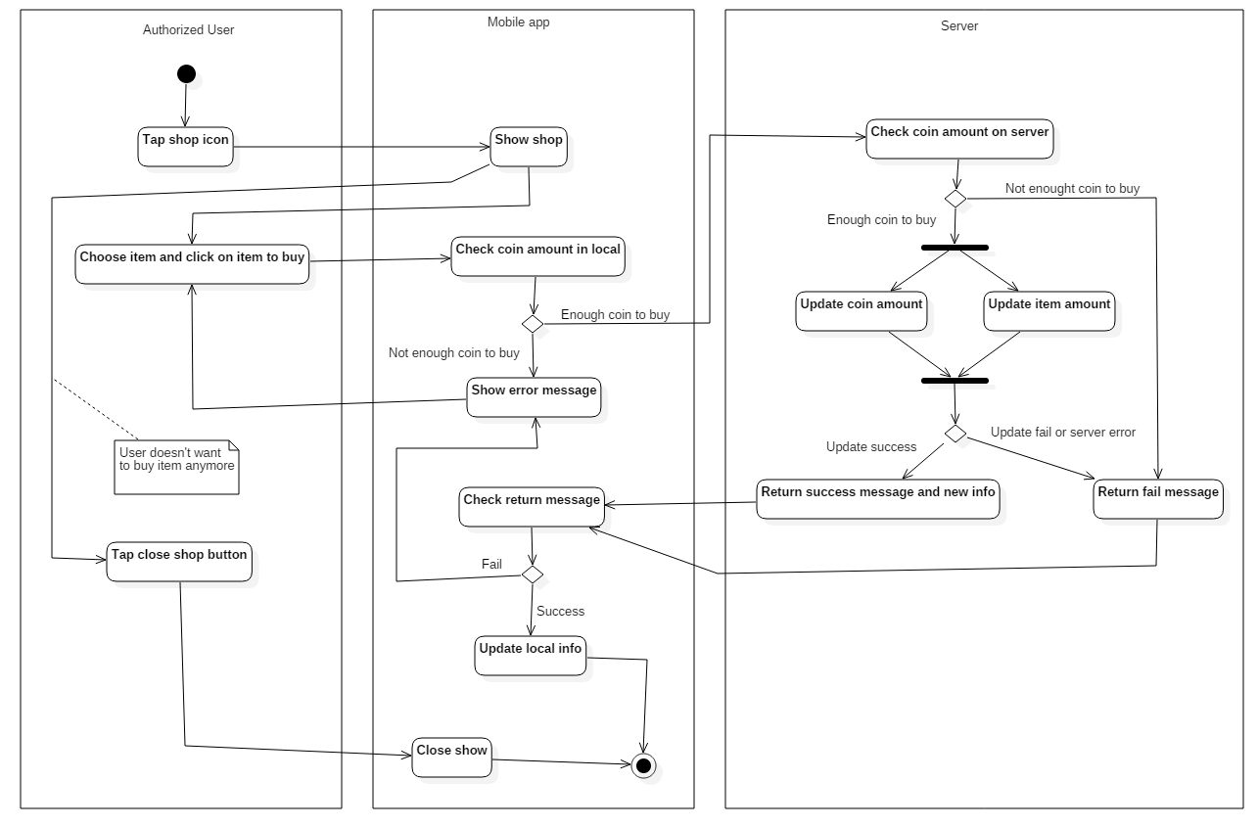

Figure 98 - <Authorized User> Buy Item AD

* + - 1. <Authorized User> Redeem coupon

**Summary:** This diagram show the Authorized user redeem coupon

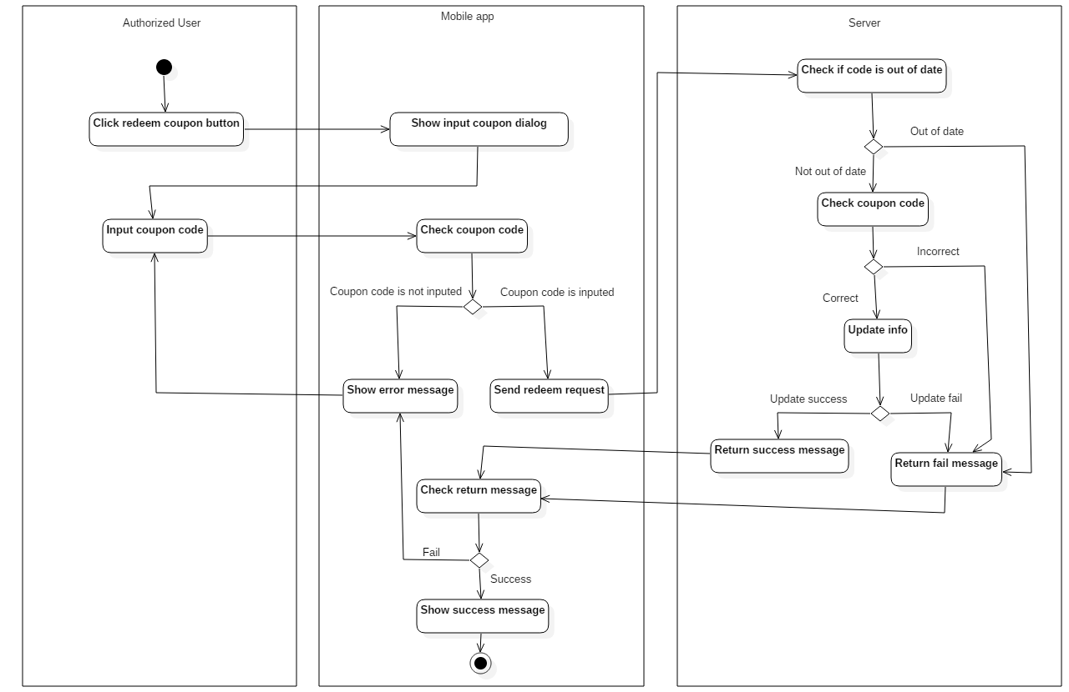

Figure 99 - <Authorized User> Redeem Coupon AD

* + - 1. <Authorized User> Redeem prize

**Summary:** This diagram show the Authorized user redeem a prize

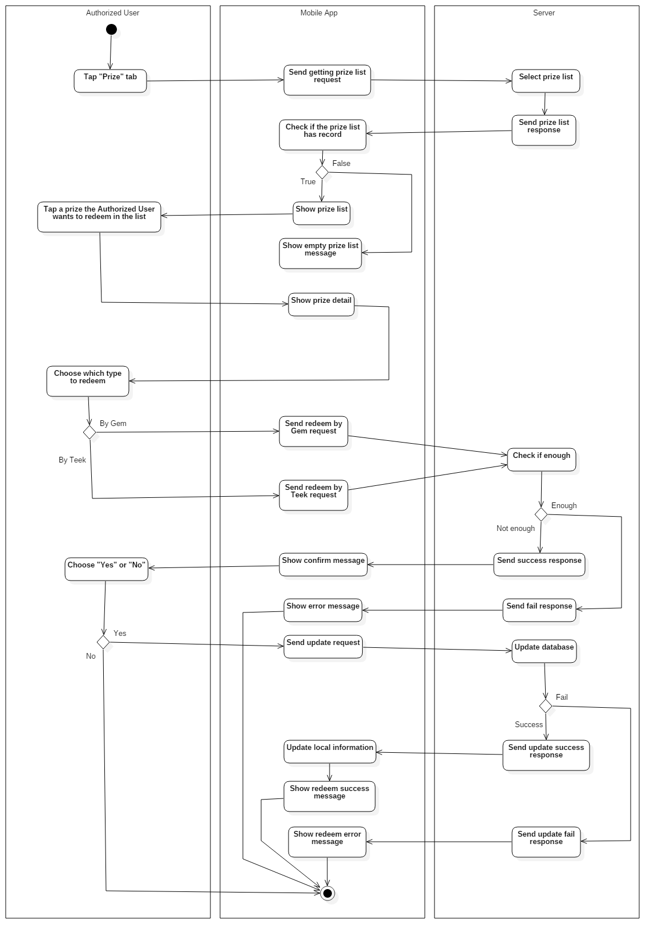

Figure 100 - <Authorized User> Redeem Prize AD

* + - 1. <Authorized User> Claim gift

**Summary:** This diagram show the Authorized user claim their gift

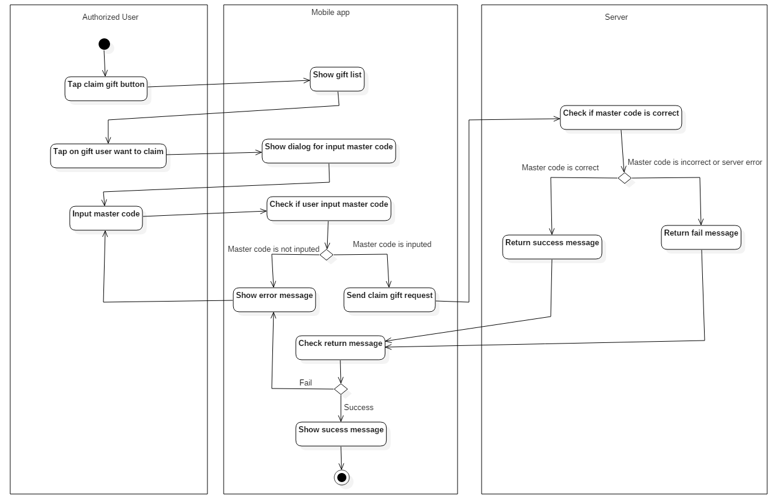

Figure 101 - <Authorized User> Claim Gift AD

* + - 1. <Authorized User> Play game

**Summary:** This diagram show the Authorized user play game

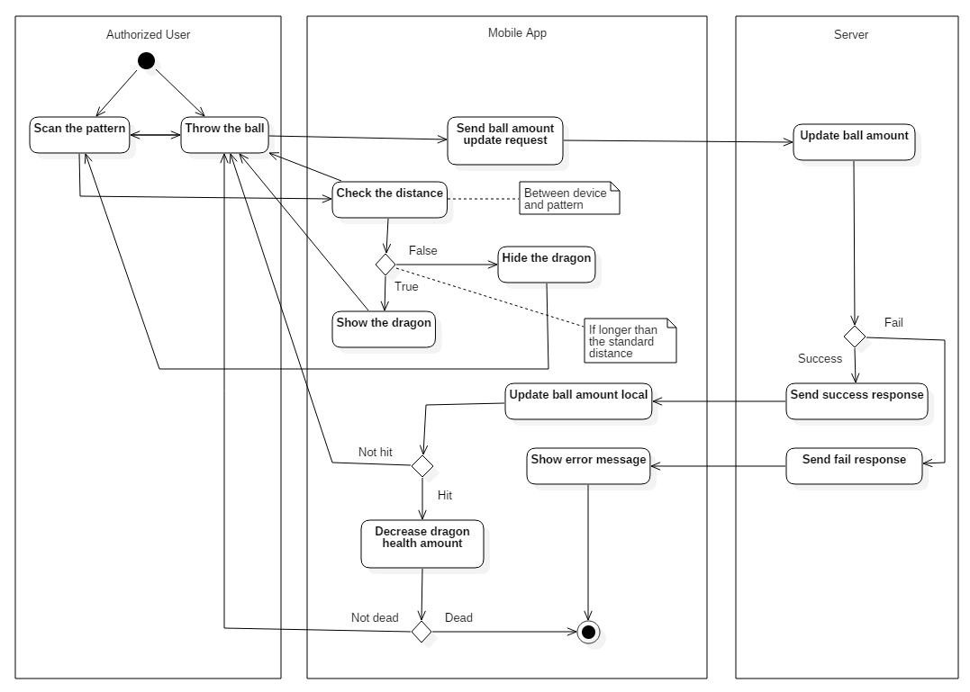

Figure 102 - <Authorized User> Play game AD

* + - 1. <Authorized User> Adjust sound

**Summary:** This diagram show the Authorized user adjust game sound

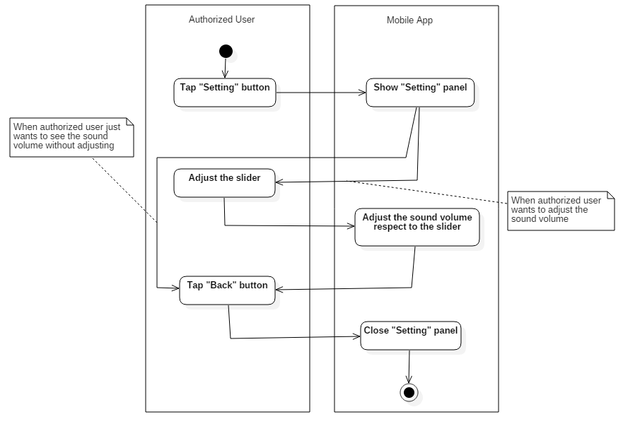

Figure 103 - <Authorized User> Adjust sound AD

* + - 1. <Authorized User> Gain item

**Summary:** This diagram show the Authorized user gain item from playing game

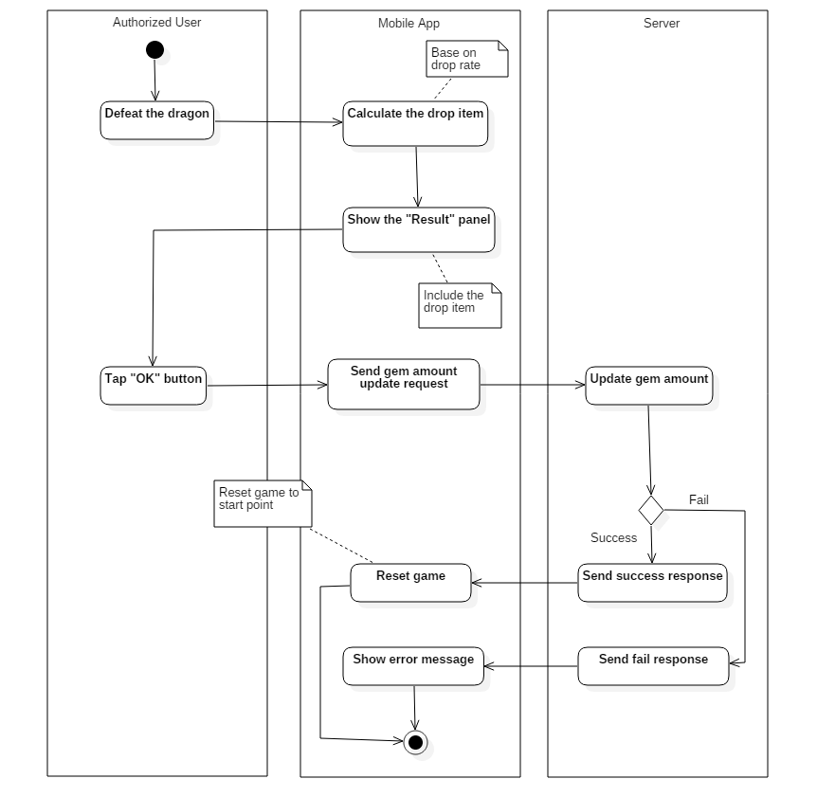

Figure 104 - <Authorized User> Gain Item AD

* 1. User Interface Design
     1. Web application user interface
        1. Register

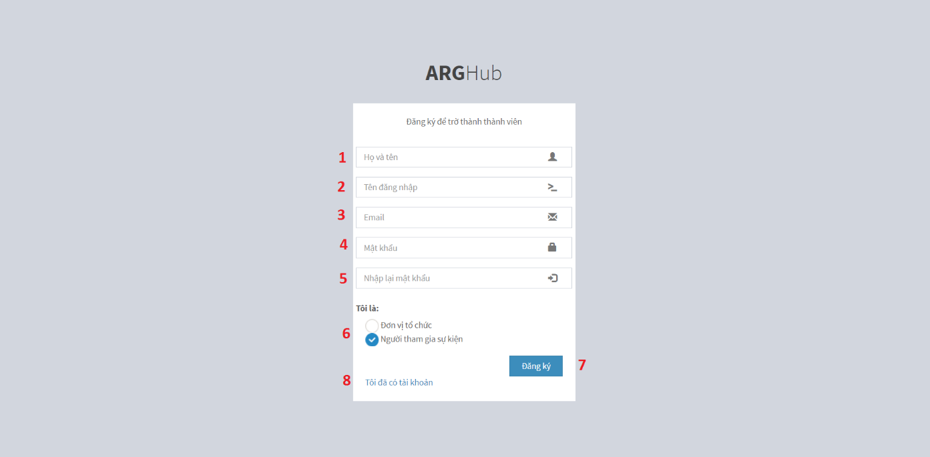

Figure 105 – Register UI

**Fields**

|  |  |  |  |  |  |  |  |
| --- | --- | --- | --- | --- | --- | --- | --- |
| **No** | **Field Name** | **Description** | **Read only** | **Mandatory** | **Control Type** | **Data Type** | **Length** |
| 1 | Full Name | Name of user | No | Yes | TextBox | String | N/A |
| 2 | Username | Username to login | No | Yes | TextBox | String | N/A |
| 3 | Email | Email of user | No | Yes | TextBox | String | N/A |
| 4 | Password | Password to login | No | Yes | TextBox | String | N/A |
| 5 | Re-type password | Re-type password | No | Yes | TextBox | String | N/A |
| 6 | Role | Type of role | No | Yes | Combo box | Int | N/A |

Table 58 - <User Interface-Field> Regster

**Buttons/Hyperlinks:**

|  |  |  |  |  |
| --- | --- | --- | --- | --- |
| **No** | **Function** | **Description** | **Validation** | **Outcome** |
| 6 | Register | Register a new account | Validate all required fields | Send request to register new account |
| 7 | Login | Return to login page | N/A | Go to login page |

Table 59 - <User Interface-Button/Hypperlinks> Register

* + - 1. Login

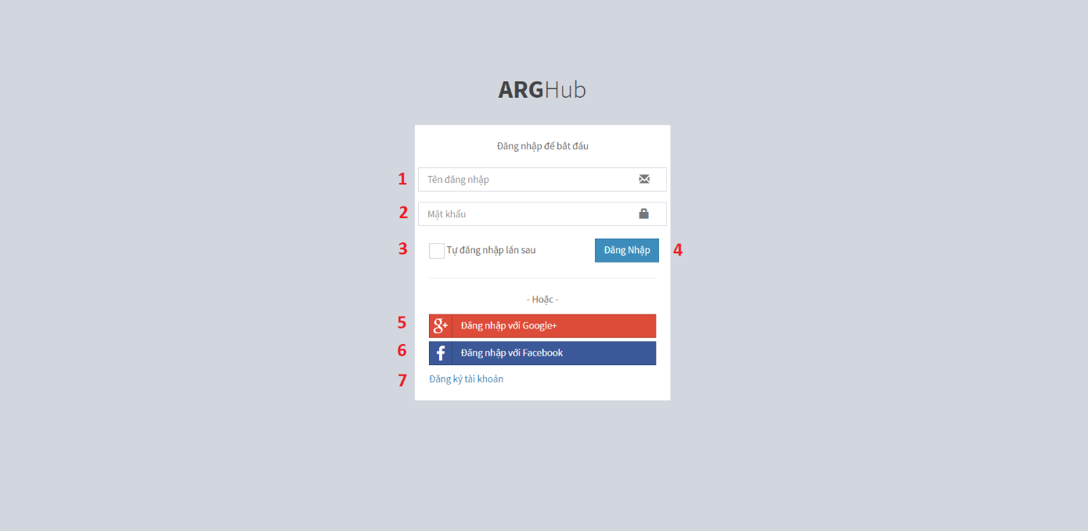

Figure 106: Login UI

**Fields**

|  |  |  |  |  |  |  |  |
| --- | --- | --- | --- | --- | --- | --- | --- |
| **No** | **Field Name** | **Description** | **Read only** | **Mandatory** | **Control Type** | **Data Type** | **Length** |
| 1 | Username | Username to login | No | Yes | TextBox | String |  |
| 2 | Password | Password to login | No | Yes | TextBox | String |  |
| 3 | Auto Login | Auto login in | No | No | Checkbox | Boolean |  |

Table 60 - <User Interface-Field> Login

**Buttons/Hyperlinks:**

|  |  |  |  |  |
| --- | --- | --- | --- | --- |
| **No** | **Function** | **Description** | **Validation** | **Outcome** |
| 4 | Login | Login into system | Validate all required fields | Go to manager page if role is Organizer.  Go to main page if role is Normal user |
| 5 | Login with Google | Login with Google account | N/A | Go to Google login page |
| 6 | Login with Facebook | Login with Facebook account | N/A | Go to Facebook login page |
| 7 | Register | Register new account | N/A | Go to register page |

Table 61 - <User Interface-Button/Hypperlinks> Login

* + - 1. Manage campaign

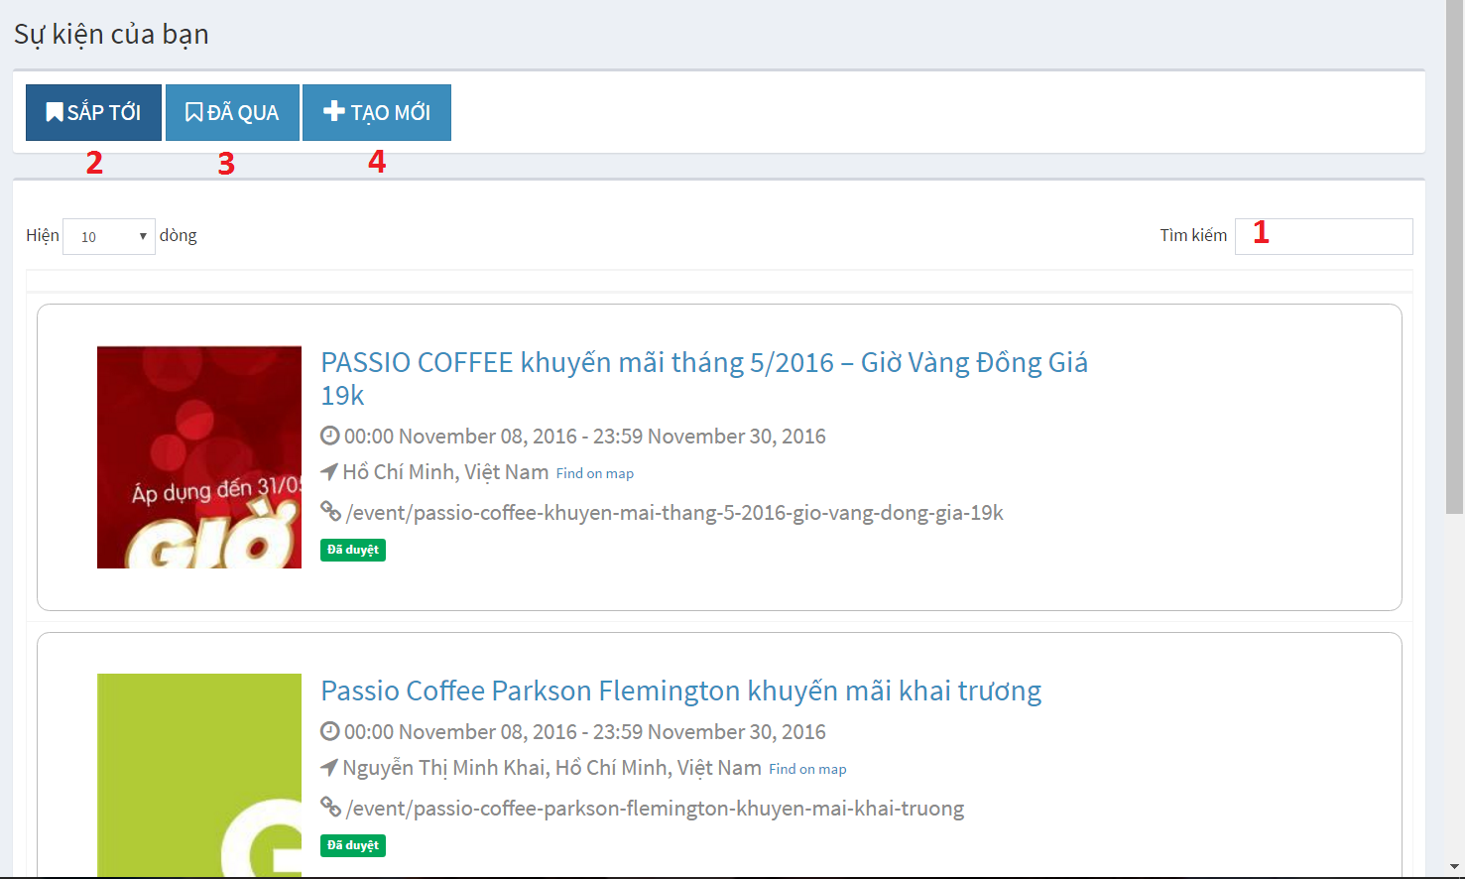

Figure 107: Manage Campaign UI

**Fields**

|  |  |  |  |  |  |  |  |
| --- | --- | --- | --- | --- | --- | --- | --- |
| **No** | **Field Name** | **Description** | **Read only** | **Mandatory** | **Control Type** | **Data Type** | **Length** |
| 1 | Search | Search for campaign | No | No | TextBox | String |  |

Table 62 - <User Interface-Field> Manage Campaign

**Buttons/Hyperlinks:**

|  |  |  |  |  |
| --- | --- | --- | --- | --- |
| **No** | **Function** | **Description** | **Validation** | **Outcome** |
| 2 | Upcoming campaign | Show upcoming campaign | N/A | Show upcoming campaign |
| 3 | Past campaign | Show campaign that already past | N/A | Show campaign that already past |
| 4 | Create campaign | Create new campaign | N/A | Show create new campaign dialog |

Table 63 - <User Interface-Button/Hypperlinks> Manage campaign

* + - 1. Create new campaign

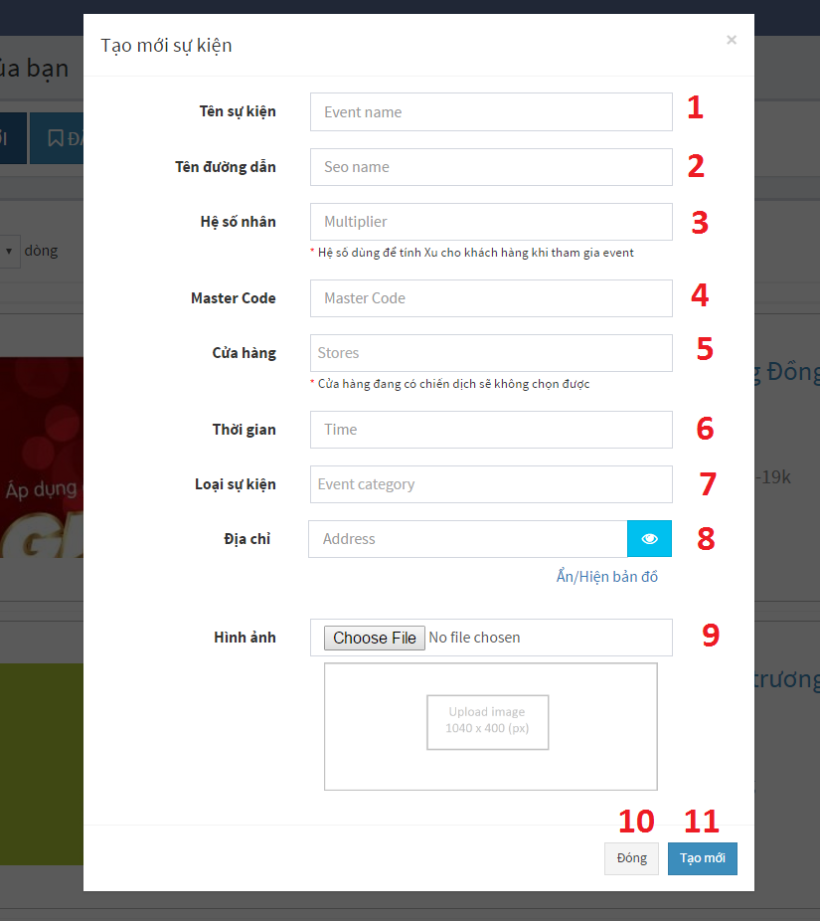

Figure 108: Create new campaign UI

**Fields**

|  |  |  |  |  |  |  |  |
| --- | --- | --- | --- | --- | --- | --- | --- |
| **No** | **Field Name** | **Description** | **Read only** | **Mandatory** | **Control Type** | **Data Type** | **Length** |
| 1 | Campaign name | Campaign name | No | Yes | Textbox | String |  |
| 2 | Seo name | Seo name of campaign | No | Yes | Textbox | String |  |
| 3 | Multiplier |  | No | Yes | Textbox | Float |  |
| 4 | Master code | Code using when user claim gift in app | No | Yes | Textbox | String |  |
| 5 | Store | List of store that campaign will be run at | No | Yes | Dropdown list | Array |  |
| 6 | Time | Campaign start time | No | Yes | Datetime picker | Datetime |  |
| 7 | Category | Cmapaign category | No | Yes | Dropdown list | Array |  |
| 8 | Address | Where campaign will be held | No | Yes | Textbox | String |  |

Table 64 - <User Interface-Field> Create new campaign

**Buttons/Hyperlinks:**

|  |  |  |  |  |
| --- | --- | --- | --- | --- |
| **No** | **Function** | **Description** | **Validation** | **Outcome** |
| 9 | Select image | Select campaign image | Image max resolution is 1040x400 px | Go to manager page if role is Organizer.  Go to main page if role is Normal user |
| 10 | Close | Close create campaign dialog | N/A | Close create new campaign dialog |
| 11 | Create | Create new campaign | Validate all required fields | Go to campaign basic information page |

Table 65 - <User Interface-Button/Hypperlinks> Create new campaign

* + - 1. Edit campaign

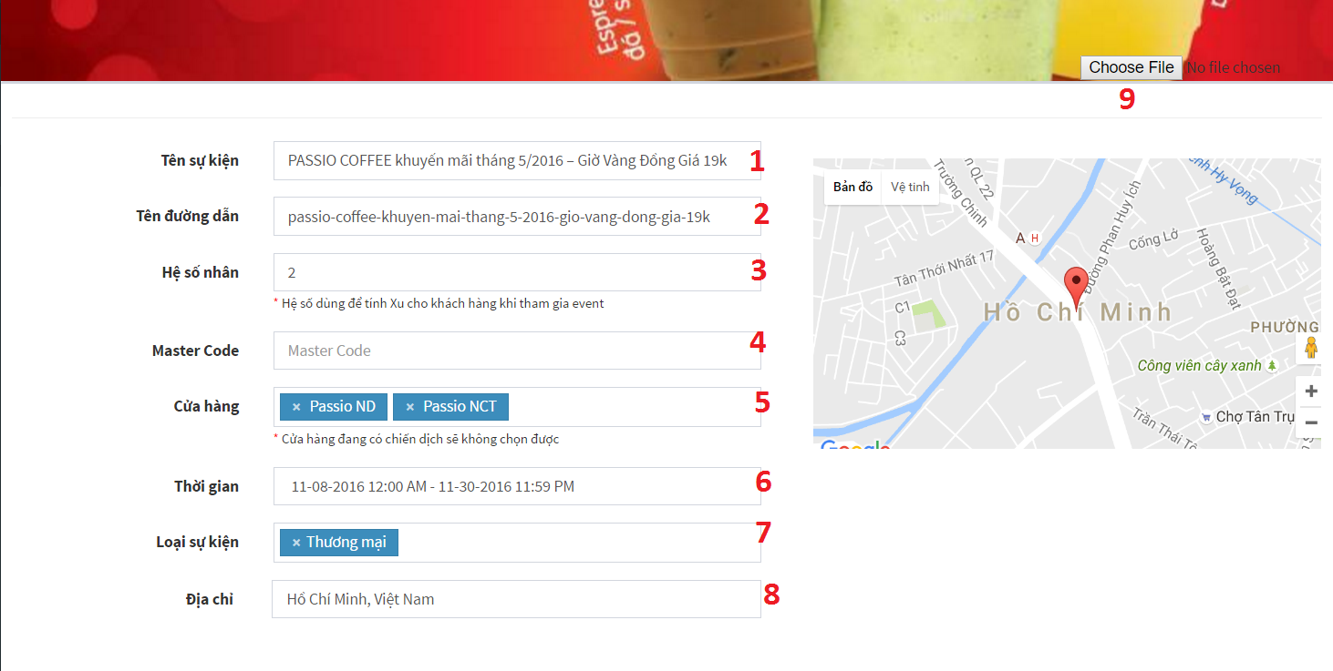

Figure 109: Edit Campaign UI-1

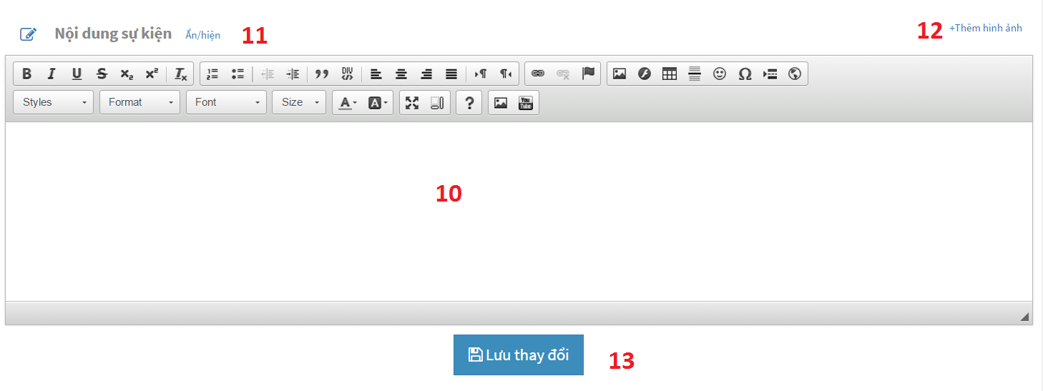

Figure 110 - Edit Campaign UI-2

**Fields**

|  |  |  |  |  |  |  |  |
| --- | --- | --- | --- | --- | --- | --- | --- |
| **No** | **Field Name** | **Description** | **Read only** | **Mandatory** | **Control Type** | **Data Type** | **Length** |
| 1 | Campaign name | Campaign name | No | Yes | Textbox | String |  |
| 2 | Seo name | Seo name of campaign | No | Yes | Textbox | String |  |
| 3 | Multiplier |  | No | Yes | Textbox | Float |  |
| 4 | Master code | Code using when user claim gift in app | No | Yes | Textbox | String |  |
| 5 | Store | List of store that campaign will be run at | No | Yes | Dropdown list | Array |  |
| 6 | Time | Campaign start time | No | Yes | Datetime picker | Datetime |  |
| 7 | Category | Cmapaign category | No | Yes | Dropdown list | Array |  |
| 8 | Address | Where campaign will be held | No | Yes | Textbox | String |  |
| 10 | Content | Campaign content | No | No | Area textbox | String |  |

Table 66 - <User Interface-Field> Edit Campaign

**Buttons/Hyperlinks:**

|  |  |  |  |  |
| --- | --- | --- | --- | --- |
| **No** | **Function** | **Description** | **Validation** | **Outcome** |
| 9 | Select image | Select campaign image | Image max resolution is 1040x400 px | Change campaign image |
| 11 | Show/Hide | Show/hide campaign content dialog | N/A | Close create new campaign dialog |
| 12 | Add image | Add image to campaign | N/A | Go to campaign basic information page |
| 13 | Save change | Save update info change | Validate all required fields | Update campaign information |

Table 67 - <User Interface-Button/Hypperlinks> Edit Campaign

* + - 1. Manage organizer

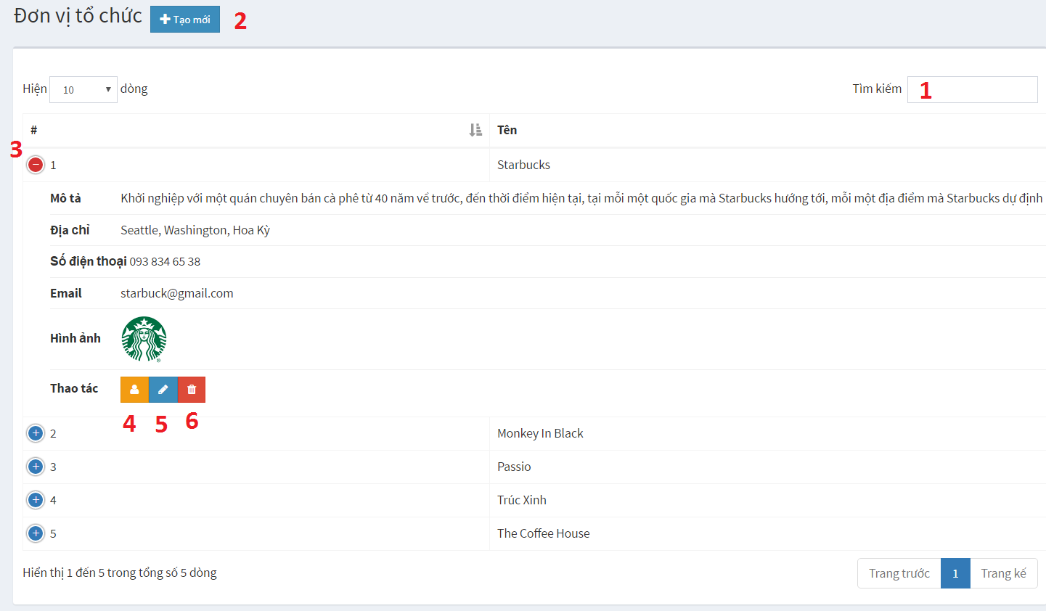

Figure 111: Manage Organizer UI

**Fields**

|  |  |  |  |  |  |  |  |
| --- | --- | --- | --- | --- | --- | --- | --- |
| **No** | **Field Name** | **Description** | **Read only** | **Mandatory** | **Control Type** | **Data Type** | **Length** |
| 1 | Search | Search for organizer | No | No | TextBox | String |  |

Table 68 - <User Interface-Field> Manage Organizer

**Buttons/Hyperlinks:**

|  |  |  |  |  |
| --- | --- | --- | --- | --- |
| **No** | **Function** | **Description** | **Validation** | **Outcome** |
| 3 | Show detail | Show organizer detail | N/A | Show organizer detail information |
| 4 | Show account manage dialog | Show organizer account manage dialog | N/A | Show dialog to manage organizer account |
| 5 | Edit | Edit organizer information | N/A | Show dialog to edit organizer information |
| 6 | Delete | Delete organizer | N/A | Show confirm dialog |

Table 69 - <User Interface-Button/Hypperlinks> Manage Organizer

* + - 1. Edit organize

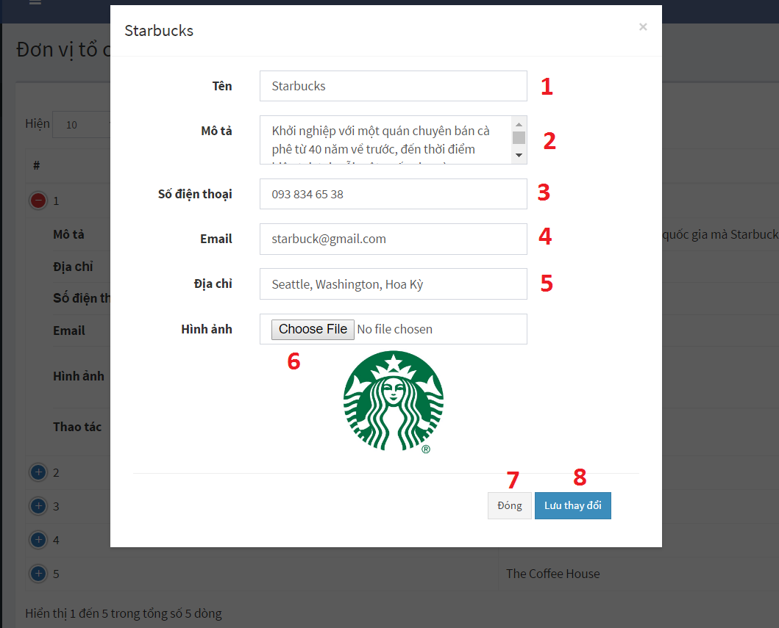

Figure 112: Edit Organizer UI

**Fields**

|  |  |  |  |  |  |  |  |
| --- | --- | --- | --- | --- | --- | --- | --- |
| **No** | **Field Name** | **Description** | **Read only** | **Mandatory** | **Control Type** | **Data Type** | **Length** |
| 1 | Organizer Name | Organizer name | No | Yes | TextBox | String |  |
| 2 | Description | Organizer description | No | Yes | TextBox | String |  |
| 3 | Phone | Phone number | No | Yes | TextBox | String |  |
| 4 | Email | Email of organizer | No | Yes | TextBox | String |  |
| 5 | Address | Organizer address | No | Yes | TextBox | String |  |

Table 70 - <User Interface-Field> Edit Organizer

**Buttons/Hyperlinks:**

|  |  |  |  |  |
| --- | --- | --- | --- | --- |
| **No** | **Function** | **Description** | **Validation** | **Outcome** |
| 6 | Select image | Select organizer image | N/A | Change organizer image |
| 7 | Close | Close edit dialog | N/A | Close edit dialog |
| 8 | Save change | Save change | Validate all required info | Update organizer information |

Table 71 - <User Interface-Button/Hypperlinks> Edit Organizer

* + - 1. Manage campaign categories

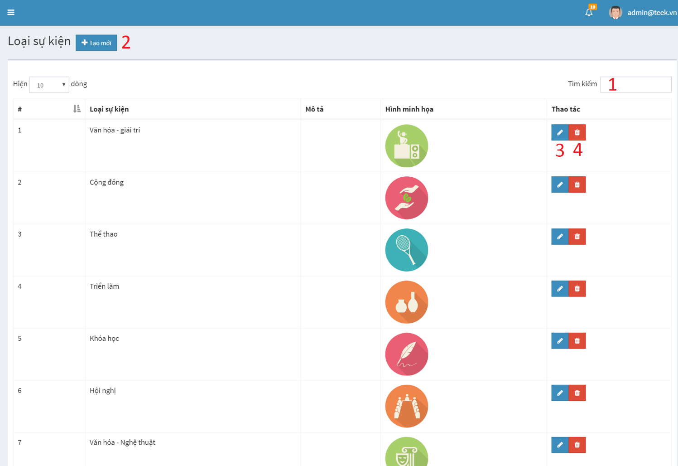

Figure 113: Manage campaign category UI

**Fields**

|  |  |  |  |  |  |  |  |
| --- | --- | --- | --- | --- | --- | --- | --- |
| **No** | **Field Name** | **Description** | **Read only** | **Mandatory** | **Control Type** | **Data Type** | **Length** |
| 1 | Search | Keyword to search | No | Yes | TextBox | String |  |

Table 72 - <User Interface-Field> Edit Campaign Category

**Buttons/Hyperlinks:**

|  |  |  |  |  |
| --- | --- | --- | --- | --- |
| **No** | **Function** | **Description** | **Validation** | **Outcome** |
| 2 | Add new | Add new category | N/A | Show |
| 4 | Edit | Edit category | N/A | Edit category information |
| 5 | Delete | Delete category | N/A | Show confirm dialog |

Table 73 - <User Interface-Button/Hypperlinks> Edit Campaign Category

* + - 1. View participant list

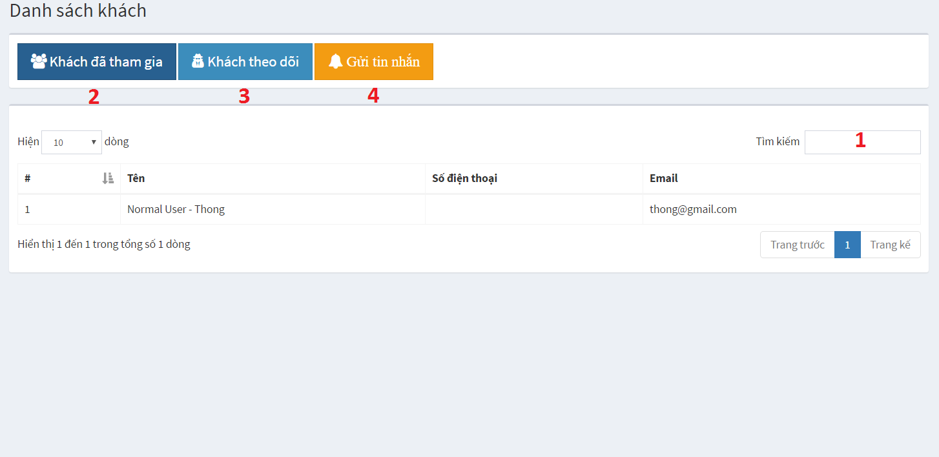

Figure 114: View Participant List UI

**Fields**

|  |  |  |  |  |  |  |  |
| --- | --- | --- | --- | --- | --- | --- | --- |
| **No** | **Field Name** | **Description** | **Read only** | **Mandatory** | **Control Type** | **Data Type** | **Length** |
| 1 | Search | Keyword to search | No | Yes | TextBox | String |  |

Table 74 - <User Interface-Field> View Participant List

**Buttons/Hyperlinks:**

|  |  |  |  |  |
| --- | --- | --- | --- | --- |
| **No** | **Function** | **Description** | **Validation** | **Outcome** |
| 2 | View participant | Add new category | N/A | Show list of participant |
| 4 | View follower | Edit category | N/A | Show list of follower |
| 5 | Send notification | Send notification to user | N/A | Show send notification dialog |

Table 75 - <User Interface-Button/Hypperlinks> View Participant List

* + - 1. Manage component

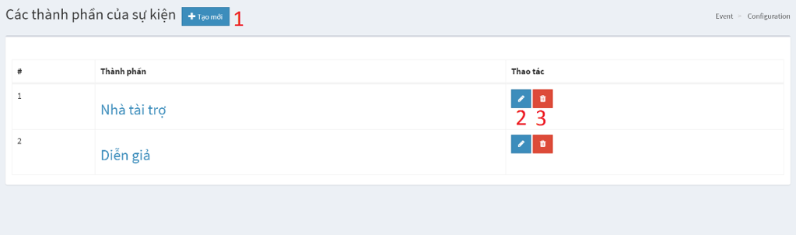

Figure 115: Manage Campaign Component UI

**Buttons/Hyperlinks:**

|  |  |  |  |  |
| --- | --- | --- | --- | --- |
| **No** | **Function** | **Description** | **Validation** | **Outcome** |
| 2 | Create | Create new component | N/A | Show dialog for create new component |
| 4 | Edit | Edit component | N/A | Show dialog for edit component information |
| 5 | Delete | Delete component | N/A | Show confirm dialog |

Table 76 - <User Interface-Button/Hypperlinks> Manage Campaign Component

* + - 1. Manage survey

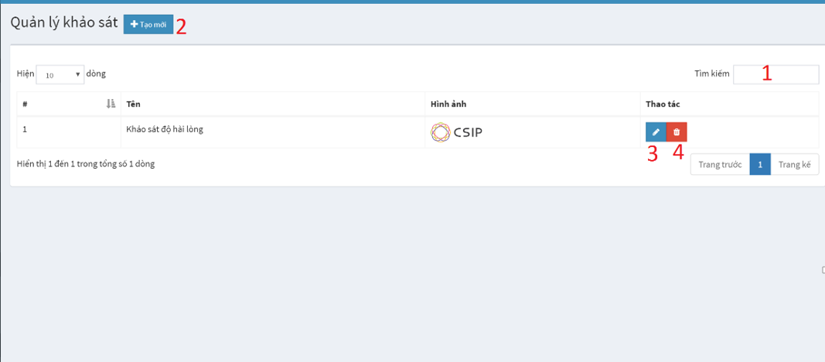

Figure 116: Manage Survey UI

**Fields**

|  |  |  |  |  |  |  |  |
| --- | --- | --- | --- | --- | --- | --- | --- |
| **No** | **Field Name** | **Description** | **Read only** | **Mandatory** | **Control Type** | **Data Type** | **Length** |
| 1 | Search | Keyword to search | No | Yes | TextBox | String |  |

Table 77 - <User Interface-Field> Manage Survey

**Buttons/Hyperlinks:**

|  |  |  |  |  |
| --- | --- | --- | --- | --- |
| **No** | **Function** | **Description** | **Validation** | **Outcome** |
| 2 | Create | Create new survey | N/A | Show dialog for create new survey |
| 4 | Edit | Edit survey | N/A | Show dialog for edit survey information |
| 5 | Delete | Delete survey | N/A | Show confirm dialog |

Table 78 - <User Interface-Button/Hypperlinks> Manage Survey

* + - 1. Create survey

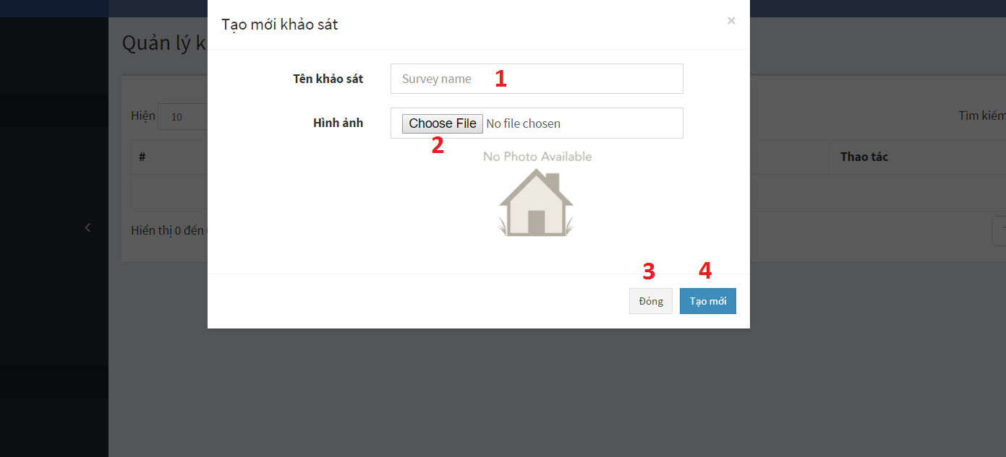

Figure 117: Create Survey UI

**Fields**

|  |  |  |  |  |  |  |  |
| --- | --- | --- | --- | --- | --- | --- | --- |
| **No** | **Field Name** | **Description** | **Read only** | **Mandatory** | **Control Type** | **Data Type** | **Length** |
| 1 | Survey name | Name of survey | No | Yes | TextBox | String |  |

Table 79 - <User Interface-Field> Create Survey

**Buttons/Hyperlinks:**

|  |  |  |  |  |
| --- | --- | --- | --- | --- |
| **No** | **Function** | **Description** | **Validation** | **Outcome** |
| 2 | Select image | Select survey image | N/A | Show dialog to select image |
| 4 | Close | Close create dialog | N/A | Close create dialog |
| 5 | Create | Create new survey | Validate all required info | Create new survey |

Table 80 - <User Interface-Button/Hypperlinks> Create Survey

* + - 1. Create questions for survey

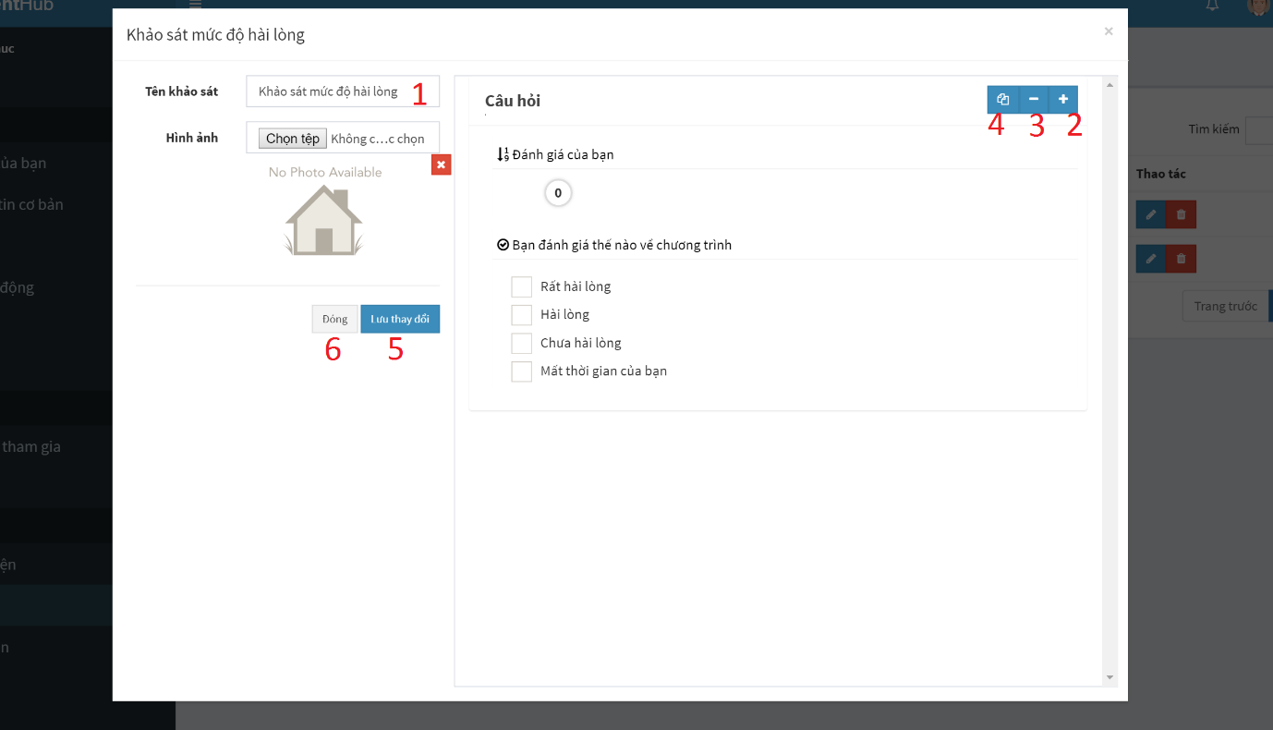

Figure 118 - Create Question For Survey UI-1

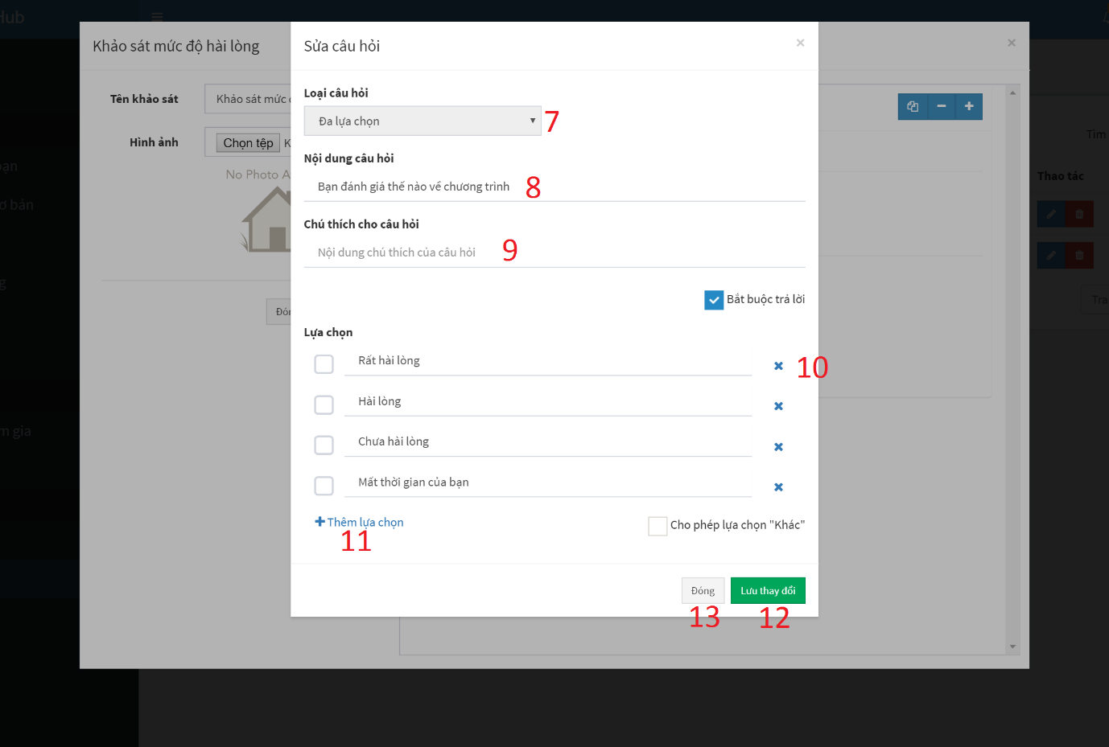

Figure 119 – Create Question For Survey UI-2

**Fields**

|  |  |  |  |  |  |  |  |
| --- | --- | --- | --- | --- | --- | --- | --- |
| **No** | **Field Name** | **Description** | **Read only** | **Mandatory** | **Control Type** | **Data Type** | **Length** |
| 1 | Survey name | Survey name | No | Yes | TextBox | String |  |
| 7 | Question type | Question type | No | Yes | Dropdown | Int |  |
| 8 | Question content | Question content | No | Yes | TextBox | String |  |
| 9 | Question note | Note for quesrion | No | No | TextBox | String |  |

Table 81 - <User Interface-Field> Create Question For Survey

**Buttons/Hyperlinks:**

|  |  |  |  |  |
| --- | --- | --- | --- | --- |
| **No** | **Function** | **Description** | **Validation** | **Outcome** |
| 2 | Create question | Send add new question command | N/A | Show create question for survey modal |
| 3 | Collapse | Collapse question content | N/A | Collapse question content |
| 4 | Duplicate | Duplicating question | N/A | Duplicating question |
| 5 | Save | Send change datasource command | Validate all required fields before submit. | Submit save change datasource. |
| 6 | Close | Close survey modal | N/A | Close survey modal |
| 10 | Delete option | Delete option of question | N/A | Show delete option modal |
| 11 | Add option | Add option for question | N/A | Add option for question |
| 12 | Save | Send change datasource command | Validate all required fields before submit. | Submit save change datasource. |
| 13 | Close | Close question modal | N/A | Close question modal |

Table 82 - <User Interface-Button/Hypperlinks> Create Question For Survey

* + - 1. Manage activity

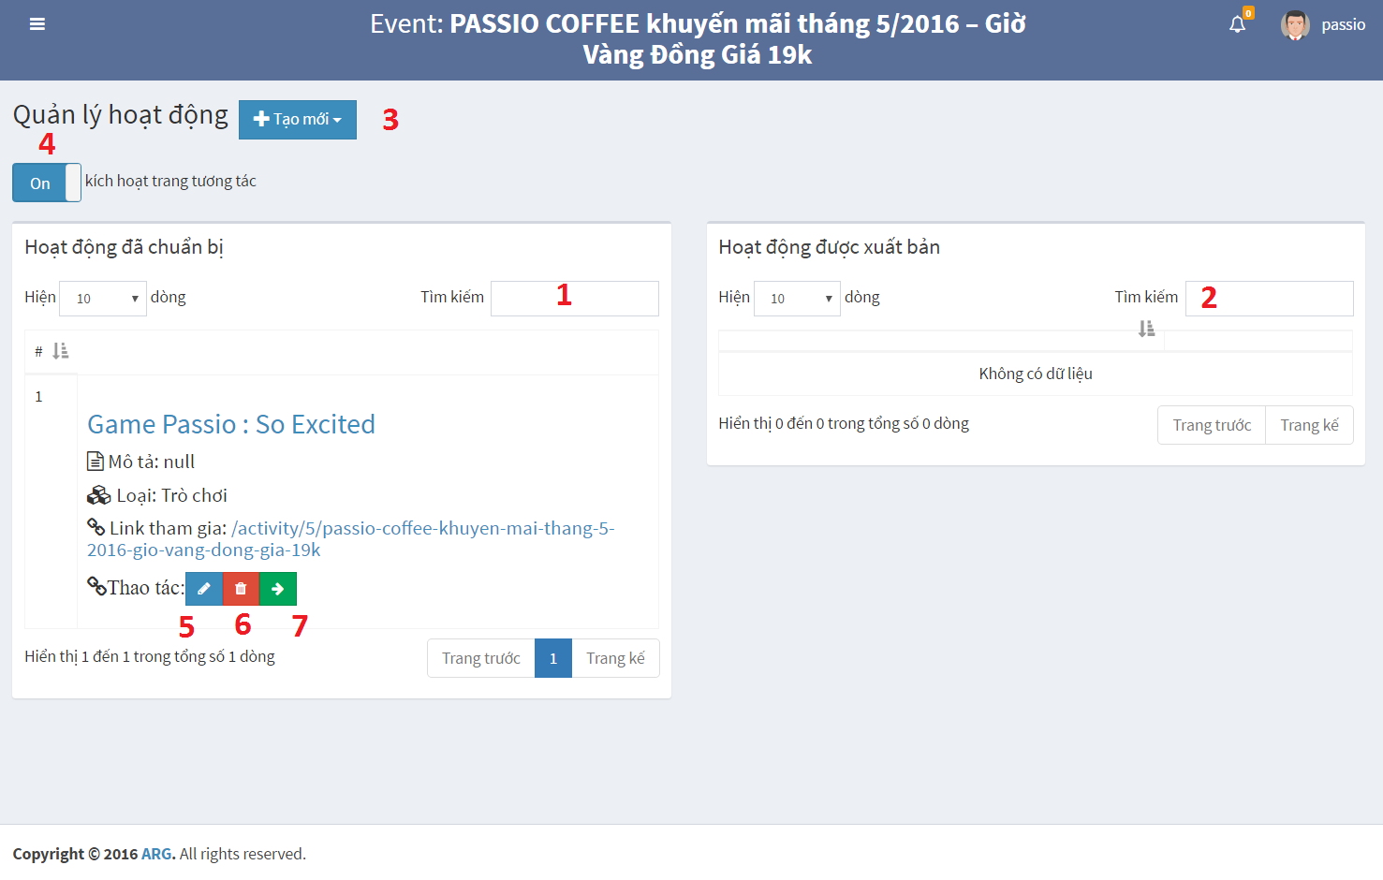

Figure 120 – Manage Activity UI

**Fields**

|  |  |  |  |  |  |  |  |
| --- | --- | --- | --- | --- | --- | --- | --- |
| **No** | **Field Name** | **Description** | **Read only** | **Mandatory** | **Control Type** | **Data Type** | **Length** |
| 1 | Search | Keyword for search unpublished activity | No | No | TextBox | String |  |
| 2 | Search | Keyword for search published activity | No | No | TextBox | String |  |

Table 83 - <User Interface-Field> Manage Activity

**Buttons/Hyperlinks:**

|  |  |  |  |  |
| --- | --- | --- | --- | --- |
| **No** | **Function** | **Description** | **Validation** | **Outcome** |
| 3 | Create activity | Create new activity for campaign | N/A | Show dropdown list to choose type of activity |
| 4 | On/Off | Publish activity | N/A | Show publish activity modal |
| 5 | Edit activity | Edit activity information | N/A | Show edit modal |
| 6 | Delete activity | Delete activity | N/A | Show comfirm dialog |
| 7 | Publish activity | Publish activity | N/A | Show publish modal |

Table 84 - <User Interface-Button/Hypperlinks> Manage Activity

* + - 1. Create game

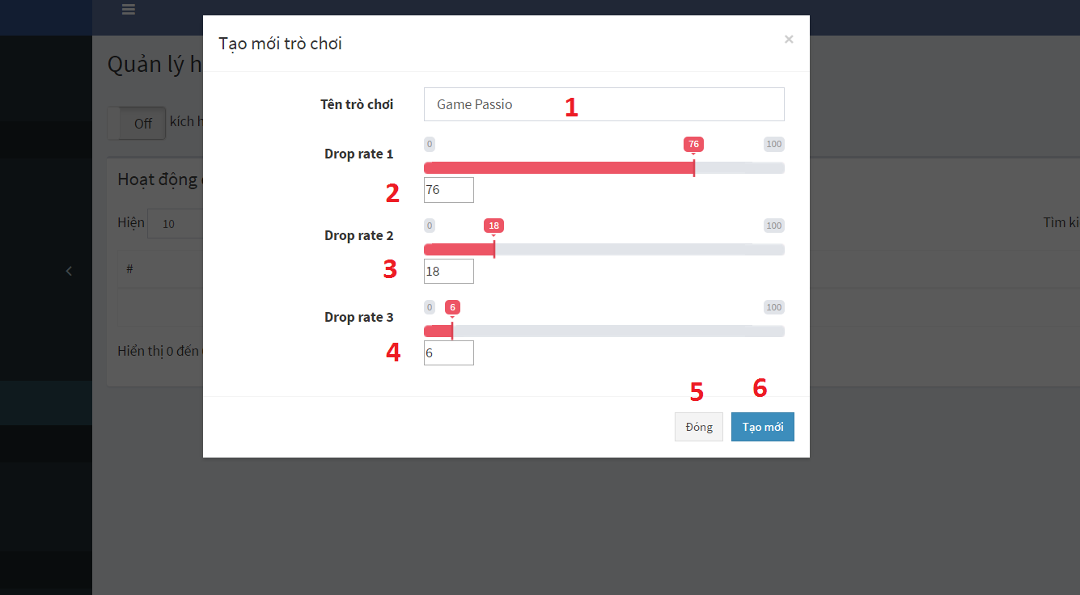

Figure 121 – Create Game UI

**Fields**

|  |  |  |  |  |  |  |  |
| --- | --- | --- | --- | --- | --- | --- | --- |
| **No** | **Field Name** | **Description** | **Read only** | **Mandatory** | **Control Type** | **Data Type** | **Length** |
| 1 | Name | Game’s name | No | Yes | TextBox | String |  |
| 2 | Drop rate 1 | Item combo 1 drop rate for game | No | Yes | TextBox | Int |  |
| 3 | Drop rate 2 | Item combo 2 drop rate for game | No | Yes | TextBox | Int |  |
| 4 | Drop rate 3 | Item combo 3 drop rate for game | No | No | TextBox | Int |  |

Table 85 - <User Interface-Field> Create Game

**Buttons/Hyperlinks:**

|  |  |  |  |  |
| --- | --- | --- | --- | --- |
| **No** | **Function** | **Description** | **Validation** | **Outcome** |
| 5 | Close | Close create game modal | N/A | Close create game modal |
| 6 | Create game | Create new game for campaign | Validate all required info | Create new game |

Table 86 - <User Interface-Button/Hypperlinks> Create Question For Survey

* + - 1. Manage prize

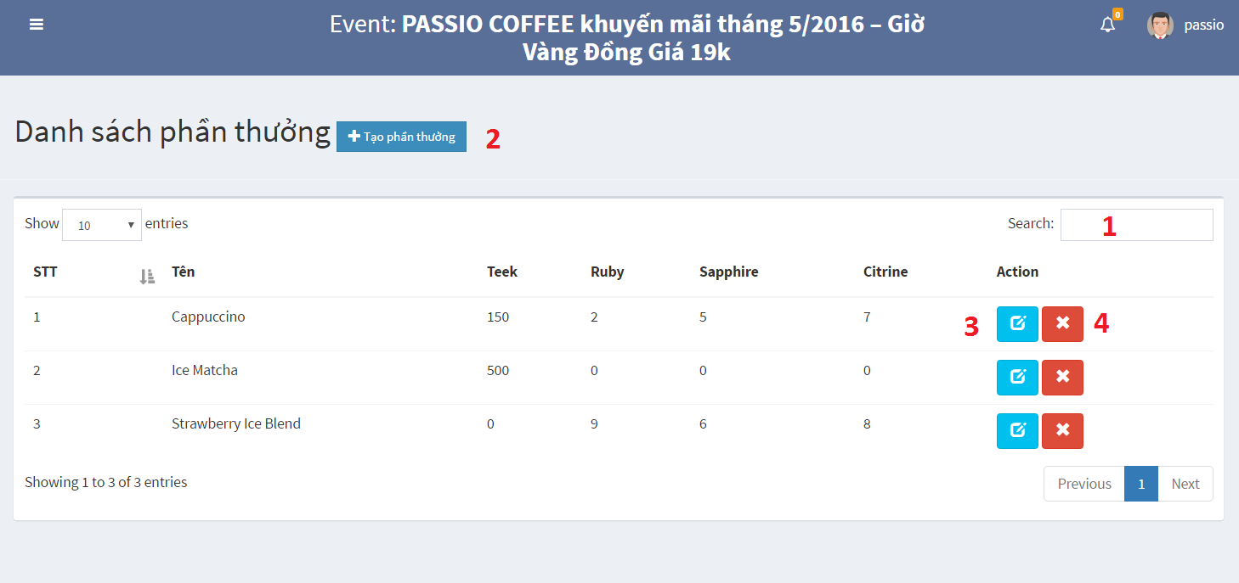

Figure 122 – Manage Prize

**Fields**

|  |  |  |  |  |  |  |  |
| --- | --- | --- | --- | --- | --- | --- | --- |
| **No** | **Field Name** | **Description** | **Read only** | **Mandatory** | **Control Type** | **Data Type** | **Length** |
| 1 | Search | Keyword for search | No | No | TextBox | String |  |

Table 87 - <User Interface-Field> Manage Prize

**Buttons/Hyperlinks:**

|  |  |  |  |  |
| --- | --- | --- | --- | --- |
| **No** | **Function** | **Description** | **Validation** | **Outcome** |
| 2 | Create prize | Create new prize | N/A | Show create modal |
| 3 | Edit prize | Edit prize information | N/A | Show edit modal |
| 4 | Delete prize | Delete prize | N/A | Show comfirm dialog |

Table 88 - <User Interface-Button/Hypperlinks> Manage Prize

* + - 1. Create new prize

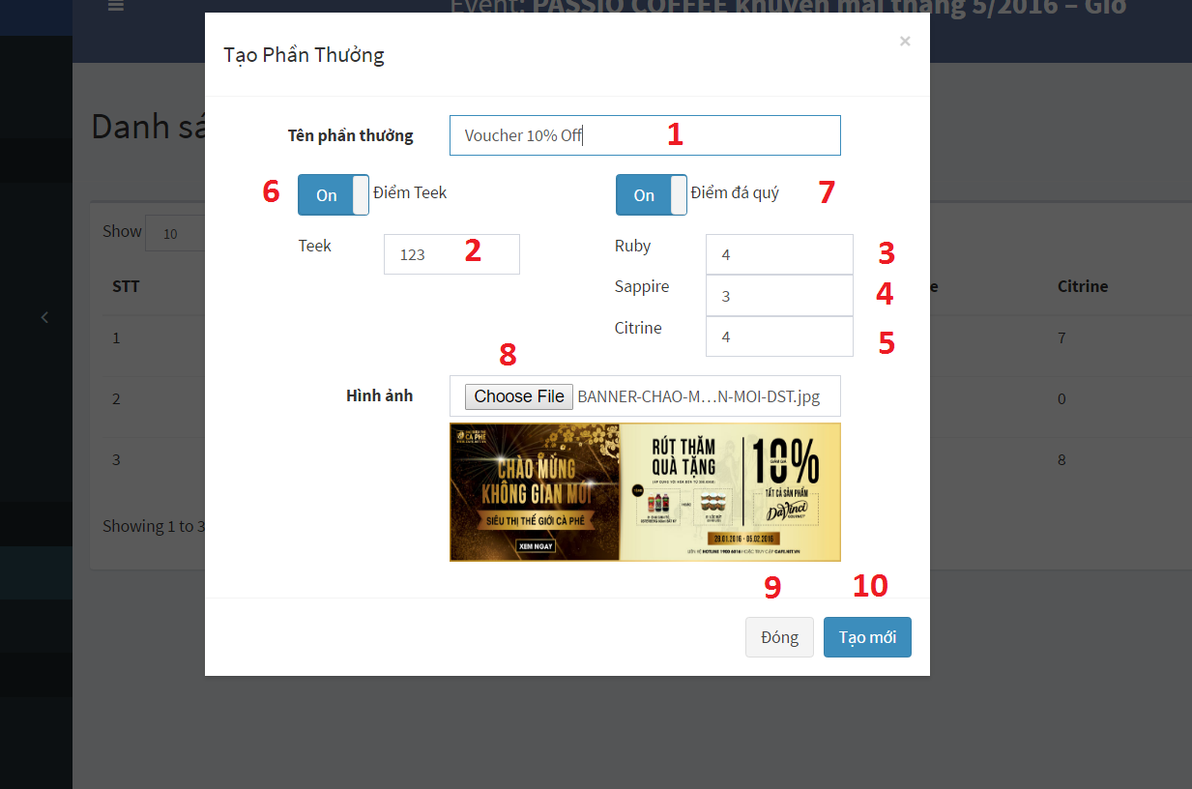

Figure 123 – Create Prize

**Fields**

|  |  |  |  |  |  |  |  |
| --- | --- | --- | --- | --- | --- | --- | --- |
| **No** | **Field Name** | **Description** | **Read only** | **Mandatory** | **Control Type** | **Data Type** | **Length** |
| 1 | Name | Prize name | No | Yes | TextBox | String |  |
| 2 | Teek | Teek point to redeem prize | No | Yes | TextBox | Int |  |
| 3 | Ruby | Ruby number to redeem prize | No | Yes | TextBox | String |  |
| 4 | Sapphire | Sapphire number to redeem prize | No | Yes | TextBox | String |  |
| 5 | Citrine | Citrine number to redeem prize | No | Yes | TextBox | String |  |

Table 89 - <User Interface-Field> Create Prize

**Buttons/Hyperlinks:**

|  |  |  |  |  |
| --- | --- | --- | --- | --- |
| **No** | **Function** | **Description** | **Validation** | **Outcome** |
| 6 | Teek point | Show input teek point modal | N/A | Show input teek point modal. Teek point become required |
| 7 | Gem combo | Show input gem modal | N/A | Show input gem modal. Gem combo become required |
| 8 | Select image | Select prize image | N/A | Show select image dialog |
| 9 | Close | Close create modal | N/A | Close create modal |
| 10 | Create | Create prize | Validate all required field | Create new prize |

Table 90 - <User Interface-Button/Hypperlinks> Create Prize

* + - 1. Manage store

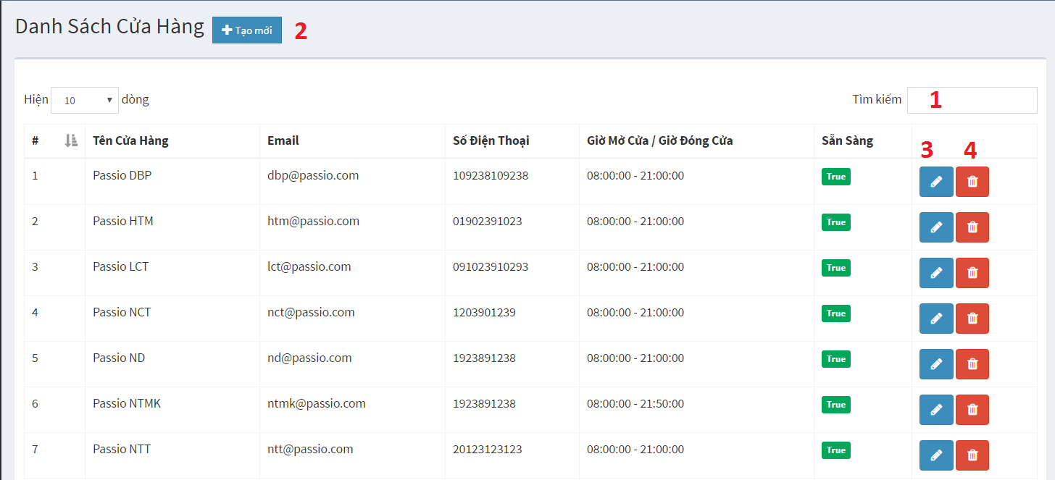

Figure 124 – Manage Store

**Fields**

|  |  |  |  |  |  |  |  |
| --- | --- | --- | --- | --- | --- | --- | --- |
| **No** | **Field Name** | **Description** | **Read only** | **Mandatory** | **Control Type** | **Data Type** | **Length** |
| 1 | Search | Keyword for search | No | No | TextBox | String |  |

Table 91 - <User Interface-Field> Manage Store

**Buttons/Hyperlinks:**

|  |  |  |  |  |
| --- | --- | --- | --- | --- |
| **No** | **Function** | **Description** | **Validation** | **Outcome** |
| 2 | Create store | Create new store | N/A | Show create modal |
| 3 | Edit store | Edit store information | N/A | Show edit modal |
| 4 | Delete store | Delete store | N/A | Show comfirm dialog |

Table 92 - <User Interface-Button/Hypperlinks> Manage Store

* + - 1. Create store

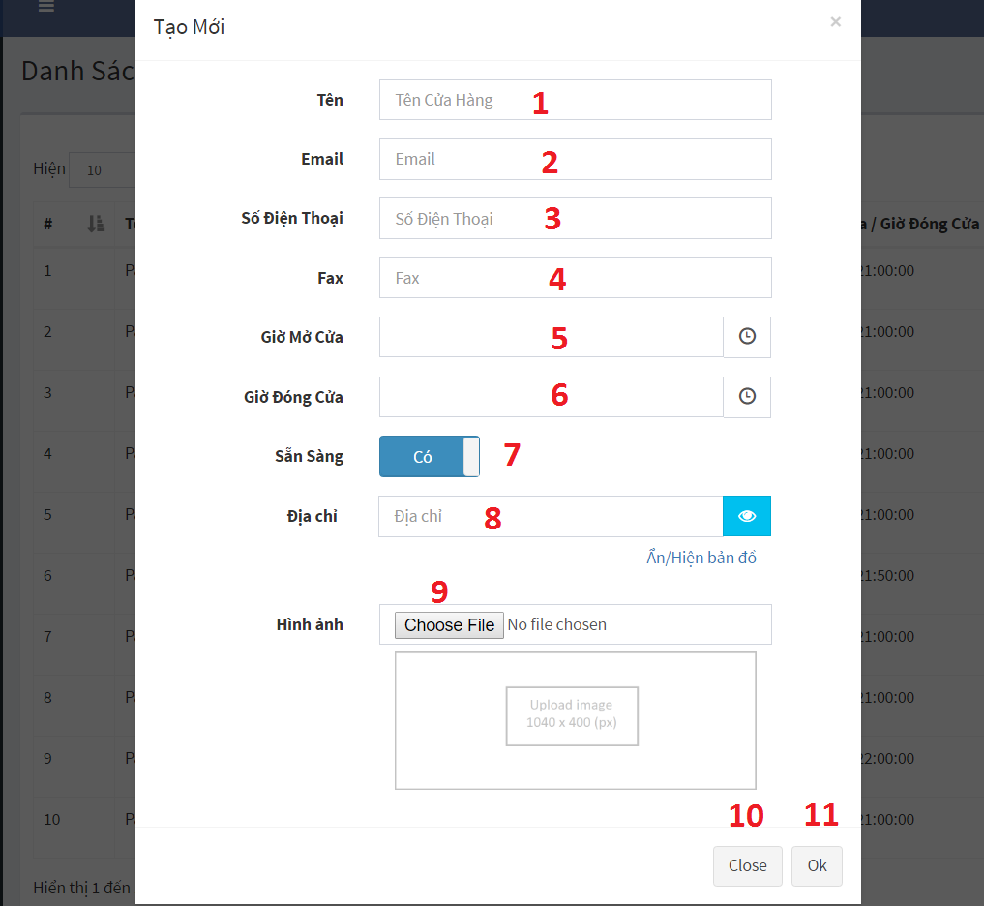

Figure 125 – Create Store

**Fields**

|  |  |  |  |  |  |  |  |
| --- | --- | --- | --- | --- | --- | --- | --- |
| **No** | **Field Name** | **Description** | **Read only** | **Mandatory** | **Control Type** | **Data Type** | **Length** |
| 1 | Name | Store name | No | Yes | TextBox | String |  |
| 2 | Email | Store email | No | Yes | TextBox | String |  |
| 3 | Phone | Store phone | No | Yes | TextBox | String |  |
| 4 | Fax | Store fax | No | Yes | TextBox | String |  |
| 5 | Open time | Store open time | No | Yes | Time picker | Time |  |
| 6 | Close time | Store close time | No | Yes | Time picker | Time |  |
| 7 | Available | Store is active or not | No | Yes | Switch button | Boolean |  |
| 8 | Address | Store address | No | Yes | Switch button | String |  |

Table 93 - <User Interface-Field> Create Store

**Buttons/Hyperlinks:**

|  |  |  |  |  |
| --- | --- | --- | --- | --- |
| **No** | **Function** | **Description** | **Validation** | **Outcome** |
| 9 | Select image | Select store image | N/A | Show select image dialog |
| 10 | Close | Close create modal | N/A | Close create modal |
| 11 | Ok | Create new store | Validate all required info | Create new store |

Table 94 - <User Interface-Button/Hypperlinks> Create Store

* + - 1. Manage wifi router

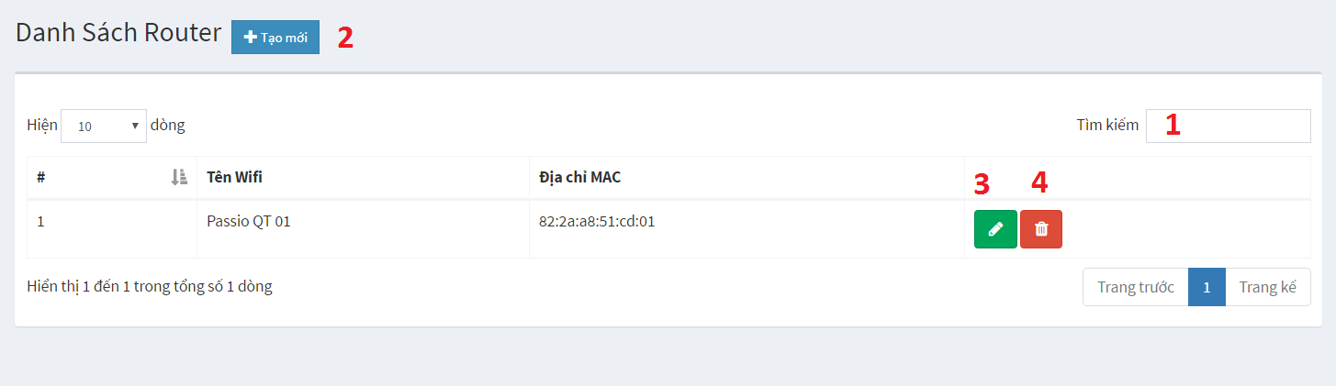

Figure 126 – Manage Wifi Router

**Fields**

|  |  |  |  |  |  |  |  |
| --- | --- | --- | --- | --- | --- | --- | --- |
| **No** | **Field Name** | **Description** | **Read only** | **Mandatory** | **Control Type** | **Data Type** | **Length** |
| 1 | Search | Keyword for search | No | No | TextBox | String |  |

Table 95 - <User Interface-Field> Manage Wifi Router

**Buttons/Hyperlinks:**

|  |  |  |  |  |
| --- | --- | --- | --- | --- |
| **No** | **Function** | **Description** | **Validation** | **Outcome** |
| 2 | Create wifi router | Create new wifi router | N/A | Show create modal |
| 3 | Edit wifi router | Edit wifi router information | N/A | Show edit modal |
| 4 | Delete wifi router | Delete wifi router | N/A | Show comfirm dialog |

Table 96 - <User Interface-Button/Hypperlinks> Manage Wifi Router

* + - 1. Create new wifi router

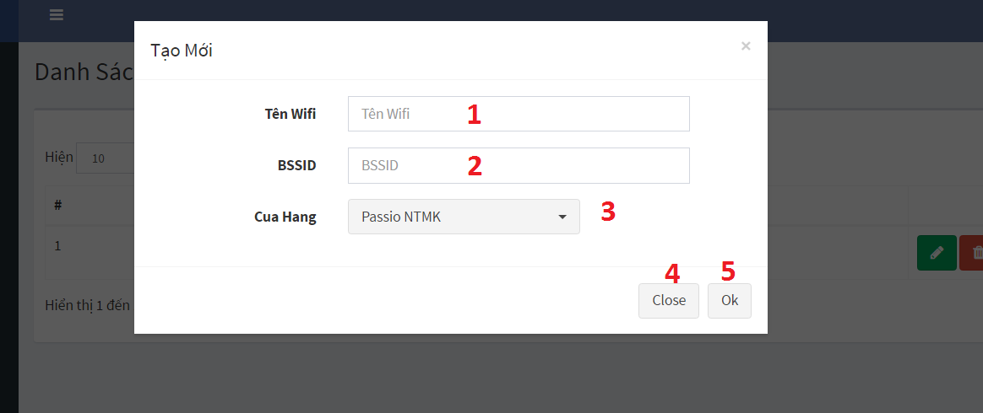

Figure 127 – Create Wifi Router

**Fields**

|  |  |  |  |  |  |  |  |
| --- | --- | --- | --- | --- | --- | --- | --- |
| **No** | **Field Name** | **Description** | **Read only** | **Mandatory** | **Control Type** | **Data Type** | **Length** |
| 1 | Router name | Wifi router name | No | Yes | TextBox | String |  |
| 7 | BSSID | BSSID of router | No | Yes | TextBox | String |  |
| 3 | Store | Store where wifi router is places | No | Yes | Dropdown list | Int |  |

Table 97 - <User Interface-Field> Create Wifi Router

**Buttons/Hyperlinks:**

|  |  |  |  |  |
| --- | --- | --- | --- | --- |
| **No** | **Function** | **Description** | **Validation** | **Outcome** |
| 4 | Close | Close create modal | N/A | Close create modal |
| 5 | Ok | Send request to create new wifi router | Validate all required info | Create wifi router |

Table 98 - <User Interface-Button/Hypperlinks> Create Wifi Router

* + 1. Mobile application user interface
       1. Register

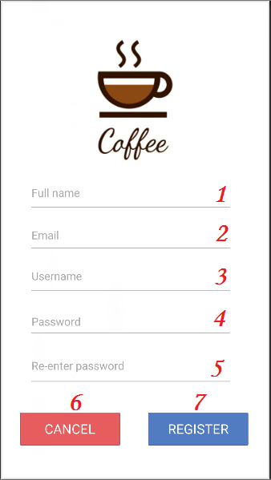

Figure 128 – Register Mobile App UI

**Fields**

|  |  |  |  |  |  |  |  |
| --- | --- | --- | --- | --- | --- | --- | --- |
| **No** | **Field Name** | **Description** | **Read only** | **Mandatory** | **Control Type** | **Data Type** | **Length** |
| 1 | Enter your full name | Full name of Customer | No | No | Textbox | String |  |
| 2 | Enter your email | Email of Customer | No | Yes | Textbox | String |  |
| 3 | Enter your Username | username of customer | No | Yes | Textbox | String |  |
| 4 | Enter your password | Password of customer | No | Yes | Textbox | String |  |
| 5 | Re-enter password | Re enter password | No | Yes | Textbox | String |  |

Table 99 - <User Interface-Field> Register – Mobile App

**Buttons/Hyperlinks:**

|  |  |  |  |  |
| --- | --- | --- | --- | --- |
| **No** | **Function** | **Description** | **Validation** | **Outcome** |
| 3 | SignUp | Redirect to register page | N/A | Redirect to register page |
| 4 | Login | Send login command | N/A | Submit login command |

Table 100 - <User Interface-Button/Hypperlinks> Register – Mobile App

* + - 1. Login

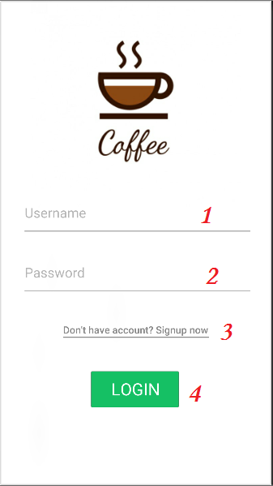

Figure 129 – Login Mobile App UI

**Fields**

|  |  |  |  |  |  |  |  |
| --- | --- | --- | --- | --- | --- | --- | --- |
| **No** | **Field Name** | **Description** | **Read only** | **Mandatory** | **Control Type** | **Data Type** | **Length** |
| 1 | Username | Fill Username | No | Yes | Textbox | String |  |
| 2 | Password | Fill Password | No | Yes | Password | String |  |

Table 101 - <User Interface-Field> Login – Mobile App

**Buttons/Hyperlinks:**

|  |  |  |  |  |
| --- | --- | --- | --- | --- |
| **No** | **Function** | **Description** | **Validation** | **Outcome** |
| 3 | SignUp | Redirect to register page | N/A | Redirect to register page |
| 4 | Login | Send login command | N/A | Submit login command |

Table 102 - <User Interface-Button/Hypperlinks> Login – Mobile App

* + - 1. Home

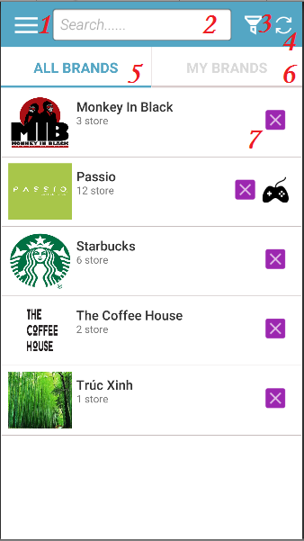

Figure 130 – Home Mobile App UI

**Fields**

|  |  |  |  |  |  |  |  |
| --- | --- | --- | --- | --- | --- | --- | --- |
| **No** | **Field Name** | **Description** | **Read only** | **Mandatory** | **Control Type** | **Data Type** | **Length** |
| 2 | Search | Search field, search by name | No | Yes | Textbox | String |  |

Table 103 - <User Interface-Field> Home – Mobile App

**Buttons/Hyperlinks:**

|  |  |  |  |  |
| --- | --- | --- | --- | --- |
| **No** | **Function** | **Description** | **Validation** | **Outcome** |
| 1 | Menu | Open Side Menu | N/A | Show side menu |
| 3 | Filter | Filter buton | N/A | Show sub filter menu |
| 4 | Refresh | Refresh button | N/A | Refresh page |
| 5 | All Brands | All Brands | N/A | Show All brands Screen |
| 6 | My Brands | My Brands | N/A | Show My brands Screen |
| 7 | Brand | Brand link | N/A | Redirected to Brand Details Screen |

Table 104 - <User Interface-Button/Hypperlinks> Home – Mobile App

* + - 1. My Brand

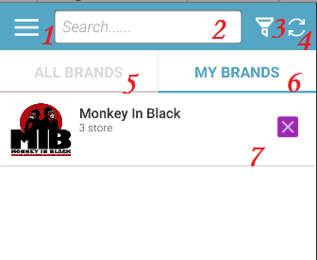

Figure 131 – My Brand Mobile App UI

**Fields**

|  |  |  |  |  |  |  |  |
| --- | --- | --- | --- | --- | --- | --- | --- |
| **No** | **Field Name** | **Description** | **Read only** | **Mandatory** | **Control Type** | **Data Type** | **Length** |
| 1 | Username | Fill Username | No | Yes | Textbox | String |  |
| 2 | Password | Fill Password | No | Yes | Password | String |  |

Table 105 - <User Interface-Field> My Brand – Mobile App

**Buttons/Hyperlinks:**

|  |  |  |  |  |
| --- | --- | --- | --- | --- |
| **No** | **Function** | **Description** | **Validation** | **Outcome** |
| 3 | SignUp | Redirect to register page | N/A | Redirect to register page |
| 4 | Login | Send login command | N/A | Submit login command |

Table 106 - <User Interface-Button/Hypperlinks> My Brand – Mobile App

* + - 1. Brand Detail

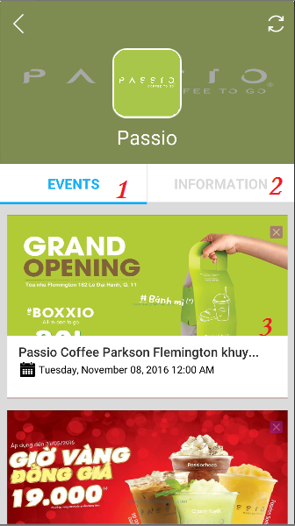

Figure 132 – Brand Detail Mobile App UI

**Fields**

**Buttons/Hyperlinks:**

|  |  |  |  |  |
| --- | --- | --- | --- | --- |
| **No** | **Function** | **Description** | **Validation** | **Outcome** |
| 1 | Events | Events tab | N/A | Redirected to Events Tab |
| 2 | Information | Information tab | N/A | Redirected to information tab |
| 3 | Event | Event link | N/A | Redirected to Event Details Screen. |

Table 107 - <User Interface-Button/Hypperlinks> Brand Detail – Mobile App

* + - 1. Claim Gift

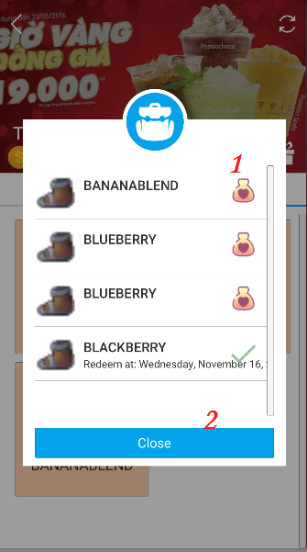

Figure 133 – Claim Gift Mobile App UI

**Buttons/Hyperlinks:**

|  |  |  |  |  |
| --- | --- | --- | --- | --- |
| **No** | **Function** | **Description** | **Validation** | **Outcome** |
| 1 | Redeem | popup new screen for enter redeem code | N/A | Redirected to enter redeem code screen |
| 2 | Close | Close | N/A | Close popup |

Table 108 - <User Interface-Button/Hypperlinks> Claim Gift – Mobile App

* + - 1. Campaign Detail

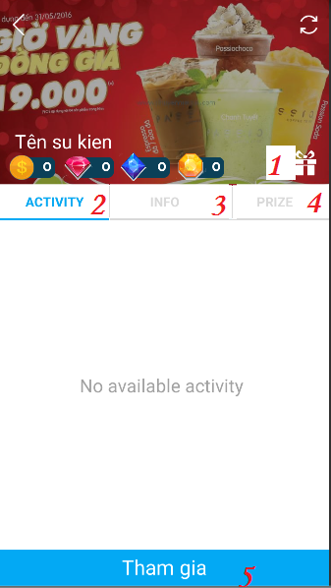

Figure 134 – Campaign Detail Mobile App UI

**Buttons/Hyperlinks:**

|  |  |  |  |  |
| --- | --- | --- | --- | --- |
| **No** | **Function** | **Description** | **Validation** | **Outcome** |
| 1 | Prize Redeem | Enter Redeem code | N/A | Show Prize Redeem popup screen |
| 2 | Activity | Activity of event | N/A | Redirected to Acitivity tab |
| 3 | Info | Information of Event | N/A | Redirected to Info tab |
| 4 | Prize | Available Prize of event | N/A | Redirected to Prize tab |
| 5 | Tham Gia | Button allow customer join event | N/A | Redirected to Event Details Screen with Joined State |

Table 109 - <User Interface-Button/Hypperlinks> Campaign Detail – Mobile App

* + - 1. Join Activity

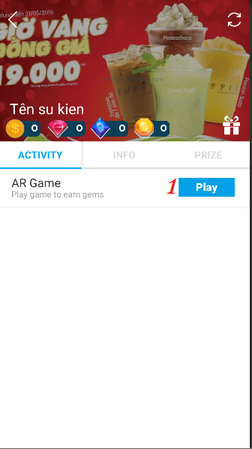

Figure 135 – Join Activity Mobile App UI

**Buttons/Hyperlinks:**

|  |  |  |  |  |
| --- | --- | --- | --- | --- |
| **No** | **Function** | **Description** | **Validation** | **Outcome** |
| 1 | Play | Play game | N/A | Redirected to Game Screen |

Table 110 - <User Interface-Button/Hypperlinks> Join Activity – Mobile App

* + - 1. Prize

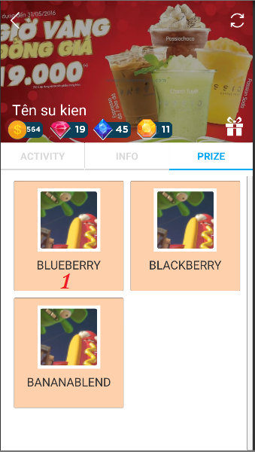

Figure 136 – Prize Mobile App UI

**Buttons/Hyperlinks:**

|  |  |  |  |  |
| --- | --- | --- | --- | --- |
| **No** | **Function** | **Description** | **Validation** | **Outcome** |
| 1 | Prize | Prize’s combo | N/A | Show Prize combo screen |

Table 111 - <User Interface-Button/Hypperlinks> Prize – Mobile App

* + - 1. Redeem Prize

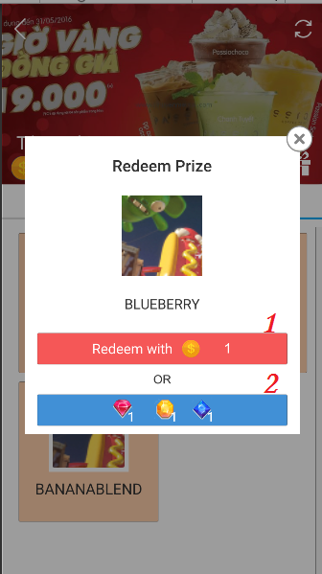

Figure 137 – Redeem Prize Mobile App UI

**Buttons/Hyperlinks:**

|  |  |  |  |  |
| --- | --- | --- | --- | --- |
| **No** | **Function** | **Description** | **Validation** | **Outcome** |
| 1 | TeekRedeem | Teek Redeem Button. Redeem Prize with Teek | Validate Customer Available Teek | Show Prize redeem Success message |
| 2 | GemsRedeem | Gems Redeem button. Redeem Prize with gems. | Validate Customer available Gems. | Show Prize Success message |

Table 112 - <User Interface-Button/Hypperlinks> Redeem Prize – Mobile App

* + - 1. Side Menu

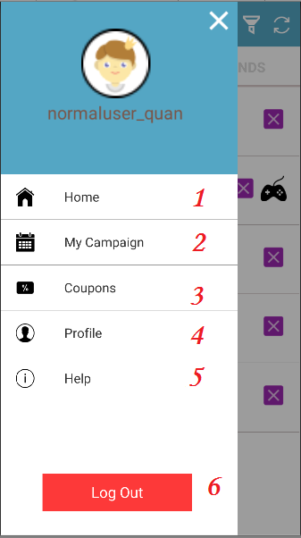

Figure 138 – Side Menu Mobile App UI

**Buttons/Hyperlinks:**

|  |  |  |  |  |
| --- | --- | --- | --- | --- |
| **No** | **Function** | **Description** | **Validation** | **Outcome** |
| 1 | Home | Home | N/A | Redirected to Home Screen |
| 2 | My Campaign | My Campaign | N/A | Redirected to My Campaign Screen |
| 3 | Coupons | Coupons | N/A | Redirected to Coupons Screen |
| 4 | Profile | Profile | N/A | Redirected to Profile Screen |
| 5 | Help | Help | N/A | Redirected to Help Screen |
| 6 | Log out | Log out | N/A | Redirected to Log in Screen |

Table 113 - <User Interface-Button/Hypperlinks> Side Menu – Mobile App

* + - 1. My Campaign

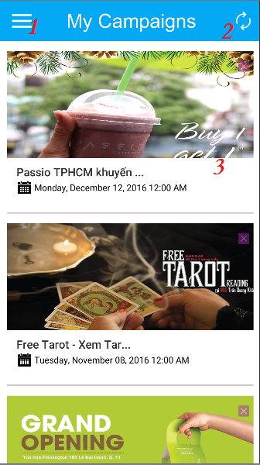

Figure 139 – My Campaign Mobile App UI

**Buttons/Hyperlinks:**

|  |  |  |  |  |
| --- | --- | --- | --- | --- |
| **No** | **Function** | **Description** | **Validation** | **Outcome** |
| 1 | Menu | Side Menu button | N/A | Open Side Menu |
| 2 | Refresh | Refresh button | N/A | Refresh Screen |
| 3 | Event | Event link | N/A | Redirected to Event Details Screen. |

Table 114 - <User Interface-Button/Hypperlinks> My Campaign – Mobile App

* + - 1. Coupon List

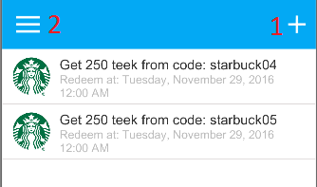

Figure 140 – Coupon List Mobile UI

**Buttons/Hyperlinks:**

|  |  |  |  |  |
| --- | --- | --- | --- | --- |
| **No** | **Function** | **Description** | **Validation** | **Outcome** |
| 3 | Redeem | Redeem coupon | N/A | Show redeem coupon modal |
| 4 | Menu | Show side menu | N/A | Show side menu |

Table 116 - <User Interface-Button/Hypperlinks> Coupon List – Mobile App

* + - 1. Redeem Coupon

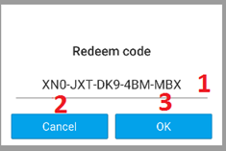

Figure 141 – Redeem Coupon Mobile App UI

**Fields**

|  |  |  |  |  |  |  |  |
| --- | --- | --- | --- | --- | --- | --- | --- |
| **No** | **Field Name** | **Description** | **Read only** | **Mandatory** | **Control Type** | **Data Type** | **Length** |
| 1 | Coupon code | Coupon code to gain teek point | N/A | Close popup screen | Textbox | String |  |

Table 117 - <User Interface-Field> Redeem Coupon – Mobile App

**Buttons/Hyperlinks:**

|  |  |  |  |  |
| --- | --- | --- | --- | --- |
| **No** | **Function** | **Description** | **Validation** | **Outcome** |
| 2 | Cancel | Cancel button | N/A | Close popup screen |
| 3 | OK | Ok button | Validate if ocde is inputed | Show success message |

Table 118 - <User Interface-Button/Hypperlinks> Redeem Coupon – Mobile App

* + - 1. Profile

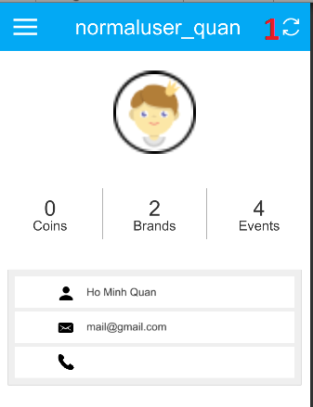

Figure 142 – Profile Mobile App UI

**Buttons/Hyperlinks:**

|  |  |  |  |  |
| --- | --- | --- | --- | --- |
| **No** | **Function** | **Description** | **Validation** | **Outcome** |
| 1 | Refresh | Reload information | N/A | Reload user information |

Table 119 - <User Interface-Button/Hypperlinks> Profile – Mobile App

* + - 1. Play Game

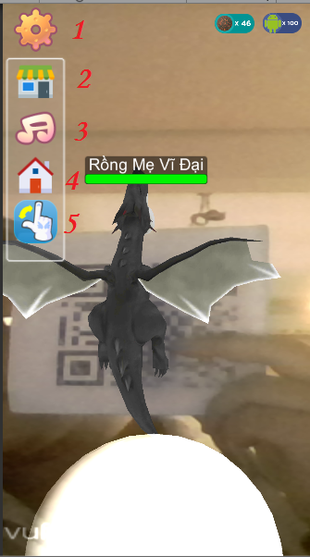

Figure 143 – Play Game Mobile App UI

**Buttons/Hyperlinks:**

|  |  |  |  |  |
| --- | --- | --- | --- | --- |
| **No** | **Function** | **Description** | **Validation** | **Outcome** |
| 1 | Menu | Menu button | N/A | Show scrolldown menu |
| 2 | Shop | Shop button | N/A | Show shop popup |
| 3 | Setting | Sound setting | N/A | Show sound setting popup |
| 4 | Home | Home button | N/A | Redirected to Home Screen |
| 5 | Switch | Switch | Validate number of ball | Switch ball |

Table 120 - <User Interface-Button/Hypperlinks> Play Game – Mobile App

* + - 1. In-game Shop

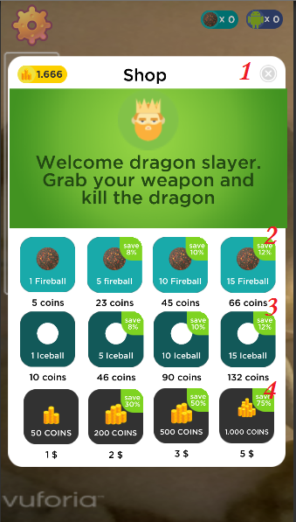

Figure 144 – In-game Shop Mobile App UI

**Buttons/Hyperlinks:**

|  |  |  |  |  |
| --- | --- | --- | --- | --- |
| **No** | **Function** | **Description** | **Validation** | **Outcome** |
| 1 | Close | Close button | N/A | Close popup screen |
| 2 | Buy Fire Ball | Buy Fire Ball button | Validate available Coins | Number of Fire ball increase |
| 3 | Buy Ice Ball | Buy Ice Ball button | Validate available Coins | Number of Ice ball increase |
| 4 | Buy Coins | Buy Coins button | N/A | Coins increase |

Table 121 - <User Interface-Button/Hypperlinks> In-game Shop – Mobile App

* + - 1. Game Setting

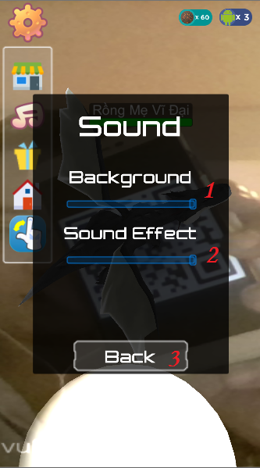

Figure 145 – Game Setting Mobile App UI

**Buttons/Hyperlinks:**

|  |  |  |  |  |
| --- | --- | --- | --- | --- |
| **No** | **Function** | **Description** | **Validation** | **Outcome** |
| 1 | Background | Sound background button | N/A | Change background sound |
| 2 | Effect | Sound Effect button | N/A | Change effect sound |
| 3 | Back | Back to game button | N/A | Back to game |

Table 122 - <User Interface-Button/Hypperlinks> Game Setting – Mobile App

* 1. Database design
     1. Entity relationship diagram

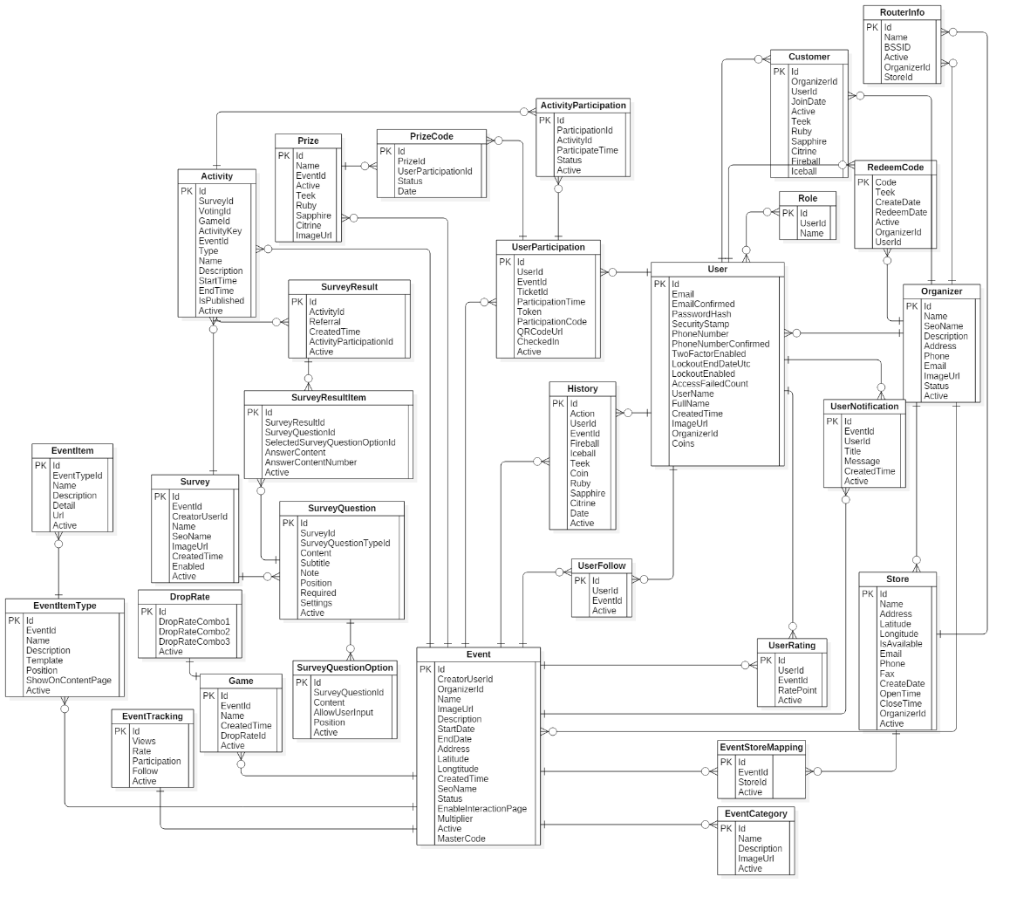

Figure 146 –Entity Relationship Diagram

* + 1. Data dictionary

|  |  |
| --- | --- |
| **Entity Data Dictionary: describe contents of all entities** | |
| **Entity Name** | **Description** |
| Role | Contain role of user, which role a user is |
| RedeemCode | Contain information of user coupon code |
| User | Contain all information about user |
| UserFollow | Contain information about which campaign user is following |
| History | Contain log of user action |
| Store | Contain all information about organizer’s store |
| RouterInfo | Contain all information about wifi router information of all store |
| Organizer | Contain all information about organizer |
| Customer | Contain information of relationship between user and organizer |
| UserRating | Cointain rating result of user about a compaign |
| UserNotification | Contain notification information to send to user |
| ActivityParticipation | Contain information about which activity user participated |
| UserParticipation | Contain information about which campaign user joined |
| PrizeCode | Cointain information of which prize user has redeemed |
| Prize | Cointain all information about prize of campaign |
| Event | Contain all information about campaign |
| EventItemType | Contain which type of a campaign’s component |
| EventTracking | Contain statistic about a campaign |
| EventCategory | Contain information about which type the capaign is |
| EventItem | Contain information about what component the campaign has |
| Game | Contain information about game of campaign |
| DropRate | Contain information about drop rate of item combo in game |
| Activity | Contain all information about campaign’s activity |
| Survey | Contain information about survey |
| SurveyQuestion | Contain information about question of survey |
| SurveyQuestionOption | Contain information about the option of a question in survey |
| SurveyResult | Contain information about result of survey when user finish doing the survey |
| SurveyResultItem | Contain information about result of each question in survey after user finish doing the survey |
| EventStoreMapping | Contain information about which store the campaign happening at |

Table 123 - Entity dictionary

* 1. Algorithms
     1. Mobile application algorithms
        1. Drop rate distribution
           1. Define problem

Each game has a drop rate for item, after the dragon is defeated, it will drop the item. So how to make the item drop correctly with the drop rate organizer has set in each game?

* + - * 1. Solution

Base on the Random function, this “Drop Rate Distribution” will solve the problem by following these steps.

**Step 1:**

* Get 3 drop rates (DropRate1, DropRate2, and DropRate3) from the server.

**Step 2:**

* Generate a random number between 1 and 100, we call it “RanPercent”.

**Step 3:**

* Check the RanPercent, there will be 3 situations:

1. RanPercent ≤ DropRate1:
   * Generate a random number between 1 and 3, we call it “RanItem”.
2. DropRate1 < RanPercent ≤ DropRate1+DropRate2:
   * Generate a random number between 1 and 3, we call it “RanItem”.
   * Increase the item amount by 1 respectively with the RanItem.
   * And do these 2 steps above 1 more time.
3. DropRate1+DropRate2 < RanPercent:
   * Generate a random number between 1 and 3, we call it “RanItem”.
   * Increase the item amount by 1 respectively with the RanItem.
   * And do these 2 steps above 2 more times.

**Step 4:**

Show the item(s) and the amount(s).

* + - * 1. Example
* The 3 drop rates we get from the server:

DropRate1: 70

DropRate2: 20

DropRate3: 10

(the unit of each drop rate is percent)

* Generate a random number between 1 and 100, it gives the result 13, the RanPercent is assigned with the value 13.
* The RanPercent is smaller than the DropRate1 (70), so this is the situation 1.
* Generate a random number between 1 and 3, it gives the result 1, the RanItem is assigned with the value 1.
* 1 is the Ruby, and the situation 1 only drops 1 item, so the result panel will show “Ruby x1”.
  + - * 1. Flowchart

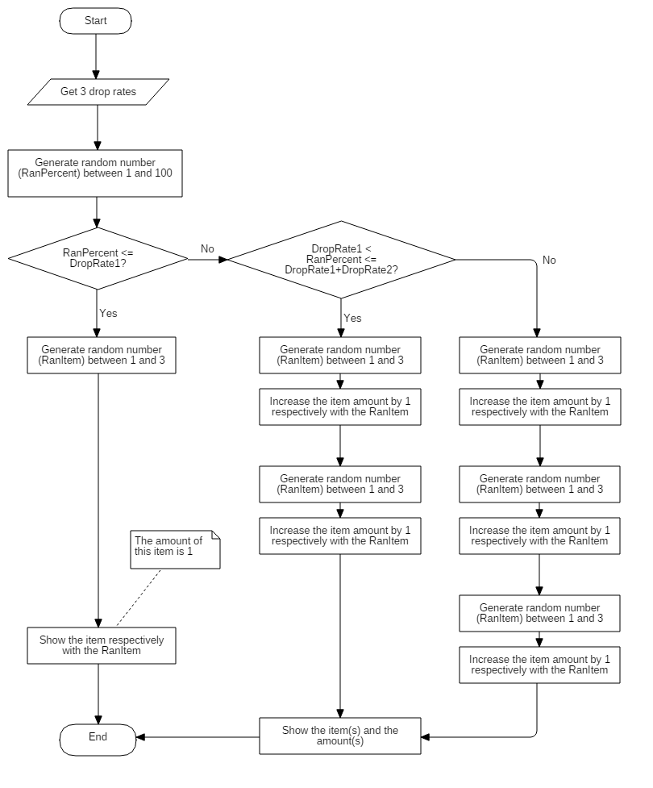

Figure 147 – <Algorithms> Drop rate distribution flow chart

* + - * 1. Complexity

The “Drop Rate Distribution” does not have any loops, so the complexity is O(1).

* + - 1. Last hit prediction
         1. Define problem

By normal we only know the ball hits the dragon when the ball collides the dragon. How can we know if the ball hits the dragon or not when the ball is newly thrown at the very beginning time?

* + - * 1. Solution

The traveling path of the ball will be a Parabola curve, the hit box of the dragon is a Sphere. We will check if this Parabola intersects with the Sphere or not. If they intersect, then the ball will hit the dragon, else it will not.

Base on the Mathematics formulas and rules, the “Last Hit Prediction” will solve the problem by following these steps:

**Step 1:**

* Get 3 continuous positions of the ball from the time when it is newly thrown.

**Step 2:**

* From these 3 positions we can define the Plane.
* The Plane formula:

$$Ax+By+Cz+D=0 \\ \left(A^{2}+B^{2}+C^{2}≠0\right)$$

**Step 3:**

* The Sphere formula:
$$x^{2}+y^{2}+z^{2}-2ax-2by-2cz+d=0 \\ \left(a^{2}+b^{2}+c^{2}-d>0\right) \\ Center I\left(a;b;c\right) \\ Radius R=\sqrt{a^{2}+b^{2}+c^{2}-d}$$

* We will check if the Plane intersects with the Sphere or not by calculating the distance between the center I of the Sphere and the Plane (P).
* The distance formula:

$$d\left(I,\left(P\right)\right)=\frac{\left|Aa+Bb+Cc+D\right|}{\sqrt{A^{2}+B^{2}+C^{2}}}$$

**Step 4:**

* Check if the distance is larger than the Radius of the Sphere or not:

1. $d>R:$ the Plane does not intersect with the Sphereggh𝑙𝑗𝑓𝑘𝑓𝑗la in the three-th the radius of the Spherere and the Plane:y the distance
   * The ball will not hit the dragon.
2. $d≤R:$ the Plane intersects with the Sphere
   * From the 3 positions in step 1 we can define the Parabola.
   * The Parabola formula:
 $$y={ax}^{2}+bx+c$$ $$(a≠0)$$ * Check if the distance equals to the Radius of the Sphere or not:
3. $d=R:$ the Plane and the Sphere have a mutual point
   * + Define this mutual point.
     + Check if this mutual point belongs to the Parabola or not.
4. $d<R:$ the Plane intersects with the Sphere and create a Circle
   * + Define this Circle.
     + The Circle formula:
 $$x^{2}+y^{2}-2a'x-2b'y+c'=0 \\ \left({a'}^{2}+b^{'2}-c'>0\right) \\ Center I'\left(a';b'\right) \\ Radius r= \sqrt{{a'}^{2}+{b'}^{2}-c'}= \sqrt{R^{2}-{d\left(I, \left(P\right)\right)}^{2}}$$

    + The center I’ of the Circle is the projectile of the center I of the Sphere on the Plane.
     + Check if this equation has solutions or not:

$$\left\{\begin{aligned}y={ax}^{2}+bx+c \\ x^{2}+y^{2}-2a'x-2b'y+c'=0\end{aligned}\right.$$

**Step 5:**

Turn on the last hit effect if the mutual point belongs to the Parabola or the equation has solutions in step 4.

* + - * 1. Example
* The 3 continuous positions of the ball:

Position1 = (1, 1, 3)

Position2 = (-1, 2, 3)

Position3 = (-1, 1, 2)

* From these 3 positions we define the Plane:
$$-x-2y+2z-3=0$$

* The center I of the Sphere:

I (3, 5, 5)

* The radius R of the Sphere:

R = 1

* The distance between the Plane and the center I:
$$\frac{\left|-1.3+\left(-2\right).5+2.5-3\right|}{\sqrt{1+4+4}}=2$$

* We have 2 > 1 which means the distance between the Plane and the center I is larger than the radius R.
* So there is no last hit effect.
  + - * 1. Flowchart

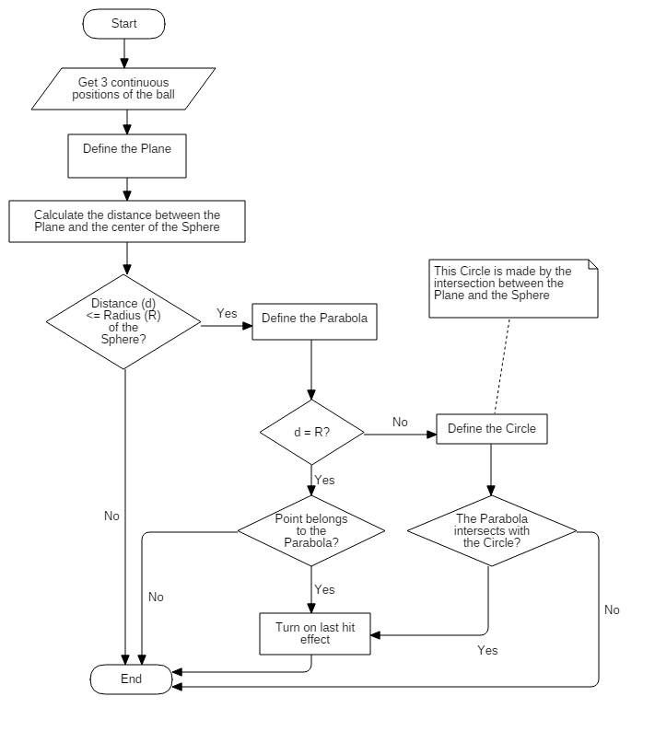

Figure 148 - <Algorithms> Last hit prediction flow chart

* + - * 1. Complexity

The “Last Hit Prediction” does not have any loops, so the complexity is O(1).

* + 1. Strategy for future expand plan

ARG mobile game application is currently store monster model information and shop information in local. So it can only be changed by make changed in Unity Project (by using Unity Editor) and build a new application. To make it easier to change these information, for example:

* Organizer can choose which monster can appear in their game
* Admin can easily edit or add item into in-game shop without working with Unity

We are intend to store these information in web server in mobile application will load and apply change inside the game

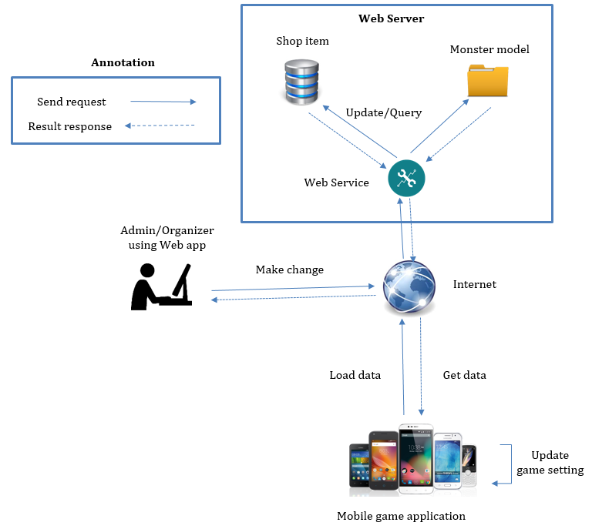

Figure 149 – Future plan strategy

1. システム展開とテスト
   1. 初めに
      1. 概要

本節で検査を計画して整理して管理するためのアプローチと方法論を述べました。その上、テスト計画、テストケース、テスト結果、テスト環境、成敗基本も記入されました。

* + 1. テストアプローチ
* **目的:** システムの基本に基づいて、全ての機能をチェックします。
* **方法:** ブラックボックステスト。
* **技術:** チェックリスト。

統合したプログラムはソフトウェア要求に合うのを確保するためにテストします。すべてのメンバーがテストします。

* 1. データベースの関係図
     1. 物理のダイアグラム

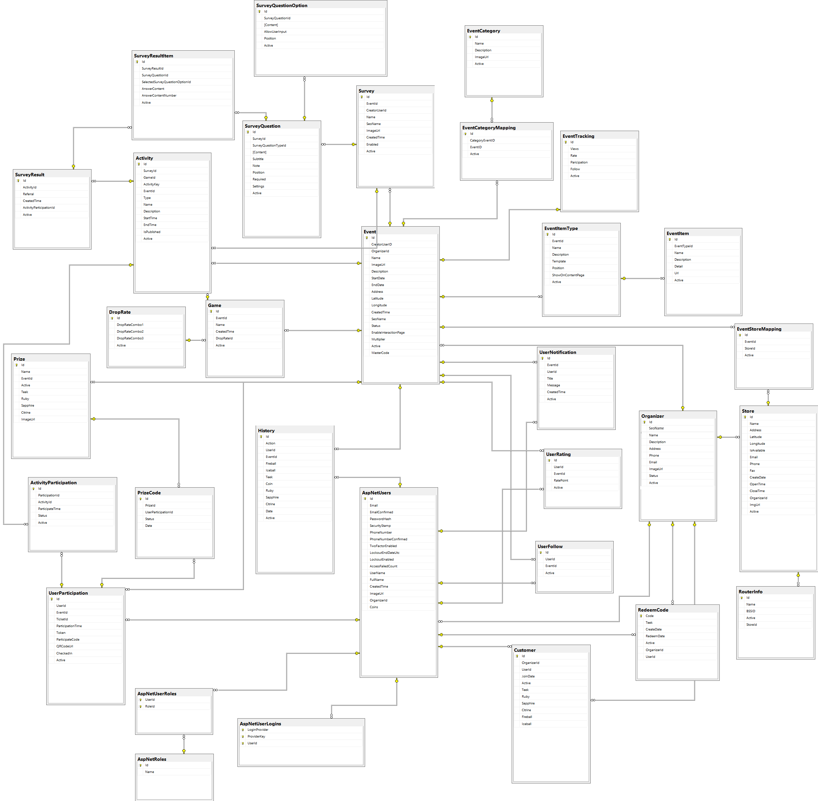

Figure 150 – 物理的なダイアグラム

* + 1. データ辞書

|  |  |  |
| --- | --- | --- |
| **データ辞書:　実本の内容をすべて記述します** | | |
| **数字** | **実本名** | **記述** |
| 1 | AspNetUserRoles | ユーザーの役割を含有します |
| 2 | RedeemCode | ユーザーのクーポンの情報を含有します |
| 3 | AspNetUser | ユーザーの情報を含有します |
| 4 | UserFollow | ユーザーのフォローしているキャンペーン情報を含有します |
| 5 | History | ユーザー活動ログの情報を含有します |
| 6 | Store | 店の情報を含有します |
| 7 | RouterInfo | 店のワイファイルーター情報を含有します |
| 8 | Organizer | ブランド情報を含有します |
| 9 | Customer | ユーザーとブランドの関係情報を含有します |
| 10 | UserRating | キャンペーン評価を含有します |
| 12 | UserNotification | ユーザーに送るメッセージの情報を含有します |
| 13 | ActivityParticipation | 参加した活動の情報を含有します |
| 14 | UserParticipation | 参加したキャンペーンの情報を含有します |
| 15 | PrizeCode | ユーザーの取った賞品情報を含有します |
| 16 | Prize | キャンペーンの賞品情報を含有します |
| 17 | Event | キャンペーンの情報を含有します |
| 18 | EventItemType | キャンペーン種類を含有します |
| 19 | EventTracking | キャンペーンの統計量を含有します |
| 20 | EventCategory | キャンペーンとキャンペーンの種類関係を含有します |
| 21 | EventItem | キャンペーンの要素情報を含有します |
| 22 | Game | ゲーム情報を含有します |
| 23 | DropRate | ゲームのアイテム落ちる率を含有します |
| 24 | Activity | キャンペーンの活動情報を含有します |
| 25 | Survey | 考察情報を含有します |
| 26 | SurveyQuestion | 考察の質問情報を含有します |
| 27 | SurveyQuestionOption | 考察質問の答え情報を含有します |
| 28 | SurveyResult | 考察の結果情報を含有します |
| 29 | SurveyResultItem | 考察の質問の答えごとに、それの情報を含有します |
| 30 | EventStoreMapping | キャンペーンと店関係を含有します |
| 31 | AspNetRoles | ユーザー役割の定義を含有します |
| 32 | AspNetUserLogins | 第三者のアカウントでログイン情報を含有します |
| 33 | EventCategoryMapping | キャンペーンの種類関係を含有します |

Table 124 – データ辞書：実本の内容をすべて記述します

* 1. パフォーマンス対策
     1. ARGサーバ接続速度
        1. 定義

パフォーマンス対策では、モバイルアプリケーションとARGサーバに情報を通信するす時間を計ります。

* + - 1. テスト環境
* サーバ:
* オペレーティングシステム: Windows 10 64-bit
* RAM: 8GB
* プロセッサー: Intel Core i3 2.10 GHz
* インターネット:　30Mbps Wireless
* クライアント:
* オペレーティングシステム: Android Marshmallow 6.0.1
* RAM: 3 GB
* プロセッサー: Qualcomm Snapdragon 801 32-bit
* インターネット:　30Mbps Wireless
  + - 1. テストケース

モバイルアプリケーションを使って、その時間を計ります。

行うテストケースリスト

|  |  |  |
| --- | --- | --- |
| **No.** | **Function name** | **Description** |
| 1 | 情報が現れます | ユーザーはキャンペーンの情報を見ます |
| 2 | ゲームをします | ユーザーはゲームします |
| 3 | アイテムを買います | ゲームの売店でアイテムを買います |

Table 125 – ARGサーバ接続速度テストケース

* + - 1. 結果

テストは１０回繰り返しします。後は、時間の平均を計算します。

|  |  |  |  |  |  |  |  |  |  |  |
| --- | --- | --- | --- | --- | --- | --- | --- | --- | --- | --- |
| **Test case** | **Time (unit: second)** | | | | | | | | | |
| **1** | **2** | **3** | **4** | **5** | **6** | **7** | **8** | **9** | **10** |
| **1** | 1.58 | 2.45 | 2.57 | 0.56 | 1.35 | 0.58 | 1.17 | 1.39 | 1.42 | 0.55 |
| **2** | 0.31 | 0.41 | 0.58 | 0.23 | 0.21 | 0.29 | 0.96 | 0.48 | 0.20 | 0.38 |
| **3** | 0.56 | 0.55 | 0.44 | 0.58 | 0.46 | 1.17 | 1.21 | 0.52 | 0.42 | 0.57 |
| **Average** | 0.8166 | 1.1366 | 1.196 | 0.4566 | 0.6733 | 0.68 | 1.113 | 0.796 | 0.68 | 0.5 |

Table 126 - ARGサーバ接続速度テストの結果

* 1. テスト計画

本分の目的はユーザーからの要求と設計の通りを確保するです。これからどの機能を検査するか検査しませんかについて説明します。

* + 1. テスト行う機能:

モバイルアプリケーションの機能を全部検査します。

* + 1. テスト行わない機能:

モバイルアプリケーションに集中することにしたからこそ、ウェブの機能を検査しません。

* 1. システムテストのテストケース
     1. 通信ダイアグラム
        1. モバイルアプリケーション

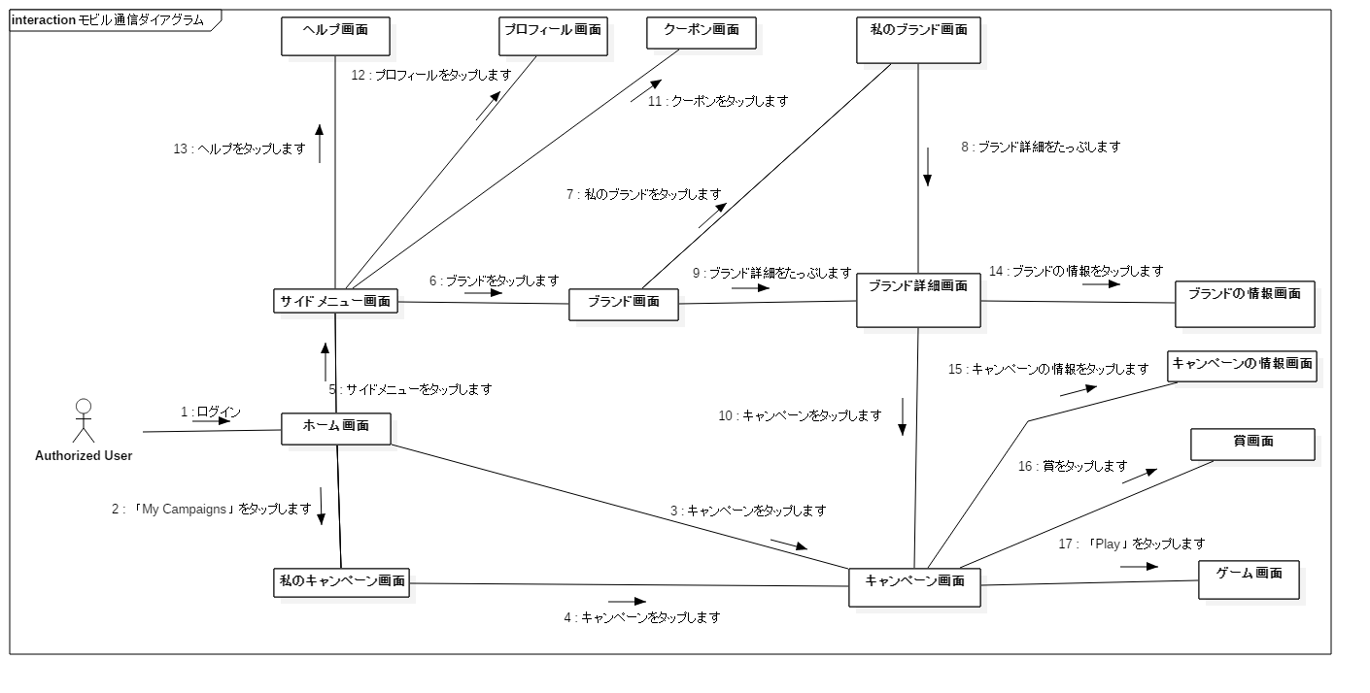

Figure 151 - Communication diagram: Web application

* + - 1. ウェブアプリケーション

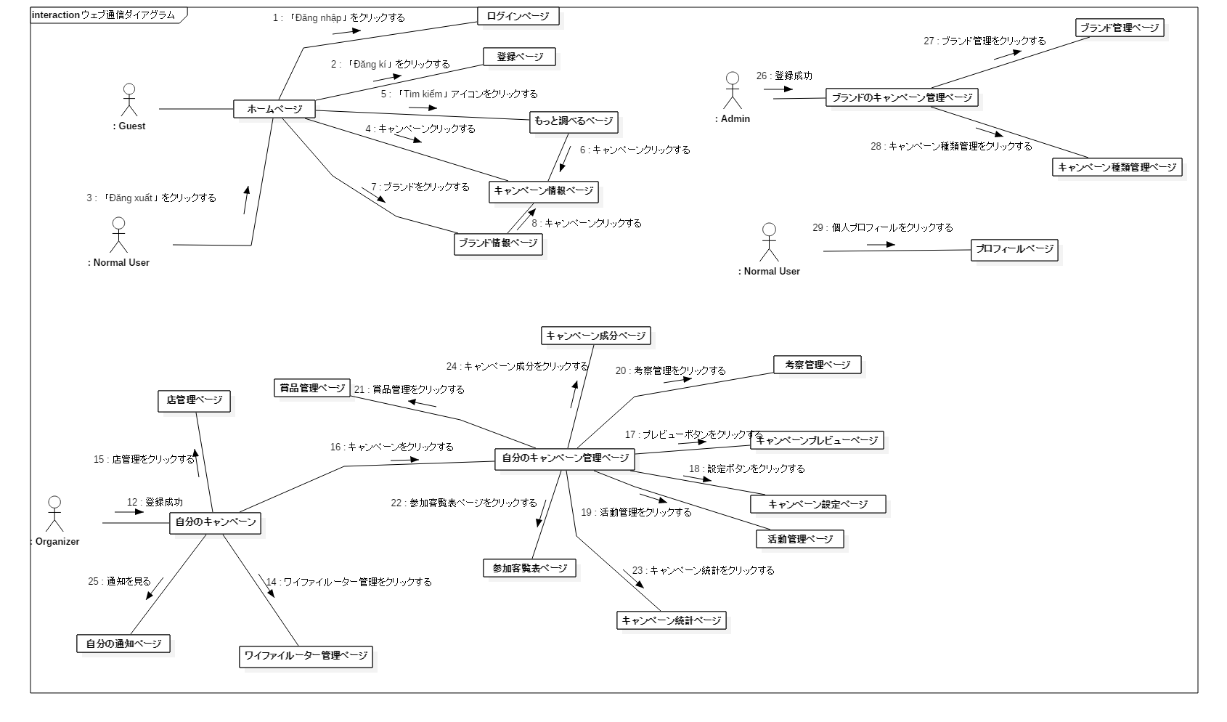

Figure 151 - Communication diagram: Web application

* + 1. テストケース
       1. モバイルアプリケーションテストケース
       2. ログイン

|  |  |  |  |  |  |  |  |
| --- | --- | --- | --- | --- | --- | --- | --- |
| **ID** | テストケースの説明 | テストケースの手順 | 予想出力 | インターテストケース依存性 | 結果 | 実行日 | **ノート** |
| 前提条件 :   1. ログインボタンをタップする | | | | | | | |
| TC001 | テストユーザー名とパスワード内容を入力間違って | 1. ユーザー名とパスワード内容を入力間違って 2. ログインボタンをタップ | 「wrong username and password」メッセージに表す |  | 合格 | 10/21/2016 |  |
| TC002 | ユーザー名とパスワードが空が入力する検証 | ２．ユーザー名とパスワードが空が入力間違って  ３．ログインボタンをタップ | 「Please enter username and password」メッセージに表す |  | 合格 | 10/21/2016 |  |
| TC003 | ユーザー名が空に入力する検証 | ２．ユーザー名が空に入力間違って  ３．ログインボタンをタップ | 「Please enter username and password」メッセージに表す |  | 合格 | 10/21/2016 |  |
| TC004 | パスワードが空に入力する検証 | 2．パスワードが空に入力間違って  ３．ログインボタンをタップ | 「Please enter username and password」メッセージに表す |  | 合格 | 10/21/2016 |  |
| TC006 | ユーザー名とパスワードを確実入力する検証 | ２．厳密ユーザー名とパスワードを入力間違って | ホーム画面を行きます |  | 合格 | 10/21/2016 |  |
| TC007 | テストユーザー名内容を入力間違って |  | 「wrong username and password」メッセージに表す |  | 合格 | 10/21/2016 |  |
| TC008 | テストパスワード内容を入力間違って |  | 「wrong username and password」メッセージに表す |  | 合格 | 10/21/2016 |  |

Table 127 - ログインテストケース

* + - 1. 登録します

|  |  |  |  |  |  |  |  |
| --- | --- | --- | --- | --- | --- | --- | --- |
| **ID** | テストケースの説明 | テストケースの手順 | 予想出力 | インターテストケース依存性 | 結果 | 実行日 | **ノート** |
| 前提条件:   1. 「Don’t have account? Sign Up」リンクをタップする | | | | | | | |
| TC009 | 登録を合格 | 2.以下のような要件フィールド内のすべての情報を入力して:  -完全な名前フィールドの内容を入力してください: NHP  -電子メールの内容を入力して:nhp@gmail.com  -ユーザー名の内容を入力して: nhp  -パスワードの内容を入力して: 123qwe123  -再入力パスワードの内容を入力して: 123qwe123   1. 3.「Register」ボタンをクリックする | ホームページに行く |  | 合格 | 10/21/2016 |  |
| TC010 | 無効な電子メール | 2.以下のような要件フィールド内のすべての情報を入力して:  -完全な名前フィールドの内容を入力してください: NHP  -電子メールの内容を入力して:nhp@gmail.com  -ユーザー名の内容を入力して: nhp  -パスワードの内容を入力して: 123qwe123  -再入力パスワードの内容を入力して: 123qwe123  3.「Register」ボタンをクリックする | 「Invalidate email」メッセージに表す |  | 合格 | 10/21/2016 |  |
| TC011 | 空のフィールドを検証 | 1. すべてのフィールドを空のまま   「 Register」ボタンをクリックする | 「Please enter fullname」メッセージに表す |  | 合格 | 10/21/2016 |  |
| TC012 | 電子メールのフィールドを検証 | 1. 電子メールのフィールドを空のまま   「 Register」ボタンをクリックする | 「Please enter email」メッセージに表す |  | 合格 | 10/21/2016 |  |
| TC013 | ユーザー名を検証 | 1. ユーザー名のフィールドを空のまま   「 Register」ボタンをクリックする | 「Please enter username」メッセージに表す |  | 合格 | 10/21/2016 |  |
| TC014 | パスワードのフィールドを検証 | 1. パスワードのフィールドを空のまま   「 Register」ボタンをクリックする | 「Please enter password」メッセージに表す |  | 合格 | 10/21/2016 |  |
| TC15 | Test validate empty re-enter password | 1. Leave field re-enter password empty   Tap “ Register” | Show message “ Please enter password”メッセージに表す |  | 合格 | 10/21/2016 |  |
| TC16 | パスワードに８字以下を検証 | 2.以下のような要件フィールド内のすべての情報を入力して:  -完全な名前フィールドの内容を入力してください: NHP  -電子メールの内容を入力して:nhp@gmail.com  -ユーザー名の内容を入力して: nhp  -パスワードの内容を入力して: 123qwe  -再入力パスワードの内容を入力して: 123qwe   1. 3.「Register」ボタンをクリックする | 「Password must be at least 8 characters」メッセージに表す |  | 合格 | 10/21/2016 |  |
| TC017 | 同じパスワードを検証 | 2.以下のような要件フィールド内のすべての情報を入力して:  -完全な名前フィールドの内容を入力してください: NHP  -電子メールの内容を入力して:nhp@gmail.com  -ユーザー名の内容を入力して: nhp  -パスワードの内容を入力して: 123qwe123  -再入力パスワードの内容を入力して: 123qweASD  3.「Register」ボタンをクリックする | 「re-enter password is not match」メッセージに表す |  | 合格 | 10/21/2016 |  |
| TC018 | 完全な名前のフィールドに番号を入力してが検証 | 2. 完全な名前のフィールドに番号を入力する  3. 「Register」ボタンをクリックする | 番号を入力することができない |  | 合格 | 10/21/2016 |  |
| TC019 | 存在ユーザー名が検証 | 2.以下のような要件フィールド内のすべての情報を入力して:  -完全な名前フィールドの内容を入力してください: NHP  -電子メールの内容を入力して:nhp@gmail.com  -ユーザー名の内容を入力して: nhp  -パスワードの内容を入力して: 123qwe123  -再入力パスワードの内容を入力して: 123qwe123  3.「Register」ボタンをクリックする | 「Failed to create new user. Name nhp is already taken」メッセージに表す |  | 合格 | 10/21/2016 |  |
| TC020 | 存在の電子メールが検証 | 2.以下のような要件フィールド内のすべての情報を入力して:  -完全な名前フィールドの内容を入力してください: NHP  -電子メールの内容を入力して:nhp@gmail.com  -ユーザー名の内容を入力して: nhp  -パスワードの内容を入力して: 123qwe123  -再入力パスワードの内容を入力して: 123qwe123  3.「Register」ボタンをクリックする | 「Failed to create new user. Email ‘nhp@gmail.com‘ is already taken」メッセージに表す |  | 合格 | 10/21/2016 |  |

Table 128 - 登録しますテストケース

* + - 1. ゲームのメニュー

|  |  |  |  |  |  |  |  |
| --- | --- | --- | --- | --- | --- | --- | --- |
| **ID** | テストケースの説明 | テストケースの手順 | 予想出力 | インターテストケース依存性 | 結果 | 実行日 | **ノート** |
| 前提条件 :   1. 「Play」ボタンをクリックする | | | | | | | |
| TC021 | 音のバック グラウンドを設定が検証 | ２．「Menu」ボタンをタップする  ３．設定ボタンをタップする   1. ４．音のスライド バーを移動する | 音のバックグラウンドを変化 |  | 合格 | 10/21/2016 |  |
| TC022 | ボールを買いことが検証 | ２．「Menu」ボタンをタップする  ３．「Shop」ボタンをタップする  ４．「Ball」ボタンをたっぷする  ５．「Buy　Now」ボタンをタップする | ボールの番号を変化 |  | 合格 | 10/21/2016 |  |
| TC023 | ボール スイッチ ボタンを検証 | ２．「Menu」ボタンをタップする  ３．ボール スイッチ ボタンをタップする | 火ボールを氷ボールを改める |  | 合格 | 10/21/2016 |  |
| TC024 | ホームボタンを検証 | ２．「Menu」ボタンをタップする  ３．「Home」ボタンをタップする | ホーム画面を行く |  | 合格 | 10/21/2016 |  |

Table 129 - ゲームのメニューテストケース

* + - 1. ゲームをします

|  |  |  |  |  |  |  |  |
| --- | --- | --- | --- | --- | --- | --- | --- |
| **ID** | テストケースの説明 | テストケースの手順 | 予想出力 | インターテストケース依存性 | 結果 | 実行日 | **ノート** |
| 前提条件 :   1. 「Play」ボタンをクリックする | | | | | | | |
| TC025 | ゲームの中にボールを買いことが検証 | ２．「Menu」ボタンをタップする6」「2  ｐ３．「Shop」ボタンをタ26+ップする  ４．「Ball」ボタンをたっぷする   1. ５．「Buy　Now」ボタンをタップする | ボールを買いことができある |  | 合格 | 10/21/2016 |  |
| TC026 | ボールと龍が会ったの音が検証 | ２．龍にボールを打ち込む来ます | 会ったの音が鳴くる |  | 合格 | 10/21/2016 |  |
| TC027 | カメラとパターンの格差が５０センチメートル以下が検証 | ２．カメラとパターンの格差が５０センチメートル以下が移動する | あの龍が現さない |  | 合格 | 10/21/2016 |  |
| TC028 | カメラとパターンの格差が５０センチメートルが検証 | ２．カメラとパターンの格差が５０センチメートルが移動する | 龍が現す |  | 合格 | 10/21/2016 |  |
| TC029 | 龍とボール会った時に龍のHPバーが変更が検証 | ２．龍にボールを投げる | 龍のHPバーが下る |  | 合格 | 10/21/2016 |  |
| TC030 | 龍に死んだ時にアイテムドロップが検証 | ２．龍死んだまでをボールを投げる | アイテムドロップ |  | 合格 |  |  |
| TC031 | 地とボールが会ったの結果検証 | ２．ボールを投げる | 地とボールが会ったの結果が音のブームや光が現す |  | 合格 | 10/21/2016 |  |
| TC032 | 龍の生が検証 | ２．ボールを投げる  ３．そのまま何もない４．２０分を待っている | 新し龍が現す |  | 合格 | 10/21/2016 |  |

Table 130 - ゲームをするテストケース

* + - 1. ホーム画面

|  |  |  |  |  |  |  |  |
| --- | --- | --- | --- | --- | --- | --- | --- |
| **ID** | テストケースの説明 | テストケースの手順 | 予想出力 | インターテストケース依存性 | 結果 | 実行日 | **ノート** |
| 前提条件 :   1. ログインボタンをタップする | | | | | | | |
| TC033 | 検索ボタンを検証 | 1. ２．検索の内容を「passio」入力して | Passioのブランドが現す |  | 合格 | 10/21/2016 |  |
| TC034 | ブランドのリンクを検証 | ２．ブランドのリンクをタップする | ブランド画面を行きます |  | 合格 | 10/21/2016 |  |
| TC035 | 更新ボタンを検証 | ２．更新ボタンをタップする | ホーム画面がも一度更新 |  | 合格 | 10/21/2016 |  |
| TC036 | フィルターボタンのチェックボックスのゲームを検証 | ２．フィルターをタップする  ３．チェックボックスのゲームをタップする | ブランドとゲームを現す |  | 合格 | 10/21/2016 |  |
| TC037 | フィルターのチェックボックスの「All」を検証 | ２．フィルターをタップする  ３．「All」チェックボックスをタップする | すべてブランドが現す |  | 合格 | 10/21/2016 |  |
| TC038 | フィルターボタンのチェックボックスの乗数を検証 | ２．フィルターをタップする  ３．チェックボックスの乗数をタップする | ブランドと乗数を現す |  | 合格 | 10/21/2016 |  |

Table 130 – ホーム画面テストケース

* + - 1. メニュー

|  |  |  |  |  |  |  |  |
| --- | --- | --- | --- | --- | --- | --- | --- |
| **ID** | テストケースの説明 | テストケースの手順 | 予想出力 | インターテストケース依存性 | 結果 | 実行日 | **ノート** |
| 前提条件 :   1. ログインボタンをタップする | | | | | | | |
| TC039 | ホームボタンを検証 | 1. ２．ホームボタンをタップする | ホーム画面を行きます |  | 合格 | 10/21/2016 |  |
| TC040 | 「My　Campaign」ボタンを検証 | ２．「My Campaign」ボタンをタップする | 「My　Campaign」画面を行きます |  | 合格 | 10/21/2016 |  |
| TC041 | クーポンボタンを検証 | ２．クーポンボタンをタップする | クーポン画面を行きます |  | 合格 | 10/21/2016 |  |
| TC042 | プロフィールボタンを検証 | ２．プロフィールボタンをタップする | プロフィール画面を行きます |  | 合格 | 10/21/2016 |  |
| TC043 | 「Help」ボタンを検証 | ２．「Help」ボタンをタップする | 「Help」画面を行きます |  | 合格 | 10/21/2016 |  |
| TC044 | 閉じるボタンを検証 | ２．閉じるボタンをタップする | ミェヌを閉じる |  | 合格 | 10/21/2016 |  |
| TC045 | ログアウトボタンを検証 | ２．ログアウトボタンをタップする | ログイン画面を行くや顧客ロールを「Guest」ロール変更する |  | 合格 | 10/21/2016 |  |

Table 130 – メニューテストケース

* + - 1. キャンペーン

|  |  |  |  |  |  |  |  |
| --- | --- | --- | --- | --- | --- | --- | --- |
| **ID** | テストケースの説明 | テストケースの手順 | 予想出力 | インターテストケース依存性 | 結果 | 実行日 | **ノート** |
| 前提条件 :   1. キャンペーン画面を行きます | | | | | | | |
| TC046 | 「Play」ボタンを検証 | 1. ２．「Play」ボタンをタップする | ゲーム画面を行きます |  | 合格 |  |  |
| TC047 | 「Info」ボタンを検証 | ２．「Info」ボタンをタップする | 「Info」タブの情報を現す |  | 合格 |  |  |
| TC048 | 「Prize」ボタンを検証 | ２．「Prize」ボタンをタップする | 「Prize」タブの情報を現す |  | 合格 |  |  |
| TC049 | 受賞のリンクを検証 | ２．「Prize」ボタンをタップする  ３．受賞のリンクをタップする | 「RedeemPrize」画面を現す |  | 合格 |  |  |
| TC050 | 交換と「Teek」ボタンを検証 | ２．「Prize」ボタンをタップする  ３．受賞のリンクをタップする  ４．交換と「Teek」ボタンをタップする | 成功の通牒を現す |  | 合格 |  |  |
| TC051 | 空のTeekを検証 | ２．「Prize」ボタンをタップする  ３．受賞のリンクをタップする  ４．空Teekの時に交換と「Teek」ボタンをタップする | 失敗の通牒を現す |  | 合格 |  |  |
| TC052 | 空のGemsを検証 | ２．「Prize」ボタンをタップする  ３．受賞のリンクをタップする  ４．空Gemsの時に交換と「Gems」ボタンをタップする | 失敗の通牒を現す |  | 合格 |  |  |

Table 130 – キャンペーンテストケース

* + - 1. 賞品を交換します

|  |  |  |  |  |  |  |  |
| --- | --- | --- | --- | --- | --- | --- | --- |
| **ID** | テストケースの説明 | テストケースの手順 | 予想出力 | インターテストケース依存性 | 結果 | 実行日 | **ノート** |
| 前提条件 :   1. キャンペーン画面を行きます 2. 賞ボタンをタップする | | | | | | | |
| TC053 | 「コードを入力する」ボタンを検証 | 1. ３．「コードを入力する」ボタンをタップする | 「コードを入力する」画面を行きます |  | 合格 |  |  |
| TC054 | 閉じるボタンを検証 | ３．閉じるボタンをタップする | この画面を閉じる |  | 合格 |  |  |
| TC055 | キャンセルボタンを検証 | ３．「コードを入力する」ボタンをタップする  ４．閉じるボタンをタップする | この画面を閉じる |  | 合格 |  |  |
| TC056 | コードが正しい入力ことを検証 | ３．「コードを入力する」ボタンをタップする  ４．コード正しい入力する | 成功通牒を現す |  | 合格 |  |  |
| TC057 | コードが間違って入力を検証 | ３．「コードを入力する」ボタンをタップする  ４．コードが間違って入力する | 失敗通牒を現す |  | 合格 |  |  |
| TC051 | 空のTeekを検証 | ２．「Prize」ボタンをタップする  ３．受賞のリンクをタップする  ４．空Teekの時に交換と「Teek」ボタンをタップする | 失敗の通牒を現す |  | 合格 |  |  |
| TC052 | 空のGemsを検証 | ２．「Prize」ボタンをタップする  ３．受賞のリンクをタップする  ４．空Gemsの時に交換と「Gems」ボタンをタップする | 失敗の通牒を現す |  | 合格 |  |  |

Table 130 – 商品を交換するテストケース

1. ソフトウェアユーザーマニュアル
   1. インストレーションガイド
      1. サーバ側の環境設定
         1. ハードウェア要求

|  |  |
| --- | --- |
| ハードウェア | 記述 |
| インターネット | 8 Mbps以上 |
| プロセッサー | Intel® Core(TM) i5 CPU , M 460 @ 2.53GHz以上 |
| RAM | 4GB以上 |
| ハードディスクドライブ | 40GB 以上 |

Table 131 - ハードウェア要求

* + - 1. ソフトウェア要求

|  |  |
| --- | --- |
| ソフトウェア | アプリケーション名前／バージョン |
| オペレーティングシステム | Window Server 2012 |
| .Net | 4.5 |
| DBMS | SQL Server 2014 |

Table 132 - ソフトウェア要求

* + 1. サーバ側に展開します
       1. 環境をチェックする

．NET　Framework　バージョンをチェックする

CMDを開けこのテキストを押してください: dir %WINDIR%\Microsoft.Net\Framework\v*

結果:

Directory of C:\Windows\Microsoft.Net\Framework

11/21/2010 10:31 AM <DIR> v1.0.3705

07/14/2009 10:20 AM <DIR> v1.1.4322

04/10/2016 06:27 PM <DIR> v2.0.50727

11/21/2010 02:06 PM <DIR> v3.0

03/28/2016 02:48 AM <DIR> v3.5

04/17/2016 12:18 PM <DIR> v4.0.30319

Note: .NET Framework 4.5 is stored in a sub-directory of 4.0.

* + - 1. データベース取り込む

「**Database**」ディレクトリの中に入ったファイルを使ってください。

* + - 1. プロジェクトを建てる

1. VisualStudio2015で「**Teek**.ｓｌｎ」を開けてください。
2. **Teek**プロジェクトを右クリックして、「Publish」をクリックしてください。
3. Puｂｌish手法を選んでください。
4. 「**Publish**」ボタンをクリックしてください。
   * + 1. IISサーバに展開する

１．「**Internet Information Services (IIS) Manager**」開けてください。

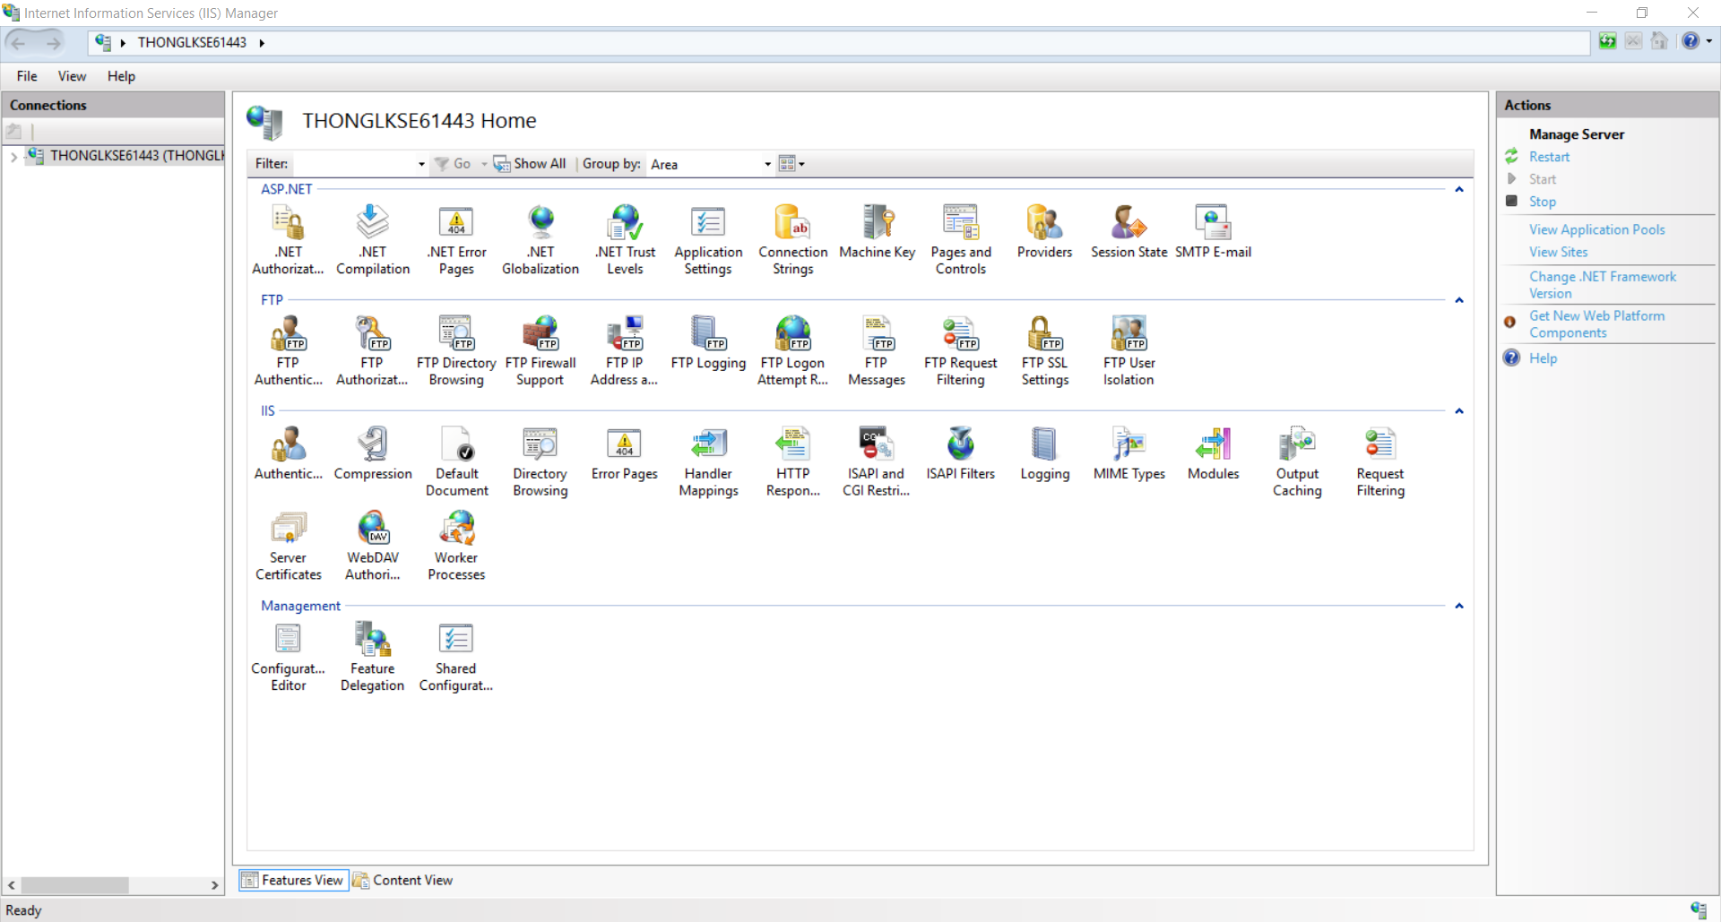

２．Application Poolを「.Net Framework v4.0.30319」にセットする

* 「**Application** **Pool**」にクリックしてください。
* 「**DefaultAppPool**」にダブルクリックしてください。
* ポップアップの中に、この写真のようにセットしてください

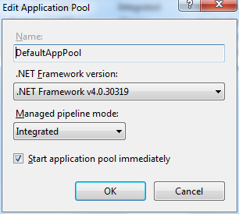

* 「**OK**」をクリックしてください。

３．IISサーバに展開します

* 「**Sites**」を右クリックして、「**Add Website**」にクリックしてください。
* ポップアップの中に、この写真のようにセットしてください。

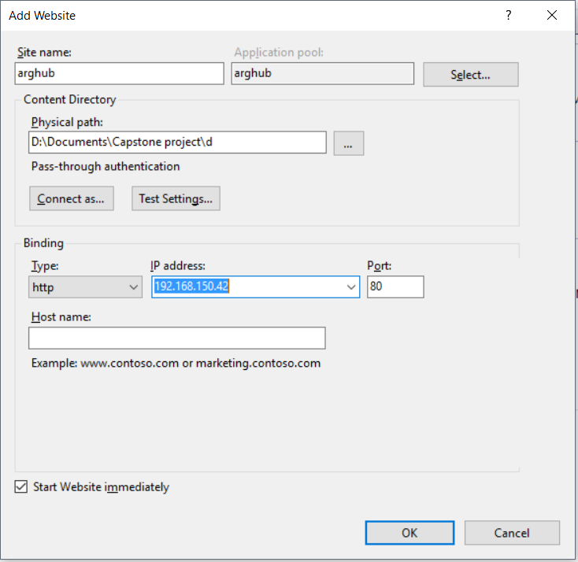

* **注意：**
  + Physical　Path：１段の建てたパッケージの場所。
  + Site　Name：あなたのウェブの名前。
* 「**OK**」をクリックしてください。
  1. ユーザーガイド
     1. ウェブアプリケーション
     2. 登録します

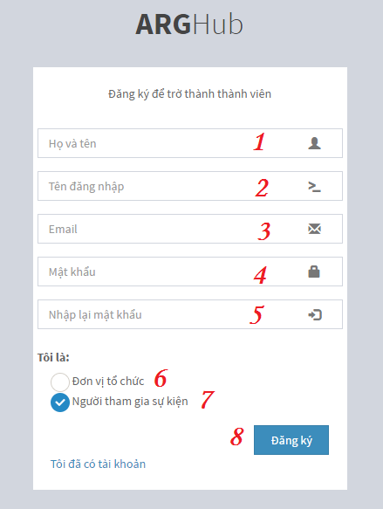

Figure 152 - ＜ユーザーガイド・ウェブ＞　登録します

|  |  |
| --- | --- |
| **Step** | **Description** |
| 1 | 完全な名前フィールドの内容を入力します。 |
| 2 | ユーザー名の内容を入力します。 |
| 3 | 電子メールの内容を入力します。 |
| 4 | パスワードの内容を入力します。 |
| 5 | 再入力パスワードの内容を入力します。 |
| 6 | 主催者には「Đơn vị tổ chức」をチェックします。  案外には「Người tham gia chiến dịch」 をチェックします。 |
| 7 | 「Đăng ký」のボタンをクリックします。 |

* + 1. ログイン

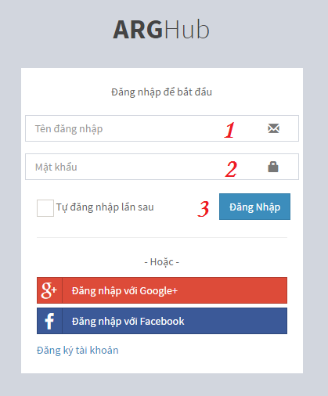

Figure 153 - ＜ユーザーガイド・ウェブ＞　登録します

|  |  |
| --- | --- |
| **Step** | **Description** |
| 1 | ユーザー名の内容を入力します。 |
| 2 | パスワードの内容を入力します。 |
| 3 | 「Đăng Nhập」のボタンをクリックします。 |

* + 1. 売店を作成します

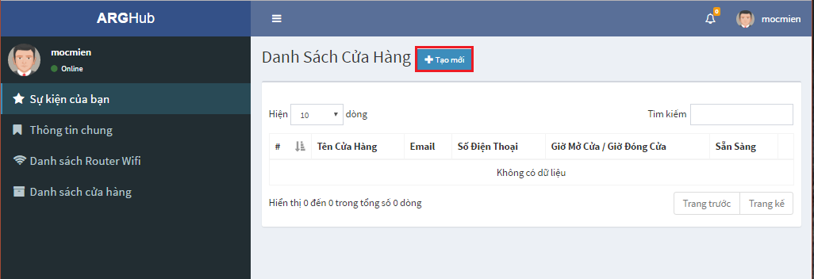

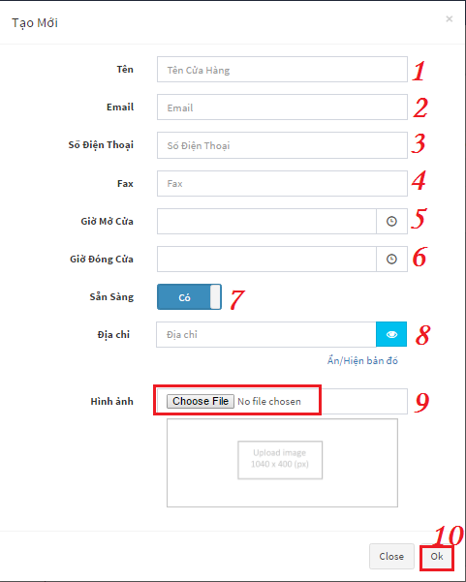

Figure 154 - ＜ユーザーガイド・ウェブ＞　売店を作成します

|  |  |
| --- | --- |
| **Step** | **Description** |
| 1 | 「Tạo mới」のボタンをクリックします。 |
| 2 | ストア名の内容を入力します。 |
| 3 | 電子メールの内容を入力します。 |
| 4 | 電話番号の内容を入力します。 |
| 5 | ファックス番号の内容を入力します。 |
| 6 | 明け時の内容を入力します。 |
| 7 | 閉時の内容を入力します。 |
| 8 | スイッチボタンの状態に「Có」を変化します。  案外には「Không」を変化します。 |
| 9 | 住所の内容を入力します。 |
| 10 | 「Choose File」のボタンをクリックして、イメージを選択します。 |
| 11 | 「OK」のボタンをクリックします。 |

* + 1. キャンペーンを作成します

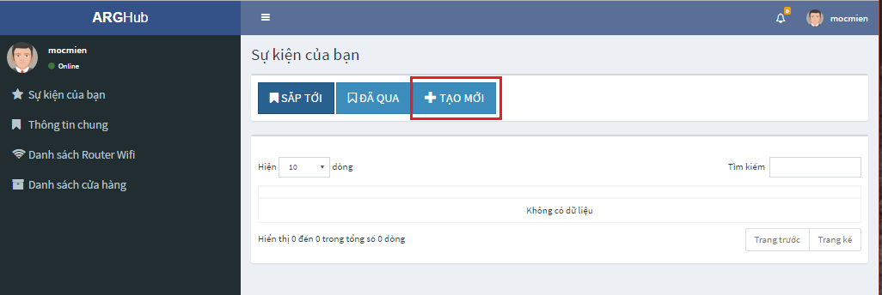

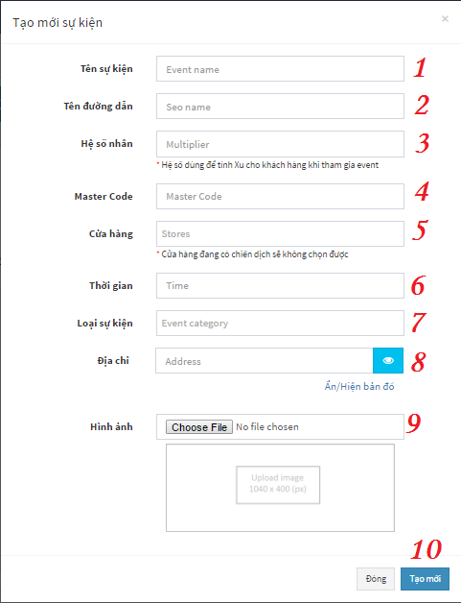

Figure 155 - ＜ユーザーガイド・モバイル＞　登録します

|  |  |
| --- | --- |
| **Step** | **Description** |
| 1 | 「Tạo mới」のボタンをクリックします。 |
| 2 | キャンペーン名の内容を入力します。 |
| 3 | SEO名の内容を入力します。 |
| 4 | 乗数の内容を入力します。 |
| 5 | マスターコードの内容を入力します。 |
| 6 | ストアにキャンペーンがあることに選択します。 |
| 7 | キャンペーンの問に起こることの内容を入力します。 |
| 8 | キャンペーン等級に選択します。 |
| 9 | 住所の内容を入力します。 |
| 10 | 「Choose File」のボタンをクリックして、イメージを選択します。 |
| 11 | 「Tạo mới」のボタンをクリックします。 |

* + 1. ゲームを作成します

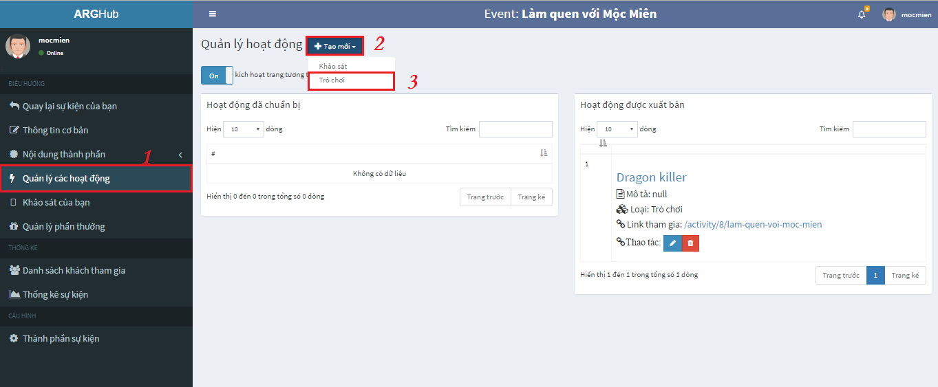

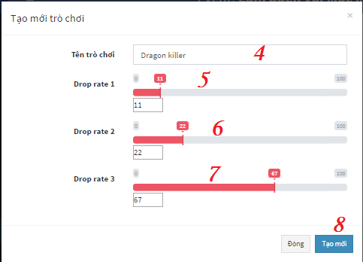

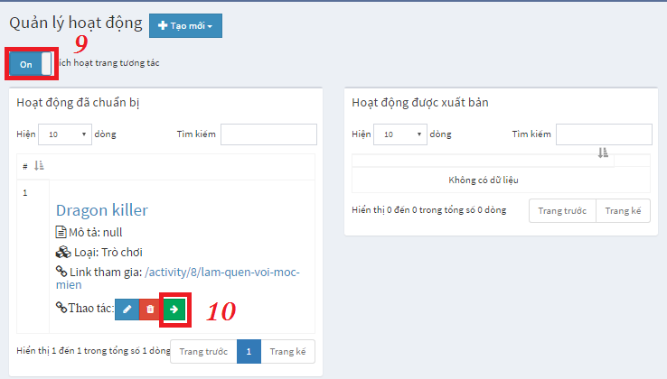

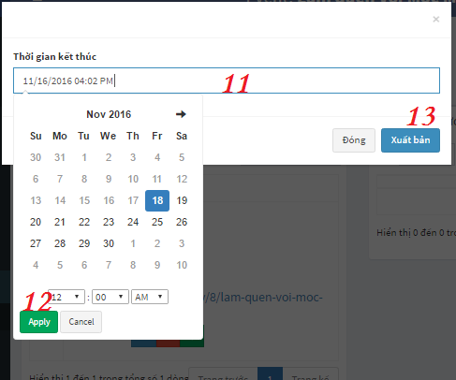

Figure 156 - ＜ユーザーガイド・モバイル＞　ゲームを作成します

|  |  |
| --- | --- |
| **Step** | **Description** |
| 1 | 「Quản lý các hoạt động」のリンクをクリックします。 |
| 2 | 「Tạo mới」のボタンをクリックします。 |
| 3 | 「Trò chơi」のリンクを選択します。 |
| 4 | ゲーム名の内容を入力します。 |
| 5 | ドロップ率１のスライドバーやドロップ率１の内容を調整します。 |
| 6 | ドロップ率２のスライドバーやドロップ率２の内容を調整します。 |
| 7 | ドロップ率３のスライドバーやドロップ率３の内容を調整します。 |
| 8 | 「Tạo mới」のボタンをクリックします。 |
| 9 | スイッチボタンの状態に「On」を変化します。  案外には「Off」を変化します。 |
| 10 | 「🡪」のボタンをクリックします。 |
| 11 | 時間を選択します。 |
| 12 | 「Apply」のボタンをクリックします。 |
| 13 | 「Xuất bản」のボタンをクリックします。 |

* + 1. モバイルアプリケーション
    2. 登録します

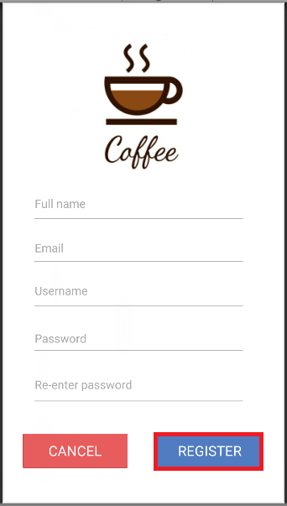

Figure 157 - ＜ユーザーガイド・モバイル＞　登録します

|  |  |
| --- | --- |
| **Step** | **Description** |
| 1 | 完全な名前フィールドの内容を入力します。 |
| 2 | 電子メールの内容を入力します。 |
| 3 | ユーザー名の内容を入力します。 |
| 4 | パスワードの内容を入力します。 |
| 5 | 再入力パスワードの内容を入力します。 |
| 6 | 「Ｒｅｇｉｓｔｅｒ」のボタンをタップに登録します。 |

* + 1. ログイン

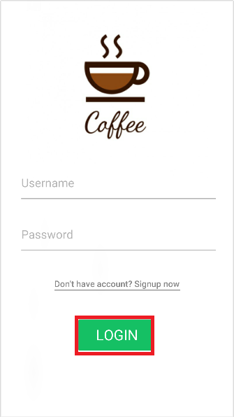

Figure 158 - ＜ユーザーガイド・モバイル＞　ログイン

|  |  |
| --- | --- |
| **Step** | **Description** |
| 1 | モバイルアプリケーションを明けます。 |
| 2 | ユーザー名を入力します。 |
| 3 | パスワードを入力します。 |
| 4 | 「Ｌｏｇｉｎ」ボタンをタップします。 |

* + 1. キャンペーンに参加します

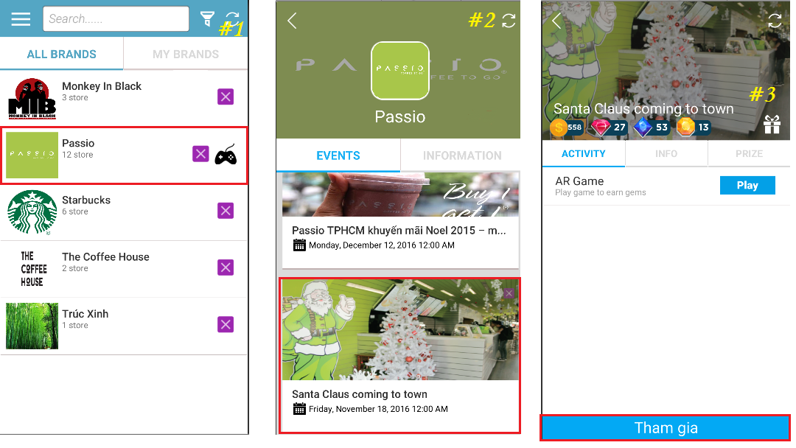

Figure 159 - ＜ユーザーガイド・モバイル＞　キャンペーンに参加します

|  |  |
| --- | --- |
| **Step** | **Description** |
| 1 | モバルアプリケーションにログインします。 |
| 2 | ここでブランドを選択します。「例えば、これはPASSIOのブランドです」 |
| 3 | イベントに選択します。「例えば、これは「Santa Claus coming to town」のイベントです」 |
| 4 | 「Ｔｈａｍ　ｇｉａ」のボタンをタップします。 |

**注意：**

-　＃１：これはホームの画面です。

-　＃２：これはブランドの画面です。

-　＃３：これはイベント詳細の画面です。

* + 1. ゲームをします

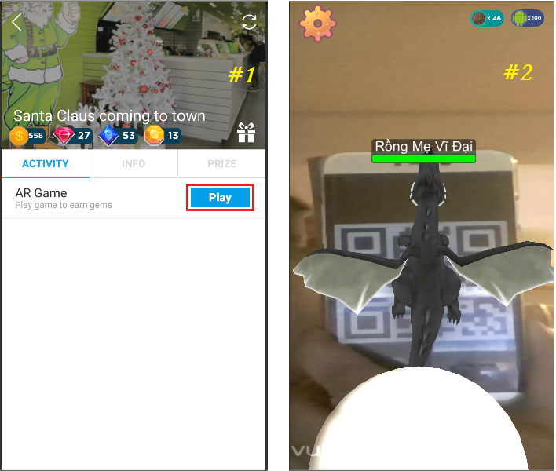

Figure 160 - ＜ユーザーガイド・モバイル＞　ゲームをします

|  |  |
| --- | --- |
| **Step** | **Description** |
| 1 | イベント詳細の画面に行きます。 |
| 2 | アクティビティタブでは「Ｐｌａｙ」のボタンをタップします。 |

**注意：**

* ＃１：これはイベント詳細の画面です。
* ＃２：これはゲームの画面です。
  + 1. 賞品を交換します

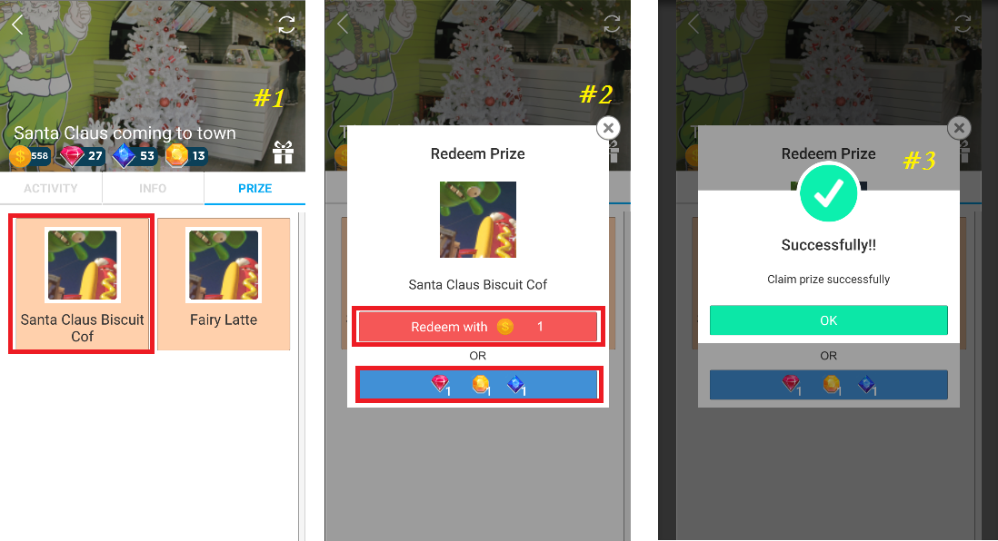

Figure 161 - ＜ユーザーガイド・モバイル＞　商品を交換します

|  |  |
| --- | --- |
| **Step** | **Description** |
| 1 | イベント詳細の画面に行きます。 |
| 2 | 「PRIZE」のタブにタップします。 |
| 3 | 賞に選択して、次にタップして、「Ｒｅｄｅｅｍ　Ｐｒｉｚｅ」のポップアップが現れます。 |
| 4 | 「」のボタンと「」のボタンを選択して、次にタップします。 |
| 5 | 成功のポップアップが現れて、「ＯＫ」のボタンにタップします。 |

**注意：**

* ＃１：これは「ＰＲＩＺＥ」のタプの画面です。
* ＃２：これは「Ｒｅｄｅｅｍ　Ｐｒｉｚｅ」のポップアップです。
* ＃３：これは成功のポップアップです。
  + 1. プレゼントを受け取ります

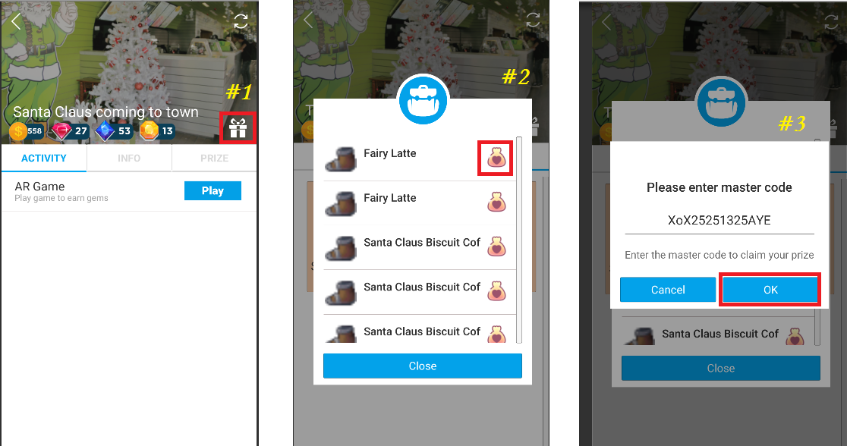

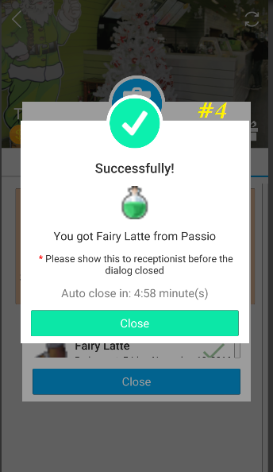

Figure 162 - ＜ユーザーガイド・モバイル＞　プレゼントを受け取ります

|  |  |
| --- | --- |
| **Step** | **Description** |
| 1 | イベント詳細の画面に行きます。 |
| 2 | プレゼントの写真「」にタップします。 |
| 3 | プレゼントのリストのポップアップが現れて、プレゼント交換のボタンにタップします。 |
| 4 | 「Ｍａｓｔｅｒ　ｃｏｄｅ」のポップアップが現れて、コードの内容を入力します。 |

注意：

* ＃１：これはイベント詳細の画面です。
* ＃２：これはプレゼントのリストのポップアップです。
* ＃３：これは「Ｍａｓｔｅｒ　ｃｏｄｅ」のポップアップです。
* ＃４：これは成功のポップアップです。

1. Appendix
2. SOFTWARE ENGINEERING 9TH EDITION, BY IAN SOMMERVILLE
3. STARUML DOCUMENTATION FOR ACTIVITY DIAGRAM:

http://www.uml-diagrams.org/activity-diagrams-controls.html

1. STARUML DOCUMENTATION OF IBM: https://www.ibm.com/developerworks/rational/library/content/RationalEdge/sep03/f_umlbasics_db.pdf
2. C# Coding Convention (C# Programing Guide) – Microsoft

https://msdn.microsoft.com/en-us/library/ff926074.aspx

1. UML FOR DRAWING DIAGRAM (2.0 STANDARD)

http://www.omg.org/spec/UML/2.0